Details for using Ubox App to access the Long Mynd North camera (or cameras if we get more)

The app is best used through an Android phone, Iphones have limited capabilities on this App so the instructions say.
This is the App as shown from Android Playstore, it is similar on IOS: There is also an App called UboxPro, not tested in detail but is not better in any way that was visible.
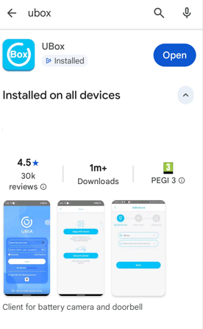

In order to access the camera
Download the app. Then select the location as UK and login (do not Register as a new user) enter the email address as cameras@longmynd.org The password will have been sent to club members via their own email address.
Once logged in you will get this view:
Important Note:
When you are viewing the live stream or recorded images do not leave the app running in fore or background on your phone as it uses a huge amount of camera battery power, with data transferring directly to your phone and will also block out other club members from viewing. Only have the app open just as long as you need to and no longer please.
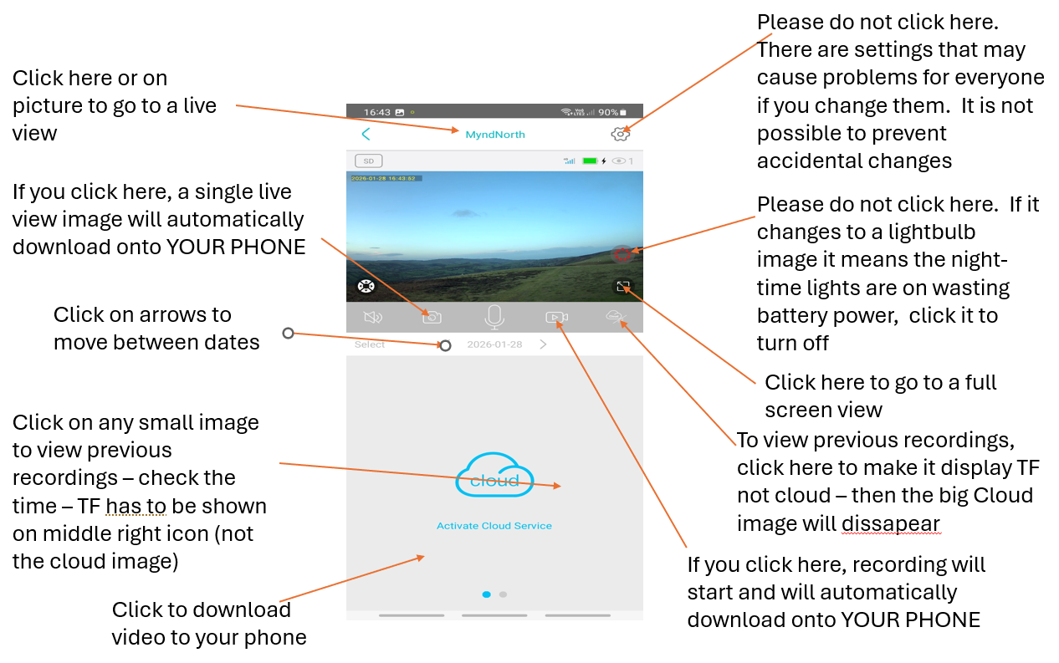

---------------------------------------------------------------------------------------------------------------
This is the method if you also already use the Ubox app for personal use at home or use the North Wales club’s Llangollen camera
The approach is to install the app on your phone, you must register it with the same email address you used to join LMSC. Other emails will not be accepted – you may have to deregister an existing registration if you have used another email address that you are not registered with LMSC.
Note that it will send you an email asking you to confirm – it may go in your junk email folder. Choose your own password. Once you have registered, send an email to cameras@longmynd.org asking to be connected.
Club Admin will check if that email address belongs to a current club member, if so you will be joined to the camera as ‘Friend’, this will then bring up a request next time you log in to the Ubox app, to accept the camera.

