**HW1 – Q2 Submission**

Megan Moore

[Mmmoore2@buffs.wtamu.edu](mailto:Mmmoore2@buffs.wtamu.edu)

1. Show first names and last names of employees in the database.

SELECT firstname, lastname

from Employees

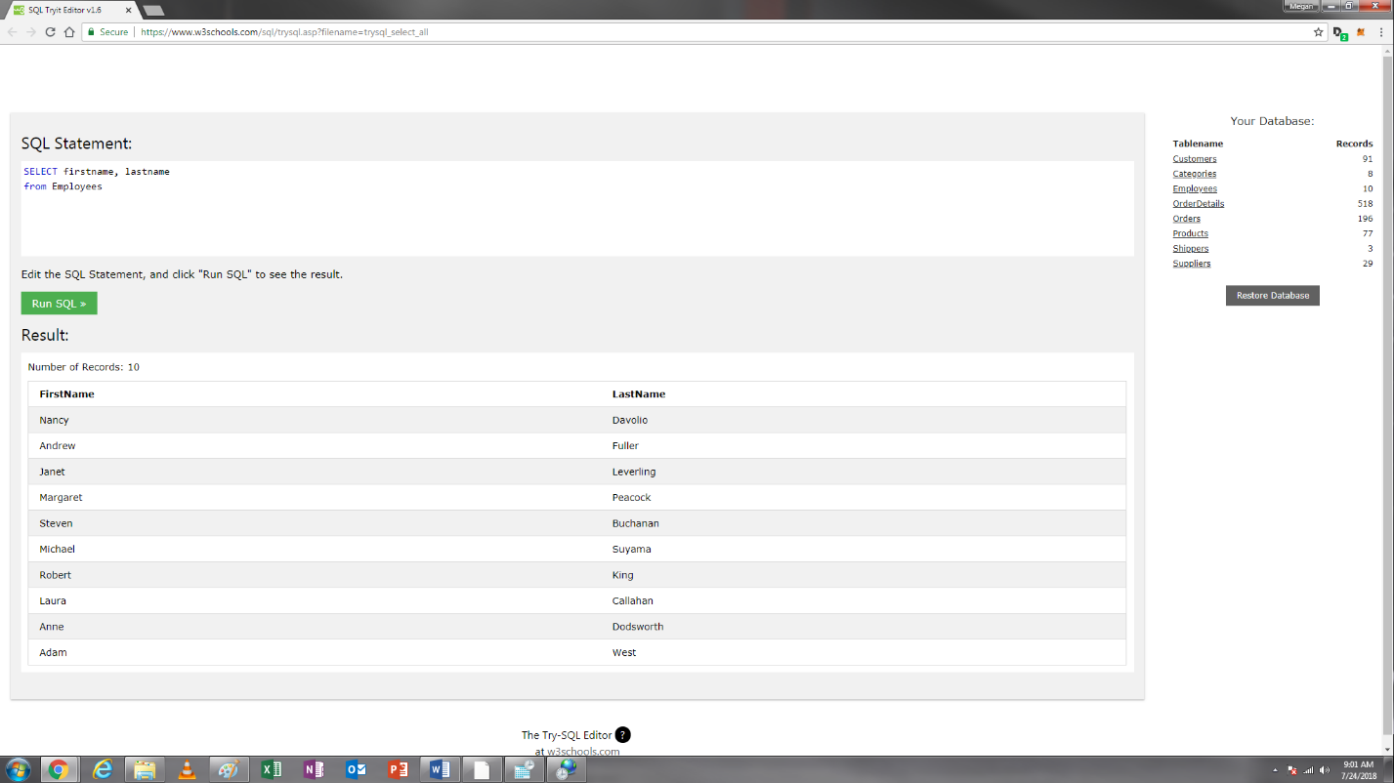

2. You want to pull all of the attributes from the Employees table.

SELECT *

from Employees

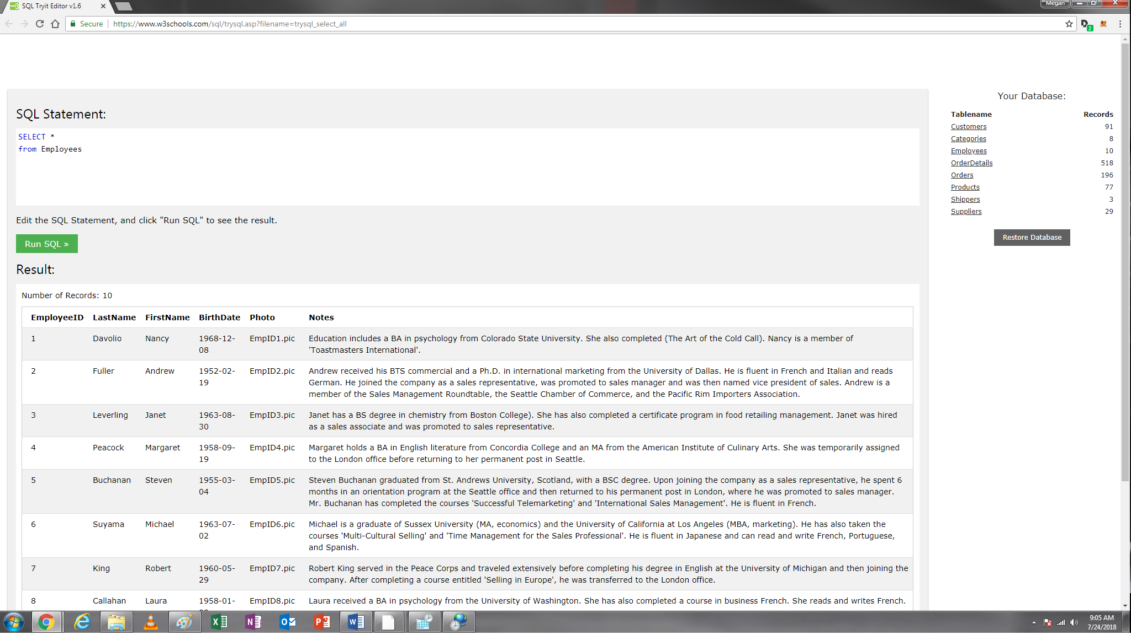

3. Show CustomerName and ContactName in the city of London from the customers table

SELECT customername, contactname, city

from customers

Where city="London"

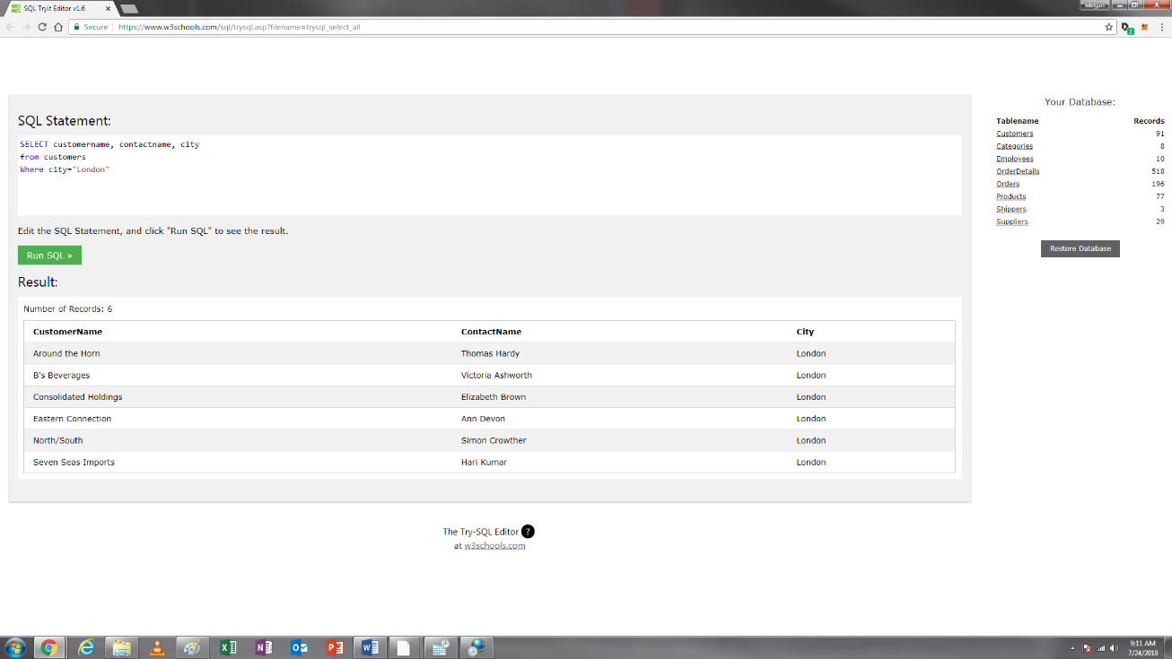

4. Find the average price for each supplier.

SELECT supplierid, AVG(price)

from products

group by supplierid

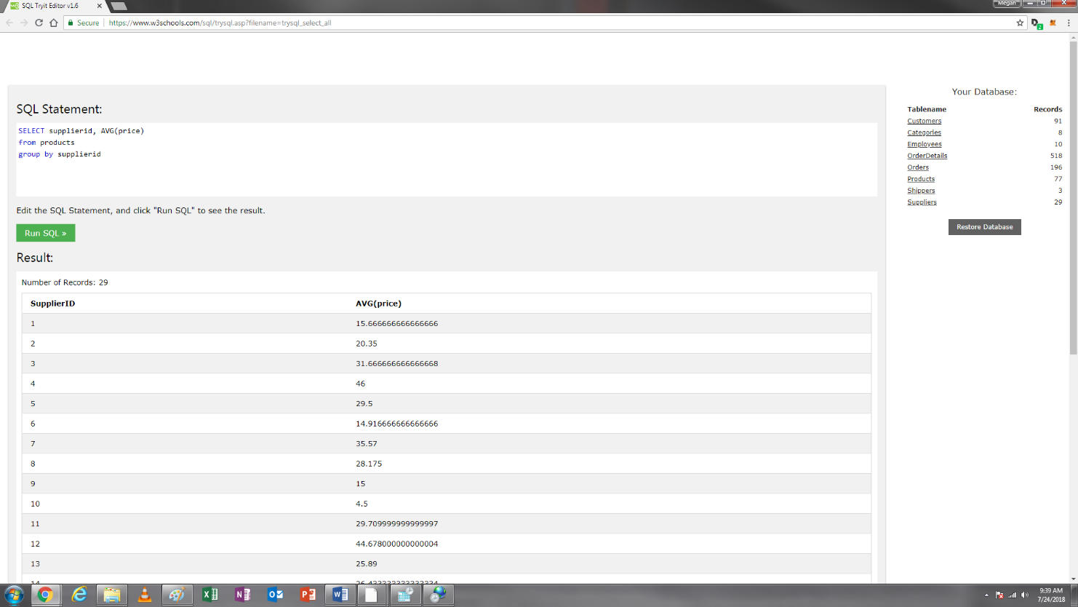

5. Find supplier with an average price greater than $20.

SELECT supplierid, AVG(price)

from products

group by supplierid

having avg(price)>20

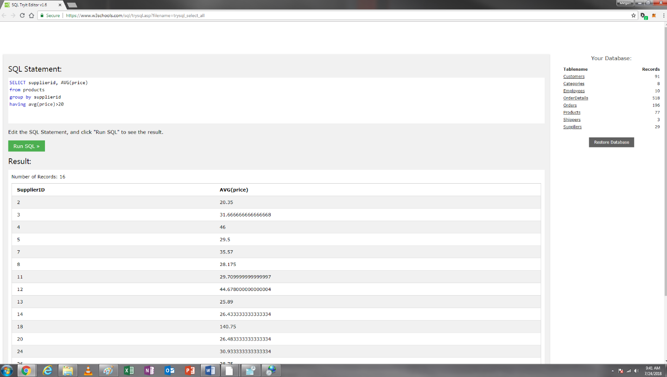

6. Find suppliers with an average price greater than $20 with supplier IDs greater than 5. Sort SupplierIDs in descending order.

SELECT supplierid, AVG(price)

from products

where supplierid>5

group by supplierid

having avg(price)>20

order by supplierid desc

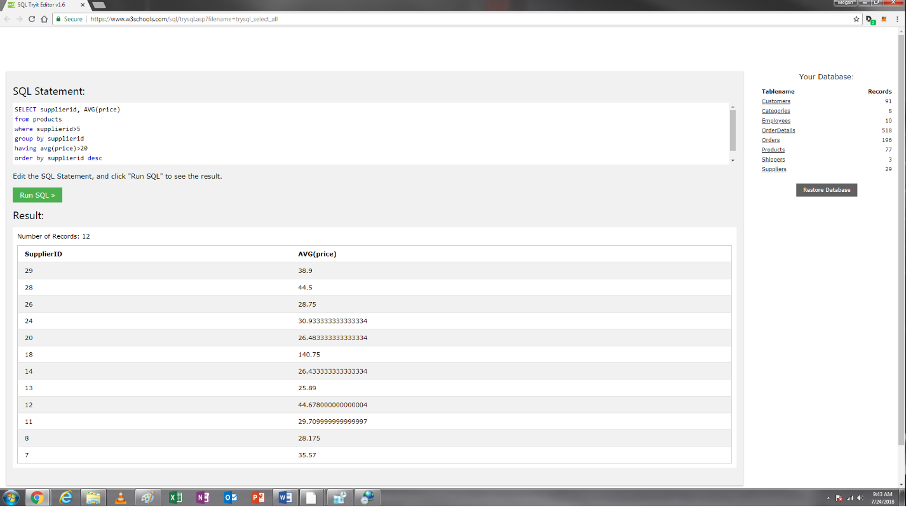

7. You want to pull all the attributes of the product with product ID greater than 5, categoryID equal to 4, and price greater than 10 from the products table.

SELECT *

from products

where productid>5 and categoryid=4 and price>10

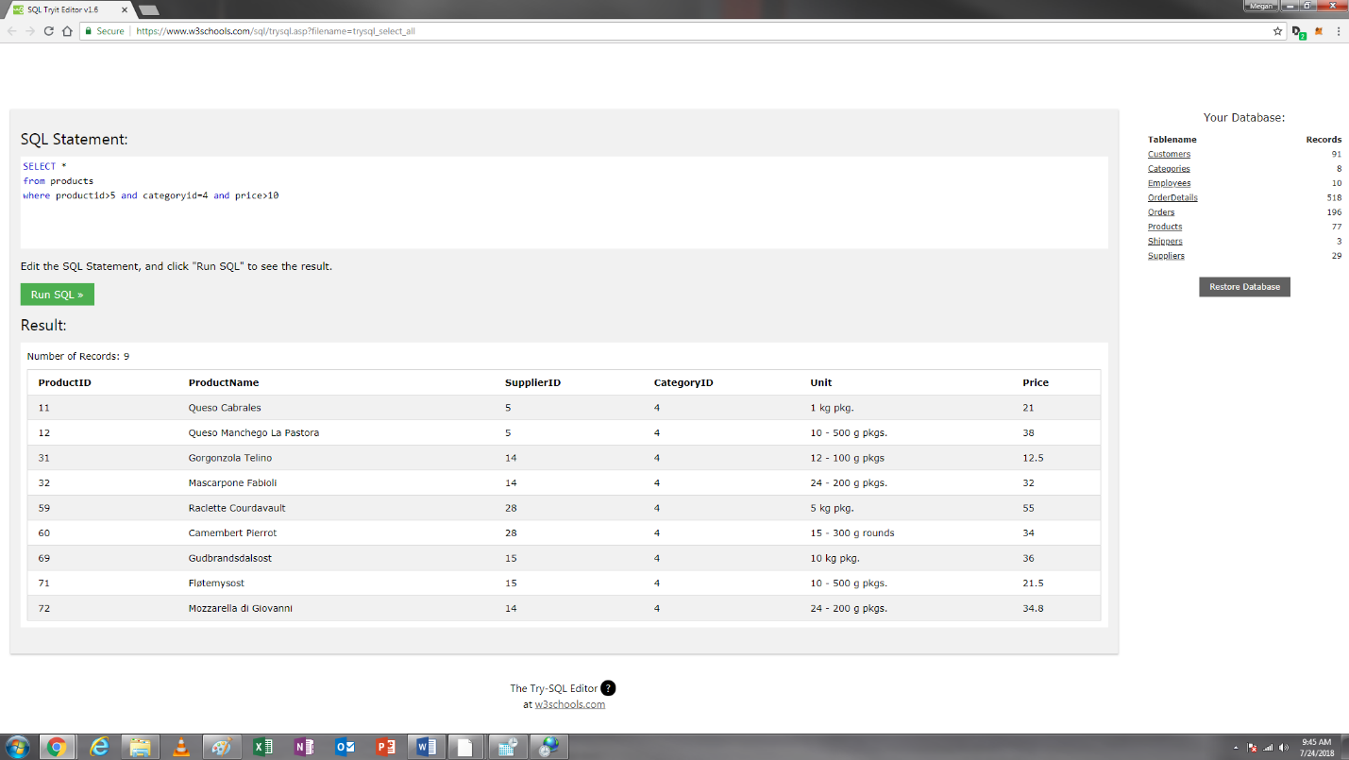

8. Show supplierID and SupplierName of suppliers with 1) supplierID greater than 2 but smaller than 10 or 2) country equal to USA [Use WHERE OR]

SELECT supplierid, suppliername

from suppliers

where (supplierid>2 and supplierid<10) or country="USA"

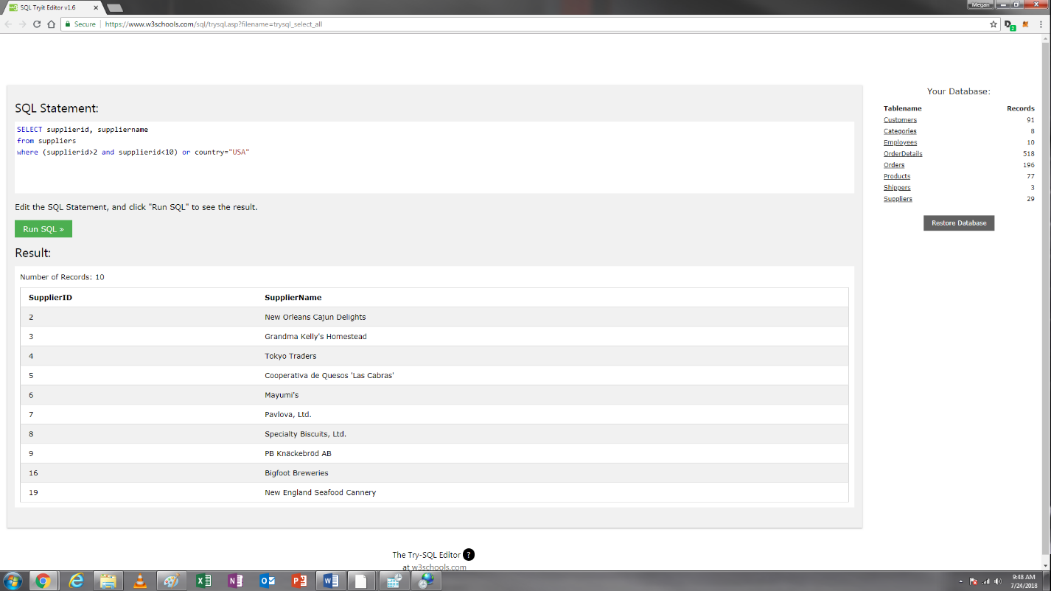

9. Show supplierID and SupplierName of suppliers with supplierID greater than 2 but smaller than 10 [Use WHERE BETWEEN AND: note the clause between X and Y includes both X and Y, so you have to change it to between X+1 and Y-1 to satisfy the requirement]

SELECT supplierid, suppliername

from suppliers

where supplierid between 3 and 9

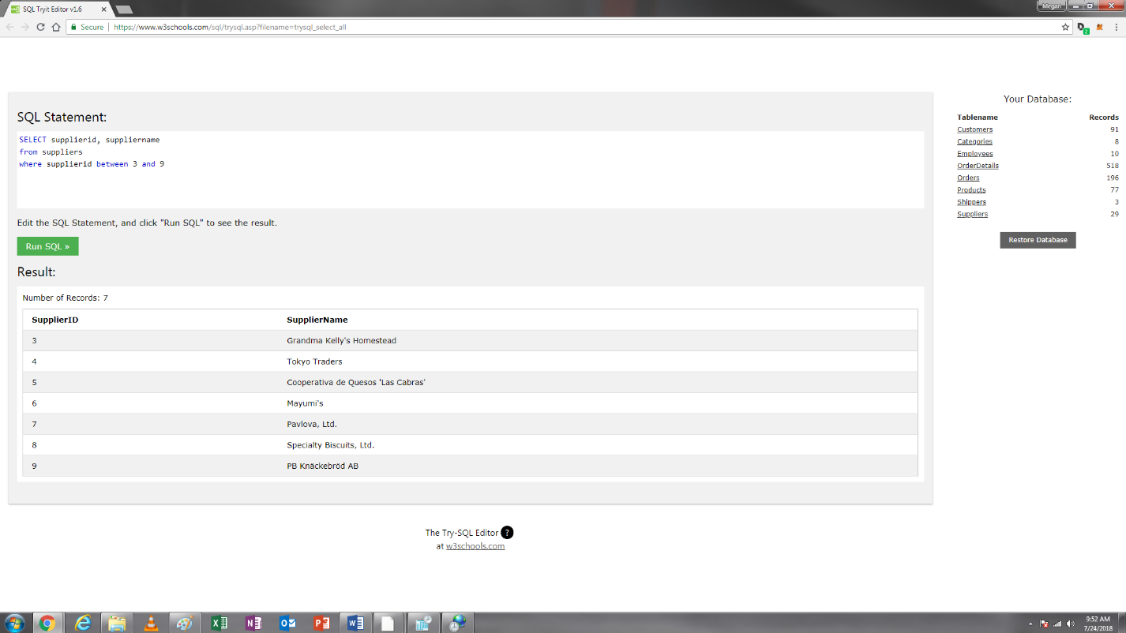

10. Show supplierID and SupplierName of suppliers with supplierID equal to 2, 4, **or** 8. [Use WHERE OR]

SELECT supplierid, suppliername

from suppliers

where supplierid=2 or supplierid=4 or supplierid=8

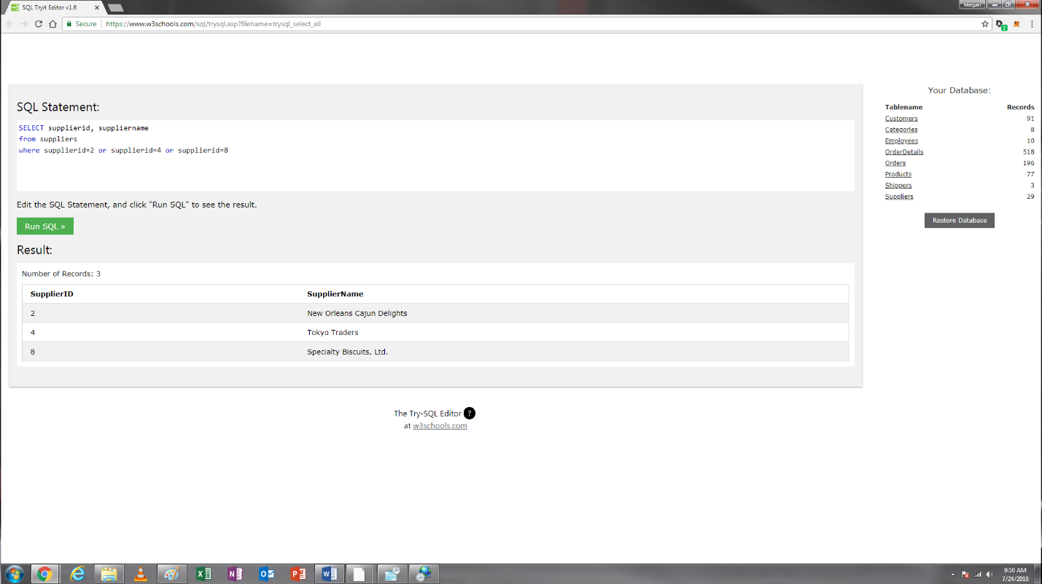

11. Show supplierID and SupplierName of suppliers with supplierID equal to 2, 4, **or** 8. [Use WHERE IN]

SELECT supplierid, suppliername

from suppliers

where supplierid in('2','4','8')

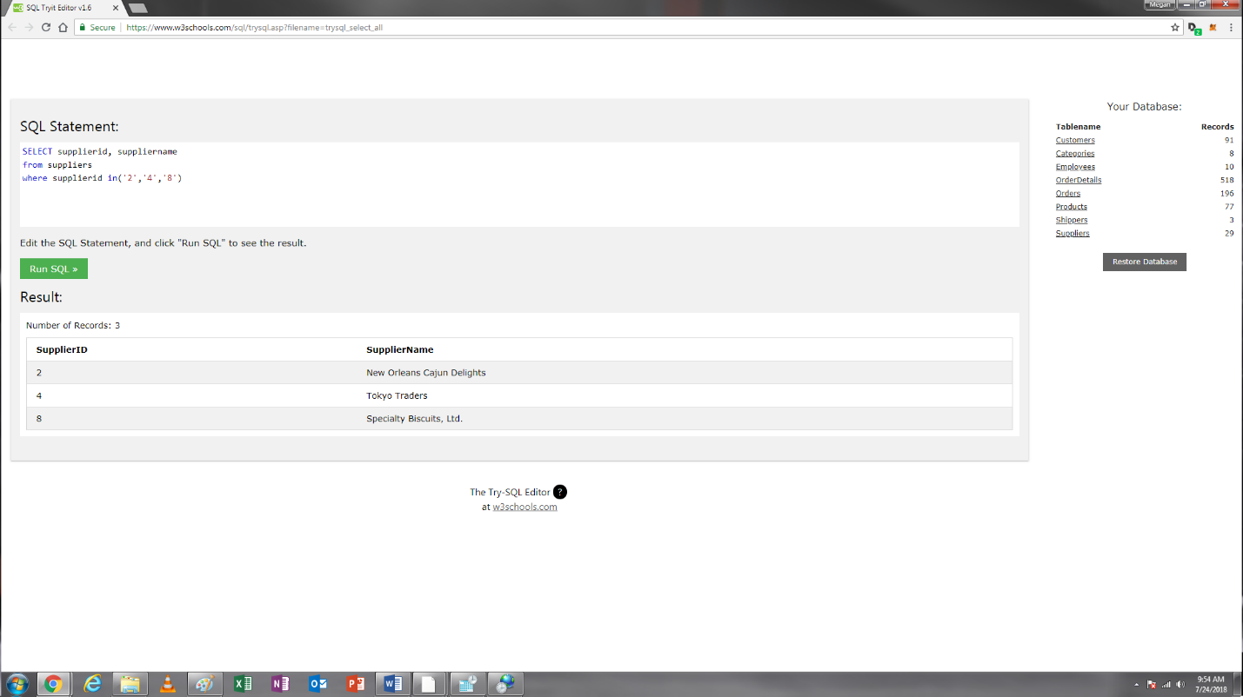

12. You want to pull all customers’ cities that start with “S” and postal codes that start with “9”.

SELECT customerid, city, postalcode

from customers

where city like 'S%' and postalcode like '9%'

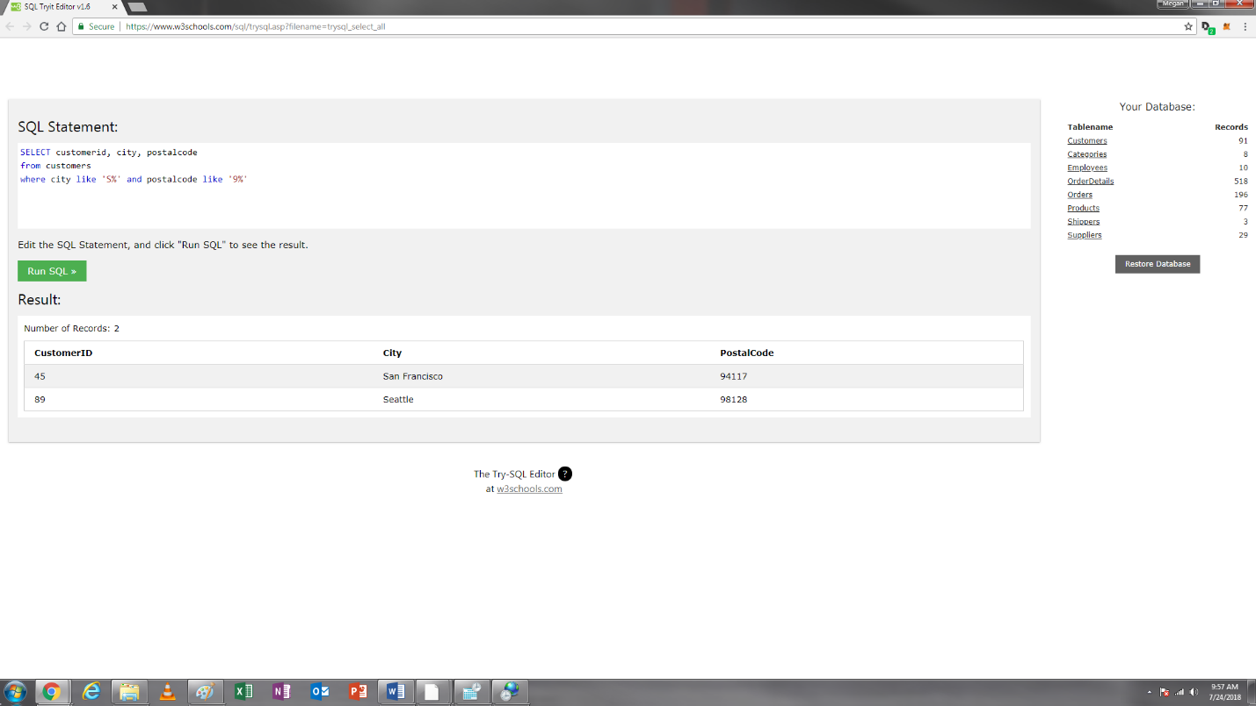

13. You want to see a list of order IDs and which employees (including their last name and first name) processed each order (organized alphabetically by employee last name).

SELECT orderid, lastname, firstname

from orders, employees

where employees.employeeid=orders.employeeid

order by lastname

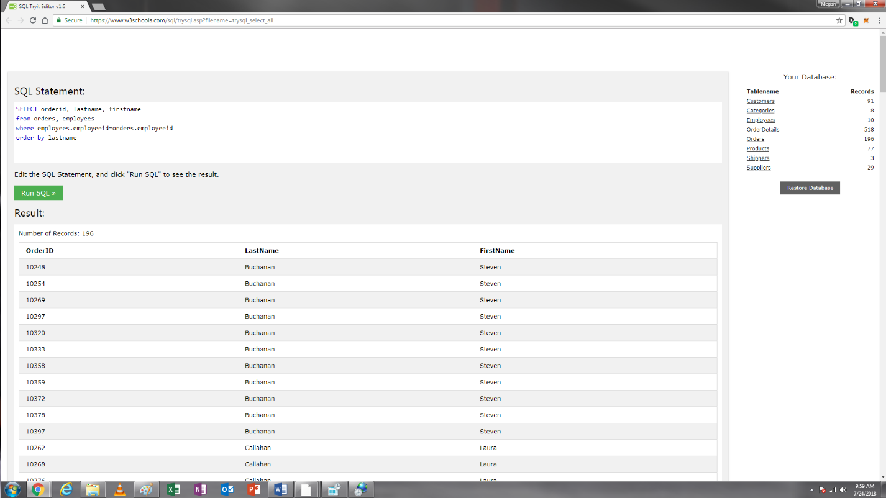

14. You want to see a list of order IDs and which customer placed each order (organized alphabetically by customername). Please use JOIN ON Statement

SELECT orderid, customername

from orders

join customers

on customers.customerid=orders.customerid

order by customername

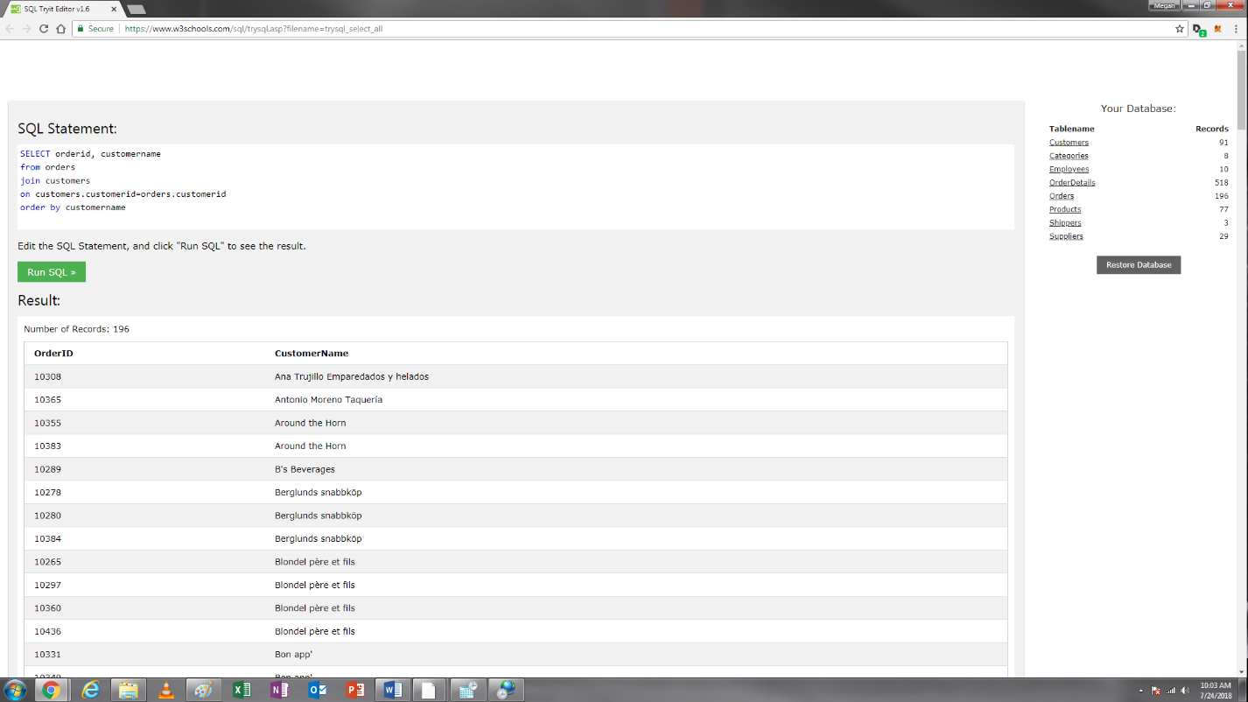

15. You want to see a list of product ID, product names, and their category names (organized by product ID at an ascending order). Please use JOIN ON Statement

SELECT productid, productname, categoryname

from products

join categories

on categories.categoryid=products.categoryid

order by productid asc

