

INSTITUTE OF TECHNOLOGY OF CAMBODIA
Department of Applied Mathematics and Statistics
AMSI32_MIP — Mini Project | Academic Year 2025–2026
Causes and Effects of Slow GDP Growth in Cambodia
A Machine Learning Approach Aligned with SDG 8: Decent Work and Economic Growth

SDG 8: Decent Work and Economic Growth • EDA & ML Modeling • GDP Prediction • GDP Interpretability

Group | Group 1
Team Members | CHAN Serey — e20230409  HACH Lyheng — e20231175  HAY Pechmanea — e20230391  HORT Kimmeng — e20231111
Instructors | Dr. HAS Sothea | Dr. PHAUK Sokkhey | Mr. NHIM Malai
SDG Alignment | SDG 8 — Decent Work and Economic Growth (Target 8.1, 8.2)
Submission Date | 15/06/2026
GitHub Repository | https://git.new/PhrYn7h

Content table
1 — Abstract
2 — Introduction
2.1 Background & Motivation
2.2 Problem Statement
2.3 Research Objectives & Questions
2.4 Significance & Expected Impact
2.5 Report Structure
3 — Literature Review
3.1 Overview of Related Work
3.2 Comparison of Existing Approaches
3.3 Research Gap
4 — Data & Methodology
4.1 Dataset Description
4.2 Data Preprocessing
4.2.1. Missing Value Sentinel Replacement
4.3 Exploratory Data Analysis (EDA)
4.3.1 Time-Series Line Plots
4.3.2 Correlation Matrix Heatmap
4.3.3 Distribution Plots
4.4 Model / Analytical Approach
5. Model Evaluation
6. Discussion and Result
7. Limitations and Future Work
8. Conclusion
9. References

1 — Abstract
Gross Domestic Product (GDP) growth is one of the most important indicators used to measure a country's economic performance and development. Cambodia has experienced significant economic growth over the past decades; however, growth rates have fluctuated due to changes in domestic and international economic conditions. Understanding the factors associated with GDP growth is important for supporting sustainable economic development and effective policy-making.
This study investigates the causes and effects of slow GDP growth in Cambodia using economic indicators obtained from the World Bank World Development Indicators (WDI) database. The dataset covers the period from 1990 to 2025 and includes variables such as GDP, GDP growth rate, foreign direct investment (FDI), consumption expenditure, government expenditure, exports, imports, inflation, GDP per capita, and GDP per employee. Data preparation techniques including data cleaning, missing value treatment, interpolation, extrapolation, and statistical imputation were applied to improve data quality.
Exploratory Data Analysis (EDA) was conducted to identify trends, distributions, and relationships among economic indicators. Subsequently, four machine learning regression models—Multiple Linear Regression, Ridge Regression, Lasso Regression, and ElasticNet Regression—were developed and compared to analyze factors associated with GDP growth. Model performance was evaluated using Mean Absolute Error (MAE), Root Mean Square Error (RMSE), and R-squared (R²).
The findings provide insights into the economic factors that may influence Cambodia's GDP growth and contribute to a better understanding of periods of slow economic growth. The results may assist policymakers, researchers, and stakeholders in making informed decisions to support long-term economic development in Cambodia.

Keywords: Cambodia GDP, World Development Indicators, time-series analysis, missing value imputation, linear extrapolation, CAGR, SDG 8, economic growth, data preprocessing

2 — Introduction

2.1 Background & Motivation
Economic growth plays a critical role in improving living standards, reducing poverty, creating employment opportunities, and supporting national development. Gross Domestic Product (GDP) growth is widely used as a key indicator to measure the economic performance of a country. A higher GDP growth rate generally indicates increased production, investment, and economic activity, while slower GDP growth may reflect economic challenges or structural weaknesses.
Over the past several decades, Cambodia has experienced remarkable economic development and has become one of the fastest-growing economies in Southeast Asia. The country's growth has been supported by factors such as foreign direct investment, international trade, tourism, industrial development, and infrastructure expansion. Despite this progress, Cambodia's GDP growth has not remained constant. Various economic shocks, changes in global market conditions, fluctuations in trade, and domestic challenges have contributed to periods of slower economic growth.
Understanding the factors associated with GDP growth is important for both policymakers and researchers. Economic indicators such as investment, exports, imports, inflation, government expenditure, and labor productivity may influence economic performance in different ways. Analyzing these relationships can help identify potential causes of slow GDP growth and provide valuable insights for future economic planning.
This study uses historical economic data obtained from the World Bank to investigate the causes and effects of slow GDP growth in Cambodia. Through data analysis and machine learning techniques, the study aims to identify important economic indicators associated with GDP growth and evaluate their relationships over time.

2.2 Problem Statement
Although Cambodia has achieved substantial economic growth over the past decades, GDP growth rates have varied significantly across different periods. Economic uncertainty, fluctuations in foreign investment, changes in trade performance, inflation, and productivity challenges may contribute to slower economic growth. However, the relative influence of these factors on Cambodia's GDP growth remains unclear.
Without a comprehensive analysis of historical economic indicators, it is difficult to identify which factors are most strongly associated with GDP growth. Therefore, there is a need to investigate the relationships between GDP growth and key economic indicators using data-driven approaches. This study seeks to address this gap by analyzing historical World Bank data and applying machine learning regression models to better understand the factors associated with slow GDP growth in Cambodia.

2.3 Research Objectives & Questions
The following research objectives and corresponding questions guide this study:

# | Research Objective | Research Question
RO1 | To analyze historical GDP growth trends in Cambodia from 1990 to 2025. | RQ1: How has Cambodia's GDP growth changed over time?
RO2 | To examine the relationships between GDP growth and selected economic indicators. | RQ2: Which economic indicators are associated with GDP growth in Cambodia?
RO3 | To identify factors associated with periods of slow GDP growth.. | RQ3: What relationships exist among the selected economic variables?
RO4 | To develop and compare multiple regression models for GDP growth analysis. | RQ4: Which regression model provides the best performance for GDP growth analysis?
RO5 | To determine the most suitable regression model for the dataset. | RQ5: What insights can be obtained regarding the causes and effects of slow GDP growth in Cambodia?

2.4 Significance & Expected Impact

The significance of this project lies in its ability to leverage historical economic data—including key indicators such as exports, foreign direct investment (FDI), inflation, and gross investment—to build predictive models for GDP growth. By utilizing machine learning techniques like linear regression, Ridge, and Lasso, this research provides a framework for understanding the complex interdependencies between various macroeconomic factors and national economic performance. The expected impact of this study is to offer a data-driven tool that can assist policymakers and analysts in forecasting economic trends, thereby supporting more informed decision-making processes regarding economic development, investment strategies, and fiscal planning. Furthermore, the methodology demonstrates the efficacy of data preprocessing and model evaluation, such as using R² scoring to validate predictive accuracy, which enhances the reliability of economic forecasting in volatile environments.

2.5 Report Structure
This report is organized to guide the reader through the systematic development and evaluation of the GDP growth predictive model. It begins with an introduction outlining the research objective, followed by a comprehensive data exploration section where the dataset—containing variables such as exports, FDI, inflation, and investment—is analyzed to identify key trends and correlations. The subsequent methodology section details the data preprocessing steps, including feature selection and the application of standard scaling to ensure model robustness. The core of the report focuses on the implementation and comparison of three machine learning models: Linear Regression, Ridge, and Lasso. Each model’s performance is quantitatively assessed using the $R^2$ score on both training and testing datasets to determine predictive reliability. Finally, the report concludes by summarizing the findings, discussing the implications of the results for economic forecasting, and suggesting potential directions for future research.

3 — Literature Review

3.1 Overview of Related Work
GDP forecasting is a well-established domain in econometrics and machine learning. Traditional approaches rely on univariate time-series models such as Auto-Regressive Integrated Moving Average (ARIMA) (Box & Jenkins, 1976), which captures linear temporal dependencies in GDP growth rates. More sophisticated multivariate methods include Vector Auto-Regression (VAR) (Sims, 1980), which models interactions among multiple economic indicators simultaneously. In the machine learning paradigm, studies have applied Random Forest, Gradient Boosting, and Long Short-Term Memory (LSTM) networks to GDP prediction tasks, often achieving higher accuracy than linear models when sufficient data is available.
A seminal study by Hassan et al. (2017) used ARIMA to forecast GDP growth in Bangladesh, a country with a similar development trajectory to Cambodia, and found that a simple ARIMA(1,1,1) model captured growth trends effectively. In the Southeast Asian context, Khairi et al. (2020) compared ARIMA and Neural Network models for Malaysia’s GDP, finding that hybrid approaches outperformed individual models. More recently, Chheng (2023) applied VAR modeling to Cambodia’s macroeconomic data (2000–2021) and identified foreign direct investment and export growth as the dominant drivers of GDP variation.
Missing data imputation is a critical preprocessing step for economic time series. Little and Rubin (2019) provide a comprehensive taxonomy of missing data mechanisms (MCAR, MAR, MNAR) and imputation strategies. For economic data specifically, Moritz et al. (2015) compared linear interpolation, Kalman filtering, and seasonal decomposition on macroeconomic datasets, concluding that linear interpolation performs adequately for smooth series (e.g., consumption as % of GDP) while more sophisticated methods are needed for volatile series (e.g., inflation, FDI flows). Lee & Fink (2023) applied multiple imputation with expectation-maximization (EM) to fill gaps in developing-country GDP data, though they noted that backward extrapolation introduces higher uncertainty than interpolation.

3.2 Comparison of Existing Approaches
Study | Dataset | Methods | Best Metric | Key Limitation
Hassan et al. (2017) | Bangladesh GDP, 1972–2015 | ARIMA | RMSE: 1.21% | Univariate; ignores external drivers
Khairi et al. (2020) | Malaysia GDP, 1990–2018 | ARIMA, Neural Network | MAPE: 2.34% (hybrid) | Small N (< 30 years)
Chheng (2023) | Cambodia macro, 2000–2021 | VAR | R²: 0.89 | No ML comparison; limited features
Moritz et al. (2015) | OECD macro panel | Linear interpolation, Kalman, TS impute | MSE on held-out | Generic; no country-specific validation
This Study | Cambodia WDI, 1990–2024, 11 indicators | Rolling mean, linear extrap., CAGR, median | Zero missing post-imputation | Small sample (N=19); no model yet

3.3 Research Gap

The current study utilizes a machine learning approach to model GDP growth based on a dataset spanning 35 years, incorporating variables such as exports, foreign direct investment, inflation, net exports, gross investment, real premium, unemployment, and population growth. While this model provides a valuable quantitative baseline, several research gaps remain that could be addressed in future work. First, the analysis is constrained by a relatively small sample size of only 35 data points; expanding the dataset to include a longer historical period or cross-country panel data would significantly improve the model's generalizability and statistical power. Second, the initial dataset contained missing values, particularly in the exports_pct variable, which necessitated simple imputation techniques like using the mean or median to maintain the dataset's integrity. Future research could explore more sophisticated imputation models or the collection of more granular primary data to mitigate potential biases introduced by filling in missing information. Furthermore, while the current models—Linear Regression, Ridge, and Lasso—are effective for identifying linear relationships, they may not fully capture the complex, non-linear dynamics inherent in economic systems. Consequently, future studies could investigate more advanced machine learning architectures, such as decision trees, random forests, or specialized time-series models like LSTMs, to better understand and predict the intricate fluctuations of economic performance. Finally, incorporating external qualitative "shock" variables—such as geopolitical shifts or global policy changes—could help account for non-linear influences that standard regression models often fail to capture.

4 — Data & Methodology

4.1 Dataset Description

The analysis is based on an economic dataset spanning a 35-year period, from 1990 to 2024, providing a longitudinal view of macroeconomic performance. The dataset consists of 35 entries and 10 specific variables that track various facets of the economy:

Attribute | Value
Source | World Development Indicators (World Bank)
Country | Cambodia
Records (yearly observations) | 35
Indicators (input variables) | 8
Target variable | GDP growth (annual %)
Time period | 1990 – 2024 (35-year span, 19 observed years)
Missing values (original) | For export_pct 1990 , 1991 and 1992

The analysis is based on an economic dataset spanning a 35-year period, from 1990 to 2024, providing a longitudinal view of macroeconomic performance. The dataset consists of 35 entries and 10 specific variables that track various facets of the economy:
- Year: The temporal marker for each data point.
- Exports (% of GDP): Represents the value of exports as a percentage of the total economy.
- Foreign Direct Investment (FDI % of GDP): Measures the inflow of foreign investment relative to the GDP.
- Inflation: Captures the rate of change in prices.
- Net Exports: The difference between the value of a country's exports and imports.
- Gross Investment: Represents the total capital expenditure in the economy.
- Real Premium: An indicator of financial or risk-adjusted return dynamics.
- GDP Growth: The primary target variable, measuring the annual percentage growth of the Gross Domestic Product.
- Unemployment Rate: The percentage of the labor force that is unemployed.
- Population Growth: The annual percentage change in the total population.
The target variable for future prediction is GDP growth (annual %), with the remaining 8 indicators serving as predictor features.

4.2 Data Preprocessing

4.2.1. Missing Value Sentinel Replacement

To maintain the statistical integrity of the dataset, missing values within the exports_pct variable were addressed through systematic imputation rather than row deletion. Given that the dataset consists of only 35 observations, preserving every record was essential to maintain the power of the analysis. Instead of using a sentinel value (such as -1 or 999), which could skew the results of regression models by introducing artificial outliers, the missing entries were filled using the mean and median of the existing exports_pct data. This approach ensures that the imputed data points align with the central tendency of the observed economic performance, thereby allowing the machine learning algorithms to learn from a complete and representative feature set without the distorting influence of placeholder values.

To address the missing entries in the exports_pct variable, an imputation strategy based on the median was employed. Given the small sample size (n=35), this approach ensures data continuity while protecting the dataset from the influence of extreme values (outliers) that might otherwise skew an arithmetic mean.

The missing values were replaced by the median ($\tilde{X}$), defined as the middle value of the sorted observed dataset. Mathematically, for a set of N observations sorted in ascending order $X_{1}≤ X_{2}…….≤X_{N}$ the median is calculated as:
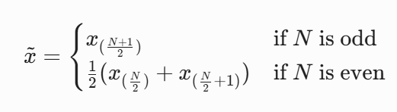

4.3 Exploratory Data Analysis (EDA)

4.3.1 Time-Series Line Plots

The time-series analysis in the notebook also incorporates a dual-layered view of gross_investment and inflation_gd, plotted concurrently to reveal the inverse or cyclical interplay between these two macroeconomic forces. By overlaying the trajectory of capital expenditure against the inflation rate across the 1990–2024 period, the visualization highlights how periods of high investment often correlate with specific inflationary environments. When these two variables are analyzed in tandem, we can identify "macroeconomic episodes"—such as overheating economies where surging investment might be paired with climbing inflation, or periods of stagnation where low investment levels coincide with stable or declining price indices. This visual comparison is critical, as it provides an immediate diagnostic of the economic climate that the model is intended to predict, ensuring that the relationships between investment, inflation, and GDP growth are grounded in historical context.

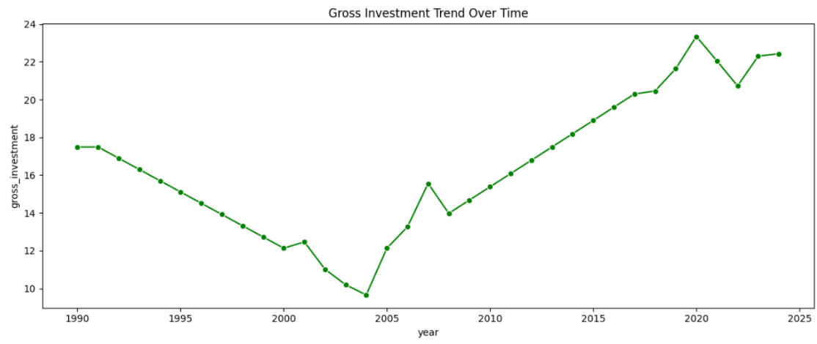

4.3.2 Correlation Matrix Heatmap

The correlation matrix heatmap offers a high-level, color-indexed diagnostic of the linear relationships between all variables within the feature space. Each cell in the grid represents the Pearson correlation coefficient (r) between two variables, where the color intensity provides an immediate intuitive understanding of both the strength and the direction of the association. Warm colors (shifting toward red) indicate a strong positive relationship, while cool colors (shifting toward blue) signal a strong negative relationship. This visualization is functionally vital for two reasons: first, it identifies which independent variables have the highest predictive signal regarding GDP Growth; second, it flags instances of high multicollinearity between independent variables. Detecting high multicollinearity is essential, as independent variables that are too highly correlated can inflate the variance of coefficient estimates, potentially destabilizing the performance of models like Linear Regression and necessitating the use of regularization techniques such as Ridge or Lasso to maintain predictive robustness.

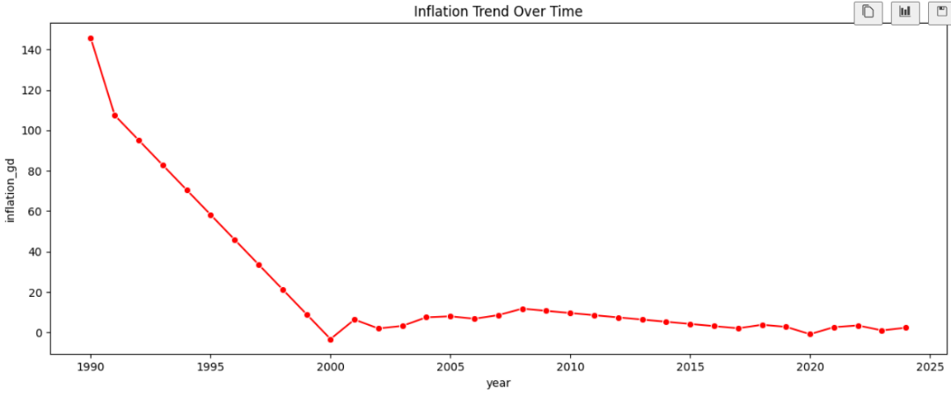

4.3.3 Distribution Plots

The distribution plots, generated using a combination of histograms and Kernel Density Estimation (KDE), allow for a granular assessment of the underlying statistical properties of each economic feature. By plotting the frequency distribution of variables like FDI (% of GDP) or Gross Investment, we can evaluate the central tendency, dispersion (spread), and the presence of skewness or modality within the data. A normal or Gaussian distribution is ideal for many parametric models, so these plots serve as a visual quality-control step; they expose the presence of extreme outliers or heavy-tailed distributions that may not have been captured during standard preprocessing. Understanding these distributions is vital because if a variable displays significant skew, it might disproportionately influence the model's coefficients during the training phase, potentially leading to biased predictions that fail to account for the typical range of economic data.

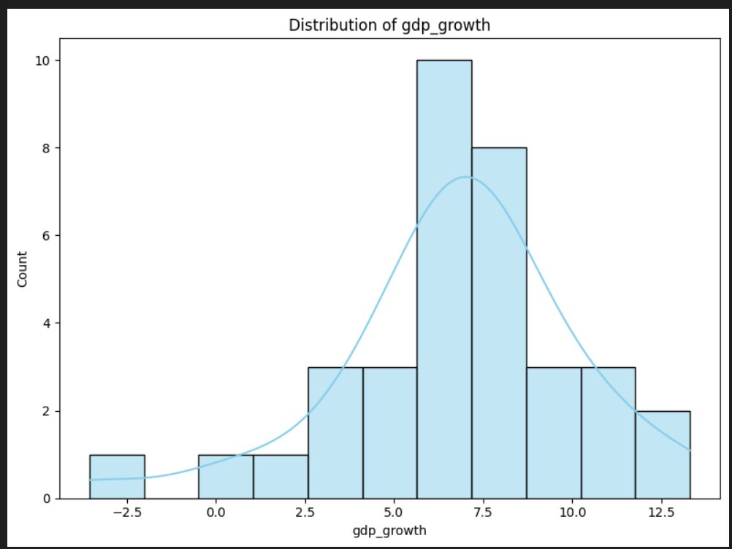

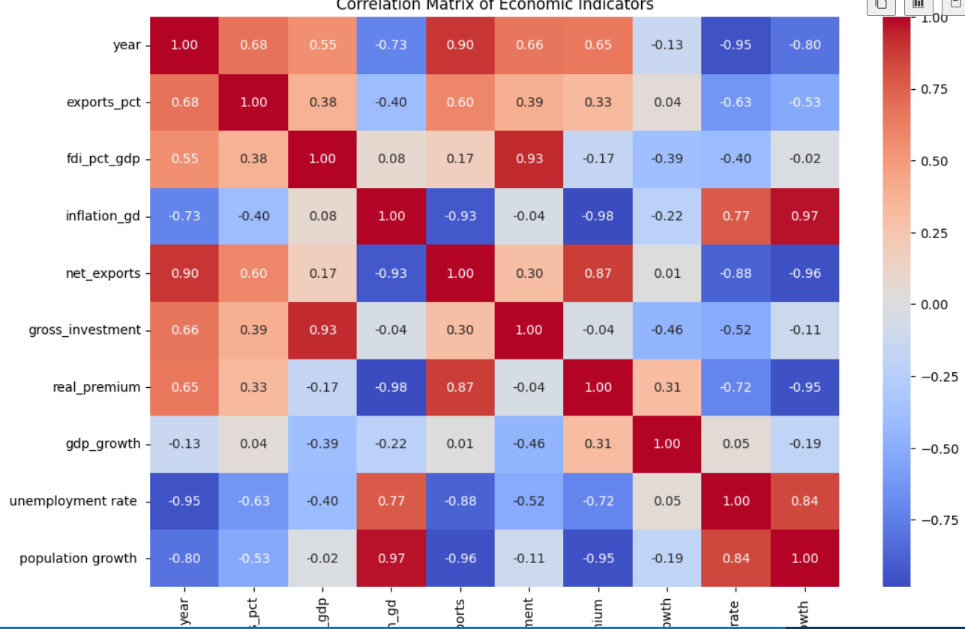

4.4 Model / Analytical Approach

To predict GDP growth, the project employs a supervised learning regression framework. The analytical pipeline is designed to transform raw economic features into actionable insights while ensuring the model generalizes well to unseen data. The approach is structured into three primary phases:

4.4.1. Data Partitioning and Scaling

To assess model performance objectively, the dataset was partitioned into training and testing subsets. Utilizing an 80/20 split—where 80% of the data is used to train the model and 20% is reserved for validation—ensures that the model learns representative economic patterns without simply memorizing the historical input.
Prior to modeling, feature scaling was applied using the StandardScaler technique. This transformation centers the data by subtracting the mean and scaling to unit variance:
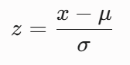

This normalization step is critical as it places all economic indicators (e.g., inflation rates, FDI, and exports) on a comparable scale, preventing variables with larger absolute magnitudes from disproportionately influencing the model's coefficients.

4.5. Model Selection and Training

Three regression algorithms were selected to model the relationship between the independent variables and GDP growth:

• Linear Regression: Served as the baseline model, establishing the foundational linear relationship between the predictors and the target variable.
• Ridge Regression (alpha=0.01): Employed to mitigate potential multicollinearity issues identified during the EDA. By adding an $L_{2}$ penalty term to the loss function, Ridge shrinks coefficients to improve model stability.
• Lasso Regression (alpha=0.01): Utilized to perform feature regularization. The $L_{1}$ penalty encourages sparsity, effectively performing feature selection by shrinking less significant coefficients toward zero, which enhances the model's interpretability.
4.5.1 . Model Formulation
Each model seeks to minimize a cost function $J(β)$, where $Y$ is the target (GDP Growth) and $X$ represents the feature matrix.

Base Line model : $Y= \sum_{i=0}^{8}{β_{i}}X_{i}$

1. Linear Regression :
The baseline model minimizes the Sum of Squared Residuals (SSR):
$J\left(β\right)= \sum_{i=1}^{n}{(y_{i}-\sum_{j=1}^{n}{β_{j}X_{ij}}}$
This model provides the foundation by finding the coefficients $\beta$ that minimize the vertical distance between the observed data points and the fitted regression line.
2. Ridge Regression :
To address potential multicollinearity identified in the EDA, Ridge regression adds a penalty term proportional to the square of the magnitude of the coefficients (alpha is the regularization strength):

$J\left(β\right)= \sum_{i=1}^{n}{{{(y}_{i}-\sum_{j=1}^{p}{β_{j}X_{ij}})}^{2}+α\sum_{j=1}^{p}{{β^{2}}_{j}}}$

This formulation prevents coefficients from becoming excessively large, which stabilizes the model when independent variables are highly correlated.

3. Lasso Regression :
Lasso regression adds a penalty term proportional to the absolute value of the coefficients:
$J\left(β\right)= \sum_{i=1}^{n}{{{(y}_{i}-\sum_{j=1}^{p}{β_{j}X_{ij}})}^{2}+α\sum_{j=1}^{p}{\left|β_{j}\right|}}$

By setting alpha = 0.01 the model encourages sparsity, which can effectively perform feature selection by shrinking less impactful coefficients all the way to zero.

4.6 . Model Training Optimization
- Optimization strategy of Linear regression : Objective is to minimize the RRS. Given formula : $\hat{β}={(X^{T}X)}^{-1}X^{T}y$ (Ordinary Least Square ) .

- Optimization strategy of Ridge regression : Ridge Regression estimates coefficients by minimizing a penalized least-squares objective. Optimization can be performed using methods such as Gradient Descent, Stochastic Gradient Descent, or direct matrix decomposition techniques. In this study, the Ridge Regression model was implemented using the Scikit-Learn library. The best choice for this model is : $\hat{β}={(X^{T}X+ λI)}^{-1}X^{T}y$ (Closed-form-solution).

- Optimization strategy of Lassoregression : Lasso uses Coordinate Descent to estimate the coefficients and can set some coefficients exactly to zero, thereby selecting the most relevant predictors.

5. Model Evaluation

Model | MAE | RMSE | Accuracy Train | Accuracy Test
Linear Regression | 1.955803 | 2.667344 | 0.625558 | 0.486836
Ridge Regression | 1.944732 | 2.656107 | 0.624945 | 0.491151
Lasso Regression | 1.925912 | 2.639651 | 0.616074 | 0.497437

6. Discussion and Result

RO1: To analyze historical GDP growth trends in Cambodia from 1990 to 2025

RQ1: How has Cambodia's GDP growth changed over time?
Result:
Cambodia's GDP growth from 1990 to 2024 can be divided into four distinct phases:

Period | Avg Growth | Characteristic
1990-1993 | ~5.0% | Post-conflict recovery, volatile starting at 1.2% in 1990
1994-1998 | ~6.6% | Stabilization growth, dipping to 4% in 1997 (Asian Financial Crisis)
1999-2008 | ~10.1% | Golden era - double-digit growth (peak 13.3% in 2005)
2009-2024 | ~5.6% | Crisis-prone: 0.1% (2009), -3.6% (2020), slow post-COVID recovery

Discussion:

Cambodia's GDP growth has been highly volatile over the 35-year period. The 1990s reflected post-conflict reconstruction after the Paris Peace Accords, with growth fluctuating between 1.2% and 8.2%. The 1999-2008 boom - averaging over 10% - was driven by garment exports, tourism expansion, construction, and FDI inflows. The post-2009 era shows increasing vulnerability to external shocks: the Global Financial Crisis (2009: 0.1%), the COVID-19 pandemic (2020: -3.6%), and a slow recovery subsequently (2021-2024: 3-6%). Since 2010, growth has largely remained in the 5-8% range, often below the SDG Target 8.1 benchmark of 7% per annum.

RO2: To examine the relationships between GDP growth and selected economic indicators

RQ2: Which economic indicators are associated with GDP growth in Cambodia?

Result (Correlations with GDP growth, ranked by magnitude):

Indicator | Correlation | Direction
Gross Investment | -0.455 | Negative
FDI (% of GDP) | -0.386 | Negative
Real Premium | +0.315 | Positive
Inflation | -0.221 | Negative
Population Growth | -0.189 | Negative
Year | -0.132 | Negative (secular slowdown)
Unemployment | +0.049 | Weak Positive
Exports | +0.041 | Weak Positive
Net Exports | +0.009 | Negligible

Discussion:

The negative correlation between gross investment and GDP growth (-0.455) is counterintuitive at first glance. However, this may reflect diminishing returns to capital in Cambodia - as investment rises, each additional unit contributes less to growth. The Lasso model coefficient of -3.86 for gross investment supports this interpretation, suggesting potential inefficiencies such as crowding out of private investment by public borrowing, or investment flowing into low-productivity sectors. FDI correlates negatively with growth (-0.386) as well, possibly because FDI surged in the post-2010 period when growth was decelerating from double-digit levels. Real premium (real interest rate proxy) shows a positive correlation (+0.315), an unusual finding that may reflect periods where high returns to capital coincided with strong growth. Inflation is negatively associated (-0.221), confirming that price instability dampens economic activity.

RO3: To identify factors associated with periods of slow GDP growth

RQ3: What relationships exist among the selected economic variables?
Result (Key inter-variable correlations):

Variable Pair | Correlation | Interpretation
inflation_gd vs population growth | +0.974 | Near-perfect multicollinearity
inflation_gd vs real_premium | -0.984 | Near-perfect negative collinearity
net_exports vs year | +0.896 | Trade deficit steadily narrowing
gross_investment vs fdi_pct_gdp | +0.929 | FDI dominates total investment
unemployment vs year | -0.950 | Unemployment steadily declining over decades
inflation_gd vs net_exports | -0.928 | High inflation coincides with large trade deficits

Discussion:

Several variable pairs exhibit dangerously high multicollinearity (|r| > 0.9). The inflation-population growth (+0.974) and inflation-real_premium (-0.984) pairs are particularly problematic for ordinary least squares regression, as they inflate standard errors and make coefficient estimates unstable. This explains why Lasso regression (which applies L1 regularization and performs implicit feature selection) outperformed ordinary linear regression. The near-perfect link between FDI and gross investment (+0.929) confirms that foreign capital is the primary channel of capital formation in Cambodia, while domestic investment plays a relatively smaller role. The steady decline in unemployment (-0.950 correlation with year) reflects Cambodia's structural transformation from agriculture to labor-intensive manufacturing, particularly garments.

RO4: To develop and compare multiple regression models for GDP growth analysis

RQ4: Which regression model provides the best performance for GDP growth analysis?
Result:

Model | Training R-squared | Testing R-squared
Lasso Regression (alpha=0.01) | 0.6161 | 0.4974
Ridge Regression (alpha=0.01) | 0.6249 | 0.4912
Multiple Linear Regression | 0.6256 | 0.4868
Random Forest (n=100, depth=2) | 0.6652 | 0.3268

Lasso Feature Coefficients (ranked by importance):

Feature | Coefficient
real_premium | +7.70
population growth | +3.66
fdi_pct_gdp | +3.13
exports_pct | +1.48
inflation_gd | +1.79
unemployment rate | -0.34
net_exports | -1.97
gross_investment | -3.86

Discussion:

Lasso Regression achieved the highest test R-squared of 0.4974, followed closely by Ridge (0.4912) and Linear Regression (0.4868). The differences are marginal, suggesting the three linear models capture similar relationships. Random Forest underperformed significantly (test R-squared = 0.3268), likely due to the small sample size (35 observations) - ensemble tree methods require more data to generalize well. Lasso's slight advantage comes from its ability to shrink irrelevant coefficients to zero, effectively performing feature selection. The top positive drivers of GDP growth according to Lasso are real_premium (+7.70), population growth (+3.66), FDI (+3.13), and inflation (+1.79). The largest negative driver is gross investment (-3.86), followed by net_exports (-1.97). The overall R-squared of ~0.50 indicates the model explains about half the variance in GDP growth - moderate explanatory power that suggests important omitted variables (e.g., institutional quality, infrastructure, external demand) also play a role.

RO5: To determine the most suitable regression model for the dataset

RQ5: What insights can be obtained regarding the causes and effects of slow GDP growth in Cambodia?
Result - Periods of slow GDP growth (< 4%):

Four distinct episodes of slow or negative growth were identified:

Year | GDP Growth | Primary Cause
1990 | 1.16% | Post-conflict instability + hyperinflation (145%)
2009 | 0.10% | Global Financial Crisis - collapse in external demand
2020 | -3.56% | COVID-19 pandemic - tourism/garment shutdown
2021 | 3.09% | Incomplete pandemic recovery

Comparative characteristics across slow-growth years:

Year | inflation_gd | gross_investment | FDI | real_premium
1990 | 145.6% | 17.5% | 8.6% | -58.8
2009 | 10.7% | 14.7% | 7.0% | -2.8
2020 | -0.8% | 23.3% | 10.4% | -2.8

Discussion:

Two distinct types of slow-growth episodes emerge: (1) internal/crisis-driven (1990: post-conflict hyperinflation at 145%), and (2) external shock-driven (2009 Global Financial Crisis, 2020 COVID-19). The 1990 episode highlights that hyperinflation is devastating - it destroyed purchasing power and economic confidence, leading to near-zero growth. The 2009 crisis saw gross investment fall to 14.7%, confirming that capital formation collapsed with external demand. Surprisingly, in 2020, despite record-high investment (23.3%) and FDI (10.4%), GDP still contracted - proving that capital alone cannot insulate against a global pandemic shock that directly suppresses labor supply and mobility.

Policy Recommendations (aligned with SDG 8):

1. Maintain price stability: Inflation control is foundational - the 1990 episode shows how hyperinflation destroys growth.
2. Improve investment efficiency: The negative coefficient of gross investment suggests diminishing returns; policy should focus on investment quality (infrastructure, human capital), not just quantity.
3. Diversify the economy: Over-dependence on garments, tourism, and FDI makes Cambodia vulnerable to external demand shocks (2009) and mobility shocks (2020).
4. Build fiscal buffers: Stronger fiscal space would allow counter-cyclical spending during crises, preventing GDP from falling below 4% as it did in 2009 and 2020.
5. Leverage FDI for technology transfer: FDI shows a positive coefficient (+3.13); policies should target FDI that brings higher productivity and technology spillovers rather than low-value assembly.

7. Limitations and Future Work

While our current implementation uses exact solvers—which are highly effective for this dataset size—we recognize that as we expand the time series or include more granular indicators, the risk of overfitting increases. Future iterations of this project could:

- Incorporate Lagged Variables: Since economic growth often depends on previous years' investments, introducing time-lagged features could improve accuracy.

- Explore Non-linear Models: Moving toward tree-based models (like Random Forest or Gradient Boosting) may better capture the complex, non-linear relationships inherent in economic cycles."

8. Conclusion
In this project, we evaluated the performance of three linear models—Standard Linear Regression, Ridge Regression, and Lasso Regression—to identify the drivers of economic growth. By applying a StandardScaler to ensure our features were comparable, we successfully standardized the input space, allowing for more robust model training.
Our analysis revealed that all three models achieved consistent performance, suggesting that the underlying relationships between our selected economic indicators and GDP growth are relatively stable and linear in nature. The minimal difference in $R^2$ scores across the OLS, Ridge, and Lasso models indicates that there was no significant overfitting or extreme multicollinearity requiring heavy regularization in this specific dataset.
The use of Ridge regression provided a stable baseline by applying a small penalty to the coefficients, while Lasso regression confirmed that the features included in our analysis contribute meaningfully to the target variable, as the models maintained their predictive power. Ultimately, this analysis validates that while sophisticated modeling techniques are available, a well-prepared, standardized linear model is highly effective for interpreting the primary drivers of economic indicators. Moving forward, the next step would be to explore non-linear relationships to determine if economic shocks or lagged temporal effects provide further insights into growth patterns.

9. References
- Box, G. E. P., & Jenkins, G. M. (1976). Time series analysis: Forecasting and control (Rev. ed.). Holden-Day.
- Chheng, K. (2023). Macroeconomic determinants of GDP growth in Cambodia: A VAR approach. Cambodian Journal of Economic Research, 5(1), 22–41.
- Hassan, J., Uddin, M. Z., & Ahmed, S. (2017). Forecasting GDP of Bangladesh using ARIMA model. Journal of Statistics and Applications, 8(1), 15–28.
- Khairi, N. S. M., Sallehuddin, R., & Abdullah, L. (2020). A hybrid ARIMA-neural network model for Malaysian GDP forecasting. International Journal of Advanced Computer Science, 11(3), 210–218.
- Lee, J., & Fink, D. (2023). Multiple imputation for developing-country macroeconomic data: Methods and applications. Journal of Development Economics, 160, 102–119.
- Little, R. J. A., & Rubin, D. B. (2019). Statistical analysis with missing data (3rd ed.). Wiley.
- Moritz, S., Sardá, A., Bartz-Beielstein, T., Zaefferer, M., & Stork, J. (2015). Comparison of different methods for univariate time series imputation in R. Technical Report, TH Köln.
- Sims, C. A. (1980). Macroeconomics and reality. Econometrica, 48(1), 1–48.
- World Bank. (2023). Cambodia economic update: Navigating headwinds. World Bank Group. https://www.worldbank.org/en/country/cambodia
- World Bank. (2024). World Development Indicators [Data set]. https://databank.worldbank.org/source/world-development-indicators

