***Author***

*Hiral Panchal*

*B.Sc. (I.T.),* **Mulund College Of Commerce**

*CyberSecurity Intern at* **DigiSuraksha Parhari Foundation**

***RED TEAM LOCKS***

**1. padlocks**

**- combination padlocks**

**- keyed padlocks**

**- shrouded padlocks**

**- smart padlocks**

* **Combination Padlocks:** These locks use a sequence of numbers or symbols to open, eliminating the need for keys. They are available in various materials and sizes, with some offering resettable combinations for added convenience. [Combination lock - Wikipedia](https://en.wikipedia.org/wiki/Combination_lock)
* **Keyed Padlocks:** The most common type, these padlocks use a key to open. They come in different security levels and can be keyed alike (one key opens multiple locks) or keyed differently (each lock has a unique key). [Buy Keyed Alike Padlock Online at Best Prices | Croma](https://www.croma.com/l/keyed-alike-padlock-0akz00a.html)
* **Shrouded Padlocks:** These padlocks feature a protective covering around the shackle, making them highly resistant to cutting and prying attacks. They are often used in high-security applications. [Exploring the Security and Durability of Shrouded Padlocks - Vanma Lock](https://www.lockmanage.com/blog/exploring-the-security-and-durability-of-shrouded-padlocks/)
* **Smart Padlocks:** These modern padlocks offer keyless entry, often using Bluetooth, fingerprint scanning, or a smartphone app. They may also include features like activity monitoring and remote access control.

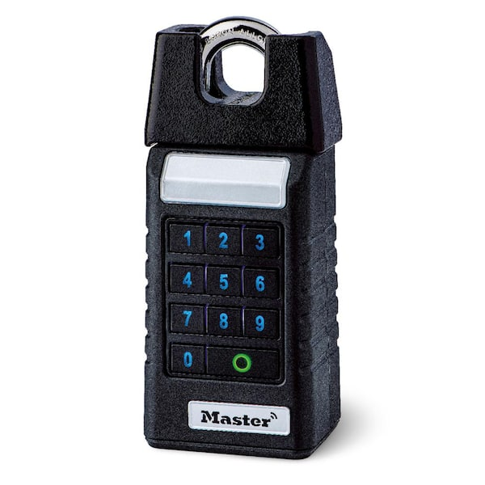**2. deadbolts**

**- single cylinder deadbolt**

**- double cylinder deadbolt**

**- lockable thumb turn deadbolt**

* **Single Cylinder Deadbolt:** These have a key cylinder on the outside and a thumb turn on the inside. They are convenient for quick exits but may be less secure than double-cylinder options.
* **Double Cylinder Deadbolt:** These require a key to open from both the inside and outside. They offer enhanced security, especially for doors with glass panels, but can be a safety hazard in emergencies if a key isn't readily available.
* **Lockable Thumb Turn Deadbolt:** This type combines the convenience of a thumb turn with the added security of being able to lock the thumb turn itself, preventing the door from being opened from the inside.

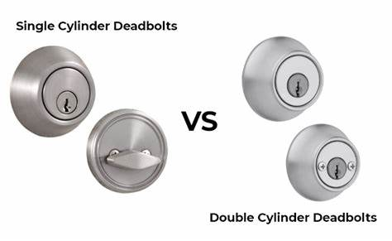

**3. knob locks**

Knob locks are commonly used for interior doors, and can come in various styles and finishes. They typically have a knob on both sides, one of which may have a locking mechanism.

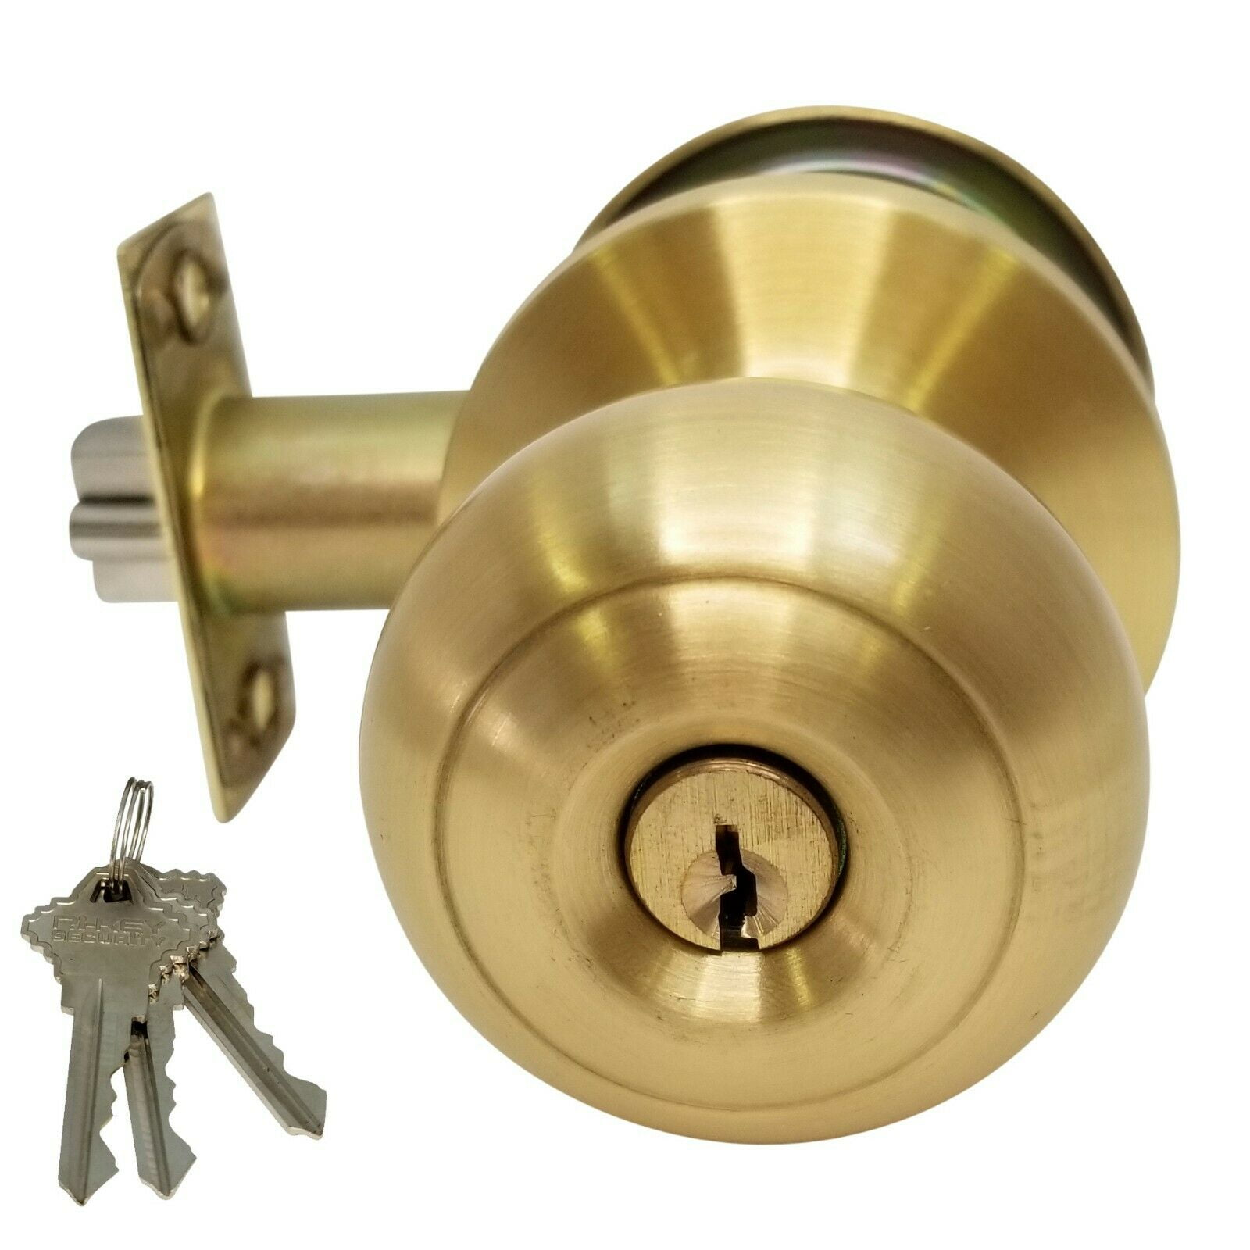**4. lever handle locks**

Lever handle locks, also known as lever door handles, are a type of door hardware that uses a horizontal lever instead of a knob to operate the latch. They are often preferred for accessibility as they are easier to grip and turn for people with limited hand strength or mobility. Lever handles can be found on both interior and exterior doors and come in a variety of styles and finishes to match different architectural designs. Some lever handles include a locking mechanism, while others are paired with separate deadbolt locks for enhanced security.

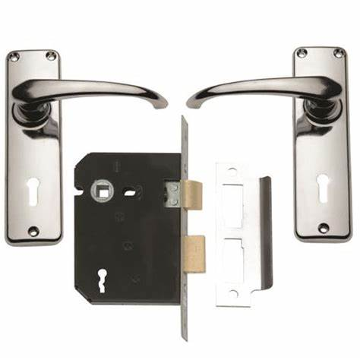

**5. mortise locks**

Mortise locks are installed into a pocket (the mortise) cut into the edge of a door. They are commonly used in older buildings and are becoming more popular in high-end residential and commercial construction. Mortise locks offer a robust and versatile locking system.

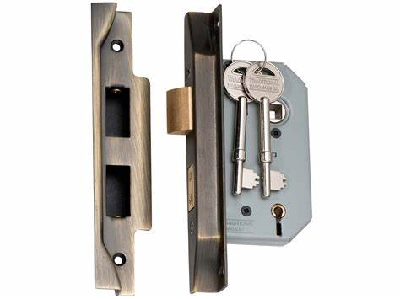

**6. rim locks**

Rim locks are surface-mounted locks, meaning they are attached to the surface of the door rather than being installed within the door's edge. They are one of the oldest types of locks and are easy to install.

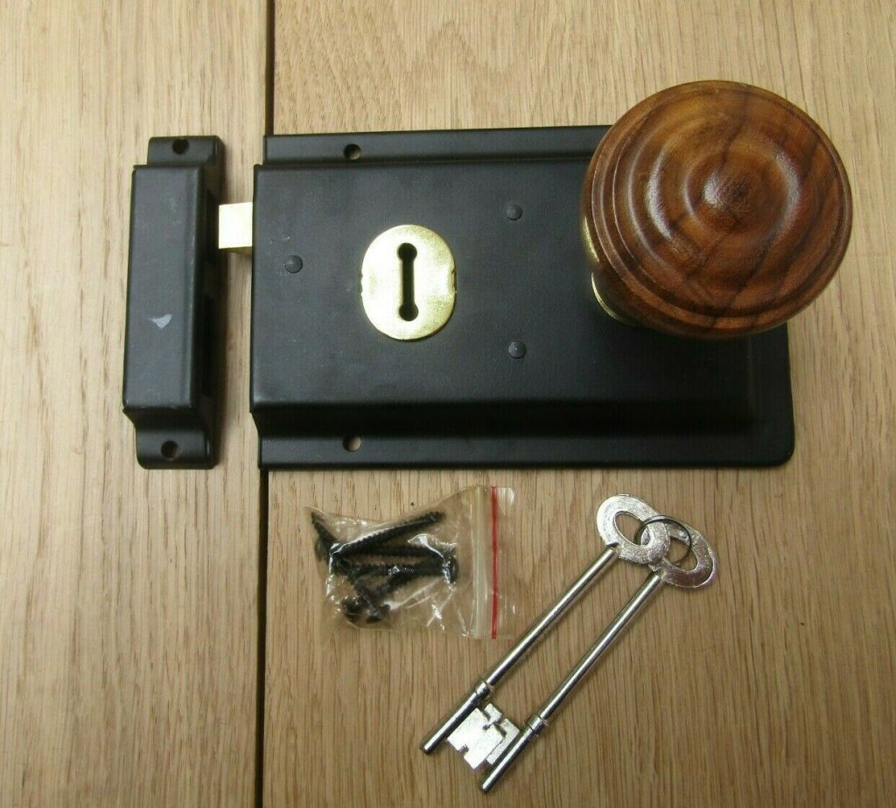**7. cam locks**

Cam locks are a type of fastener that uses a rotating cam to secure two or more components together. They are commonly used in furniture, cabinets, and other applications where a simple and secure locking mechanism is needed.

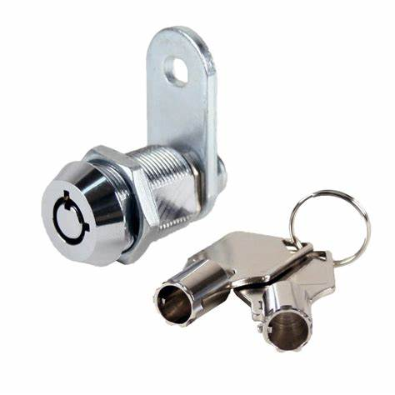

**8. euro cylinder locks**

**- single cylinder**

**- double cylinder**

**- thumb turn**

Euro cylinder locks are a common type of lock used in Europe and are known for their ease of replacement. Here are the main types you inquired about:

* **Single Cylinder:** These locks have a keyway on the outside and a thumb turn on the inside. This allows for key operation from the outside and easy, keyless operation from the inside.
* **Double Cylinder:** These locks have a keyway on both the inside and outside. This means a key is required to operate the lock from either side, offering enhanced security.
* **Thumb Turn:** As described above (and in single cylinder locks), these have a keyway on the outside and a thumb turn on the inside for easy, keyless operation from within.

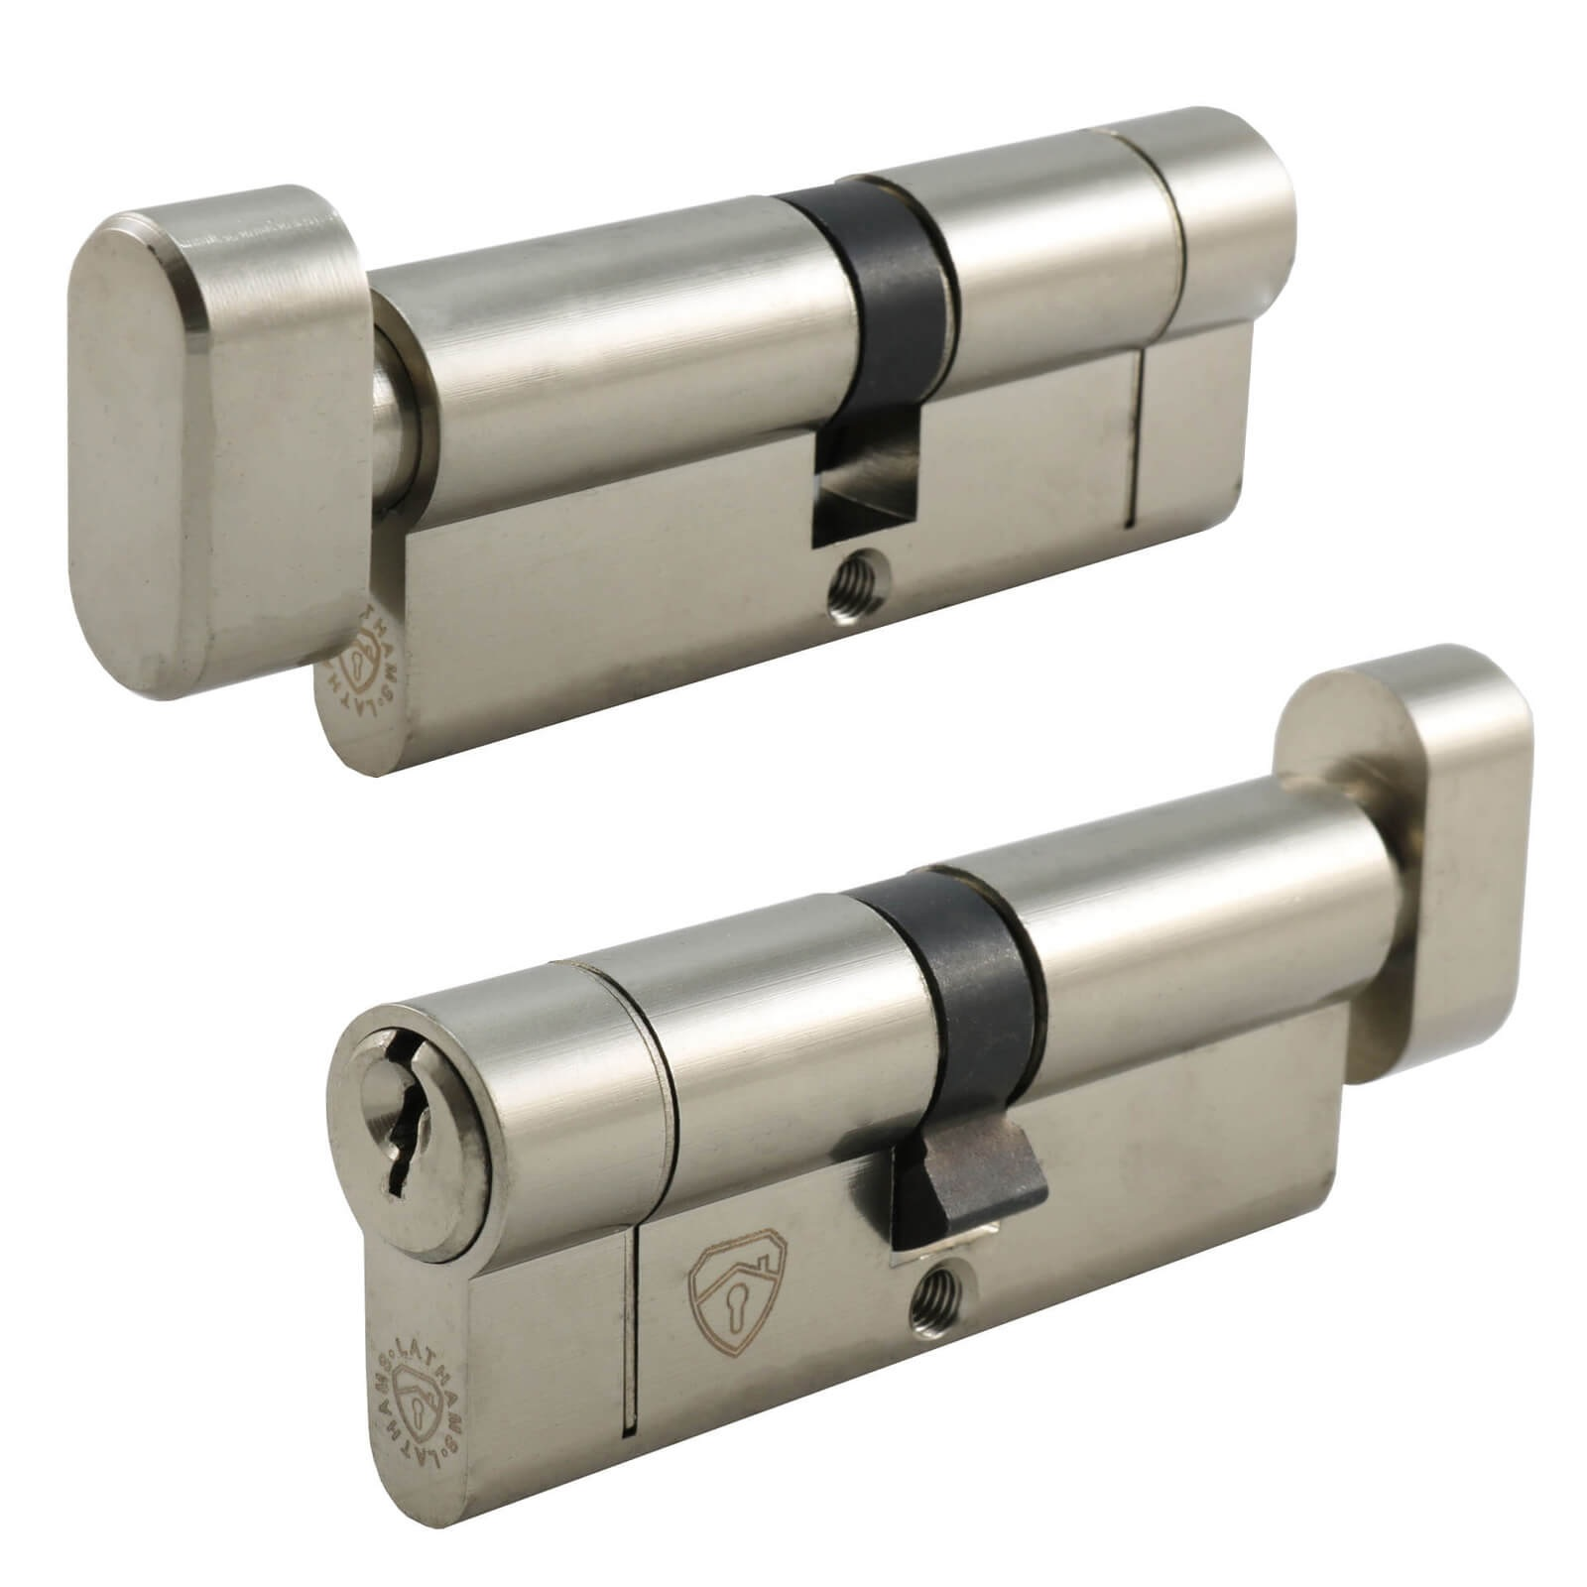**9. magnetic locks**

Magnetic locks, also known as electromagnetic locks or maglocks, use electromagnetism to secure a door. When energized, the lock creates a strong magnetic force that holds the door shut. They are often used in access control systems due to their quick operation and durability.

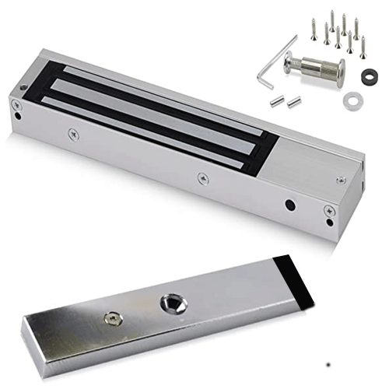

**10. keycard locks**

Keycard locks use a flat, rectangular plastic card to unlock doors. These cards store a physical or digital pattern that the lock mechanism recognizes. They are commonly used in hotels and access control systems for their convenience and security.

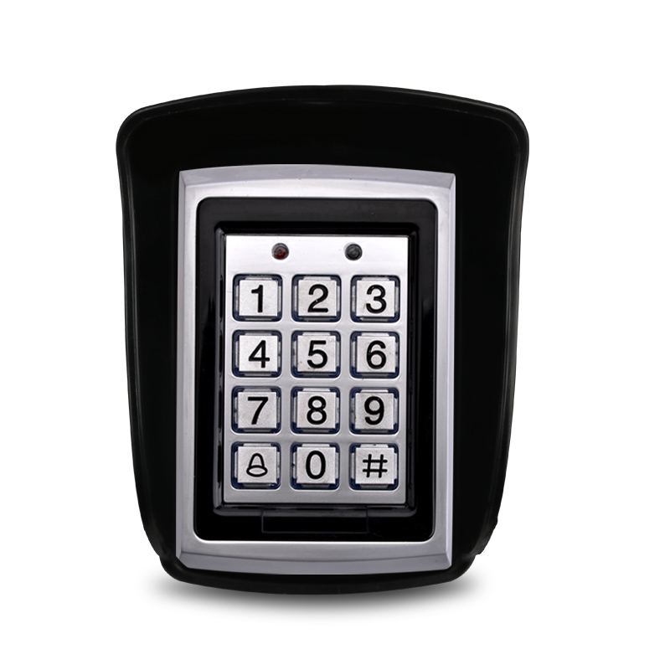**11. smart locks**

**- fingerprint locks**

**- bluetooth / wi-fi locks**

**- voice-activated locks**

* **Fingerprint Locks:** These smart locks use biometric technology to grant access based on unique fingerprint scans. They offer keyless entry and enhanced security through personalized identification.
* **Bluetooth / Wi-Fi Locks:** These locks connect to smartphones or home Wi-Fi networks, allowing users to lock and unlock doors remotely via an app. They often offer features like guest access, activity logs, and auto-lock functions.
* **Voice-Activated Locks:** Integrating with voice assistants like Amazon Alexa or Google Assistant, these locks can be controlled using voice commands, providing hands-free convenience.

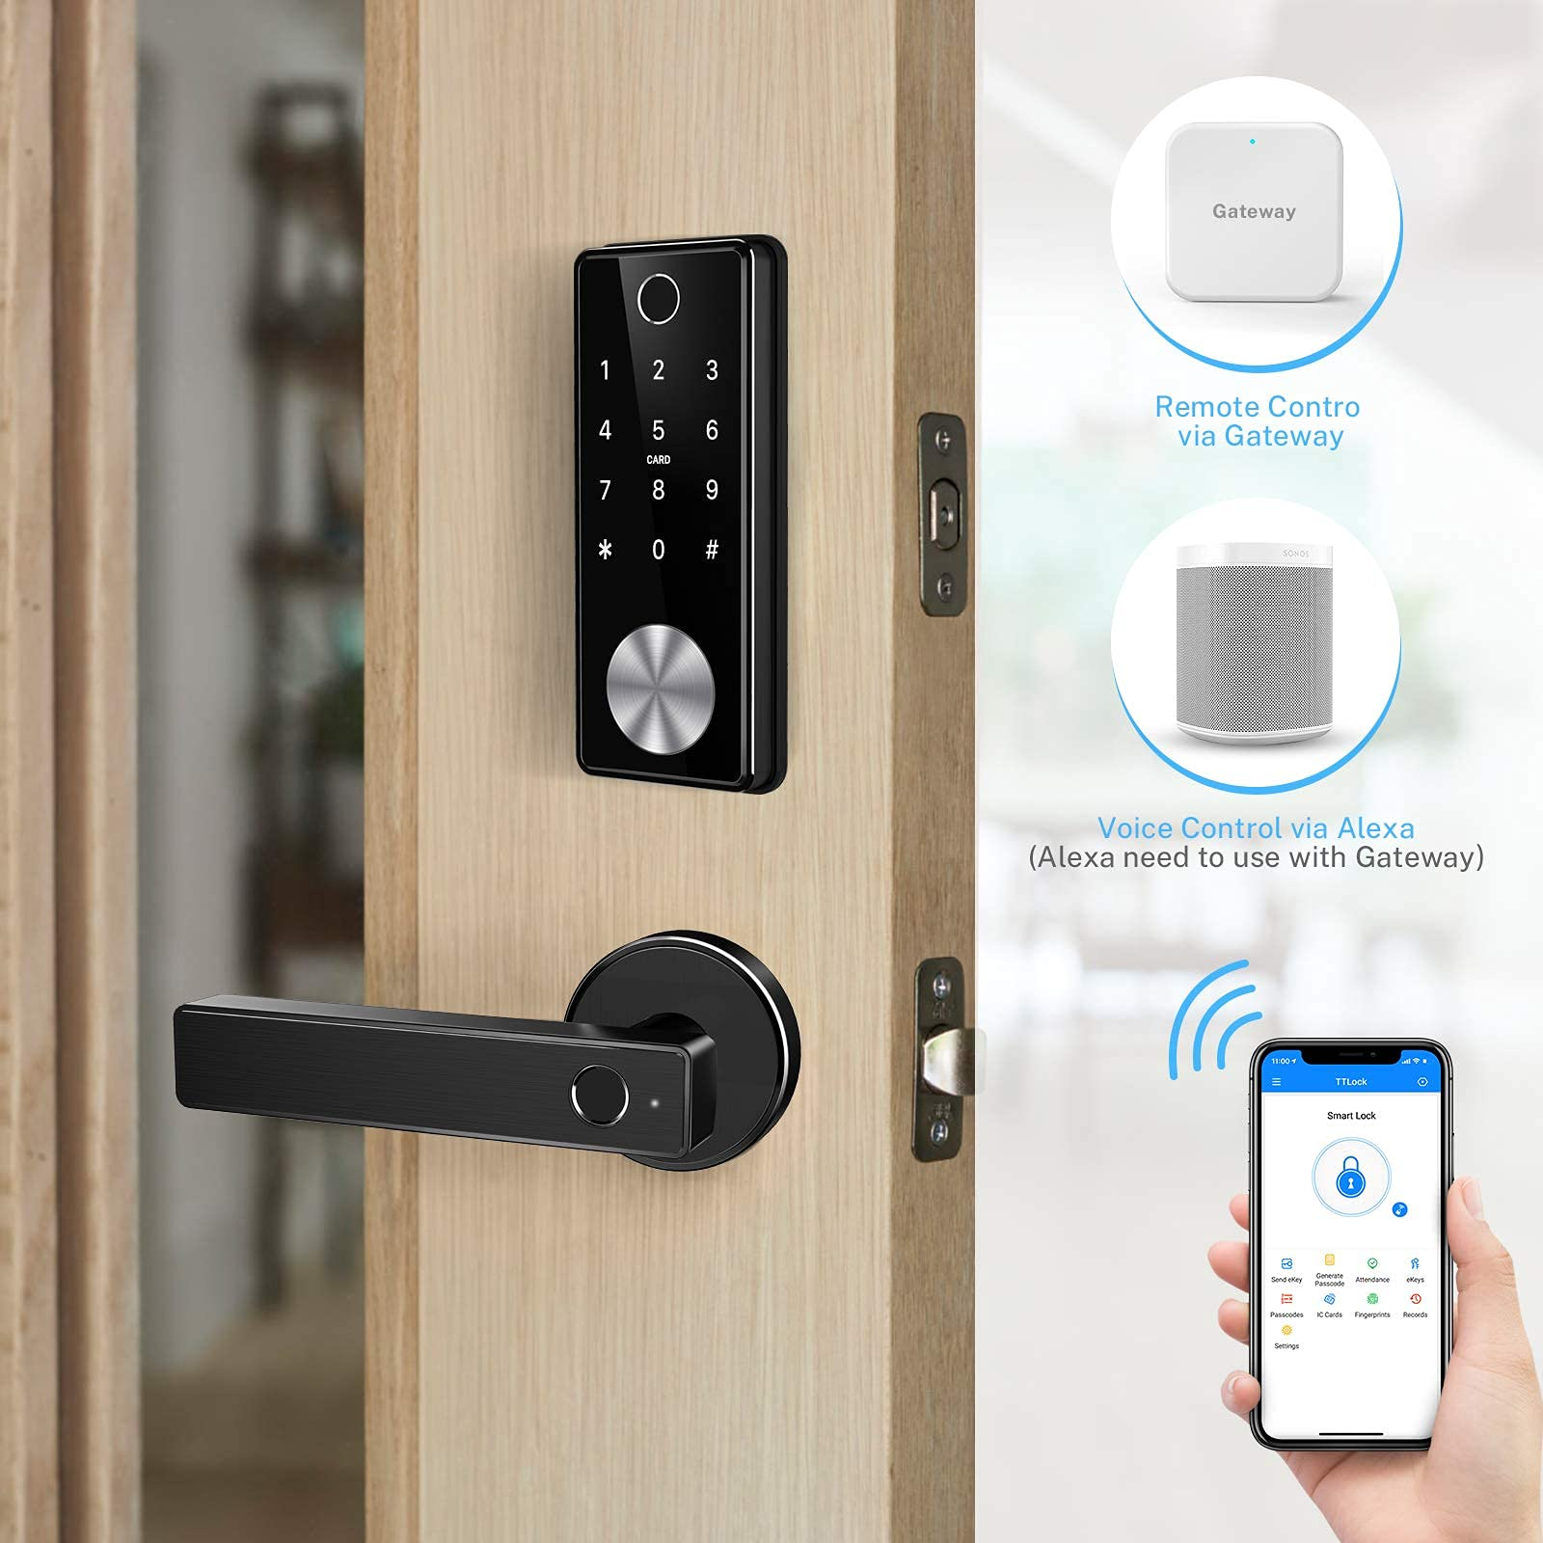**12. chain locks**

Chain locks, also known as door chains, are a simple security device consisting of a short length of chain attached to a sliding bolt on the door and a catch on the door frame. They allow the door to be partially opened to view who is outside or to have a limited conversation without fully exposing the interior. While they offer a basic level of security, they are not as robust as deadbolts or other more advanced locking mechanisms.

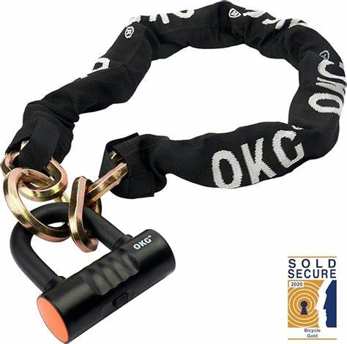

**13. barrel bolt / slide bolt**

Barrel bolts and slide bolts are simple locking mechanisms used to secure doors, gates, and other closures. They consist of a cylindrical or rectangular bolt that slides into a receiving bracket or hole. They are easy to install and use, providing a basic level of security.

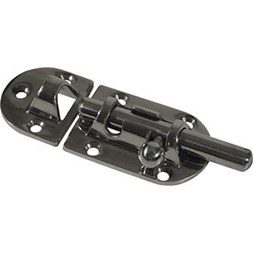

**14. disc tumbler locks**

Disc tumbler locks use a series of rotating discs to prevent the lock from opening without the correct key. They are known for their resistance to picking and are often used in high-security applications.

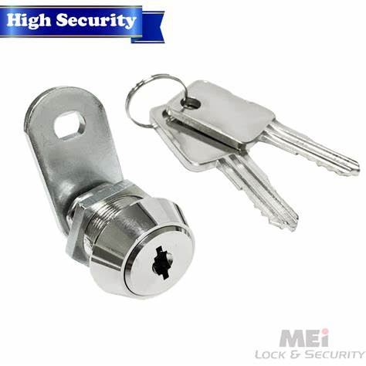

**15. wafer locks**

Wafer locks use flat wafers to prevent the lock from opening without the correct key. They are commonly used in low to medium-security applications such as in desks, cabinets, and cars.

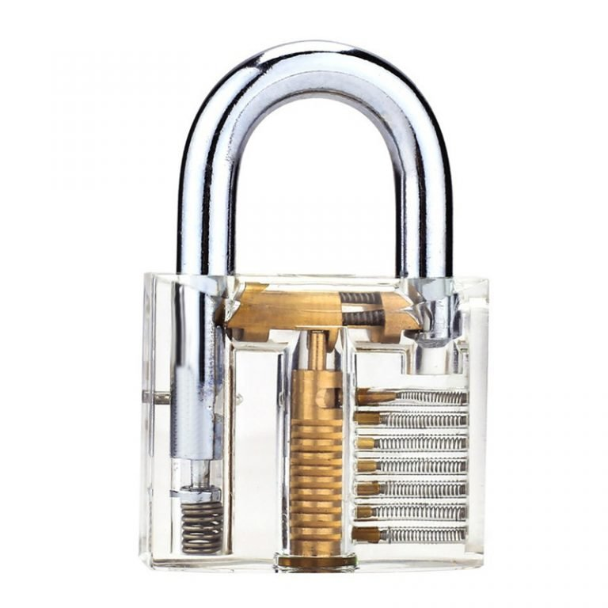**16. locking bars**

Locking bars are used to secure multiple drawers or doors simultaneously, often found in cabinets and safes. They enhance security by preventing individual access.

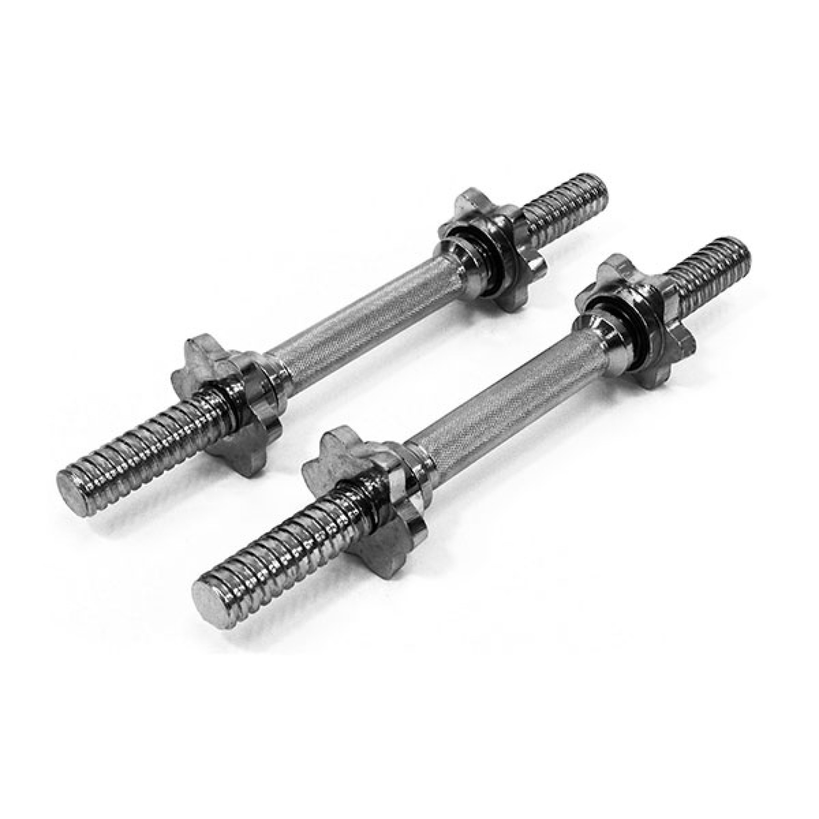**17. combination locks**

Combination locks use a sequence of numbers or symbols to open, eliminating the need for a key. They are available in various forms, from small padlocks to large safe locks, and can have fixed or resettable combinations.

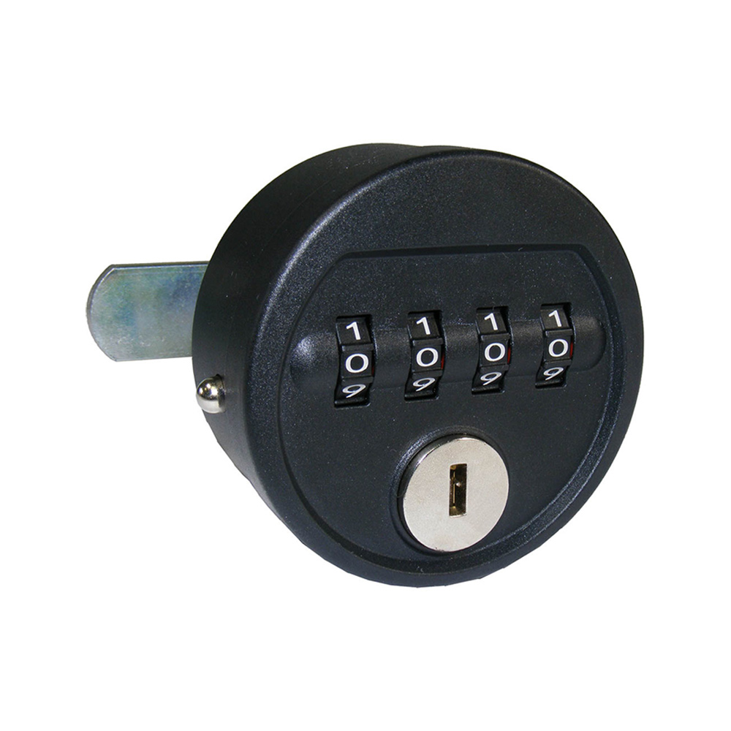**18. biometric locks**

Biometric locks use unique biological traits, such as fingerprints, facial recognition, or voice identification, to grant access. This eliminates the need for keys and enhances security.

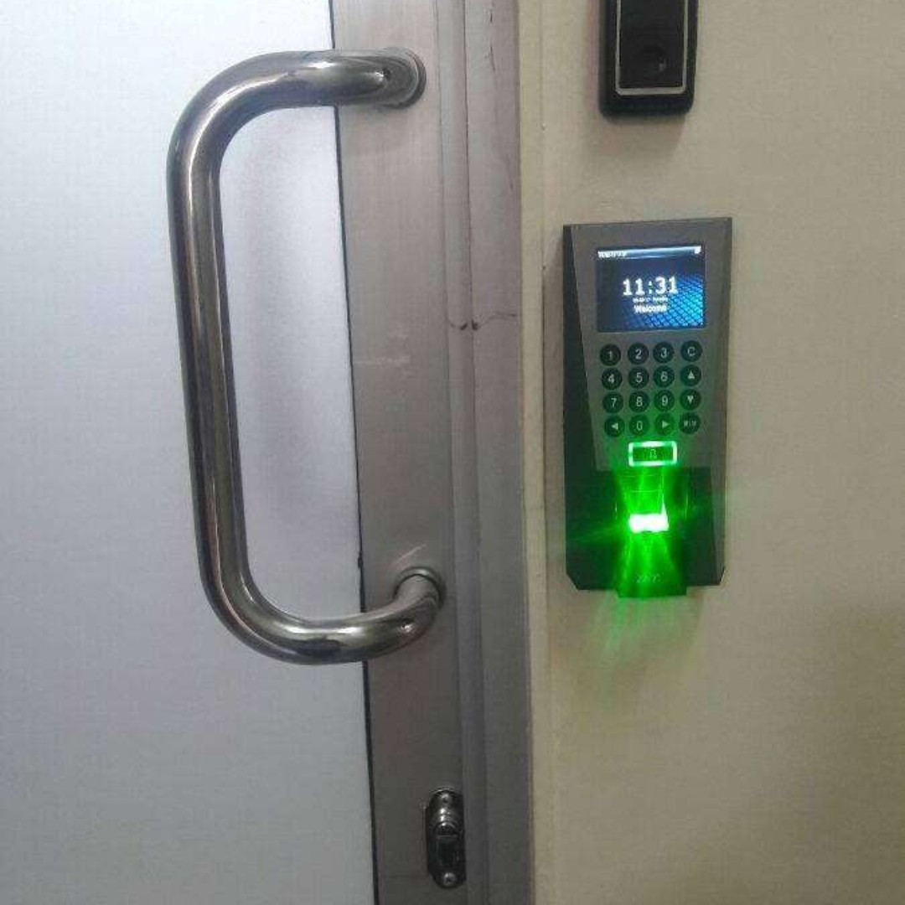**19. cable locks**

Cable locks consist of a flexible steel cable, often coated in plastic, used to secure items like bikes or luggage. They come in various types, including combination, keyed, and retractable versions.

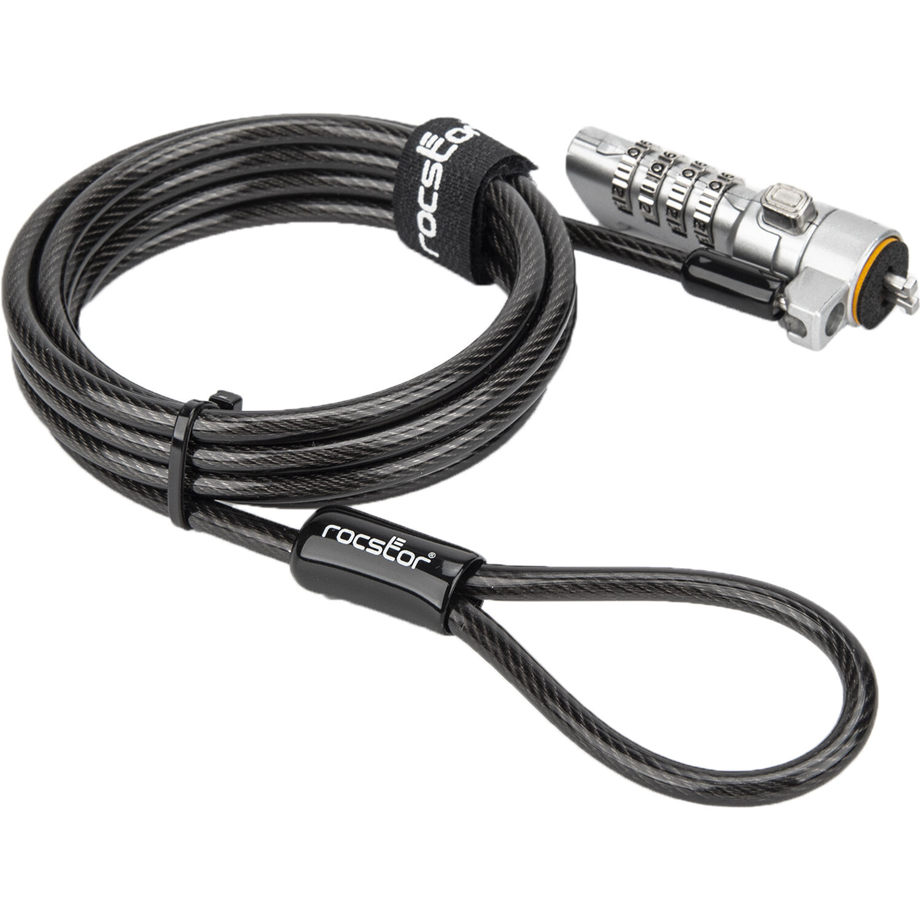**20. t-handle locks**

T-handle locks are named for their T-shaped handle, used to operate the locking mechanism. They are commonly found on toolboxes, service vehicles, and other industrial applications.

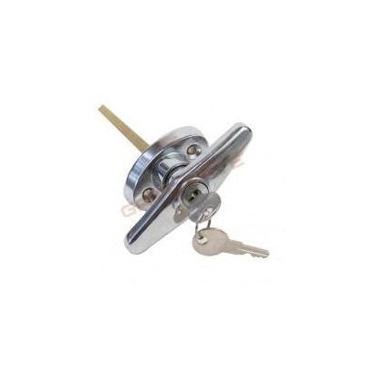

**21. shackle locks**

Shackle locks are padlocks featuring a U-shaped bar (the shackle) that secures through an opening. They come in open, closed, long, adjustable, and shrouded designs.

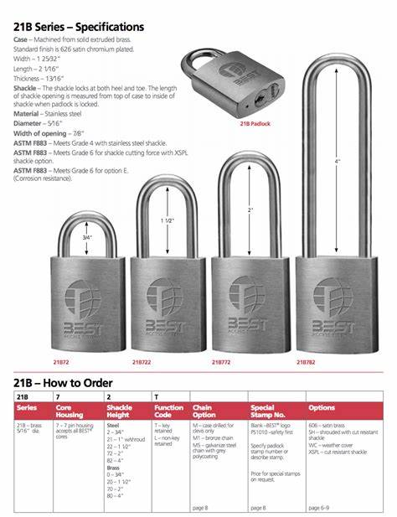

**22. cylinder locks**

Cylinder locks are a widely used type of lock mechanism that employs a cylinder containing a pin tumbler or wafer mechanism. When the correct key is inserted, the tumblers or wafers align, allowing the cylinder to turn and the lock to open. They are commonly found in door locks, padlocks, and various other security devices.

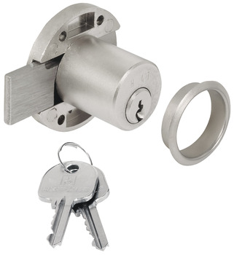

**23. antique / vintage locks**

Antique and vintage locks are collectible items valued for their historical significance and craftsmanship. They come in various styles and materials, including brass, iron, and steel, often featuring ornate designs and intricate mechanisms.

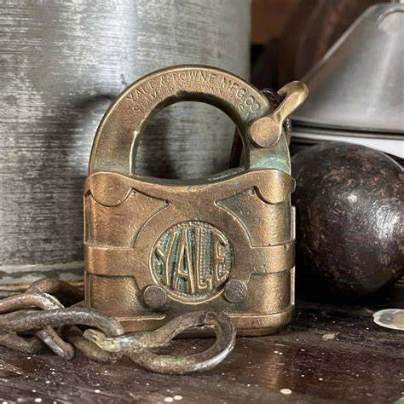

**24. high-security locks**

High-security locks are designed with advanced features to provide enhanced protection against unauthorized access, picking, and manipulation. These locks are crucial for applications where heightened security is essential.

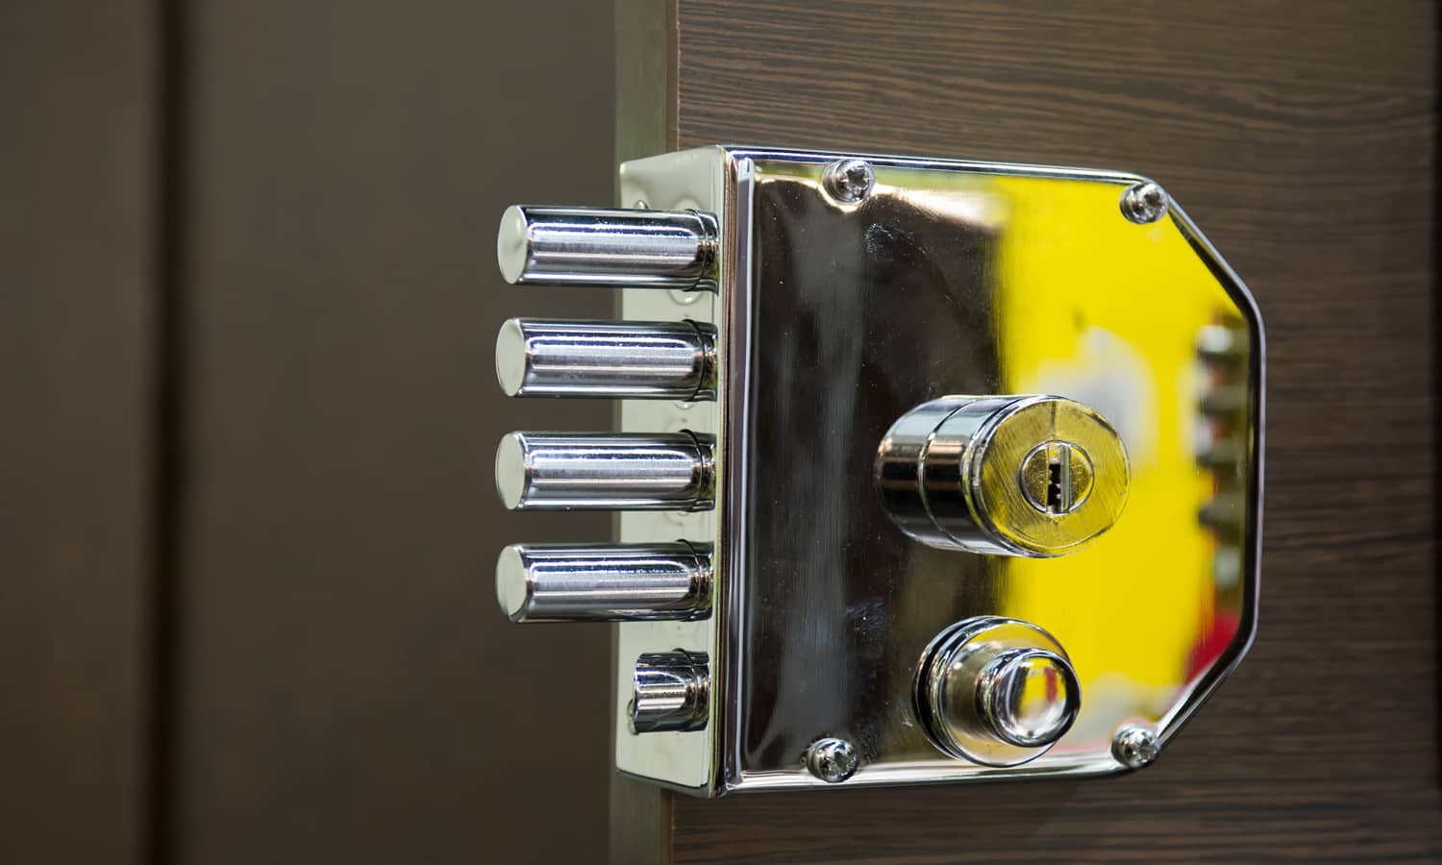**25. furniture locks**

Furniture locks are specifically designed to secure drawers, cabinets, and other pieces of furniture. They come in various types, such as cam locks, drawer locks, and sliding door locks, offering security for personal belongings and important documents stored within furniture.

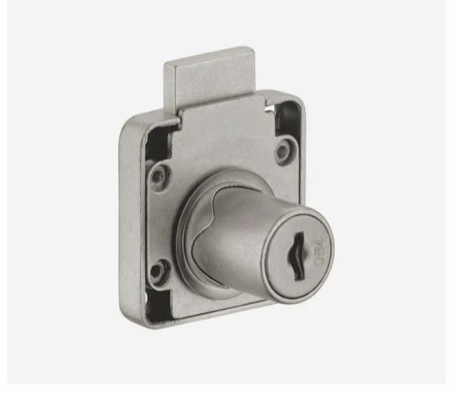**26. time locks**

Time locks are locking mechanisms often found in high-security containers like bank vaults. They are designed to prevent the opening of the safe or vault until a preset time, even if the correct combination is known.

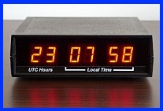

**27. pivot locks**

Pivot locks are used in various applications, including doors and industrial settings. They allow objects to rotate or pivot while also providing a locking mechanism for security or stability.

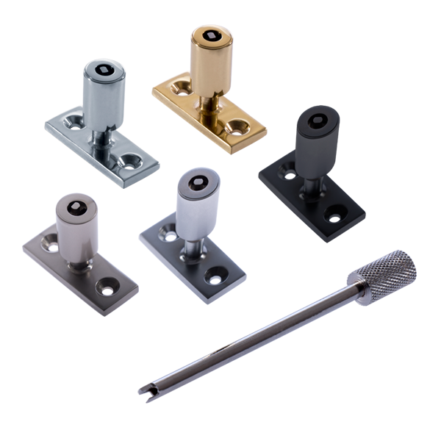**28. drop bolts / electronic strike locks**

Drop bolts are locking mechanisms that drop a bolt into a socket for security. Electronic strike locks are access control devices used on door frames, allowing doors to be opened without using a key.

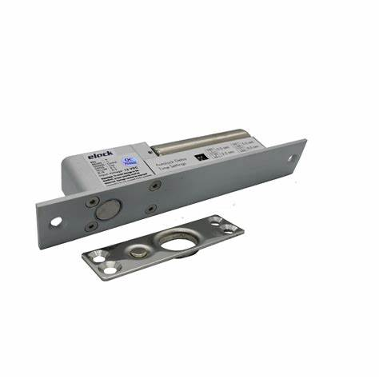

**29. rim latches**

Rim latches are locking devices that are attached to the surface of a door.

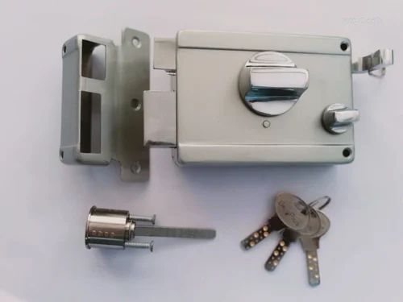

**30. multipoint locks**

Multipoint locks have multiple locking mechanisms. This makes them more secure than single-point locks.

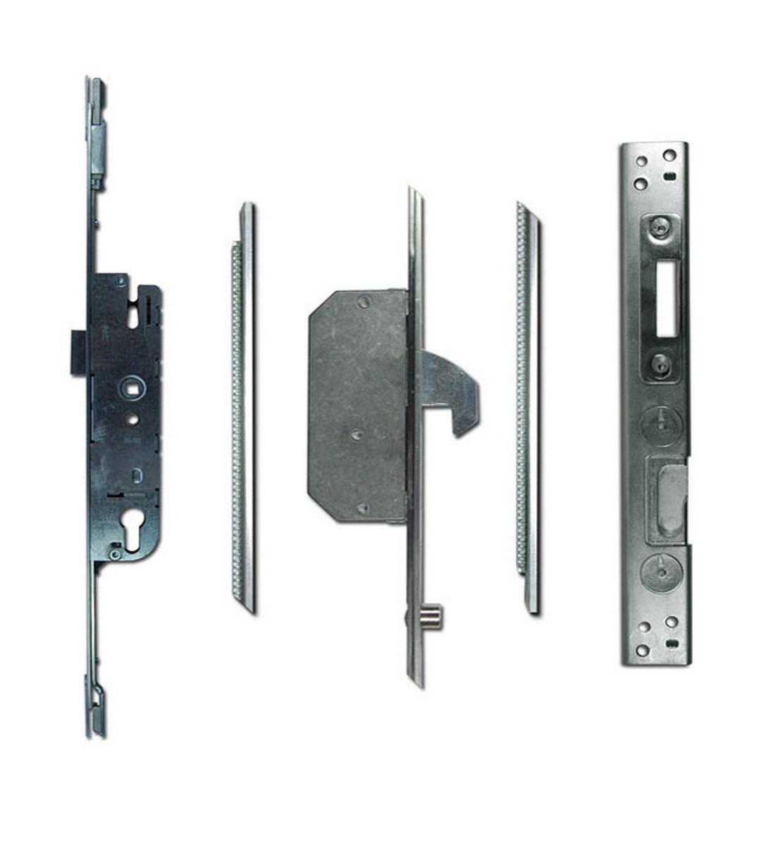

**31. tubular locks**

Tubular locks are a type of pin tumbler lock where the pins are arranged in a circle. They are often used in vending machines and bicycle locks.

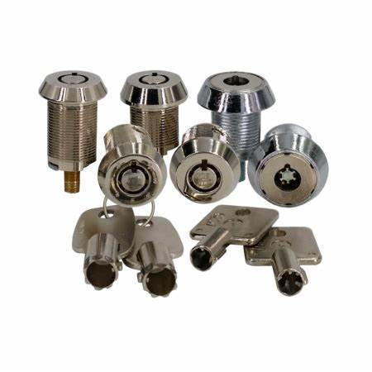

**32. cross locks**

Cross locks, also known as cruciform locks, have a cross-shaped keyhole and are more difficult to pick than standard locks. They are often used in steering wheel locks and safes.

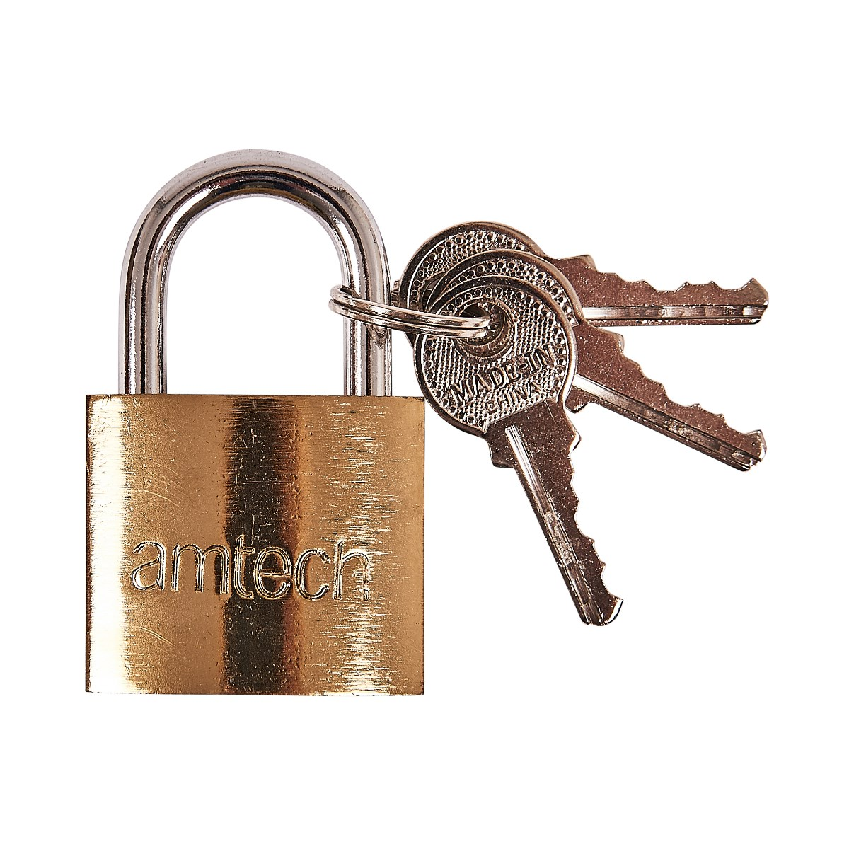**33. restricted keyway locks**

Restricted keyway locks are designed to prevent unauthorized key duplication, offering enhanced security. They often involve unique key shapes or groove patterns.

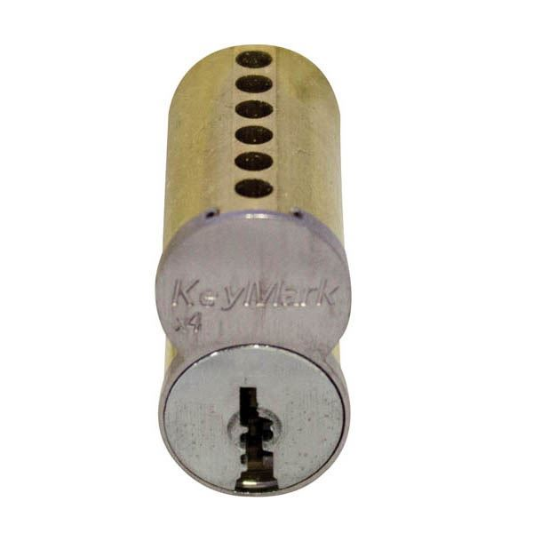**34. keyless mechanical locks**

Keyless mechanical locks offer a way to secure doors without keys, often using a combination or keypad.

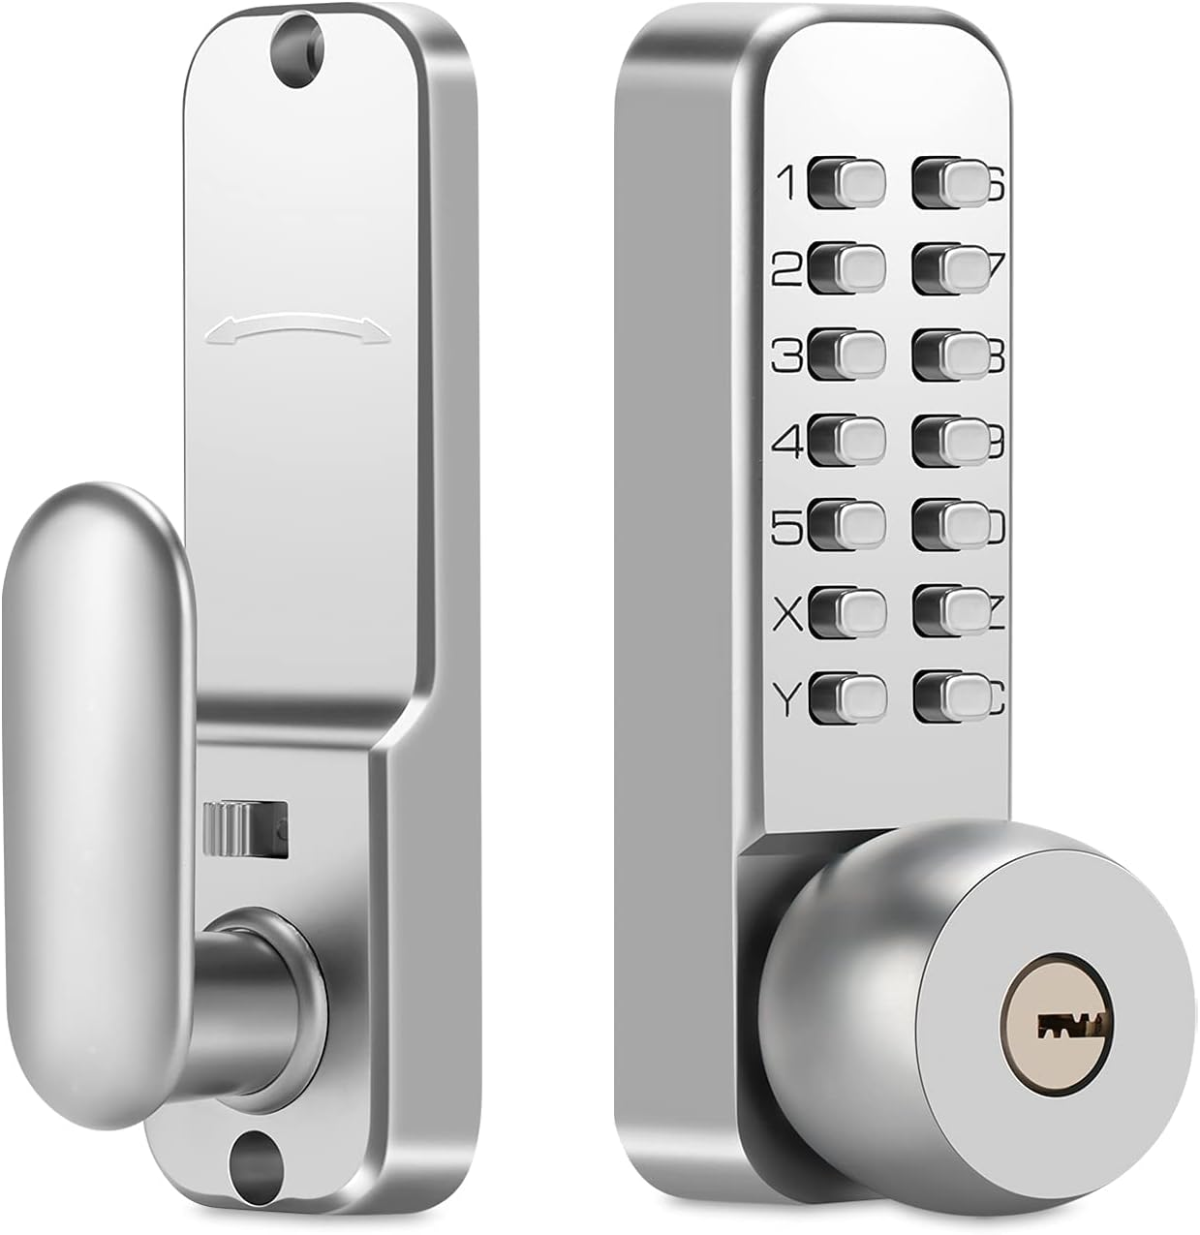

**35. rfid locks**

RFID locks use radio-frequency identification to grant access, often used in hotels and offices.

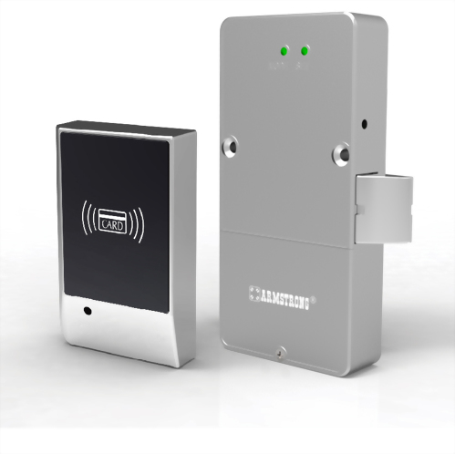

**36. safe locks**

**- dial locks**

**- digital locks**

Safe locks are robust security mechanisms designed to protect the contents of a safe. Here are the two main types you mentioned:

* **Dial Locks:** These traditional safe locks use a rotating dial with a specific sequence of numbers that must be entered correctly to unlock the safe. They are known for their reliability and resistance to electromagnetic pulses (EMPs).
* **Digital Locks:** Also known as electronic safe locks, these use a keypad where a numerical code is entered to unlock the safe. They often offer features like multiple user codes, time delays, and audit trails.

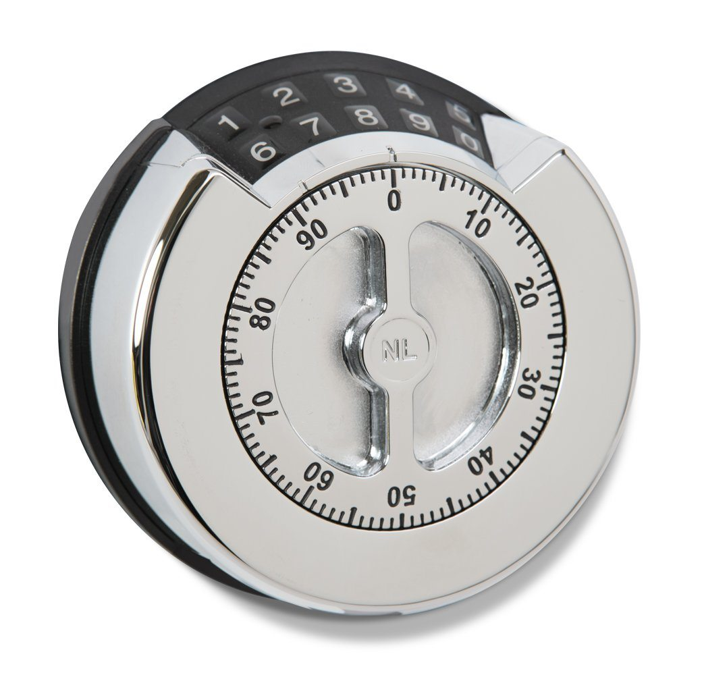**37. chain-and-hasp locks**

Chain-and-hasp locks are a simple and durable locking mechanism consisting of a hinged metal plate (the hasp) that fits over a staple and is secured with a padlock or chain. They are commonly used for securing gates, doors, and storage containers.

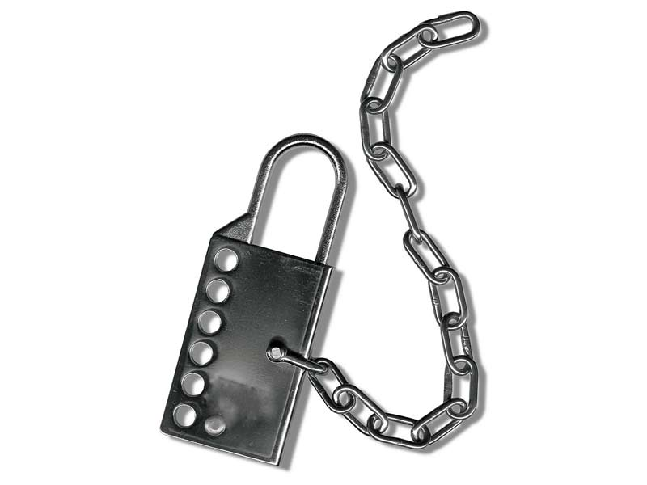**38. surface-mounted locks**

Surface-mounted locks are attached to the surface of a door, making them easier to install compared to mortise locks. They come in various types, including night latches and deadbolts.

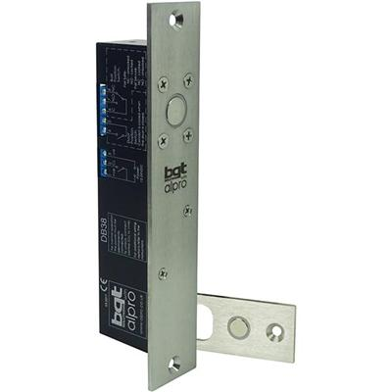

**39. gate locks**

Gate locks are designed to secure gates, providing security and controlling access to properties. They come in various types, including padlocks, deadbolts, and electronic locks, with different materials and security levels.

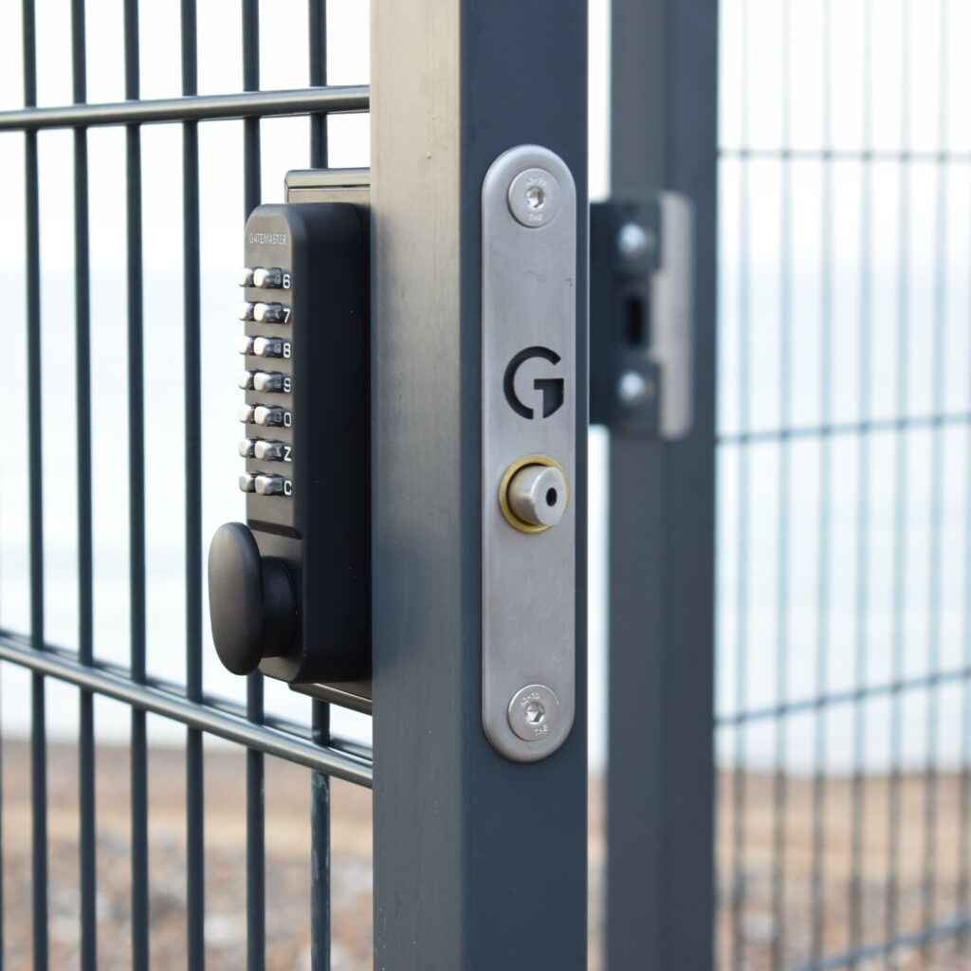**40. vehicle locks**

**- ignition locks**

**- steering locks**

Vehicle locks are essential for security, preventing theft and unauthorized use. Here are the two types you mentioned:

* **Ignition Locks:** This lock is typically integrated into the steering column and requires the correct key to start the vehicle's engine. It also often locks the steering wheel when the key is removed.
* **Steering Locks:** These are additional security devices that physically lock the steering wheel in place, making it very difficult to steer the vehicle. They can come in various forms, such as bars or clubs that attach across the steering wheel.

