Decision Tree (Gini,Entropy)

# library link

**install :**

<https://scikit-learn.org/stable/install.html>

**github :**

<https://github.com/scikit-learn/scikit-learn/blob/82df48934eba1df9a1ed3be98aaace8eada59e6e/sklearn/tree/_classes.py>

# basic description

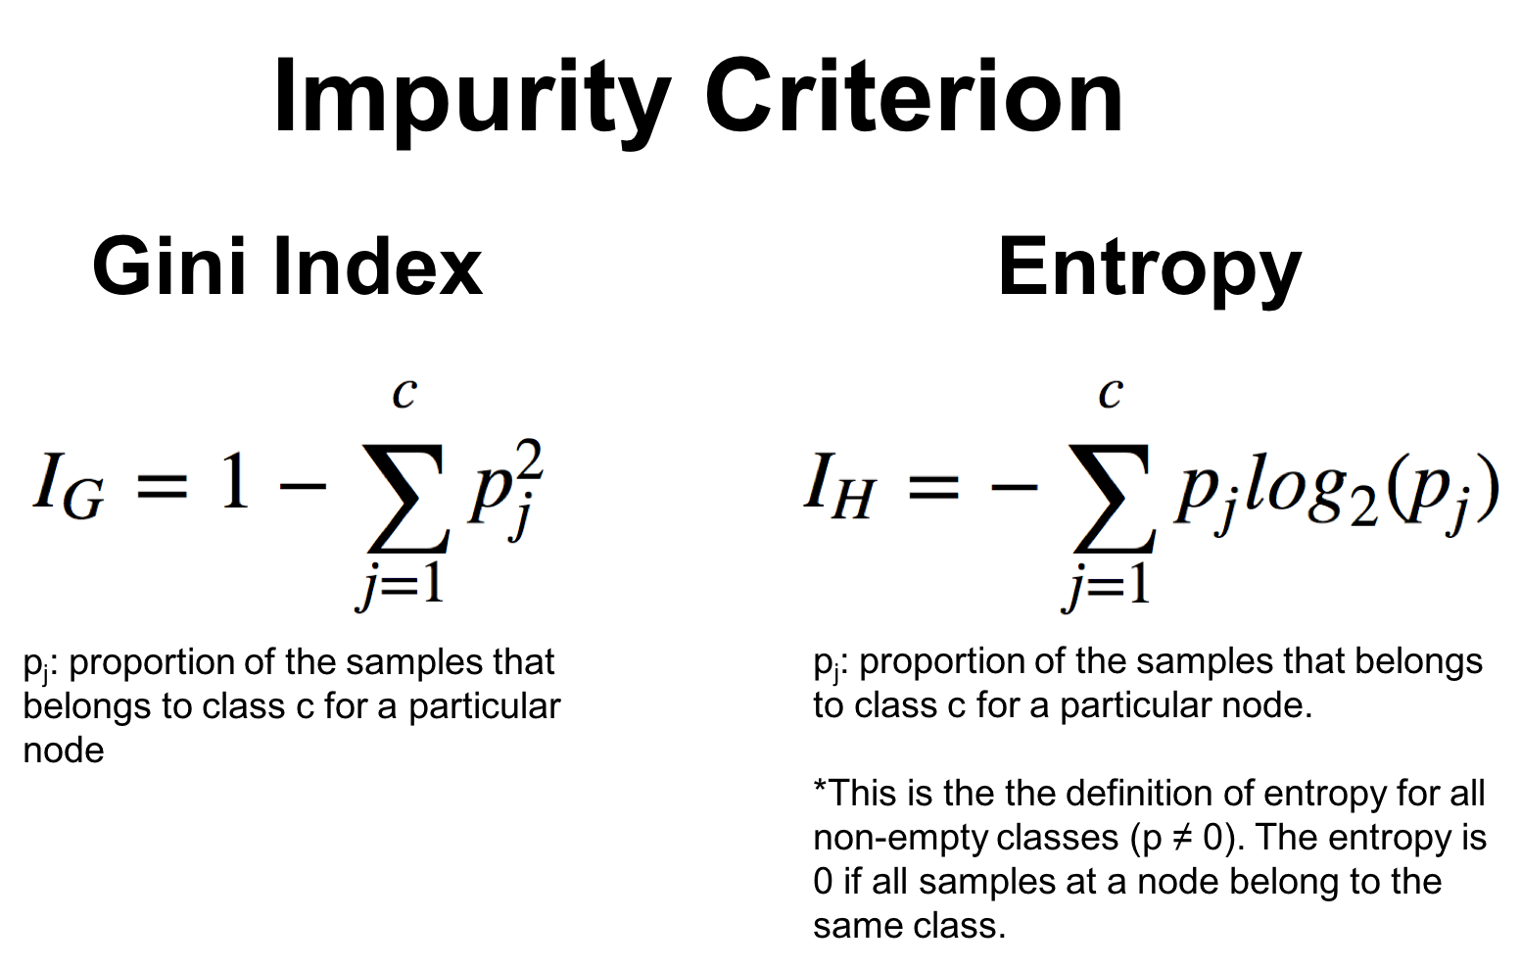

Decision tree learning or induction of decision trees is one of the predictive modelling approaches used in statistics, data mining and machine learning. It uses a decision tree (as a predictive model) to go from observations about an item (represented in the branches) to conclusions about the item's target value (represented in the leaves).

# version

* NumPy >= 1.14.6 (pip install numpy)
* Scipy >= 1.1.0 (pip install scipy)
* Joblib >= 0.11 (pip install joblib
* Threadpoolctl >= 2.0.0 (pip install threadpoolctl)
* pandas >= 1.2.4 (pip install pandas)
* matplotlib == 3.22 (pip install matplotlib)
* sklearn == 1.0.2 (pip install sklearn)
* graphviz == 0.10.1 (pip install graphviz)

# dataset

* diabetes.scv: This dataset is originally from the National Institute of Diabetes and Digestive and Kidney Diseases. The objective of the dataset is to diagnostically predict whether or not a patient has diabetes, based on certain diagnostic measurements included in the dataset. Several constraints were placed on the selection of these instances from a larger database. In particular, all patients here are females at least 21 years old of Pima Indian heritage.
* Sources : https://www.kaggle.com/uciml/pima-indians-diabetes-database

# code description

* After receiving the patient's case data diabetes.scv for diabetes as a dataset, learning it in the Decision Tree model, indicating the verification accuracy of the model and storing and outputting the created Decision Tree in pdf format.

# validation

* Inside the code, the dataset is divided into learning datasets and verification datasets to verify this.

(test_size = 0.2, random_state = 0)

* Additionally, the fitness between the actual value and the predicted value is evaluated using Sklearn's acuity_score function.