hierarchical Agglomerative clustering

# library link

**install :**

https://scikit-learn.org/stable/install.html

https://scipy.org/download/

**github :**

https://github.com/scipy/scipy/blob/v1.7.1/scipy/cluster/hierarchy.py

https://github.com/scikit-learn/scikit-learn/blob/7e1e6d09b/sklearn/cluster/_agglomerative.py#L740

# basic description

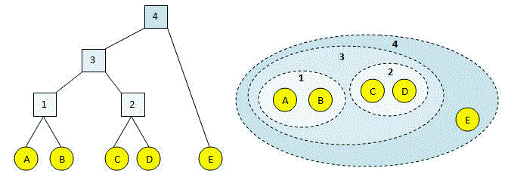

hierarchical clustering is a method of cluster analysis which seeks to build a hierarchy of clusters. And hierarchical Agglomerative clustering is a "bottom-up" method for creating hierarchical clusters. Each observation starts in its own cluster, and pairs of clusters are merged as one moves up the hierarchy.

# version

* NumPy >= 1.14.6 (pip install numpy)
* Scipy >= 1.1.0 (pip install scipy)
* scikit-learn >= 1.0.2 (pip install sklearn)
* joblib>= 0.11 (pip install joblib)
* threadpoolctl >= 2.0.0 (pip install threadpoolctl)

# dataset

* Customers Cluster.scv: Data sets for customers' IDs, gender, age, income, and Spending.
* Sources : <https://www.kaggle.com/tohuangjia/customer-cluster/metadata>

# code description

* To show the process of the hierarchical clustering method through a graph, a test set is created for temporary x,y data, and the learning results of the test set are output using scipy’s linkage and dendrogram.
* After that, information on age and income is extracted individually from the actual customers' datasets, shown on the graph using scipy’s linkage, dendrogram, and then learned actual customer information using Sklearn's Agglomeric Clustering model, and the results are shown through a scattergraph.

# validation

* X