Spearman

# library link

**pypi :**

https://pypi.org/project/scipy/

**github :**

https://github.com/scipy/scipy/blob/8a64c938ddf1ae4c02a08d2c5e38daeb8d061d38/scipy/stats/statlib/spearman.f

# basic description

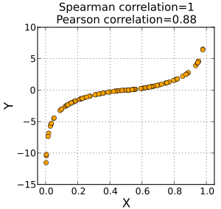

pearman's rank correlation coefficient or Spearman's *ρ,* is a nonparametric measure of rank correlation (statistical dependence between the rankings of two variables). It assesses how well the relationship between two variables can be described using a monotonic function.

# Version

* Scipy == 1.7.3 (pip install scipy)
* Pandas == 1.1.5 (pip install pandas)
* Matplotlib == 3.22 (pip install matplotlib)

# dataset

* Data.xlsx : An xlsx format dataset consisting of two simple types of comparison values.
* StudentsPerformance.csv : this data set consists of the marks secured by the students in various subjects.

Sources : making

Sources : https://www.kaggle.com/spscientist/students-performance-in-exams

# code description

* Statistical data inside Data.xlsx and StudiesPerformance.csv are utilized in whole or in part to express the scatter plot, and the Spearman correlation coefficient is calculated and output using the Scipy library internal function.

# validation

* x