Multiple Regression

# library link

**install :**

<https://scikit-learn.org/stable/install.html>

**github :**

<https://github.com/scikit-learn/scikit-learn/blob/main/sklearn/linear_model/_base.py>

# basic description

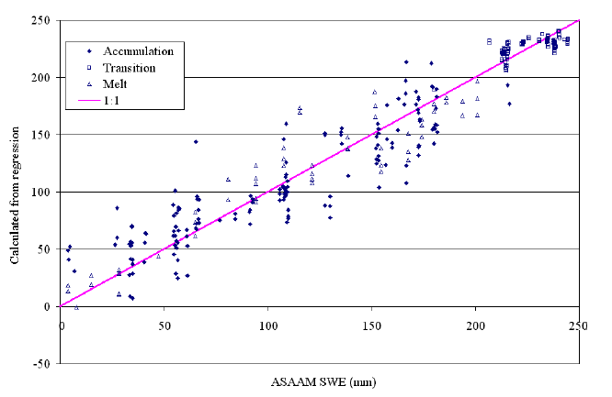

Linear regression method based on two or more explanatory variables (independent variable, X value) during the linear session in statistics.

# version

* NumPy >= 1.14.6 (pip install numpy)
* Scipy >= 1.1.0 (pip install scipy)
* Joblib >= 0.11 (pip install joblib
* Threadpoolctl >= 2.0.0 (pip install threadpoolctl)
* pandas >= 1.2.4 (pip install pandas)
* matplotlib == 3.22 (pip install matplotlib)

# dataset

* imports-85.data : Automobile Data Set provided by the UCI Machine Learning Repository.
* Detailed data information is attached to the inside of the import-85.names file.
* Cite This Dataset : Automobile. (1987). UCI Machine Learning Repository.

Sources : <https://archive-beta.ics.uci.edu/ml/datasets/automobile>

# code description

* Code that learns and verifies “price” information on explanatory variables [“engine-size”,”highway-mpg”,”city-mpg”] through multiple_regression format using the automobile dataset of imports-85.data
* (Attachment 1: NaN data is generated due to Missing Attribute Values inside the data, which is replaced with the average value grouped based on the “make” variable inside the dataset.)

# validation

* multiple_regression_ex1.ipynb: Inside the code, the dataset is divided into learning datasets and verification datasets to verify this.  
  (test_size = 0.2, random_state = 0)
* Measurement of the similarity between the predicted value and the actual data value in the learned model using the r2_socre function.