Polynomial Regression

# library link

**install :**

<https://scikit-learn.org/stable/install.html>

**github :**

<https://github.com/scikit-learn/scikit-learn/blob/main/sklearn/linear_model/_base.py>

# basic description

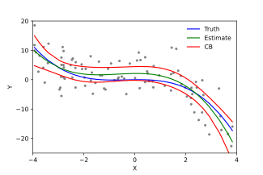

polynomial regression is a form of regression analysis in which the relationship between the independent variable x and the dependent variable y is modelled as an nth degree polynomial in x.

# version

* NumPy >= 1.14.6 (pip install numpy)
* Scipy >= 1.1.0 (pip install scipy)
* Joblib >= 0.11 (pip install joblib
* Threadpoolctl >= 2.0.0 (pip install threadpoolctl)
* pandas >= 1.2.4 (pip install pandas)
* matplotlib == 3.22 (pip install matplotlib)

# dataset

* Create and use sample data for 1000 points representing similar tendencies to the Sin graph by drawing a Sin graph inside the code and mixing some random numerical noise data.

# code description

* After creating 1000 sample datasets showing similar tendencies to the Sin graph, dividing them into training sets for learning and val sets for verification, and learning them respectively in the first and third degree models, and for this, displaying a trend graph of each model and showing learning curves.
* Then, using these learning models, the fitness between the predicted value estimated through the valset and the actual valset is expressed through the r2_socre function.

# validation

* Inside the code, the dataset is divided into learning datasets and verification datasets to verify this.

(test_size = 0.2, random_state = 0)

* Additionally, the fitness between the actual value and the predicted value is evaluated using the r2_socre function.