ridge

# library link

**install :**

<https://scikit-learn.org/stable/install.html>

**github :**

https://github.com/scikit-learn/scikit-learn/blob/3e0f49b62339941722d0dfbcb90f5af0ad1b2e6c/sklearn/linear_model/_ridge.py

# basic description

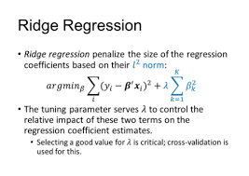

Ridge regression is a method of estimating the coefficients of multiple-regression models in scenarios where independent variables are highly correlated. It has been used in many fields including econometrics, chemistry, and engineering.

# version

* NumPy >= 1.14.6 (pip install numpy)
* Scipy >= 1.1.0 (pip install scipy)
* Joblib >= 0.11 (pip install joblib
* Threadpoolctl >= 2.0.0 (pip install threadpoolctl)
* pandas >= 1.2.4 (pip install pandas)
* matplotlib == 3.22 (pip install matplotlib)

# dataset

* Make sample dataset by using Numpy’s sin() and random method.

# code description

* Making Dataset in code. And make RIDGE regression model with different alpha parameters using sklearn.linear_model.Ridge.
* And than draw the graph of RIDGE regression model with different alpha parameters
* And also shows the result table showing the relationship between alpha values and coefficients.

# validation

* x