Lasso

# library link

**install :**

<https://scikit-learn.org/stable/install.html>

**github :**

[https://github.com/scikit-learn/scikit-learn/blob/7e1e6d09b/sklearn/linear_model/_coordinate_descent.py#L1109](https://github.com/scikit-learn/scikit-learn/blob/82df48934eba1df9a1ed3be98aaace8eada59e6e/sklearn/tree/_classes.py)

# basic description

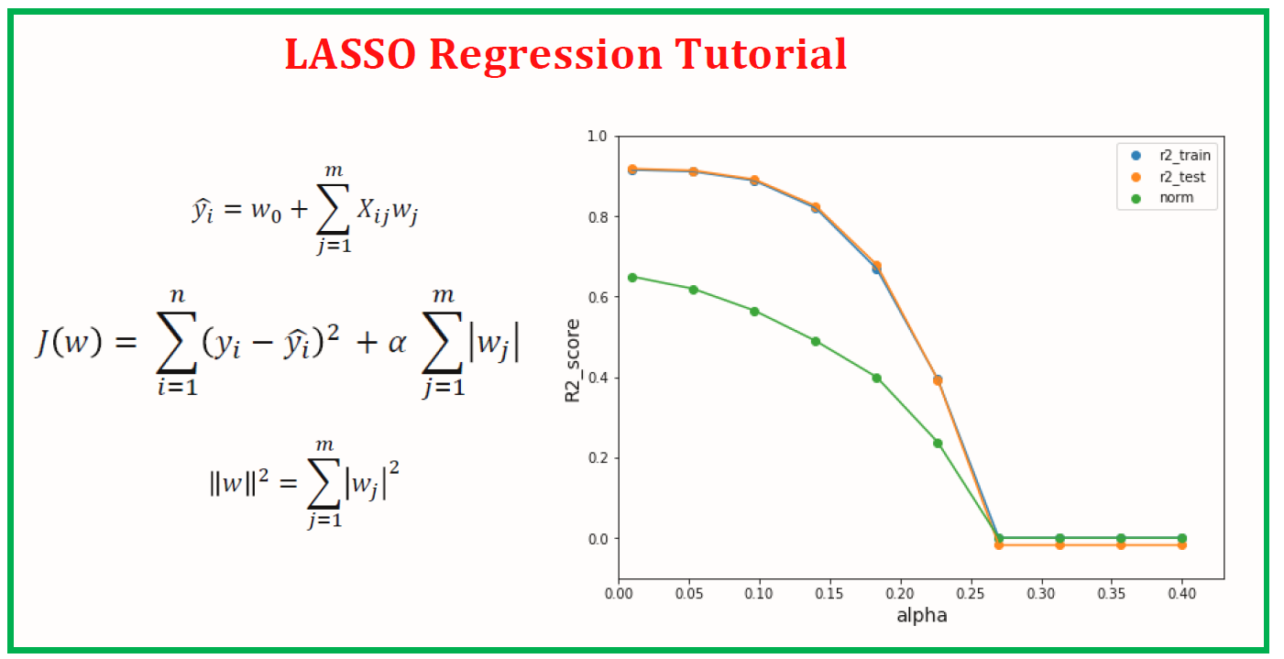

Lasso is a regression analysis method that performs both variable selection and regularization in order to enhance the prediction accuracy and interpretability of resulting statistical model.

# version

* NumPy >= 1.14.6 (pip install numpy)
* Scipy >= 1.1.0 (pip install scipy)
* Joblib >= 0.11 (pip install joblib
* Threadpoolctl >= 2.0.0 (pip install threadpoolctl)
* pandas >= 1.2.4 (pip install pandas)
* matplotlib == 3.22 (pip install matplotlib)

# dataset

* Make sample dataset by using Numpy’s sin() and random method.

# code description

* Making Dataset in code. And make Lasso regression model with different alpha parameters using sklearn.linear_model.Ridge.
* And than draw the graph of Lasso regression model with different alpha parameters
* And also shows the result table showing the relationship between alpha values and coefficients.

# validation

* x