github blog

# How to use

* Select a blog theme from the link below.
* <https://jekyllthemes.io>
* <http://jekyllthemes.org>
* Typically, the theme of the link below will be used.
* <https://jekyllthemes.io/theme/jekyll-now>
* Go to the code store of the selected theme.
* <https://github.com/barryclark/jekyll-now>
* Copy the code of theme released into my storage.
* Click the forks shown in the image below.

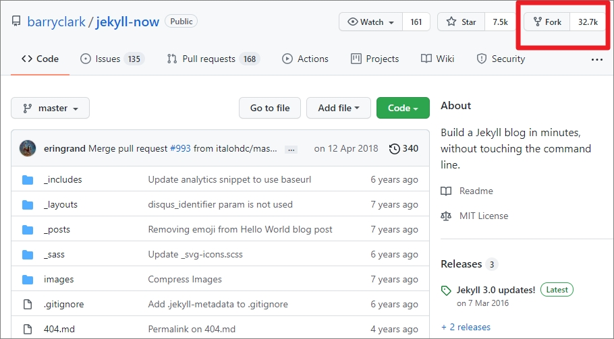

* Publishing blogs, deciding on URLs.
* Go into ‘Settings’ and change the name of the sotrage you want.
* If the repository name is ‘abc’, the blog address is  
  **https://accountID.github.io/abc**

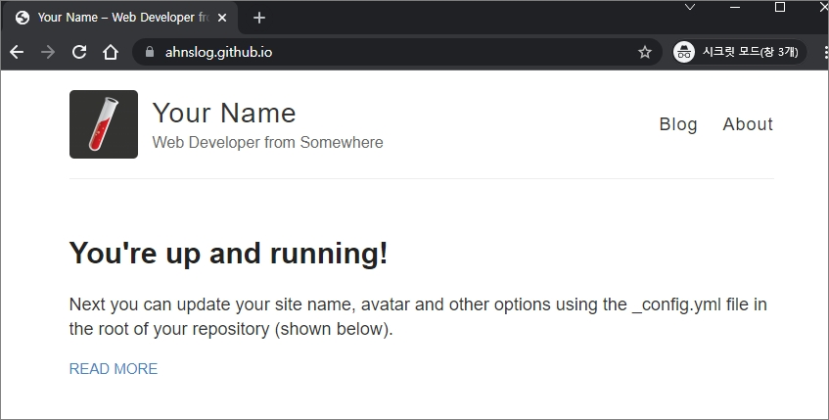

* Modifying basic information.
* Enter modification mode in a file named _config.yml.

- To modify the name of the site, find the part of the code that says name: and and change it to the dedsired name.

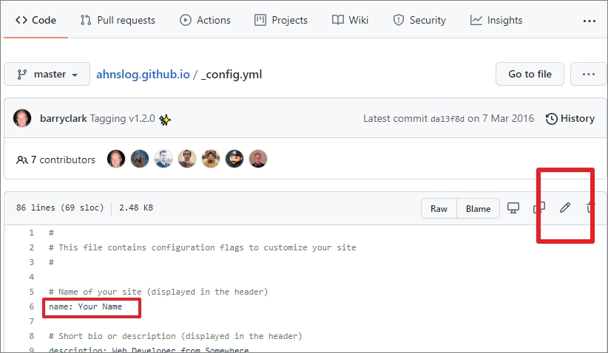

* Change it and click on the ‘commit changes’.
* Posting
* You can enter the _posts path and check the sample of the file.

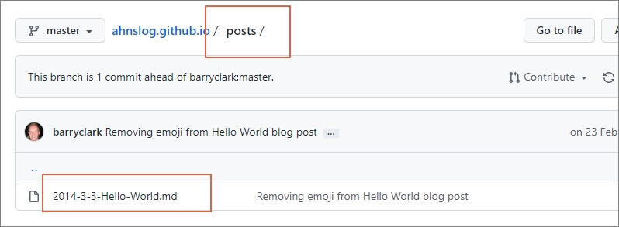

* Betwenen --- and --- shows meta information. (Title, layout, date, issue status of tahe posting page)
* After the meta-information, it’s the content of the actual posting, so you can fill it out according to the mark down form.