Open data xml parsing (python)

# library link

**github :**

<https://github.com/python/cpython/blob/3.10/Lib/xml/etree/ElementTree.py>

# open API link

**DATA.go.kr :**

[https://www.data.go.kr/data/15098715/openapi.do](https://github.com/scikit-learn/scikit-learn/blob/82df48934eba1df9a1ed3be98aaace8eada59e6e/sklearn/tree/_classes.py)

# basic description

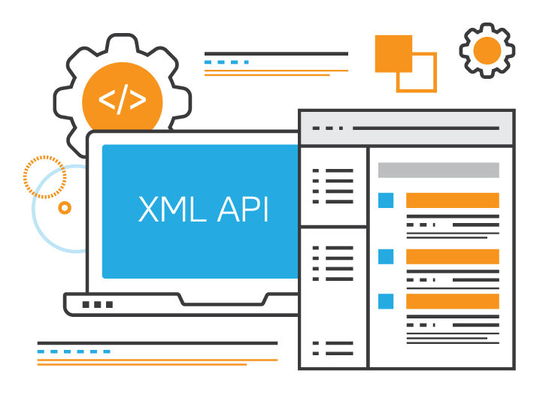

XML is a markup language that specifies the structure of documents or data using tags, and is a multipurpose markup language that is recommended to be used to create a markup language with other special purposes.

It has the characteristic of making it easy to exchange data between different types of systems, especially those connected to the Internet.

Today, it is used for data transmission and reception through various APIs.

This example shows the procedure for receiving XML data provided through the "Health Insurance Review and Assessment Service_Information Service for Designated Medical Institutions" API provided by the public data portal, reading it in a python environment, parsing it, and using it.

# version

* Python >=3.7
* requests == 2.27.1 (pip install requests)

# code description

* After applying for the use of api in the public data portal, a personal service key is issued, and XML data is requested to the designated API EndPoint using the HTTP protocol. In response to this, the XML data received and parsed, necessary data is searched and extracted, stored in a separate list, and then output.

# Data source

* Provider: Health Insurance Review and Assessment Service.
* API type: REST
* Data format : XML
* source : https://www.data.go.kr/data/15098715/openapi.do