Youtube data api, json parsing(python)

# library link

**github :**

https://github.com/python/cpython/blob/3.10/Lib/json/__init__.py

# open API link

**YouTube Data API :**

https://developers.google.com/youtube/v3/docs/channels?hl=ko

# basic description

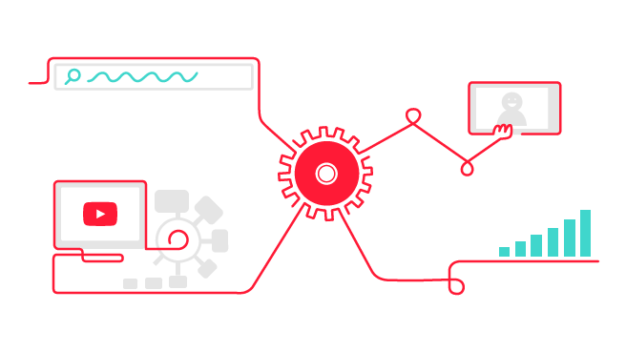

JSON is an open standard format that uses human-readable text to deliver "key:value" paired data objects, and is also known as a way to express data when exchanging data between browsers and servers or on the Internet, and is especially suitable for expressing variable values in computer programs.

This example shows the procedure for requesting and receiving json data for YouTube Channel provided by YouTube Data API through HTTP protocol, reading it in a python environment, parsing it, and using it.

# version

* Python >=3.7
* Requests == 2.27.1 (pip install requests)

# code description

* Access the Google API console, register the application, and receive API keys after applying for API use. Request the desired JSON data from the specified YouTube data api endpoint using the HTTP protocol in a GET method. In response of this, the received JSON data is parsed to output the YouTube channel name and thumbnail image url, the last uploaded video ID, the number of views, the number of subscribers, and the number of videos.

# Data source

* Provider: Google Developers
* API type: REST
* Data Type: JSON
* Source : https://developers.google.com/youtube/v3/docs/channels?hl=ko