Webhook (Youtube push notifications)

# library link

**simple-bodyparser:**

https://github.com/cosmosgenius/simple-bodyparser

**fast-xml-parser :**

https://github.com/NaturalIntelligence/fast-xml-parser

**Youtube Notifications :**

https://developers.google.com/youtube/v3/guides/push_notifications?hl=ko

**pubsubhubbub :**

[https://github.com/pubsubhubbub/](https://github.com/scikit-learn/scikit-learn/blob/82df48934eba1df9a1ed3be98aaace8eada59e6e/sklearn/tree/_classes.py)

# basic description

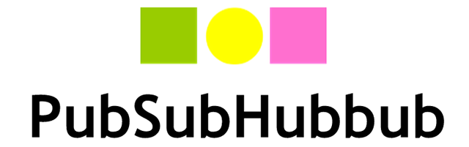

WebSub (formerly PubSubHubbub) is an open protocol for distributed publish–subscribe communication on the Internet. Initially designed to extend the Atom (and RSS) protocols for data feeds, the protocol can be applied to any data type (e.g. HTML, text, pictures, audio, video) as long as it is accessible via HTTP. Its main purpose is to provide real-time notifications of changes.

This example includes a series of processes of receiving push notification information of a specific YouTube channel through an express server of node.js using PubSubHubub, YouTube's push notification service.

(Source : <https://en.wikipedia.org/wiki/WebSub> )

# version

* Node.js == 16.14.0
* express >=4.17.2 (npm install express)
* simple-bodyparser >=1.0.0 (npm install simple-bodyparser)
* fast-xml-parser >=4.0.2 (npm install fast-xml-parser)

# Pre-set

* Use the Google hub (<https://pubsubhubbub.appspot.com/subscribe?hl=ko>) to subscribe to receive push notifications:
* Set the mode to subscribe. (Or set the mode to unsubscribe to cancel a subscription.)
* Set the CallBack URL to the URL of the server to run through express.
* Set the topic URL to https://www.youtube.com/xml/feeds/videos.xml?channel_id=CHANNEL_ID, where CHANNEL_ID is the YouTube channel ID for which you want to retrieve push notifications.

# code description

* To process Atom feed notification transmitted from YouTube's push notification service PubSububub, configure a callback server using node.js and express, and output and parse the Atom feed data delivered from the HTTP protocol on the server to output the notification YouTube video title and video ID, channel ID.

# notification format

* <feed xmlns:yt="http://www.youtube.com/xml/schemas/2015"
* xmlns="http://www.w3.org/2005/Atom">
* <link rel="hub" href="https://pubsubhubbub.appspot.com"/>
* <link rel="self" href="https://www.youtube.com/xml/feeds/videos.xml?channel_id=CHANNEL_ID"/>
* <title>YouTube video feed</title>
* <updated>2015-04-01T19:05:24.552394234+00:00</updated>
* <entry>
* <id>yt:video:VIDEO_ID</id>
* <yt:videoId>VIDEO_ID</yt:videoId>
* <yt:channelId>CHANNEL_ID</yt:channelId>
* <title>Video title</title>
* <link rel="alternate" href="http://www.youtube.com/watch?v=VIDEO_ID"/>
* <author>
* <name>Channel title</name>
* <uri>http://www.youtube.com/channel/CHANNEL_ID</uri>
* </author>
* <published>2015-03-06T21:40:57+00:00</published>
* <updated>2015-03-09T19:05:24.552394234+00:00</updated>
* </entry>
* </feed>