colab(Colaboratory)

# colab

Colab is a service that allows you to write and run Python scripts within a browser based on Jupiter's laptop, and is a remote platform service that allows you to learn AI machine learning through GPU and TPU from simple Python code writing and execution through a web browser without any configuration.

# Basic knowledge

**Knowledge 1: Cell**

* Cells contain either explanatory text or executable code and its output.

**Knowledge 2: Notebook**

* A Colab notebook is a list of cells

# colab use

* Create a Colab notepad (note).
* Add and move cells.
* Create and execute Python code.
* Adding external Python library to Colab.
* Using Colab GPU, TPU runtime.
* How to load and store data from an external source in Colab.

# Create a Colab notepad (note).

* After accessing the Colab site, press the New Note button in the pop-up window or the upper left file menu.
* Thereafter, a new note named Untitled*.ipynb is automatically generated, and a default screen is created and displayed.

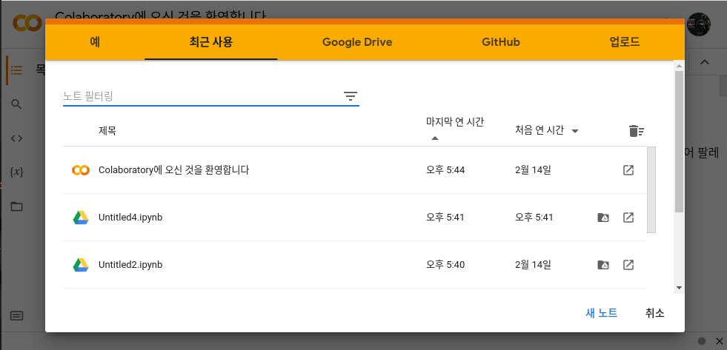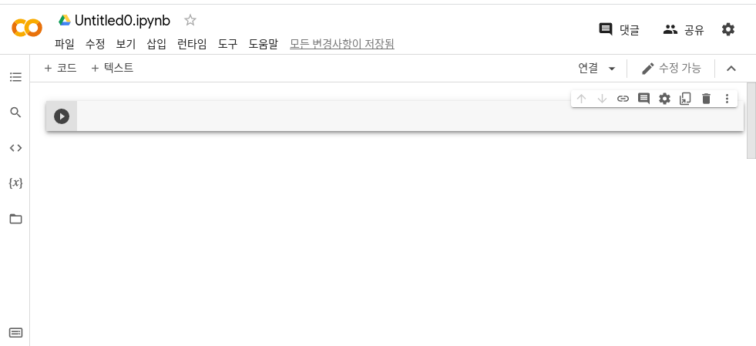

# Add and move cells.

* Cells can be created using the "+ Code" and "+ Text" buttons located in the upper left corner of the Colab Notepad (Note) edit screen, or can be created through a button overlaid when raising the mouse cursor at the top or last of the created cells.
* In addition, cell-related functions such as cell movement and cell setting can be controlled through the cell menu at the upper right of the generated cell.

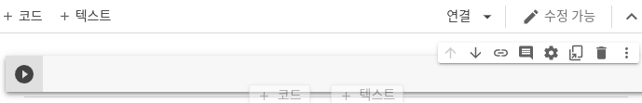 **<Colab Cell Screen>**

# Create and execute Python code.

* In the code type (+ code button, etc.) cell , creating the desired python example code, you can press the left play icon or use Cmd/Ctrl+Enter to execute the code, and you can also use various shortcut keys such as Shift+Enter or Alt+Enter to perform interlocking tasks.

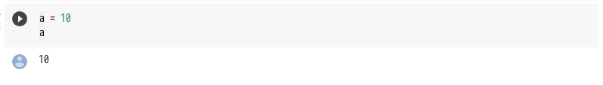<Colab python code execute example>

# Adding external Python library to Colab.

* To add a python library that Colab doesn't provide default,
* You can use !pipe install or !apt=get install.

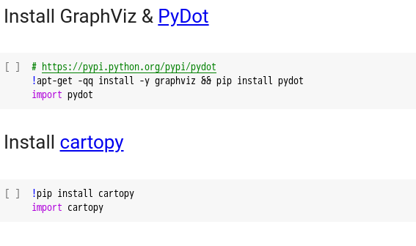<Colab !pip,!apt-get example>

# Using Colab GPU, TPU runtime.

* In order to proceed with GPU and TPU-related tasks in Colab, it is necessary to activate them by changing runtime settings first.
* ‘You can change the hardware accelerator from none to GPU or TPU through Note settings in the upper left modification menu, or you can also change it through the Change Runtime Type option in the Runtime menu.

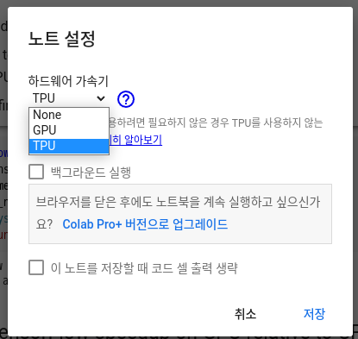**<note setting menu>**

# How to load and store data from an external source in Colab.

* Upload a local file system file.
* Files.upload returns a dictionary of the uploaded file.

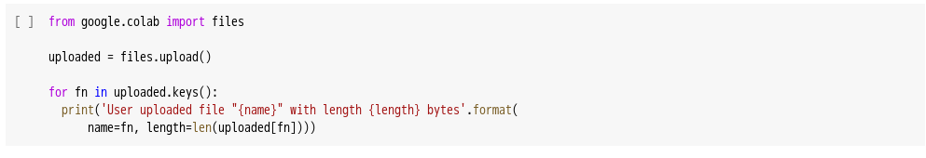

* Download files to the local file system.
* files.download calls the browser download of the file to the local computer.

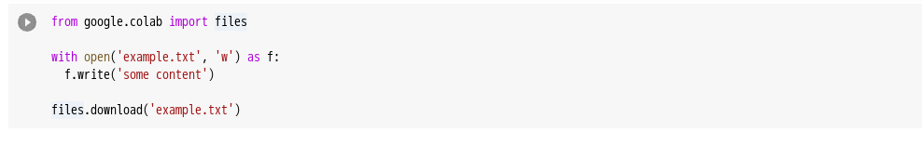

* Google Drive interworking.
* Google Drive can be mounted on the Colab runtime virtual machine. The following example is an example of Google Drive mount and file input/output to Colab.

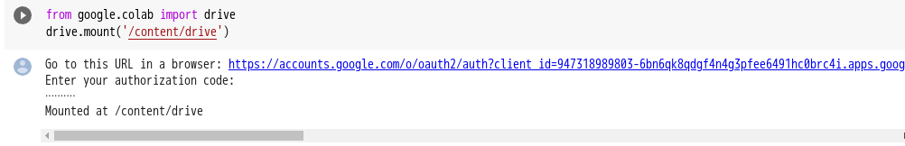

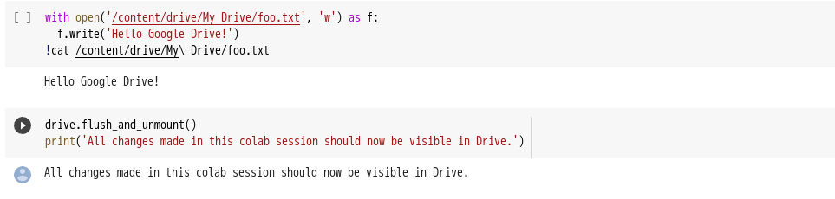**<Goolge Drive mount example>**