long short-term memory(LSTM)

# library link

<https://github.com/pytorch/pytorch/blob/master/torch/nn/modules/rnn.py>

# basic description

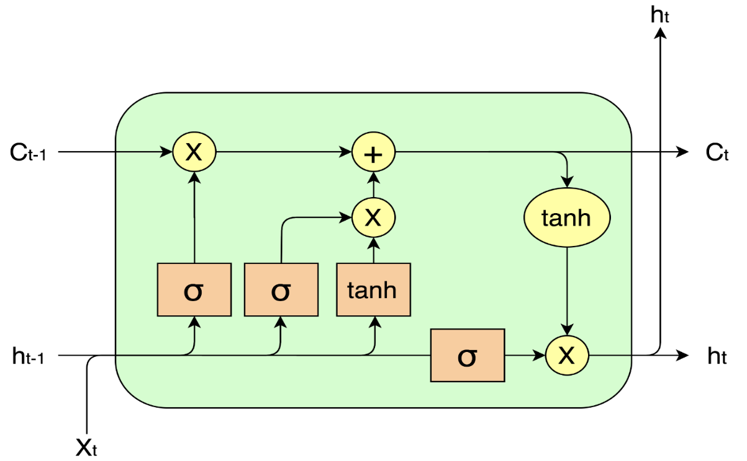

LSTM was explicitly designed to avoid problems with long dependence periods. Remembering information for a long time should be the basic behavior of the model, and the model is designed to learn it.

# version

* Pytorch >= 1.10.1+cu102 (pip install torch)
* Torchtext >= 0.11.1 (pip install torchtext)
* Numpy >= 1.19.4 (pip install numpy)
* Pandas >= 1.0.1 (pip install pandas)
* matplotlib >= 3.1.3 (pip install matplotlib)
* Colab

# dataset

* News dataset containg real and fake contents.
* Download and upload (google drive)

<https://www.kaggle.com/nopdev/real-and-fake-news-dataset>

# code description

* Code that classifies real and fake in the test dataset based on news datasets containg real and fake content.

# validation

* Divide the news dataset into training data and test data
* Train the training data and verify it using a confusion matrix.