bert

# library link

<https://github.com/google-research/bert>

# basic description

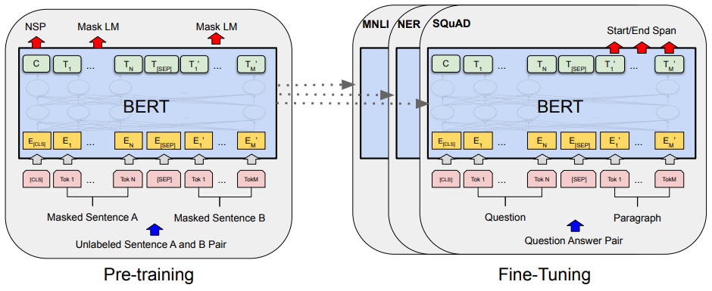

It is a pre-training technology for natural language processing(NLP) developed by Google and is not limited to a specific field, but a general-purpose language model that performs well in all natural language processing fields. In more than 11 natural language processing tasks, BERT is said to have state-of-the-art performance, but the reason is not well known. However, BERT is a language model that is receiving a lot of attention because it performs better than the ensemble model that has been used for natural language processing so far.

# version

* Pytorch >= 1.10.1+cu102 (pip install torch)
* Torchtext >= 0.11.0 (pip install torchtext)
* transformer >= 4.15.0 (pip install transformers)
* colab

# dataset

* IMDB data set

# code description

* code for sentiment analysis using IMDB dataset.

# validation

* test datasets were extracted and verified from existing datasets.