lenet

# library link

we can implement it

# basic description

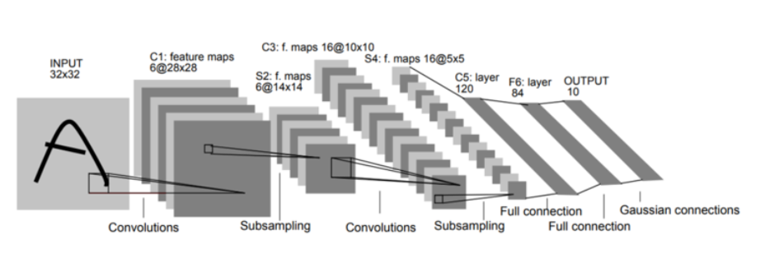

LeNet-5 is a CNN network structure introduced in a 1998 paper by Yann LeCun. LeNet-5 is a model that utilizes convolutional neural networks(CNNs) to overcome the limitations of Multilayer Neural Network, which has been used in handwriting recognition.

# version

* Torch version == 1.10.0+cu111 (pip install torch)
* Torchvision version == 0.11.1+cu111 (pip install torchvision)
* Colab

# dataset

* MNIST handwritten data set.

# code description

* Code to find out the actual number of the MNIST handwritten dataset iamge using LeNet-5.

# validation

After classifying the test data sets, the accuracy is measured.