alexnet

# library link

<https://github.com/pytorch/vision/blob/main/torchvision/models/alexnet.py>

# basic description

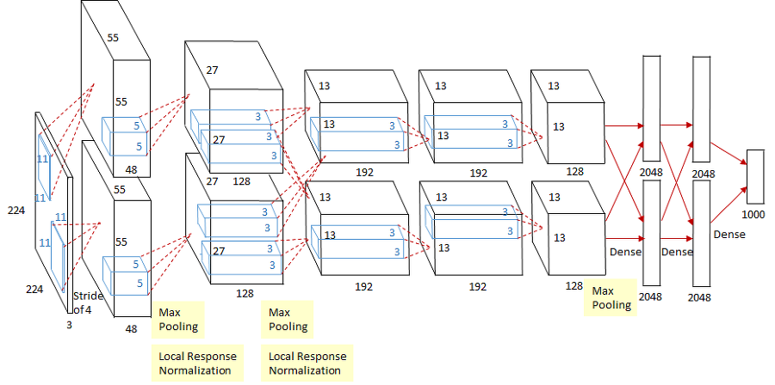

AlexNet is a type of deep learning CNN that won the ILSVRC(ImageNet Large Scale Visual Recreation Challenge) competition in 2012. In fact, LeNet, which is almost similar to AlexNet, was already developed in 1998, but the reason why it stands out in performance now is because of increased hardware performance and GPU parallel processing. What AlexNet done is to refine the concept of LeNet, process parallelism, and change activation functions to speed up computation. The generic term for the model in the paper “ImageNet Classification with Deep Convolutional Neural Networks” is called AlexNet after the paper author Alex Khrizevsky.

# version

* Torch version == 1.10.0+cu111 (pip install torch)
* Torchvision version == 0.11.1+cu111 (pip install torchvision)
* Colab

# dataset

* CIFAR10 data set.

# code description

* Code for classifying each animal after learning AlexNet using the CIFAR10 dataset.

# validation

* After classifying the test data sets, the accuracy is measured.