vggnet

# library link

<https://github.com/pytorch/vision/blob/main/torchvision/models/vgg.py>

we can implement it.

# basic description

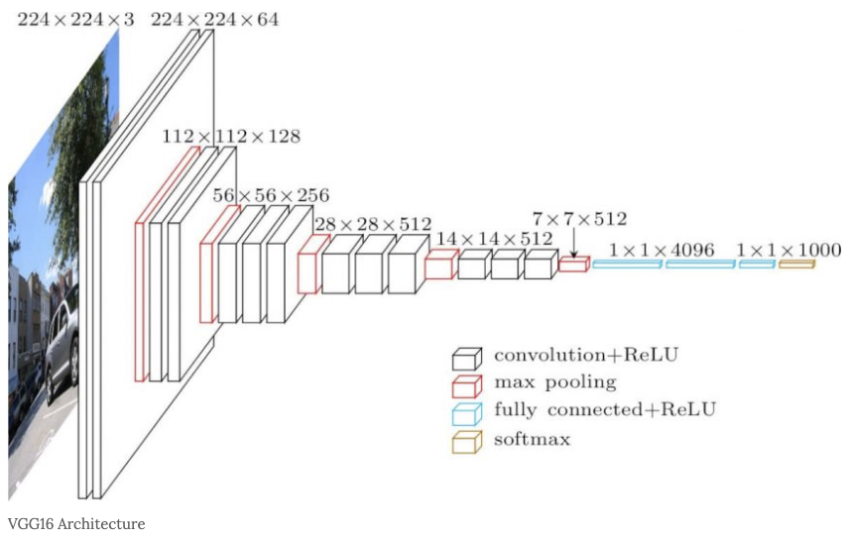

The VGG model succeeded in learning networks more than twice as deep as AlexNet’s 8-layers model, which opened the era of deep learning-based computer vision models, reducing AlexNet’s error rate in ImageNet Challenge by half (16.4 > 7.3). The VGG model was able to learn deep neural networks ranging from 16-19 layers becaused of the use of 3X3 filters in all convolutional layers.

# version

* Torch version == 1.10.0+cu111 (pip install torch)
* Torchvision version == 0.11.1+cu111 (pip install torchvision)
* Colab

# dataset

* STL10 data set.

# code description

* Code for classifying images corresponding to 10 labels after learning vggnet using STL 10 datasets.

# validation

* After classifying the test data sets, the accuracy is measured.