googlenet

# library link

<https://github.com/pytorch/vision/blob/main/torchvision/models/googlenet.py>

we can implement it.

# basic description

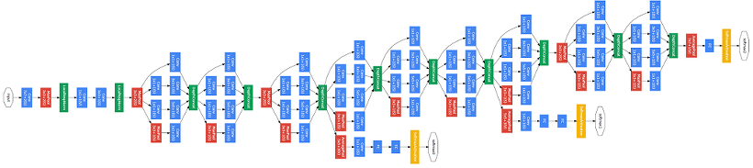

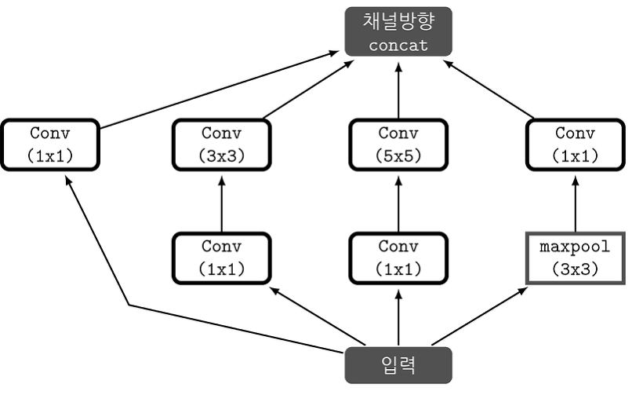

GoogLeNet won first place at the ILSVRC14 (ImageNet Large-Scale Visual Recreation Challenge 2014) held by ImageNet in 2014. Shortly after winning the tournament, he published a paper called Going Deep With Convictions to deal with a study on GoogLeNet named Inception. The Inception Module performed four types of Convolution, Pooling for input values, and combined the four results in the channel direction, which performed well.

# version

* Torch version == 1.10.0+cu111 (pip install torch)
* Torchvision version == 0.11.1+cu111 (pip install torchvision)
* Colab

# dataset

* STL10 data set.

# code description

* Code for classifying images corresponding to 10 labels after learning vggnet using STL 10 datasets.

# validation

* After classifying the test data sets, the accuracy is measured.