auto encoder

# library link

We can implement it.

# basic description

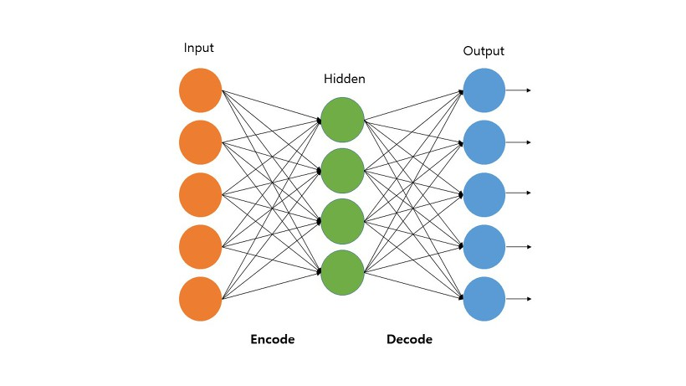

Neural network that learns representation learning or feature learning in the form of unsupervised learning to reduce dimensions.

# version

* Torchvision == 0.11.2 +cu102 (pip install torchvision)
* Torch >= 1.10.1 + cu102 (pip install torch)
* numpy >= 1.19.5 (pip install numpy)
* matplotlib >= 3.2.2 (pip install matplotlib)

# dataset

* FASHION MNIST data set.

# code descriptio

* Code to compare images created using Autoencoder with actual fashion datasets.

# validation

* It is verifed by comparing the image created based on the test dataset with the actual fashion dataset.