Generalized zero-shot learning

# library link

<https://github.com/Hanzy1996/CE-GZSL>

# basic description

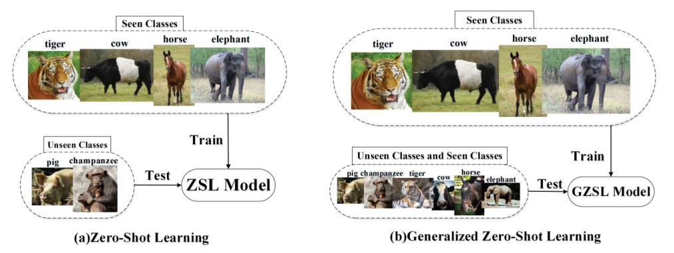

Zero-shot learning is a learning method which uses seen data in training phase and then tested with unseen data. Generalized zero-shot learning is a learning method which uses seen data in training phase and tests both seen and unseen data.

# version

* Python == 3.6
* Pytorch == 1.2.0 (pip install torch)
* sklearn >= 0.22.1 (pip isntall sklearn)

# dataset

* CUB dataset

<https://www.mpi-inf.mpg.de/departments/computer-vision-and-machine-learning/research/zero-shot-learning/zero-shot-learning-the-good-the-bad-and-the-ugly>

# code description

* Download the code from the github.
* After download the datasets and unpack the compressed file, you can put them in the folder: data/
* Change the CE_GZSL.py line 21 from *default*='./data’ to *default*='data/xlsa17/data/'
* Ex) parser.add_argument('--dataroot', *default*='data/xlsa17/xlsa17/data/', *help*='path to dataset')
* Run the file ‘CE_GZSL.py’ in CE-GZSL folder as below:

python CE_GZSL.py --dataset CUB --class_embedding sent --syn_num 100 --batch_size 2048 --attSize 1024 --nz 1024 --embedSize 2048 --outzSize 512 --nhF 2048 --ins_weight 0.001 --cls_weight 0.001 --ins_temp 0.1 --cls_temp 0.1 --manualSeed 3483 --nclass_all 200 --nclass_seen 150

# validation

* x