Software Requirements Specification
for
AI Interview Coach
Comprehensive Interview Preparation Platform

Prepared by
Adwaidh AS (ASI23CA04)
Devadath Viswam (ASI23CA027)
Magnel Olivero (ASI23CA040)
Athul Chandran AK (ASI23CA021)

S5 - MCA
Adi Shankara Institute of Engineering and Technology, Kalady

Field | Details
Project ID | AIIC-2025-001
Document Version | 2.0
Document Date | March 4, 2026
Status | Final Release

Revision History
Date | Revision | Description | Author
February 2026 | 1.0 | Initial SRS document | Development Team
February 28, 2026 | 1.5 | Added API specs and database schema | Development Team
March 4, 2026 | 2.0 | Final comprehensive SRS with all sections | Development Team

Table of Contents

1. Purpose
AI Interview Coach is an intelligent, AI-powered interview preparation platform designed to help candidates master their next job interview. The system combines modern web technologies with advanced AI capabilities to provide personalized interview coaching, realistic practice questions, and intelligent feedback analysis.
The platform enables users to simulate real interview environments by selecting their target job field, experience level, and company. The AI then generates tailored questions and evaluates their answers with detailed, actionable feedback, scores, and improvement suggestions.

1.1 Scope
The AI Interview Coach covers the complete lifecycle of interview preparation:
- User authentication and profile management
- Real-time interview session creation and management
- AI-powered question generation via Mistral 7B language model
- Interactive Q&A session with per-question navigation
- Intelligent answer analysis and scoring (0–100)
- Performance feedback: strengths, improvements, detailed commentary
- User dashboard with analytics and interview history
- Complete data persistence using SQLite with SQLAlchemy ORM

1.2 Definitions, Acronyms, Abbreviations

1.2.1 Definitions
- Interview Session: A single end-to-end mock interview with 5 AI-generated questions.
- Answer Analysis: The process by which Mistral 7B evaluates a user answer and returns score, strengths, and improvement points.
- JWT: JSON Web Token — a stateless, digitally signed token used for user authentication.
- PBKDF2: Password-Based Key Derivation Function 2 — the algorithm used for secure password hashing via Werkzeug.
- ORM: Object-Relational Mapping — SQLAlchemy abstraction layer over the SQLite database.
- UUID: Universally Unique Identifier — used as primary keys for interview sessions and questions.
- REST: Representational State Transfer — the architectural style used for the API.

1.2.2 Acronyms
Acronym | Full Form
AI | Artificial Intelligence
JWT | JSON Web Token
UUID | Universally Unique Identifier
ORM | Object-Relational Mapping
PBKDF2 | Password-Based Key Derivation Function 2
REST | Representational State Transfer
CORS | Cross-Origin Resource Sharing
WCAG | Web Content Accessibility Guidelines
ACID | Atomicity, Consistency, Isolation, Durability
LLM | Large Language Model
API | Application Programming Interface

1.3 References
- Flask Documentation — https://flask.palletsprojects.com/
- SQLAlchemy ORM Guide — https://docs.sqlalchemy.org/
- JWT RFC 7519 — https://tools.ietf.org/html/rfc7519
- OWASP Security Guidelines — https://owasp.org/
- WCAG 2.1 Standards — https://www.w3.org/WAI/WCAG21/
- Mistral AI Documentation — https://docs.mistral.ai/
- REST API Best Practices — https://www.restapitutorial.com/

1.4 Overview
This document describes the Software Requirements Specification for the AI Interview Coach platform. Section 2 covers the overall system description including architecture and feature overview. Section 3 details specific functional requirements. Section 4 addresses non-functional requirements. Section 5 presents the database design. Section 6 provides the full system architecture with diagrams. Sections 7–9 cover UI specifications, API endpoints, and use cases. Section 10 concludes with qualification provisions.

2. Overall Description

2.1 Product Perspective
AI Interview Coach is a standalone web application built on a client-server architecture. The frontend consists of HTML5/CSS3/Vanilla JavaScript pages served by the Flask backend. The backend exposes a RESTful API that handles authentication, interview session management, and integration with the Mistral 7B large language model for question generation and answer evaluation. All data is persisted in a SQLite database managed via SQLAlchemy.

The complete processing pipeline for an interview session is as follows:
- User registers and authenticates via JWT token.
- User configures an interview session (field, level, company).
- Backend creates an interview record and calls Mistral 7B to generate 5 questions.
- Questions are stored in the database linked to the interview UUID.
- User answers each question; backend sends answer + context to Mistral 7B for analysis.
- AI returns score (0–100), strengths, improvements, and detailed feedback.
- All answers and feedback are persisted; session is marked completed with overall score.

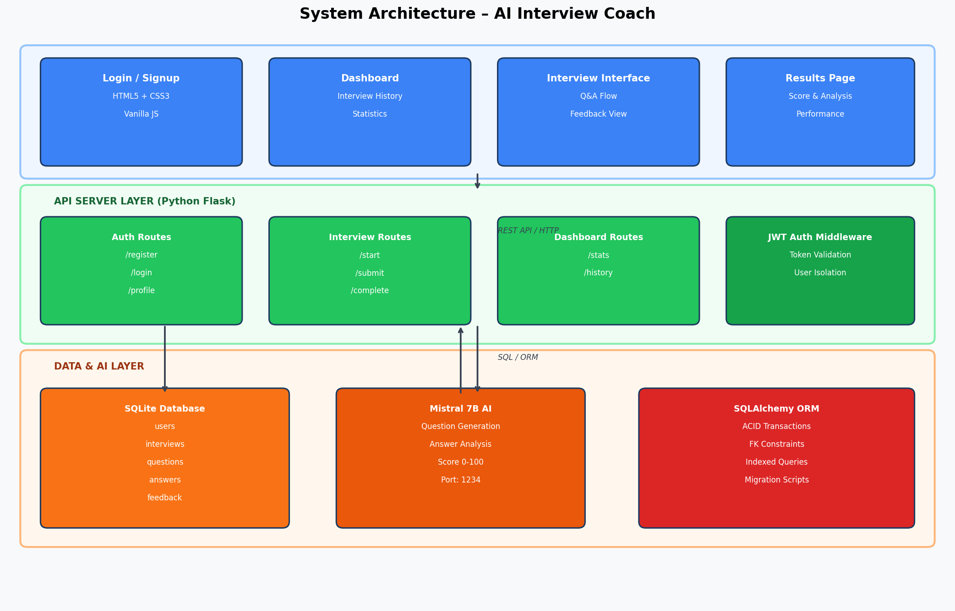
Figure: System Architecture Diagram — AI Interview Coach

2.2 Product Architecture
The system is organized into three primary layers:
- Client Layer: Browser-based frontend using HTML5, CSS3, and Vanilla JavaScript. Pages include Login, Signup, Dashboard, and Interview Interface. All communication is via Fetch API calls to the REST backend.
- API Server Layer: Python Flask application that implements authentication routes, interview management routes, and dashboard/analytics routes. Business logic includes JWT authentication middleware, AI integration, and data validation.
- Data & AI Layer: SQLite database with SQLAlchemy ORM for ACID-compliant data storage. Mistral 7B Instruct v0.2 runs locally via LM Studio on port 1234 and handles both question generation and answer analysis.

2.3 Product Functionality / Features
The system is divided into the following major functional areas:
Feature Area | Description
User Authentication | Registration, login, JWT token management, password hashing
Profile & Dashboard | User statistics, interview history, performance metrics
Interview Session | Session creation with configurable parameters (field/level/company)
AI Question Generation | 5 personalized questions generated by Mistral 7B per session
Answer Analysis | AI scoring (0-100), strengths, improvements, detailed feedback
Results & Analytics | Per-session results with full Q&A history and overall performance
Data Persistence | SQLite with relational schema across users, interviews, Q&A, feedback

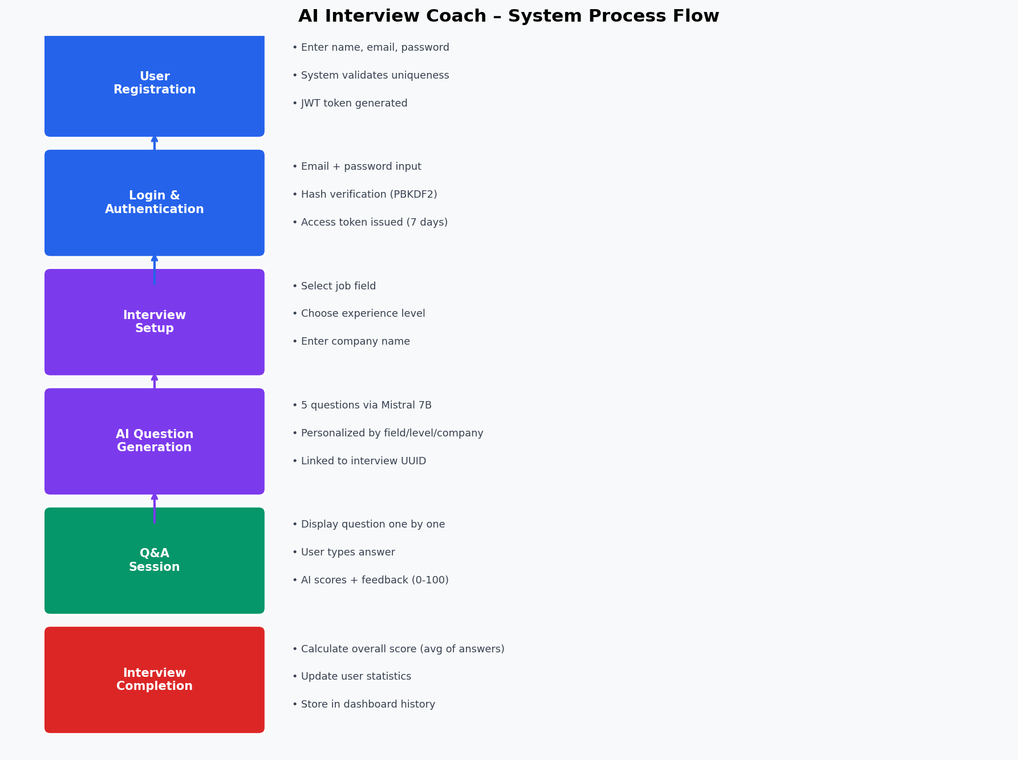
Figure: System Process Flow Diagram

2.4 User Characteristics

Admin / Registered User
- Can register an account with email and password.
- Can log in and receive a JWT access token.
- Can start a new interview session with custom parameters.
- Can view interview history and performance statistics on the dashboard.
- Can review detailed results including per-question feedback.
- Cannot access other users' data (strict user isolation via JWT).

2.5 Constraints
- AI Dependency: Question generation and answer analysis require Mistral 7B to be running. The system falls back to pre-generated questions if the AI service is unavailable.
- Network: The AI service runs locally on port 1234 (LM Studio). Production deployment requires cloud-hosted AI or an alternative inference server.
- Database: SQLite is suitable for development and moderate production loads. High-concurrency production environments should migrate to PostgreSQL.
- Authentication: JWT tokens are stored in browser localStorage. Production environments should enforce HTTPS and consider httpOnly cookies.
- Answer Quality: AI analysis quality depends on answer length and coherence. Very short or incoherent answers may receive generic feedback.

2.6 Assumptions and Dependencies
- The Mistral 7B model is assumed to be running and accessible at http://127.0.0.1:1234/v1 during development.
- AI question generation is assumed to complete within 3 seconds per question.
- AI answer analysis is assumed to complete within 2 seconds per submission.
- The system assumes Python 3.8+ and Flask 2.x as the backend runtime.
- The frontend assumes a modern browser with ES6+ support and Fetch API availability.
- Password minimum length of 8 characters is enforced; no restrictions on character types.

3. Specific Requirements

3.1 Functional Requirements

FR-3.1 Authentication & User Management
User Registration (POST /api/auth/register)
- Input: firstName, lastName, email (unique), password (min 8 chars). All fields mandatory.
- Output: JWT access token, user ID, name fields.
- Error handling: HTTP 409 for duplicate email, HTTP 400 for invalid input.

User Login (POST /api/auth/login)
- Input: Registered email and matching password.
- Output: JWT access token with 7-day expiration.
- Error handling: HTTP 401 for invalid credentials.

Profile Retrieval (GET /api/user/profile)
- Requires valid JWT Bearer token.
- Returns: user ID, name, email, total interviews, average score.
- Strict user isolation — users can only access their own profile.

FR-3.2 Interview Session Management
Interview Creation (POST /api/interview/start)
- Input: job field, experience level (Junior/Mid/Senior), company name.
- Process: Validate auth → generate UUID → create Interview record → generate 5 questions via Mistral 7B → link questions to interview_id.
- Output: Interview UUID and first question object.

Answer Submission (POST /api/interview/{uuid}/submit)
- Input: question_id, answer_text.
- Validation: question must exist and belong to the current interview.
- Process: Send answer + context to Mistral 7B → receive score/strengths/improvements/feedback → INSERT Answer + INSERT Feedback → increment questions_answered.
- Output: Score, feedback object, next question (if any).

Interview Completion (POST /api/interview/{uuid}/complete)
- Marks interview status as "completed", calculates overall_score (average of all answer scores).
- Updates user statistics (total_interviews, average_score).
- Output: Complete results JSON with all Q&A interactions.

FR-3.3 Dashboard & Analytics
- GET /api/dashboard/stats — Returns user statistics and recent interview history.
- Metrics: total interviews, average score, best/worst score, interviews in past 30 days.
- Recent interviews list sortable by date (descending), paginated.

3.2 External Interface Requirements
- Modern web browser (Chrome 90+, Firefox 88+, Edge 90+, Safari 14+).
- HTTP/HTTPS connectivity between browser and Flask backend (port 5000).
- Internal HTTP connectivity between Flask and Mistral 7B (port 1234).
- Minimum screen resolution: 360px width (mobile-first responsive design).

3.3 Internal Interface Requirements
- Python Flask 2.x with Flask-JWT-Extended for authentication middleware.
- SQLAlchemy ORM for all database operations (no raw SQL in application code).
- OpenAI-compatible Python client for Mistral 7B API calls.
- Flask-CORS for cross-origin request handling between frontend and backend.

3.4 Internal Data Requirements
- All user passwords stored as PBKDF2 hashes — never as plaintext.
- Interview sessions identified by UUID (not auto-increment ID).
- All questions linked to their interview via interview_id foreign key.
- AI feedback stored as structured JSON (strengths, improvements arrays).
- Timestamps stored in ISO 8601 format with UTC timezone.

3.5 Design and Implementation Constraints
- Single-file frontend artifacts (HTML, CSS, JS) for simplicity and portability.
- Expected overall AI scoring accuracy: context-appropriate feedback for 95%+ of valid answers.
- All database operations must use ACID-compliant transactions.
- API must return standardized error responses with HTTP status codes, error codes, and messages.

3.6 Other Requirements
- Interview sessions must be isolated — questions from one session cannot appear in another.
- A fallback question bank must be available if Mistral 7B is unreachable.
- The system must support at least 100 concurrent users in production.

4. Non-Functional Requirements

4.1 Safety Requirements
- All user-submitted data must be validated and sanitized before processing.
- Database operations must be wrapped in transactions to prevent partial writes.
- AI analysis failures must degrade gracefully — the session must not crash if Mistral 7B returns an error.
- System must log all errors and exceptions with sufficient context for debugging.

4.2 Security and Privacy Requirements
- JWT tokens: HS256 signature, 7-day expiration, string-based user identity.
- Passwords: PBKDF2 hashing via Werkzeug; salt auto-generated and stored.
- SQL injection: Prevented via SQLAlchemy ORM parameter binding.
- CORS: Configured to allow only the frontend origin in production.
- HTTPS: Enforced in production; all API calls must use TLS 1.2+.
- User isolation: All data queries filtered by authenticated user ID.
- Interview data: Deleted on user account deletion via ON DELETE CASCADE.

4.3 Environmental Requirements
- Operating System: Windows 10/11 (development), Linux (production).
- Python: Version 3.8 or later.
- Browser: Modern browsers with ES6+ and Fetch API support.
- AI Service: Mistral 7B Instruct v0.2 via LM Studio on port 1234.

4.4 Computer Resource Requirements

4.4.1 Computer Hardware Requirements
Component | Minimum Specification
RAM | 16 GB (for running Mistral 7B locally)
Storage | 20 GB free (AI model ~4GB, database, logs)
CPU | Intel i5 8th Gen or AMD Ryzen 5 3000 series
GPU | NVIDIA GTX 1660 or better (for AI inference)
Network | Local loopback for AI service (port 1234)
Monitor | 1280 x 720 minimum resolution

4.4.2 Computer Hardware Resource Utilization
- RAM: ~8GB for Mistral 7B + ~256MB for Flask + SQLite.
- CPU: Moderate load during question generation and answer analysis.
- Disk I/O: Minimal — SQLite reads/writes for session data.
- GPU VRAM: ~6GB for Mistral 7B inference (quantized 4-bit model).

4.4.3 Computer Software Requirements
Software | Version / Notes
Python | 3.8+
Flask | 2.x
Flask-JWT-Extended | Latest stable
Flask-SQLAlchemy | Latest stable
Flask-CORS | Latest stable
Werkzeug | Latest stable (password hashing)
SQLite | Built-in with Python
LM Studio | For running Mistral 7B locally
Node.js | Optional — for build/tooling

4.4.4 Computer Communication Requirements
- Frontend ↔ Backend: HTTP REST API on port 5000.
- Backend ↔ AI Service: HTTP OpenAI-compatible API on port 1234 (loopback).
- No external third-party API calls — all processing is local.
- CORS headers configured for frontend domain.

4.5 Software Quality Factors
Quality Factor | Target / Description
Performance | API response < 500ms; AI analysis < 2s; page load < 2s
Reliability | 99.5% uptime; graceful AI fallback; ACID transactions
Security | JWT auth; PBKDF2 passwords; ORM SQL injection prevention
Usability | WCAG 2.1 Level A; responsive design; intuitive navigation
Maintainability | Modular code; rotating logs; env-based config management
Scalability | Support 100+ concurrent users; 100,000+ interview records
Accuracy | Context-appropriate AI feedback for 95%+ of valid answers

4.6 Packaging Requirements
- Python dependencies listed in backend/requirements.txt.
- Application deployable via Gunicorn (production WSGI server).
- Docker containerization supported (Dockerfile provided).
- Environment variables managed via .env file (never committed to version control).

4.7 Precedence and Criticality of Requirements
Priority | Requirement
Critical | User authentication and JWT security
Critical | Interview session creation and question generation
Critical | Answer submission and AI feedback pipeline
High | Database persistence and ACID compliance
High | Dashboard statistics and interview history
Medium | Responsive UI and accessibility features
Low | Download results (future), refresh token (future)

5. Database Design and Structure

5.1 Entity Relationship Diagram
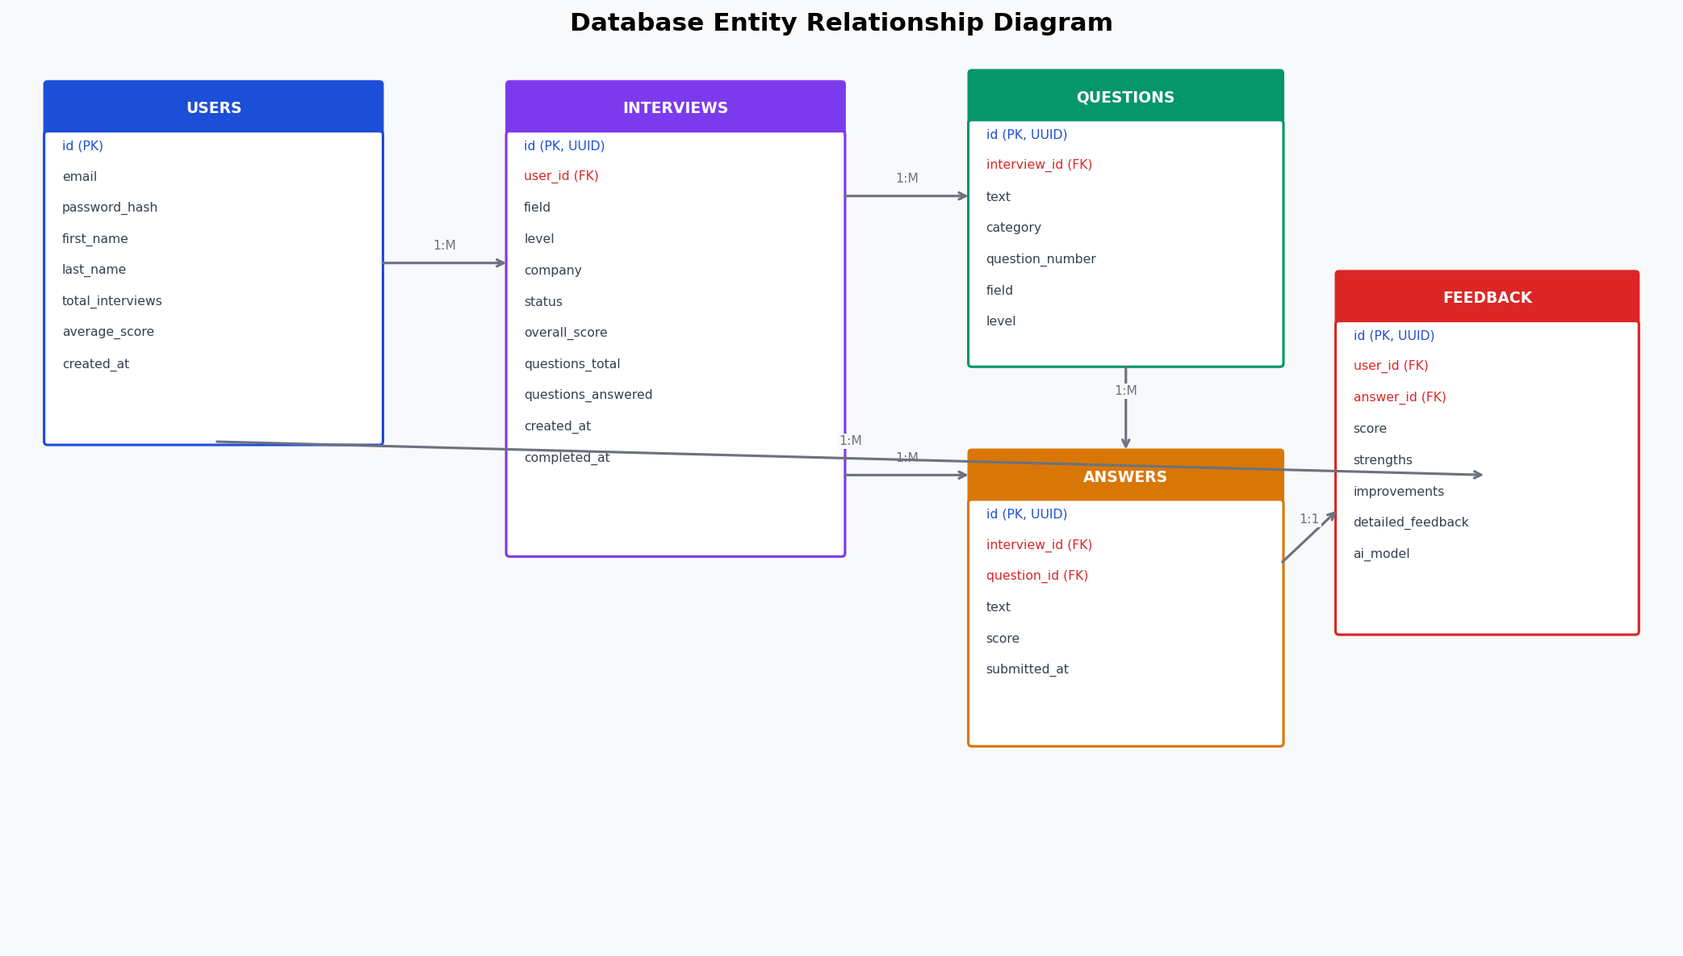
Figure: Entity Relationship Diagram — AI Interview Coach Database

5.2 Database Schema

Table: users
Stores user account information and aggregated statistics.
Column | Type / Constraint
id | INTEGER PRIMARY KEY AUTOINCREMENT
email | VARCHAR(255) UNIQUE NOT NULL
password_hash | VARCHAR(255) NOT NULL — PBKDF2 hash
first_name | VARCHAR(100) NOT NULL
last_name | VARCHAR(100) NOT NULL
total_interviews | INTEGER DEFAULT 0
average_score | DECIMAL(5,2) DEFAULT 0
created_at | TIMESTAMP DEFAULT CURRENT_TIMESTAMP
updated_at | TIMESTAMP DEFAULT CURRENT_TIMESTAMP

Table: interviews
Stores individual interview session data.
Column | Type / Constraint
id | VARCHAR(36) PRIMARY KEY — UUID
user_id | INTEGER NOT NULL — FK → users(id) ON DELETE CASCADE
field | VARCHAR(100) — job field (e.g., Software Engineer)
level | VARCHAR(50) — Junior / Mid / Senior
company | VARCHAR(100) — target company
status | VARCHAR(20) DEFAULT 'active' — active/completed/abandoned
overall_score | DECIMAL(5,2) — average of all answer scores
questions_total | INTEGER DEFAULT 5
questions_answered | INTEGER DEFAULT 0
created_at | TIMESTAMP DEFAULT CURRENT_TIMESTAMP
completed_at | TIMESTAMP

Table: questions
Stores AI-generated questions linked to specific sessions.
Column | Type / Constraint
id | VARCHAR(36) PRIMARY KEY — UUID
interview_id | VARCHAR(36) NOT NULL — FK → interviews(id) [CRITICAL]
text | TEXT NOT NULL — question text
field | VARCHAR(100) — job field context
level | VARCHAR(50) — experience level context
company | VARCHAR(100) — company context
question_number | INTEGER — sequence 1–5
category | VARCHAR(50) — behavioral/technical/situational
created_at | TIMESTAMP DEFAULT CURRENT_TIMESTAMP

Table: answers
Column | Type / Constraint
id | VARCHAR(36) PRIMARY KEY — UUID
interview_id | VARCHAR(36) NOT NULL — FK → interviews(id)
question_id | VARCHAR(36) NOT NULL — FK → questions(id)
text | TEXT NOT NULL — user answer
score | DECIMAL(5,2) — AI-generated 0–100
submitted_at | TIMESTAMP DEFAULT CURRENT_TIMESTAMP

Table: feedback
Column | Type / Constraint
id | VARCHAR(36) PRIMARY KEY — UUID
user_id | INTEGER NOT NULL — FK → users(id)
answer_id | VARCHAR(36) NOT NULL — FK → answers(id)
score | DECIMAL(5,2) — analysis score 0–100
strengths | JSON — array of strength strings
improvements | JSON — array of improvement strings
detailed_feedback | TEXT — full feedback paragraph
ai_model | VARCHAR(100) DEFAULT 'mistral-7b'
created_at | TIMESTAMP DEFAULT CURRENT_TIMESTAMP

5.3 Relationships
- users (1) → (M) interviews — One user has many interview sessions.
- interviews (1) → (M) questions — One session has exactly 5 questions.
- interviews (1) → (M) answers — One session has up to 5 answers.
- questions (1) → (M) answers — One question has answers within the same interview.
- answers (1) → (1) feedback — Each answer has one AI feedback record.
- users (1) → (M) feedback — Users are linked to all feedback across sessions.

6. System Architecture

6.1 Component Overview
The AI Interview Coach follows a three-tier client-server architecture. The presentation tier consists of browser-based HTML/CSS/JS pages. The application tier is a Python Flask REST API with JWT middleware and AI integration. The data tier combines SQLite (persistent storage) and Mistral 7B (AI inference).

6.2 Sequence Diagram — Interview Session
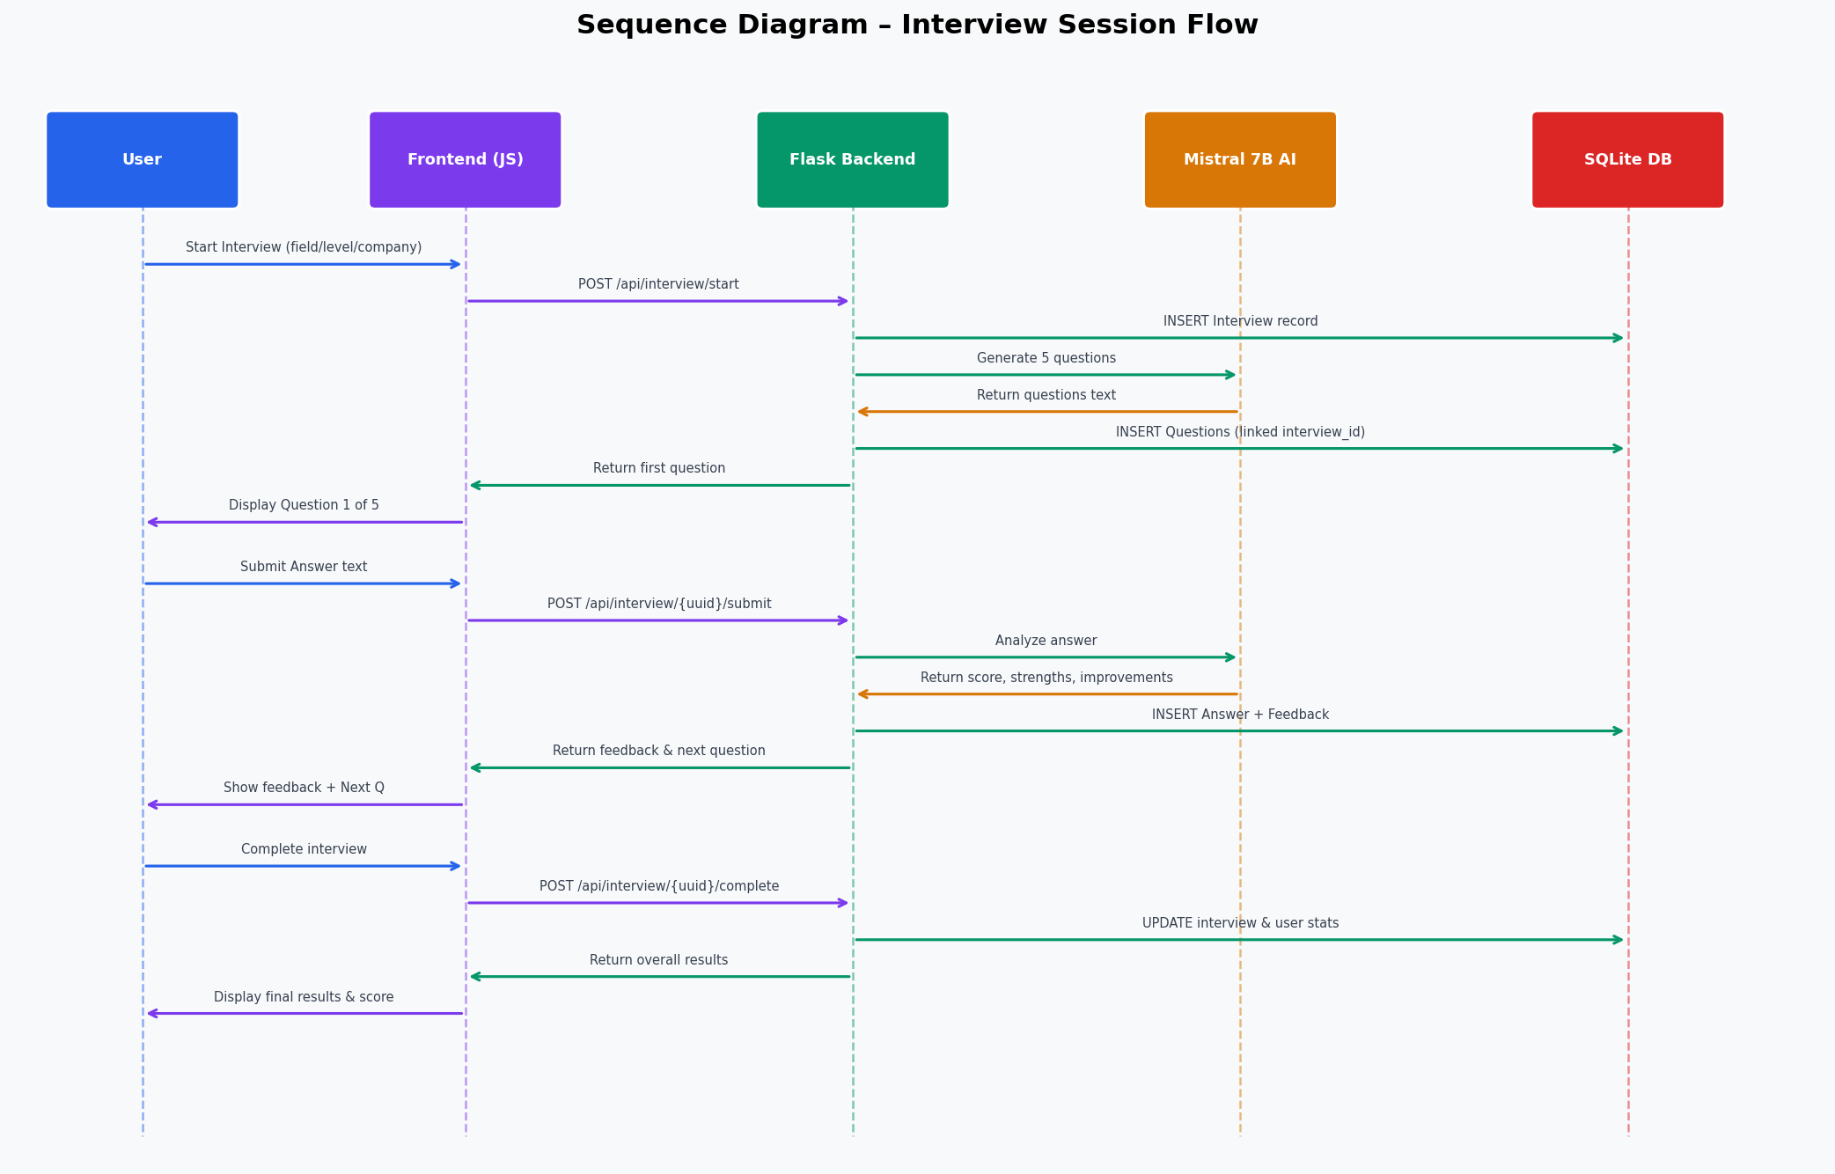
Figure: Sequence Diagram — Interview Session Creation and Q&A Flow

6.3 Use Case Diagram
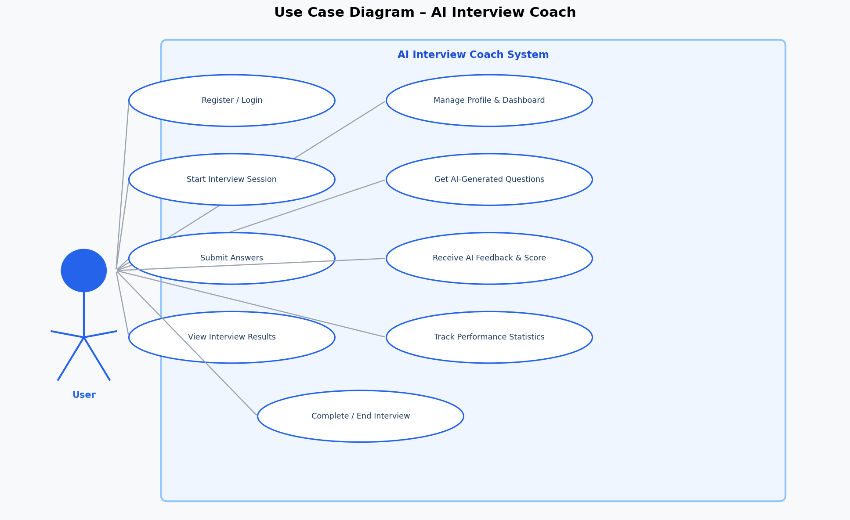
Figure: Use Case Diagram — AI Interview Coach

6.4 Technology Stack
Component | Technology
Frontend | Vanilla JavaScript, HTML5, CSS3
Backend | Python Flask 2.x
Database | SQLite3 with SQLAlchemy ORM
Authentication | Flask-JWT-Extended (JWT HS256)
Password Security | Werkzeug PBKDF2
AI Model | Mistral 7B Instruct v0.2 via LM Studio
AI Client | OpenAI-compatible Python client
CORS | Flask-CORS
Logging | Python RotatingFileHandler
Deployment | Gunicorn / Docker

6.5 Deployment Environment

Development
- OS: Windows 10/11 or Linux
- Python 3.8+, Flask backend on port 5000
- Mistral 7B via LM Studio on port 1234
- SQLite database: interview_coach.db

Production
- Scalable to cloud deployments (AWS, Azure, GCP, Heroku)
- Docker containerization supported
- Gunicorn WSGI server with 4+ workers
- Environment-based configuration via .env

7. User Interface Specifications

7.1 Pages and Components
Page | Purpose & Key Elements
index.html (Landing) | Hero section, feature highlights, Login/Signup CTAs, particle background
login.html | Email + password form, JWT token storage, redirect to dashboard on success
signup.html | Registration form (name, email, password, confirm), real-time validation
dashboard.html | Welcome message, stats cards (total interviews, avg score), history table, Start Interview button
Interview Interface | Question display, answer text area, progress indicator, feedback view, completion screen

7.2 Color Scheme
Color Role | Hex Code
Primary Blue | #2563EB
Secondary Purple | #7C3AED
Success Green | #10B981
Warning Orange | #F59E0B
Error Red | #EF4444
Neutral Gray | #6B7280

7.3 Responsive Breakpoints
- Mobile: < 640px — single-column layout, stacked cards.
- Tablet: 640px–1024px — two-column dashboard, condensed navigation.
- Desktop: > 1024px — full layout with sidebar statistics.

7.4 Accessibility Features
- WCAG 2.1 Level A compliance.
- Semantic HTML5 structure (main, nav, article, section).
- ARIA labels for all interactive elements.
- Keyboard navigation support — full tab order.
- Color contrast ratios ≥ 4.5:1 for all text.
- Focus indicators on all interactive elements.

8. API Endpoint Specifications

8.1 Authentication Endpoints
Endpoint | Method | Auth Required | Description
POST /api/auth/register | POST | No | Register new user, returns JWT token
POST /api/auth/login | POST | No | Authenticate user, returns JWT token
GET /api/user/profile | GET | JWT | Retrieve user profile and statistics

8.2 Interview Management Endpoints
Endpoint | Method | Description
POST /api/interview/start | POST | Create session, generate 5 AI questions
GET /api/interview/{uuid}/questions | GET | Retrieve all questions for a session
POST /api/interview/{uuid}/submit | POST | Submit answer, receive AI analysis
POST /api/interview/{uuid}/complete | POST | Finalize session, calculate overall score
GET /api/interview/{uuid}/results | GET | Retrieve complete Q&A + feedback results

8.3 Dashboard Endpoints
Endpoint | Description
GET /api/dashboard/stats | User statistics: totals, averages, recent interview history

8.4 HTTP Status Code Reference
Code | Meaning | Usage
200 | OK | Successful GET/PUT
201 | Created | Successful POST (resource created)
400 | Bad Request | Invalid input or missing fields
401 | Unauthorized | Missing or invalid JWT token
403 | Forbidden | User lacks permission (not interview owner)
404 | Not Found | Resource not found
409 | Conflict | Duplicate resource (email already registered)
500 | Server Error | Backend/database/AI service error

9. Use Cases and Workflows

9.1 UC-1: User Registration
Field | Detail
Actor | Prospective User
Precondition | User is not yet registered
Main Flow | 1. Navigate to signup.html  2. Enter name, email, password  3. System validates fields  4. System checks email uniqueness  5. Password hashed (PBKDF2)  6. User record created  7. JWT token generated and returned  8. Redirect to dashboard
Postcondition | Account created; user authenticated
Alternate Flows | A1: Duplicate email → HTTP 409 error  A2: Invalid email → validation message  A3: Password < 8 chars → requirement message

9.2 UC-2: Start Interview Session
Field | Detail
Actor | Authenticated User
Precondition | User logged in, on dashboard
Main Flow | 1. Click "Start New Interview"  2. Enter field, level, company  3. System creates Interview record (UUID)  4. System calls Mistral 7B for 5 questions  5. Questions stored with interview_id FK  6. First question returned and displayed
Postcondition | Session active; Question 1 of 5 displayed
Alternate Flows | A1: AI unavailable → fallback pre-generated questions  A2: Missing parameter → HTTP 400 validation error

9.3 UC-3: Answer Interview Question
Field | Detail
Actor | User in active interview session
Precondition | Interview active, question displayed
Main Flow | 1. Type answer in text area  2. Click Submit  3. Validate question belongs to interview  4. Send to Mistral 7B for analysis  5. AI returns score, strengths, improvements  6. Store Answer + Feedback records  7. Display feedback and next question button
Postcondition | Answer analyzed; feedback displayed; ready for next question
Alternate Flows | A1: Empty answer → display validation message  A2: AI error → default feedback, error flag stored

9.4 UC-4: View Interview Results
Field | Detail
Actor | Authenticated User (interview owner)
Precondition | Interview status = "completed"
Main Flow | 1. Click "View Results" on dashboard  2. GET /api/interview/{uuid}/results  3. System retrieves all Q&A + feedback  4. Display overall score, per-question breakdown  5. Show strengths, improvements, detailed feedback
Postcondition | Full results displayed; performance analysis shown
Alternate Flows | A1: Not interview owner → HTTP 403 Forbidden  A2: Interview not found → HTTP 404

10. Security and Compliance

10.1 Authentication Security
- JWT token format: HS256 signature with 7-day expiration.
- Token stored in browser localStorage; production should use httpOnly cookies.
- JWT validation performed on every protected endpoint via Flask-JWT-Extended.
- Multi-session support: users can log in from multiple browsers simultaneously.

10.2 Data Protection
- HTTPS enforced in production (TLS 1.2 minimum).
- SQL injection prevented via SQLAlchemy ORM parameterized queries.
- Input validation on all API endpoints (email format, UUID format, field enums).
- CORS restricted to frontend domain only in production.
- Sensitive data: only email and password_hash stored; no payment or PII beyond name/email.

10.3 GDPR Considerations (Future)
- User consent mechanism for data collection.
- Data export functionality (GDPR Article 20 portability).
- Data deletion functionality (GDPR Article 17 right to erasure).
- Privacy policy documentation required before production launch.

10.4 Audit and Logging
- All user registrations, logins, interview creations, and errors logged.
- Rotating log files: 10MB max per file, 10 backup files retained.
- Log location: logs/app_fixed.log.
- Log format: ISO 8601 timestamp, event type, user ID, request details.

5. Qualification Provisions
The following table defines the qualification test plan for the AI Interview Coach system, specifying each function, its description, and the corresponding test cases.

Function | Description | Test Plan
User Registration | New user creates account with email and password. | 1) Valid input → HTTP 201, JWT token returned.  2) Duplicate email → HTTP 409 Conflict.  3) Password < 8 chars → HTTP 400 validation error.  4) Missing field → HTTP 400 error.
User Login | Existing user authenticates with email and password. | 1) Valid credentials → HTTP 200, JWT token returned.  2) Wrong password → HTTP 401 Unauthorized.  3) Unknown email → HTTP 401 Unauthorized.  4) Missing fields → HTTP 400 Bad Request.
Interview Session Creation | Authenticated user starts a new interview session. | 1) Valid params → Interview UUID + first question returned.  2) Missing field/level → HTTP 400 error.  3) AI unavailable → fallback questions returned.  4) Invalid JWT → HTTP 401 Unauthorized.
AI Question Generation | System generates 5 personalized questions via Mistral 7B. | 1) Questions generated and linked to interview_id.  2) Each question has unique question_number (1–5).  3) Questions context-appropriate for field/level/company.  4) If AI fails → pre-generated fallback used.
Answer Submission | User submits answer; AI returns analysis. | 1) Valid answer → score 0-100, strengths, improvements returned.  2) Empty answer → HTTP 400 Bad Request.  3) Question from different interview → HTTP 400 validation error.  4) AI error → graceful degradation, default feedback stored.
Interview Completion | User ends interview; system calculates final score. | 1) All 5 answers → overall_score = avg of answer scores.  2) Partial answers → overall_score = avg of answered only.  3) Status updated to "completed".  4) User statistics (total_interviews, average_score) updated.
View Results | User retrieves complete Q&A + feedback results. | 1) Valid owner + completed interview → full results JSON.  2) Different user accessing interview → HTTP 403 Forbidden.  3) Non-existent interview UUID → HTTP 404 Not Found.  4) Active (not completed) interview → partial results.
Dashboard Statistics | User views performance stats and interview history. | 1) Logged-in user → total_interviews, average_score, best/worst scores.  2) No interviews yet → zeros returned, empty history list.  3) Pagination: limit/offset params respected.  4) Invalid JWT → HTTP 401 Unauthorized.

All test cases must pass without error in the development environment before the system is released to production. Integration tests must cover the complete end-to-end flow: registration → login → start interview → submit all answers → complete → view results → verify dashboard statistics.

