AI-Based Analysis and Prediction of El Niño Impact on Indian Monsoon, Agriculture and Water Resources

Abstract
El Niño and La Niña events significantly influence Indian monsoon variability.
This project analyzes ENSO patterns, rainfall, temperature, agriculture and water
resource datasets using exploratory data analysis and machine learning techniques.
The aim is to understand climate impacts and develop predictive insights.

1. Introduction
Indian agriculture and water resources are highly dependent on monsoon rainfall.
ENSO (El Niño Southern Oscillation) causes variations in global climate patterns,
affecting rainfall distribution across India.

2. Objectives
1. Analyze the relationship between ENSO and Indian monsoon rainfall.
2. Predict rainfall using machine learning models.
3. Study agricultural impact due to rainfall variability.
4. Analyze reservoir conditions and water availability.
5. Provide climate adaptation recommendations.

3. Dataset Description
Datasets used:
• ENSO ONI Dataset - Climate indicator
• Indian Rainfall Dataset - Monsoon analysis
• Temperature Dataset - Climate trends
• Agriculture Dataset - Crop production analysis
• Water Resource Dataset - Reservoir analysis

4. Methodology
Data Collection
↓
Data Cleaning
↓
Exploratory Data Analysis
↓
Feature Engineering
↓
Machine Learning Models
↓
Impact Analysis
↓
Recommendations

5. Exploratory Data Analysis
EDA was performed using correlation analysis, rainfall trends,
ONI-rainfall relationship analysis and ENSO phase comparison.

6. Machine Learning Model
Machine learning models were developed to predict monsoon rainfall.
Linear Regression and Random Forest algorithms were evaluated using:
MAE, RMSE and R² score.

7. Results and Discussion
The analysis showed that ENSO phases influence Indian monsoon rainfall.
El Niño years generally showed lower rainfall compared to La Niña years.

8. Agriculture Impact Analysis
Agricultural production and yield trends were analyzed to understand
the effect of climate variability on crop outcomes.

9. Water Resource Impact Analysis
Reservoir storage levels were analyzed across different river basins
to understand water availability conditions.

10. Recommendations
• AI-based climate early warning systems
• ENSO-based crop planning
• Improved reservoir management
• Drought preparedness strategies

11. Conclusion
This project demonstrates how artificial intelligence and climate datasets
can be used to analyze El Niño impacts on rainfall, agriculture and water resources.

Machine Learning Model Comparison
Two machine learning models were evaluated for predicting rainfall departure using Oceanic Niño Index (ONI) and average temperature as predictor variables.
Linear Regression achieved an R² score of 0.277, while Random Forest Regression achieved an R² score of -0.025.
The results indicate that Linear Regression outperformed Random Forest Regression on the available dataset. The negative R² score obtained by Random Forest suggests that the model was unable to generalize effectively due to the limited dataset size and feature set.
Therefore, Linear Regression was selected as the final prediction model for this study.

Model Performance Metrics
Metric | Value
R² Score | 0.277
MAE | 7.785

Model Results
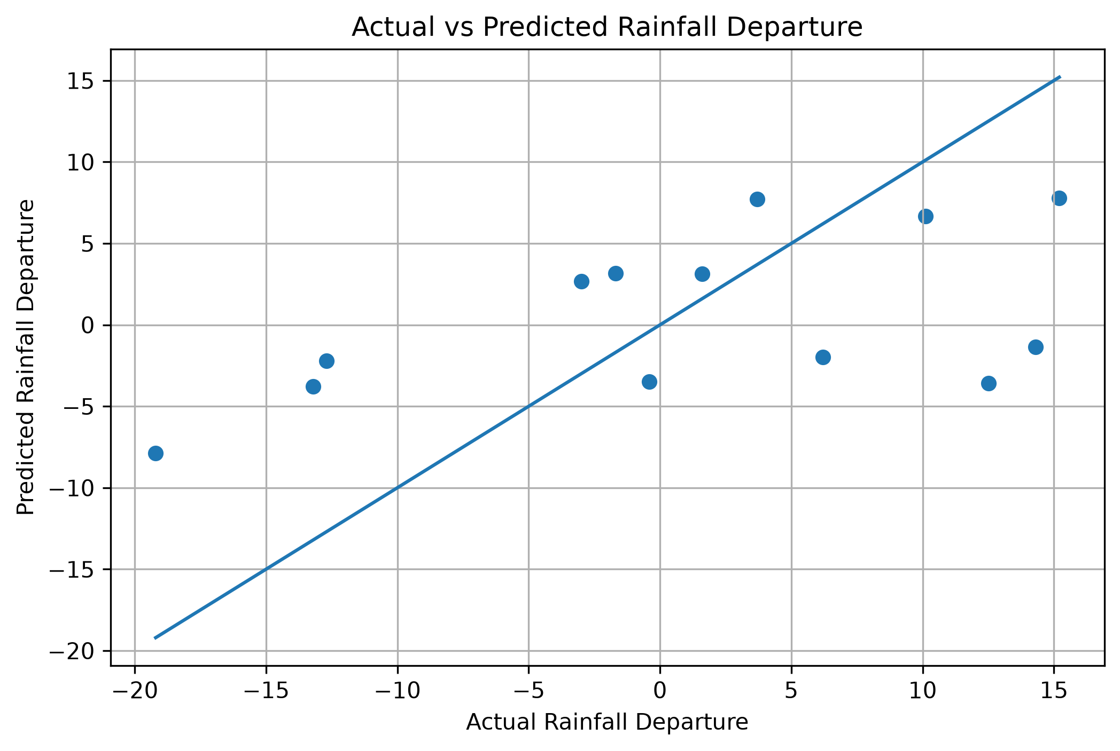
Figure: Actual vs Predicted Rainfall Departure using Linear Regression.
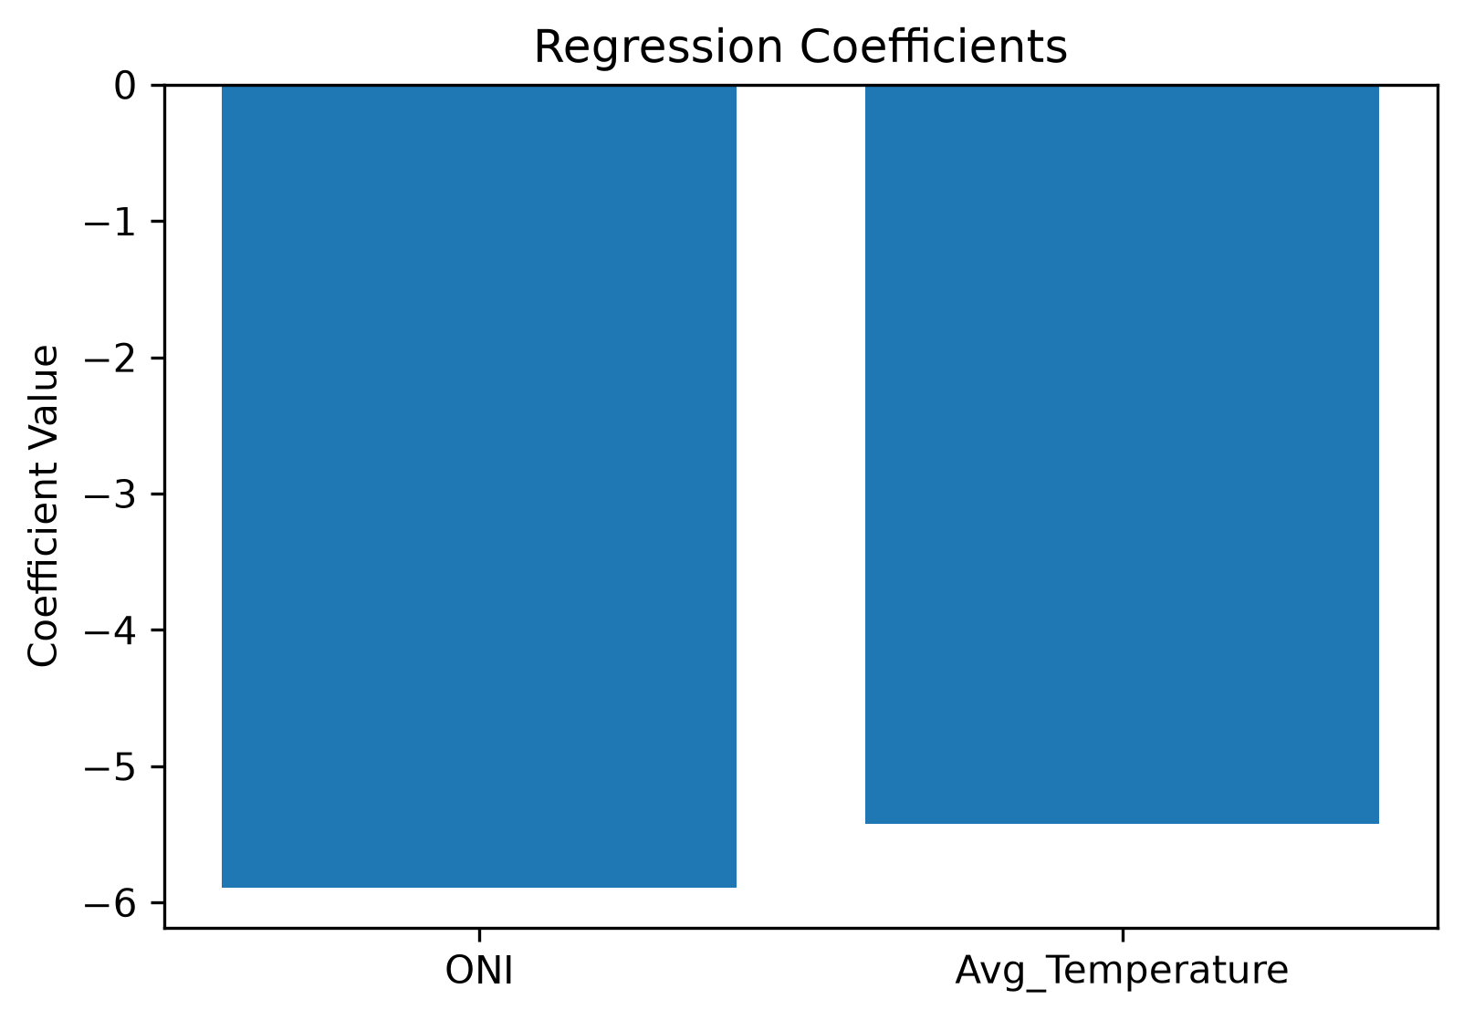
Figure: Regression coefficients showing the influence of predictor variables.

Conclusion
This study investigated the impact of El Niño conditions on Indian monsoon rainfall using climate and environmental datasets. Exploratory Data Analysis revealed observable relationships between Oceanic Niño Index (ONI), rainfall variability, and temperature.
Machine learning techniques were applied to predict rainfall departure. Linear Regression achieved the best performance with an R² score of 0.277, outperforming Random Forest Regression.
The findings indicate that ENSO conditions influence monsoon behavior and can be used as an important predictor for rainfall forecasting. Future work can incorporate additional climatic variables and larger datasets to improve predictive accuracy.

Recommendations
- Strengthen seasonal monsoon forecasting using ENSO indicators.
- Promote climate-resilient agricultural practices in drought-prone regions.
- Improve reservoir and water resource planning during El Niño years.
- Integrate additional climate variables into future predictive models.
- Develop AI-based early warning systems for rainfall anomalies.

