

Electronics and Digital Circuits Project Proposal #1
Module Title: Electronics and Digital Circuits
Module Code: 25CSCI10C
Module Leader: Assoc. Prof. Khaled M. Abdelgaber
Semester: One
University: The British University in Egypt (BUE)
Project Title: Automatic Motion Sensor Switch using CD4017 Decade Counter and E18-D80NK IR Proximity Sensor
Team (A14T4) Members:
ID | Student Name | E-mail (BUE E-mail)
251551 | Youssef Wael Fawzy | youssef251551@bue.edu.eg
257403 | Ziad Mostafa Gaber | ziad257403@bue.edu.eg
257678 | Mahmoud Samir Moustafa | mahmoud257678@bue.edu.eg
258948 | Ziad Ayman | ziad258948@bue.edu.eg
244144 | Ahmed Ali Abdelmotal | ahmed244144@bue.edu.eg
Brief Description:
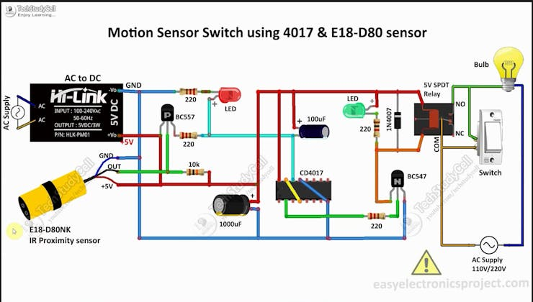
Brief Description:
This project implements an automatic motion-activated switching system that controls AC-powered appliances (such as lights, fans, or other devices) based on motion detection. The system uses an E18-D80NK infrared proximity sensor to detect motion and a CD4017 decade counter IC to toggle the output state, creating a smart ON/OFF control mechanism.
Circuit Operation: The IR proximity sensor continuously emits infrared radiation. When an object or person enters the detection range, the reflected infrared signal is detected by the sensor, causing its output to go LOW. This triggers a BC557 PNP transistor, which sends a clock pulse to the CD4017 decade counter IC. The CD4017 toggles its output state (Pin-2) between HIGH and LOW with each motion detection. When Pin-2 is HIGH, it activates a BC547 NPN transistor, which energizes a 5V relay to turn ON the connected AC load. The next motion detection triggers another clock pulse, returning Pin-2 to LOW and turning OFF the load.

Key Features:
- Automatic hands-free operation (touchless control)
- Toggle ON/OFF with motion detection
- Manual override switches for conventional control
- AC appliance control (110V/220V) through relay isolation
- Energy-efficient with minimal standby power
- Wide detection range (up to 80cm adjustable)
Practical Applications:
- Automatic room lighting systems
- Bathroom/corridor lighting control
- Energy-saving in offices and homes
- Accessibility aid for elderly or disabled persons
- Smart home automation integration
- Touchless appliance control (post-pandemic hygiene)

List of Components:
Component | Function/Type
Integrated Circuits | - CD4017 Decade Counter IC - 1 unit  - HLK-PM01 AC to DC Converter Module (5V output) - 1 unit
Transistors | - BC557 PNP Transistor - 1 unit  - BC547 NPN Transistor - 1 unit
Resistors | - 220Ω, 0.25W resistors - 3 units  - 1kΩ, 0.25W resistor - 1 unit  - 10kΩ, 0.25W resistor - 1 unit
Capacitors | - 100µF, 25V electrolytic capacitor - 1 unit  - 1000µF, 25V electrolytic capacitor - 1 unit
Sensors | - E18-D80NK IR Proximity Sensor Module - 1 unit
Diodes & LEDs: | - 1N4007 Rectifier Diode - 1 unit  - 5mm LEDs (indicator lights) - 2 units
Relay & switching | - 5V SPDT (Single Pole Double Throw) Relay - 1 unit  - Latched toggle switches - 2 units
Other Components | - IC base/socket (for CD4017) - 1 unit  - Connectors (screw terminals/wire connectors) - as needed  - PCB or breadboard - 1 unit  - AC power cord with plug - 1 unit  - Light bulb/AC load for testing - 1 unit  - Connecting wires - as needed  - Project enclosure box - 1 unit (optional)

CIRCUIT OPERATION SUMMARY:
Power Supply Section:
- HLK-PM01 module converts 110V/220V AC mains to regulated 5V DC
- Powers the CD4017 IC, transistors, relay, and IR sensor
- Capacitors (100µF, 1000µF) provide filtering and stability
Motion Detection Section:
- E18-D80NK IR sensor continuously emits infrared signals
- When motion is detected, sensor output goes LOW
- BC557 PNP transistor activates (conducts) when sensor output is LOW
- Clock pulse is sent to CD4017 IC (Pin-14)
Toggle Logic Section:
- CD4017 counter toggles output state with each clock pulse
- First motion: Pin-2 goes HIGH → Load turns ON
- Second motion: Pin-2 goes LOW → Load turns OFF
- Pattern repeats with subsequent detections
Load Control Section:
- Pin-2 of CD4017 drives BC547 NPN transistor base
- When transistor conducts, relay coil is energized
- Relay switches AC load (bulb) ON
- LED indicators show power and relay status
Manual Override:
- Two latched switches allow conventional manual control
- One switch controls AC supply, another can bypass sensor

