
Database (1) - 25CSIS03C
Smart City Transportation System
Group (8)
Final Phase
(Database Mapping and Implementation)
Team Members (8):
ID | Student Name | E-mail (BUE E-mail)
257678 | Mahmoud Samir Moustafa | Mahmoud257678@bue.edu.eg
255322 | Yousef Mahmoud Ali | Yousef255322@bue.edu.eg
257511 | Ibrahim Moustafa | Ibrahim257511@bue.edu.eg
258748 | Seif Adel Mahmoud | Seif258748@bue.edu.eg
255444 | Hassan Moustafa Nosir | Hassan255444@bue.edu.eg

Under Supervision of TA. Amira

Team Contribution Table
Student ID | Student Name | Contribution
257678 | Mahmoud Samir Moustafa | (USER & STAFF & DRIVER & DISPATCHER & MAINTENANCE_STAFF) Mapping  (USER & STAFF & DRIVER & DISPATCHER & MAINTENANCE_STAFF) Creation  (USER & STAFF & DRIVER & DISPATCHER & MAINTENANCE_STAFF) Insertion  (USER & STAFF & DRIVER & DISPATCHER & MAINTENANCE_STAFF) Queries
255322 | Yousef Mahmoud Ali | (TRIP_LOCATION & LOYALTY_PROGRAM & ENROLLED_IN) Mapping  (TRIP_LOCATION & LOYALTY_PROGRAM & ENROLLED_IN) Creation  (TRIP_LOCATION & LOYALTY_PROGRAM & ENROLLED_IN) Insertion  (TRIP_LOCATION & LOYALTY_PROGRAM & ENROLLED_IN) Queries
257511 | Ibrahim Moustafa | (VEHICLE & BUS & METRO & Taxi) Mapping  (VEHICLE & BUS & METRO & Taxi) Creation  (VEHICLE & BUS & METRO & Taxi) Insertion  (VEHICLE & BUS & METRO & Taxi)  Queries
258748 | Seif Adel Mahmoud | (TRIP & TICEKT & ROUTE) Mapping  (TRIP & TICEKT & ROUTE) Creation  (TRIP & TICEKT & ROUTE) Insertion  (TRIP & TICEKT & ROUTE) Queries
255444 | Hassan Moustafa Nosir | (ROUTE_STOP & SMART_CARD & PASSENGER) Mapping  (ROUTE_STOP & SMART_CARD & PASSENGER) Creation  (ROUTE_STOP & SMART_CARD & PASSENGER) Insertion  (ROUTE_STOP & SMART_CARD & PASSENGER) Queries

Detailed Description
The Smart City Transportation System Database stores all the essential information needed to manage transportation services in a modern urban environment. The database represents passengers, staff members, vehicles, routes, trips, tickets, and smart card operations in a clear and organized structure.
The system supports daily transportation activities such as scheduling trips, assigning drivers and vehicles, tracking passenger journeys, recording ticket purchases, and managing route stops. Passengers can own smart cards, purchase tickets, and enroll in loyalty programs, while staff members include drivers, dispatchers, and maintenance workers with different responsibilities.
Vehicles are categorized into buses, metro units, and taxis through specialization to capture differences between types. Trips record the details of each journey, including start time, end time, assigned vehicle, and driver. Trip locations record GPS data for monitoring movement. Tickets are stored as a weak entity because they depend on both a passenger and a trip.
The database also includes structured attributes such as composite (Name, Address), multivalued (Email, Phone numbers), complex attributes (Contact Info), and derived attributes (Trip Duration). These allow the system to accurately model real-world transportation information. Overall, the database provides a reliable foundation for managing smart city transportation operations efficiently.

Scope
The scope of the Smart City Transportation System covers all essential processes required to operate public transportation efficiently within an urban environment. The database focuses on managing passengers, staff roles, vehicles, routes, trips, ticketing, and smart card interactions.
The system supports passenger-related activities such as registering users, storing personal information, handling contact details, managing smart cards, processing ticket purchases, and tracking loyalty program enrollment. It also manages staff members including drivers, dispatchers, and maintenance personnel, ensuring that each employee is assigned appropriate responsibilities.
On the operational side, the system manages vehicles of different types of buses, metro units, and taxis and organizes their assignments to scheduled trips. Routes and route stops are included to define the structure of travel paths, while trip details and trip location updates allow accurate tracking of each journey.
The system does not cover areas such as payment gateway integration, city-wide traffic prediction, real-time sensor networks, or mobile app interfaces. Instead, it focuses specifically on the core data needed to support transportation scheduling, operation, and passenger management, forming the foundation for future system modules.

EERD (Enhanced Entity Relationship Diagram)

Figma Link for Full Preview: https://www.figma.com/board/U90n8pGLmvWIeLn9qIPGVp/EERD-V.25?node-id=0-1&t=ElR1qoMxBbv4nX1K-1

Mapping Schema

Figma Link for Full Preview: https://www.figma.com/board/U90n8pGLmvWIeLn9qIPGVp/EERD-V.25?node-id=0-1&t=ElR1qoMxBbv4nX1K-1

SQL Implementation
Mahmoud Samir Moustafa 257678
Table Creation:
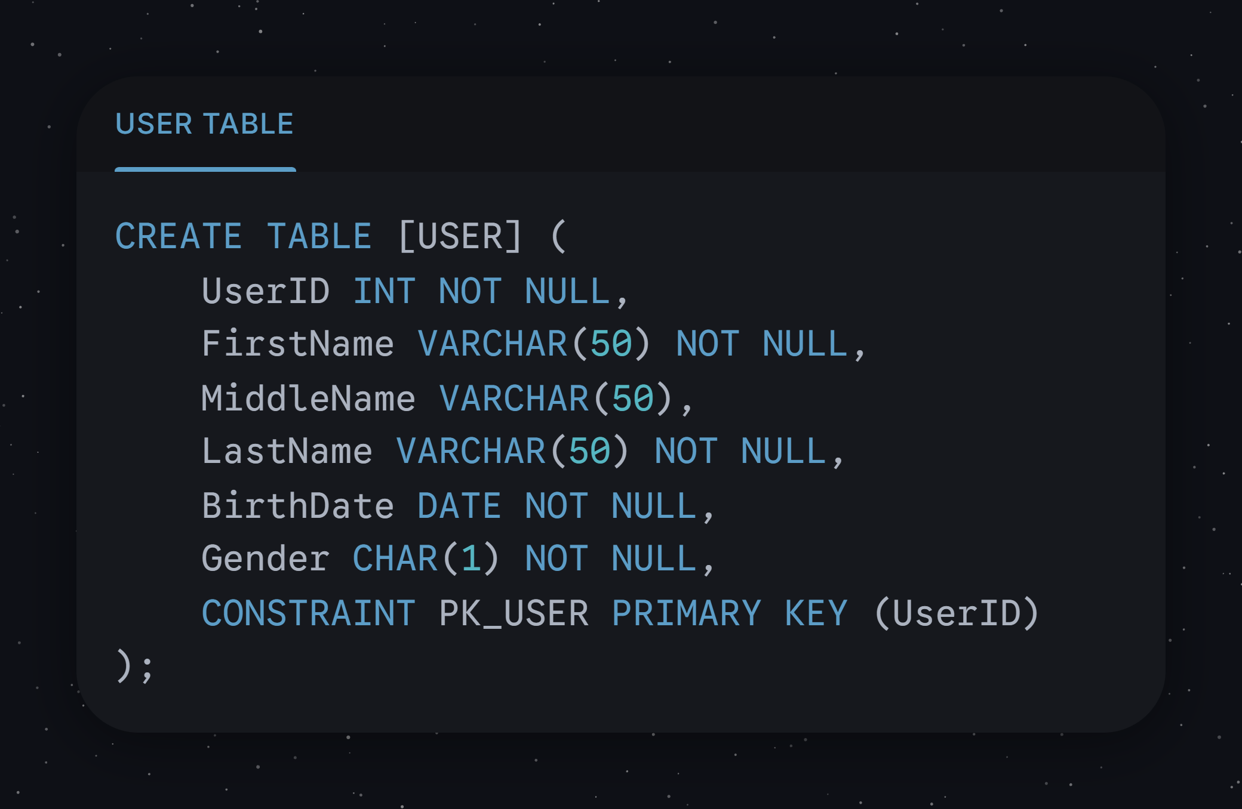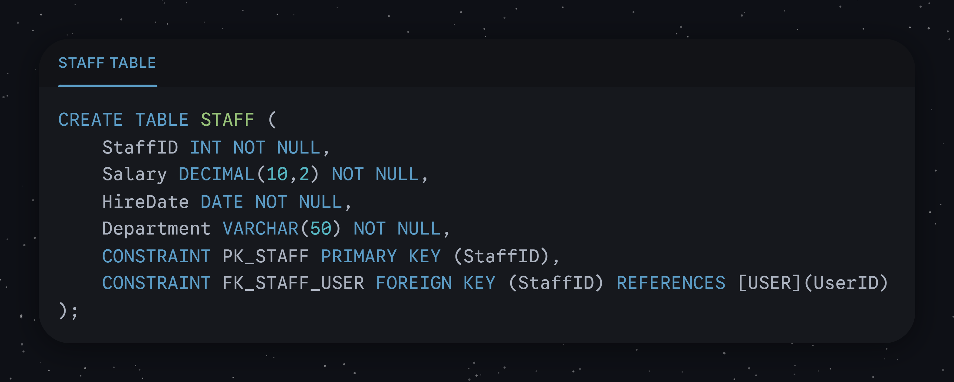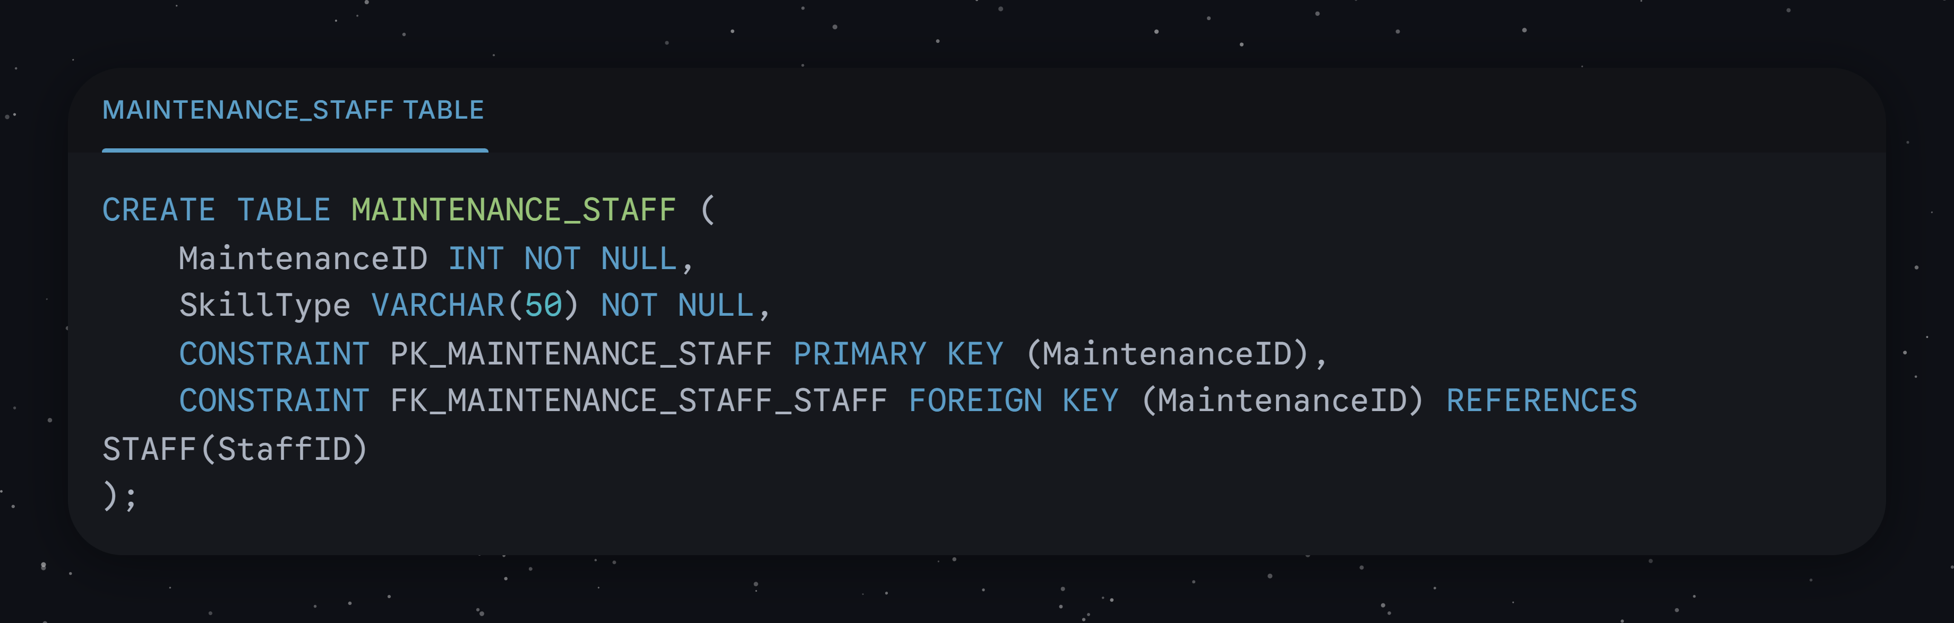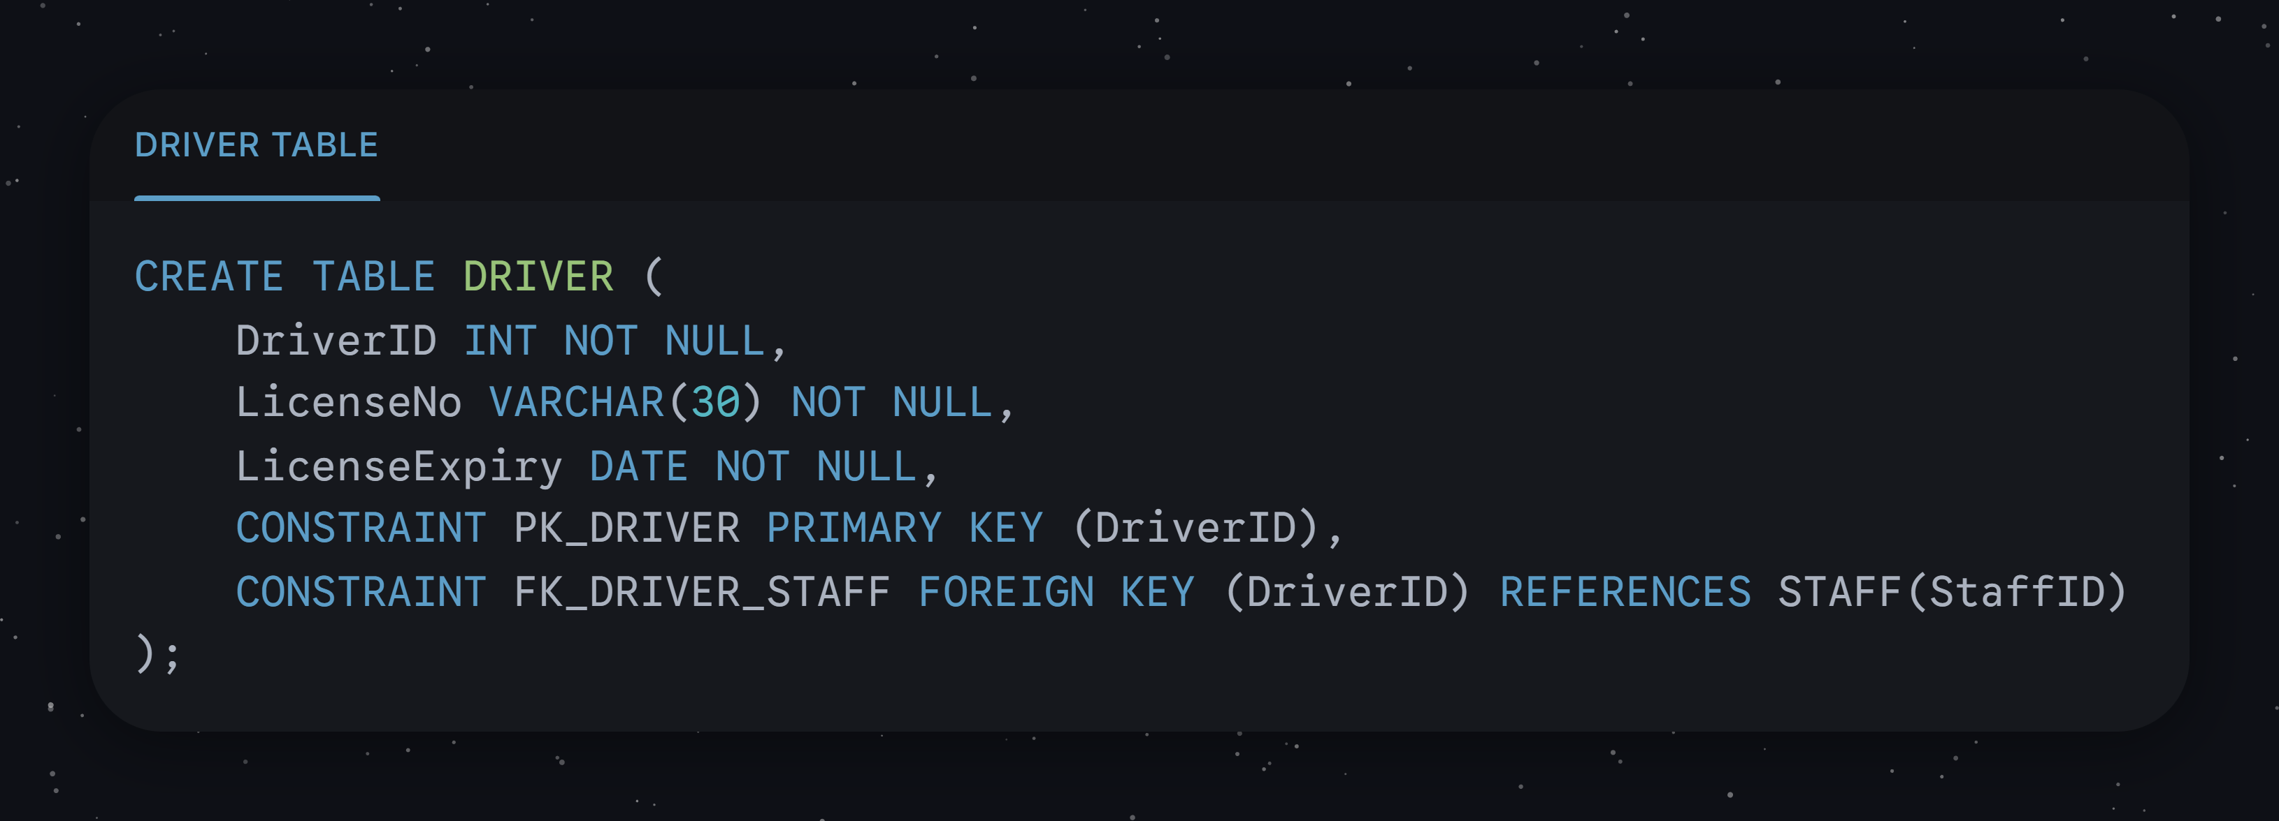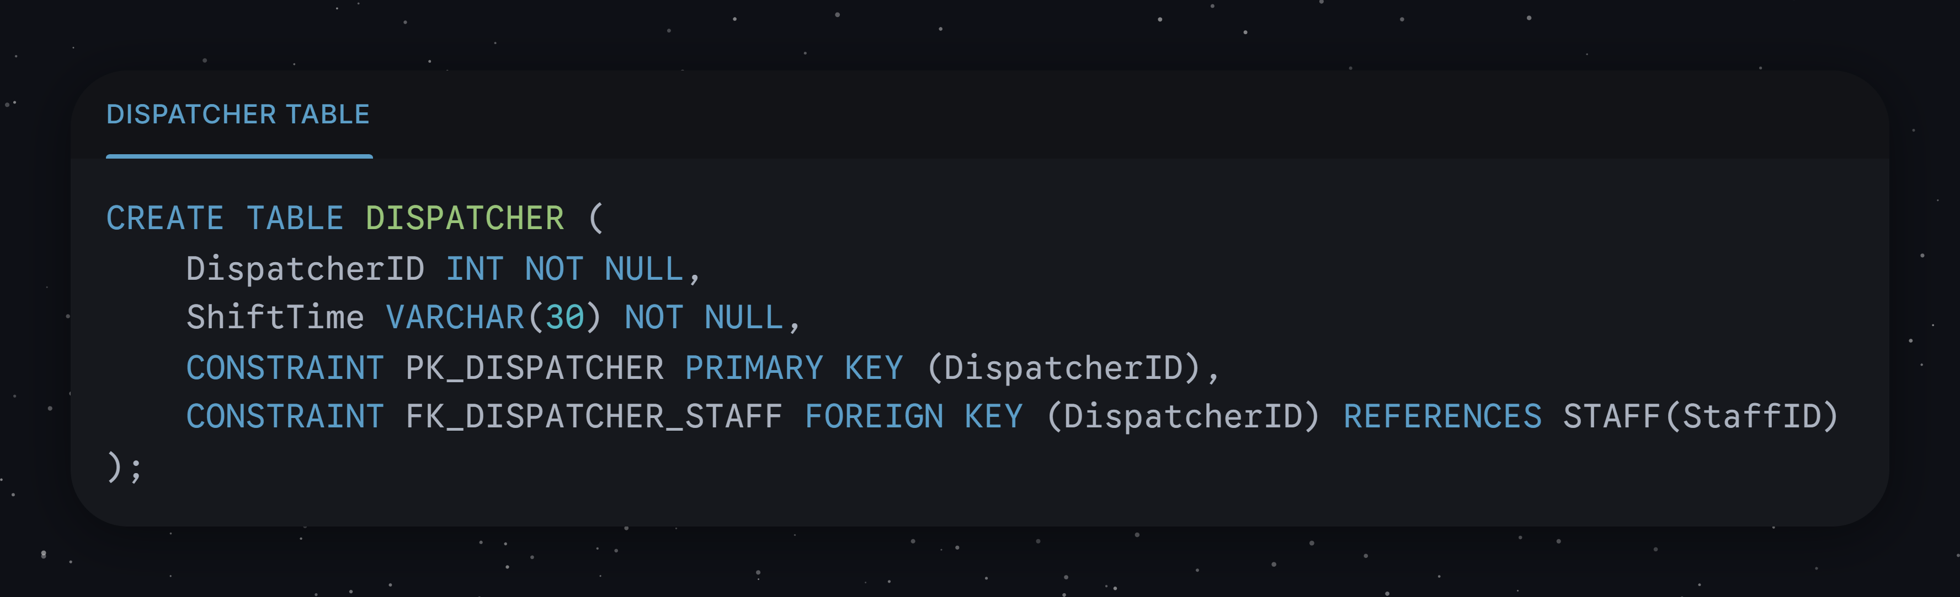

Queries:
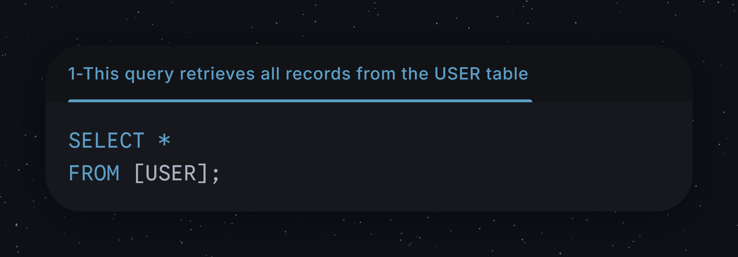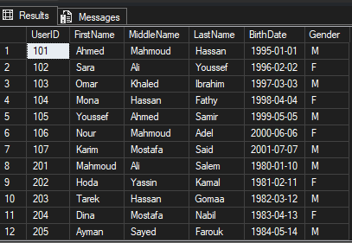
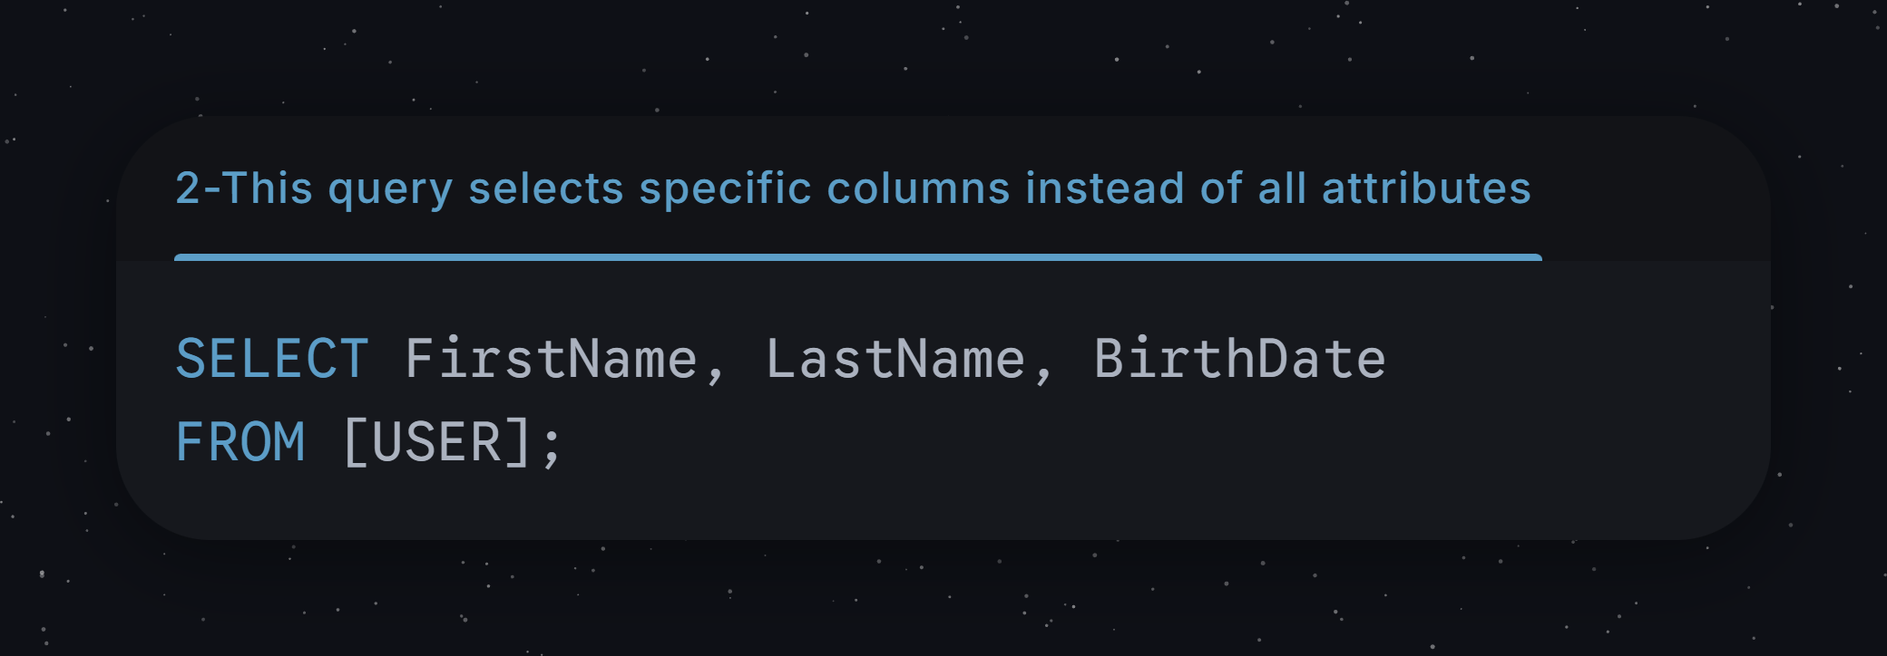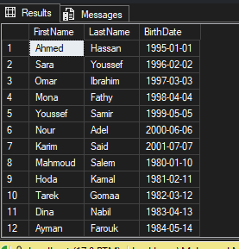
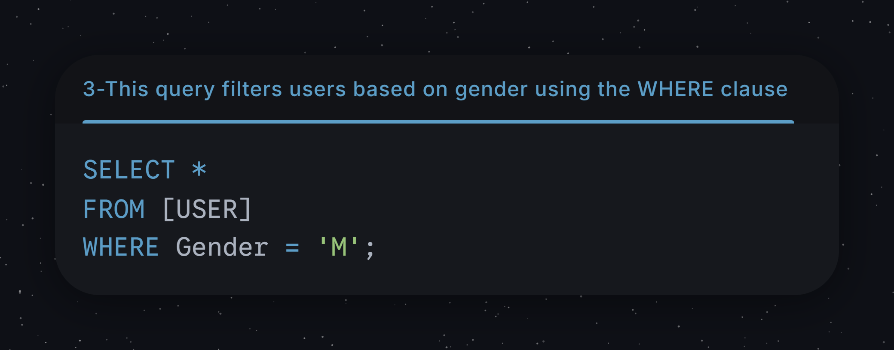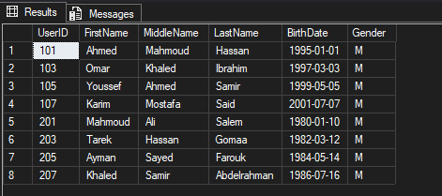
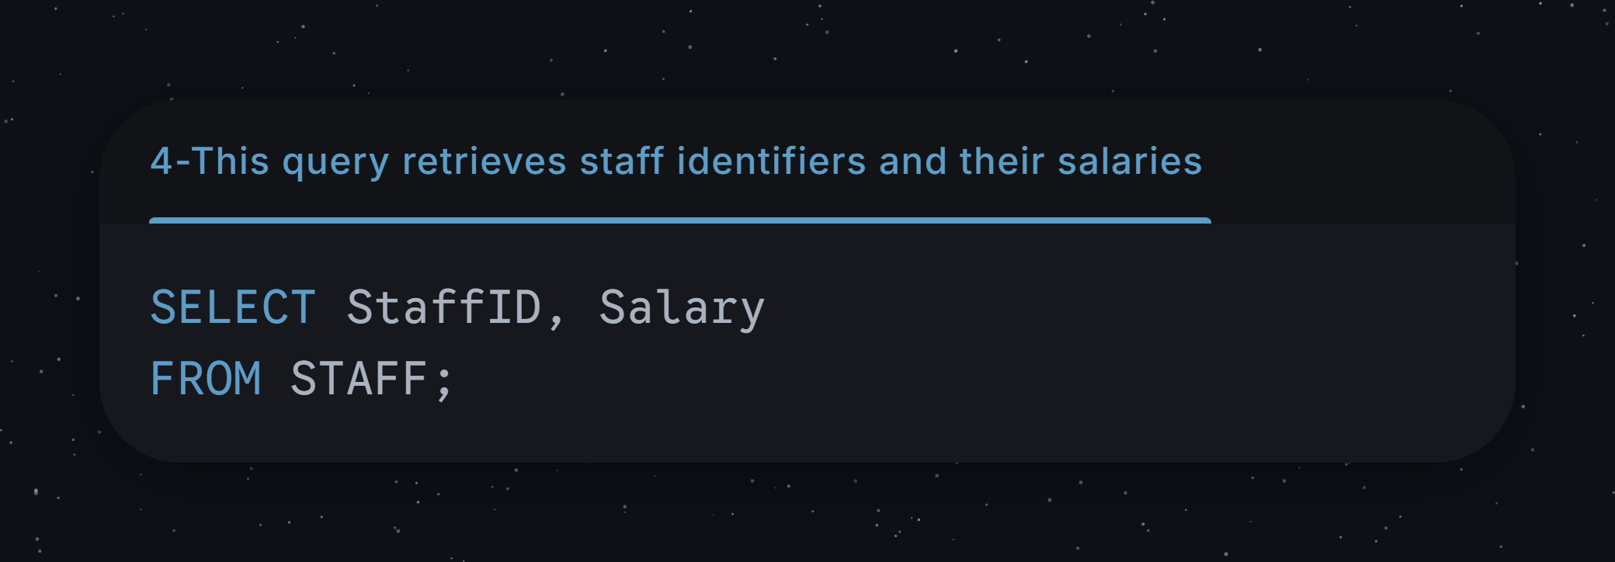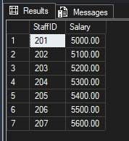
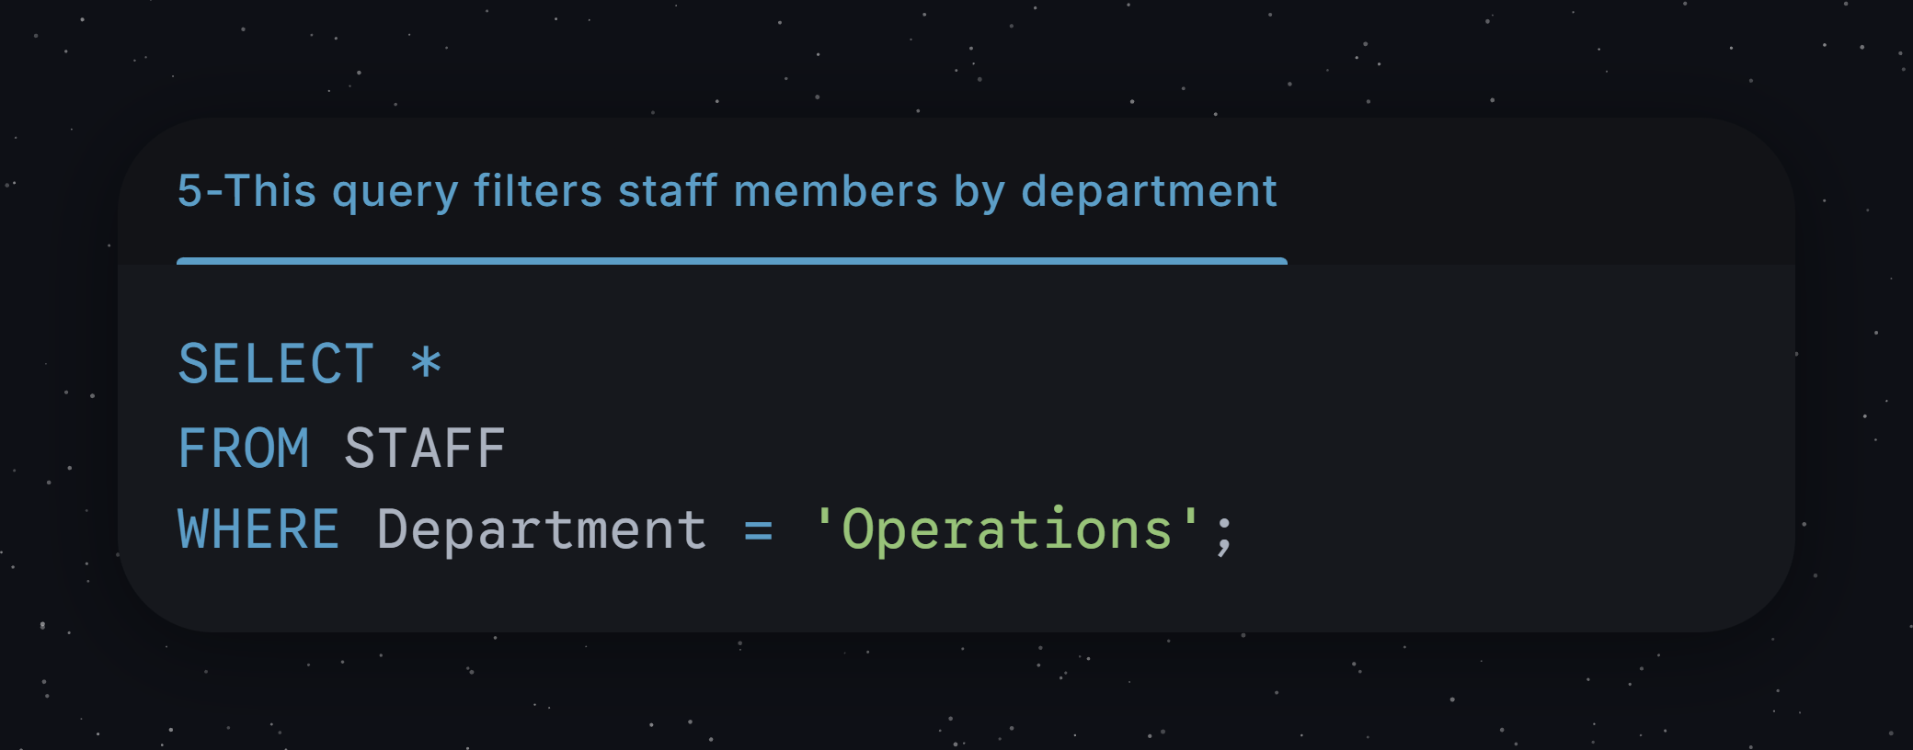
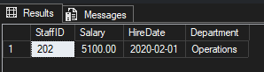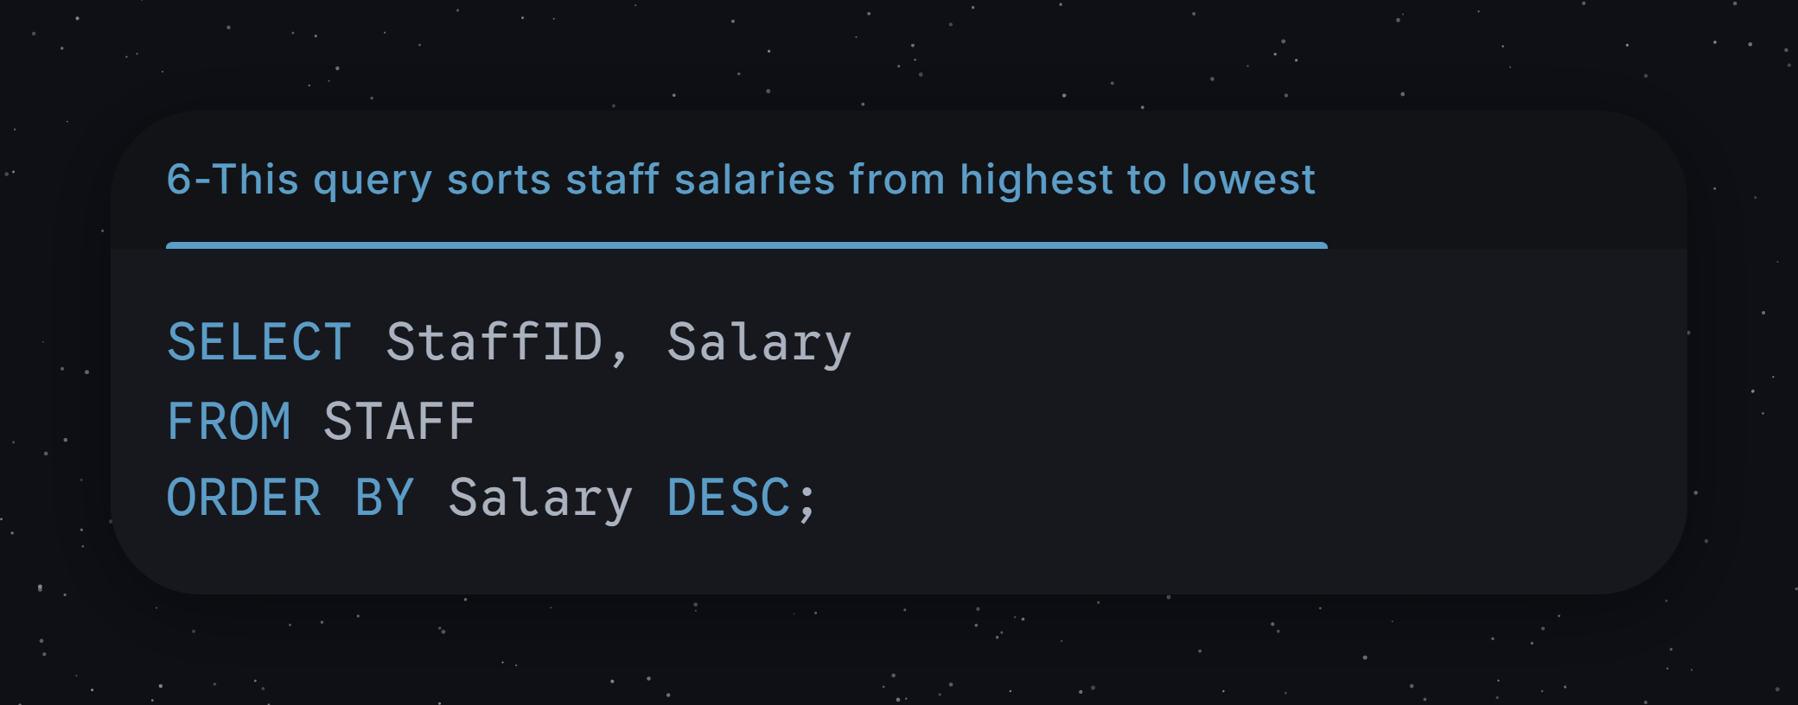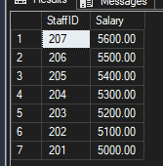
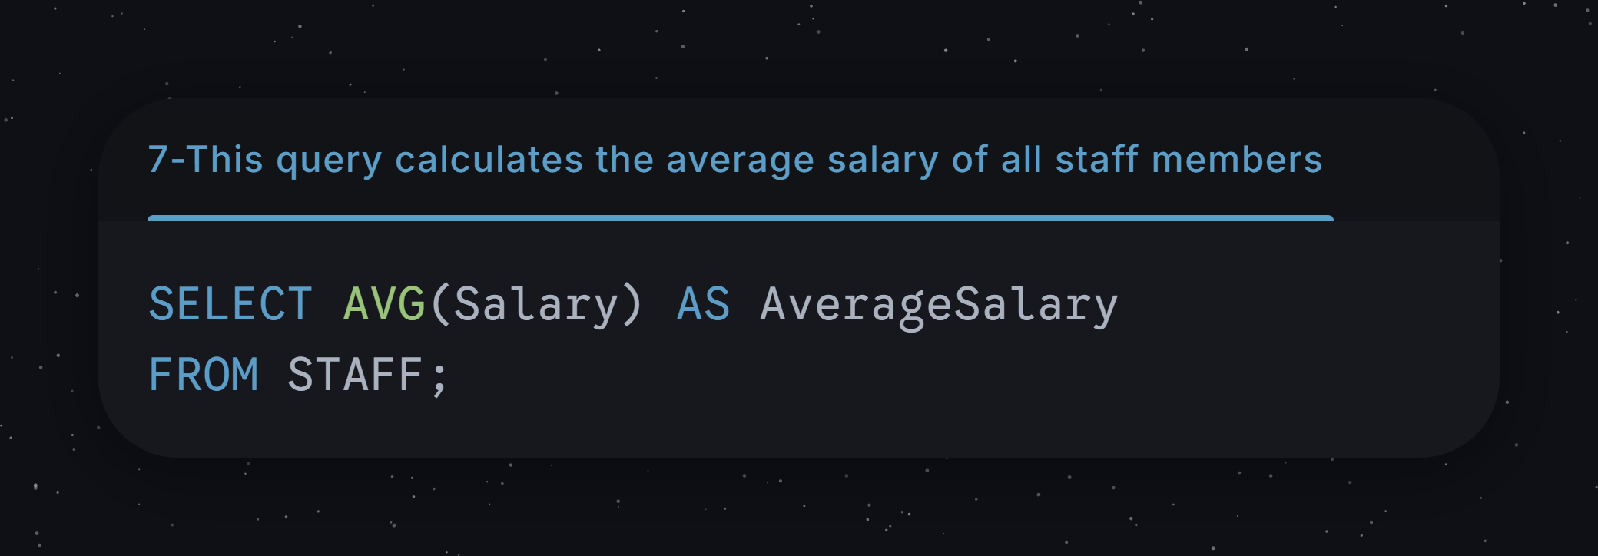
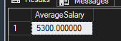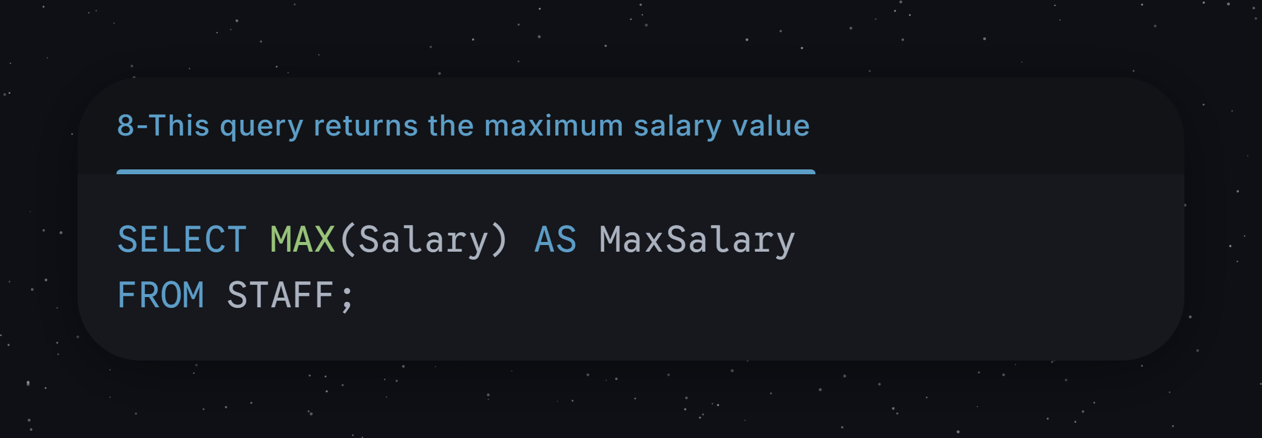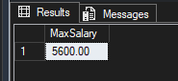

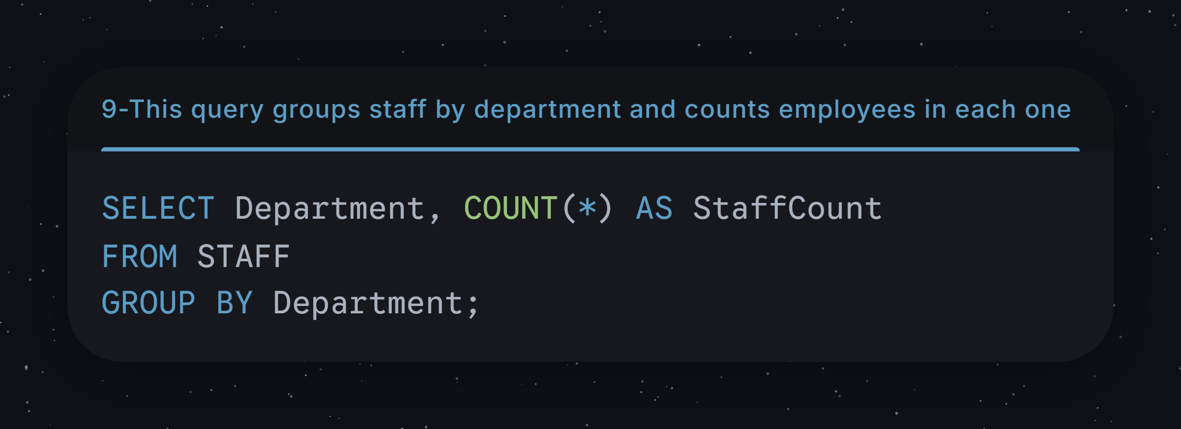
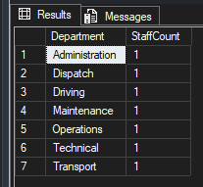

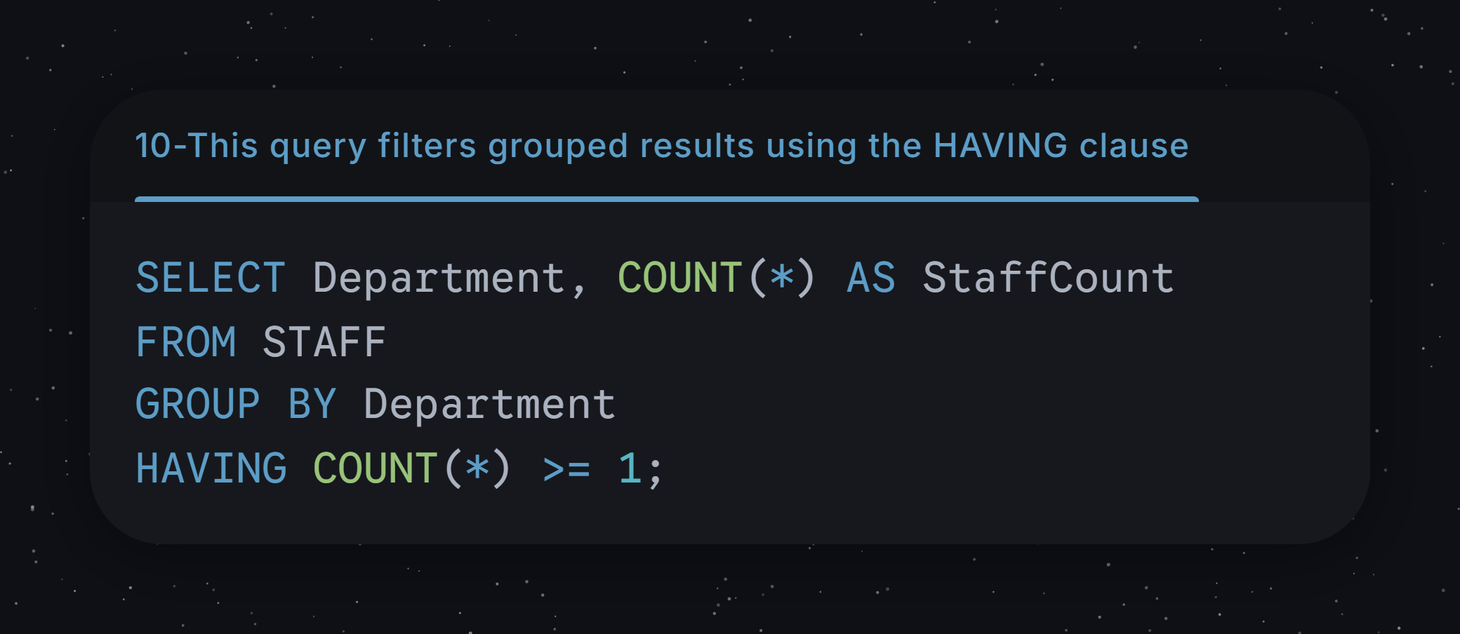
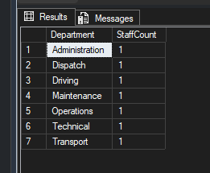
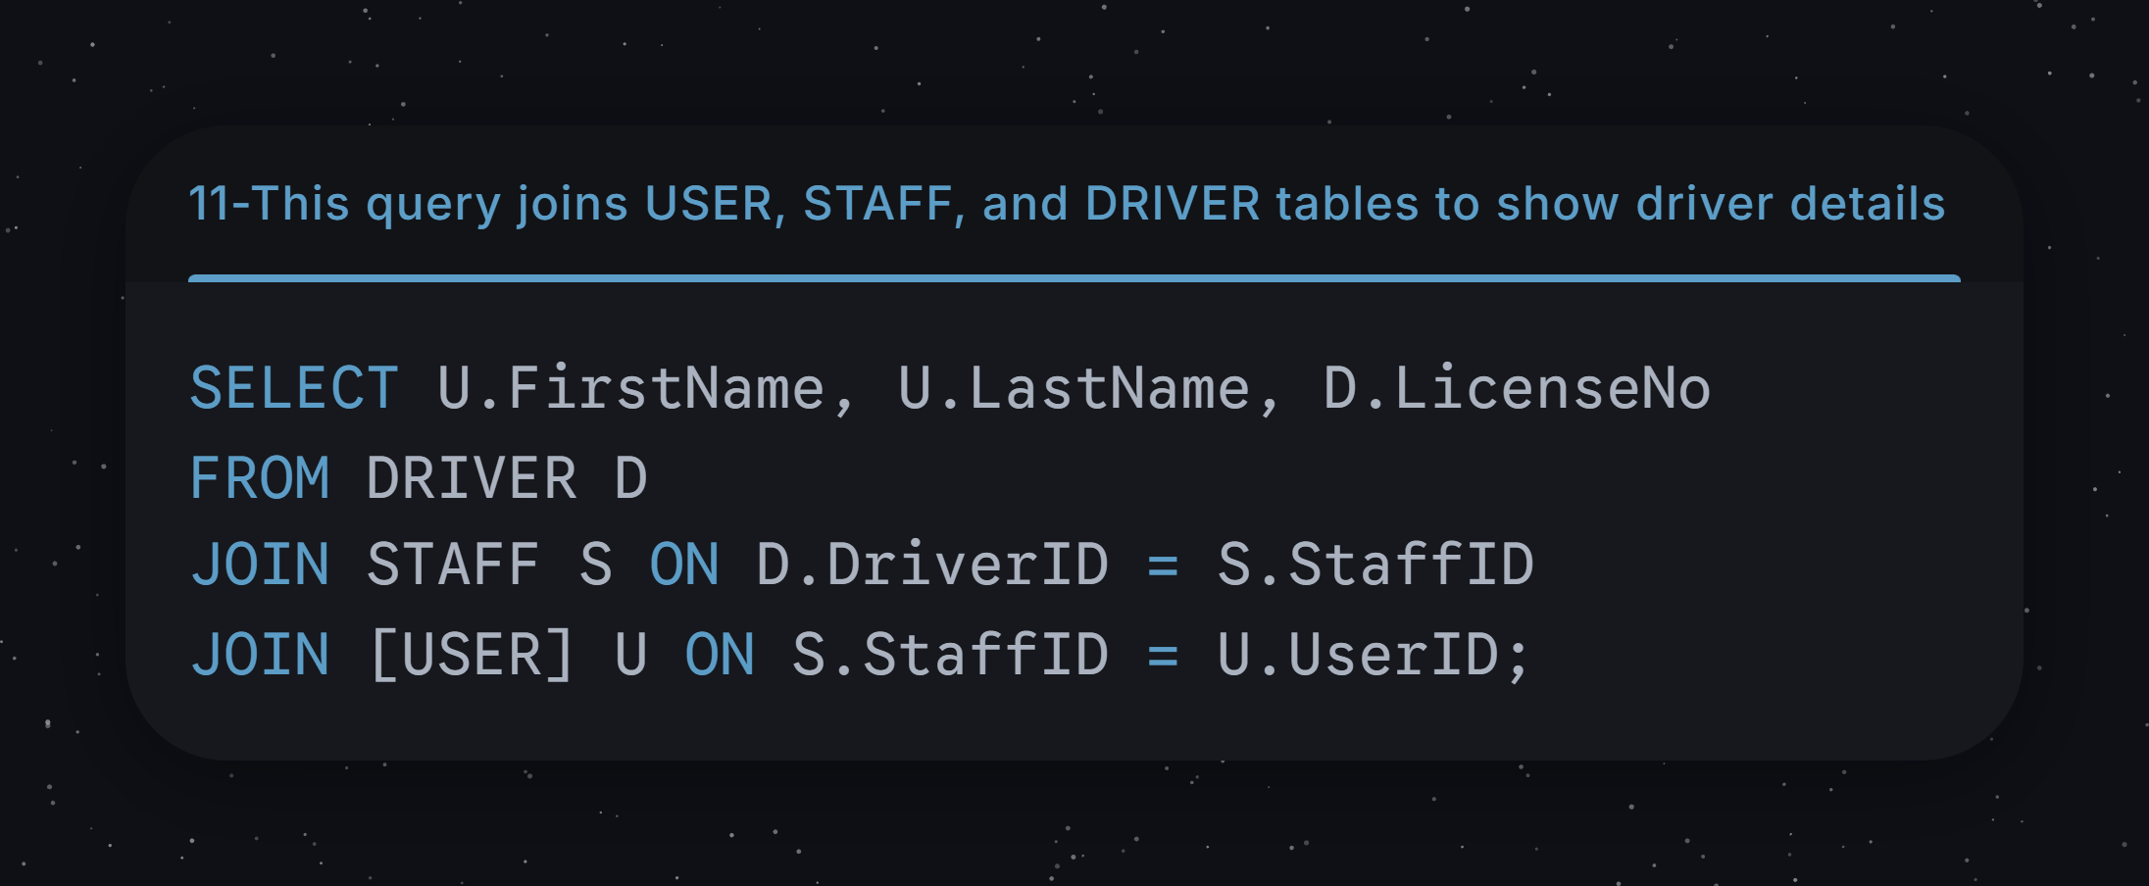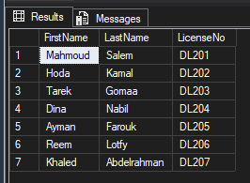
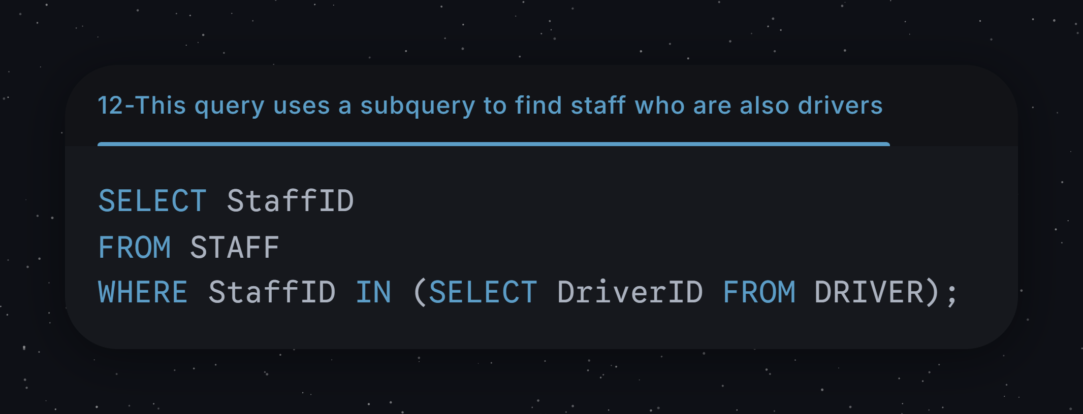
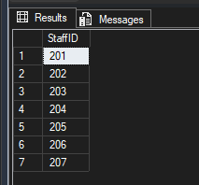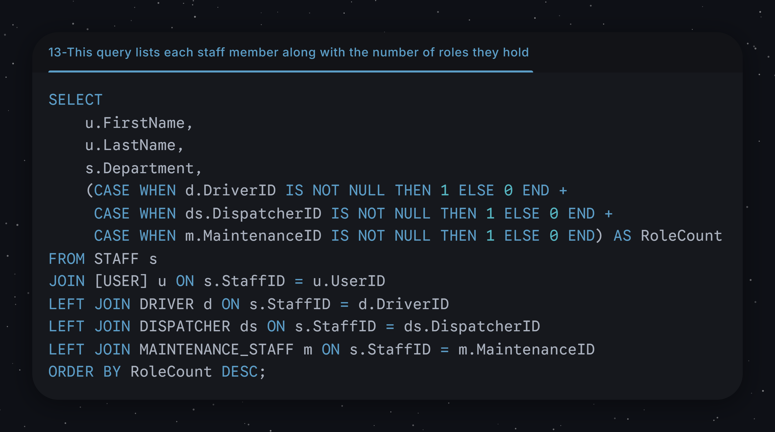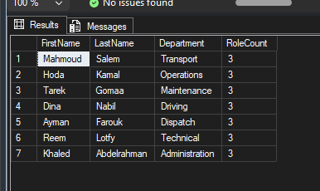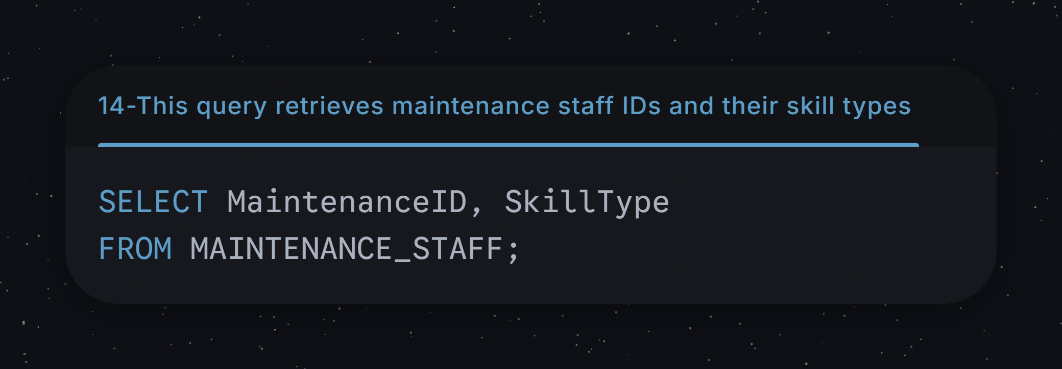
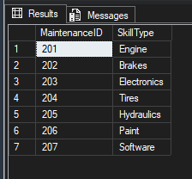

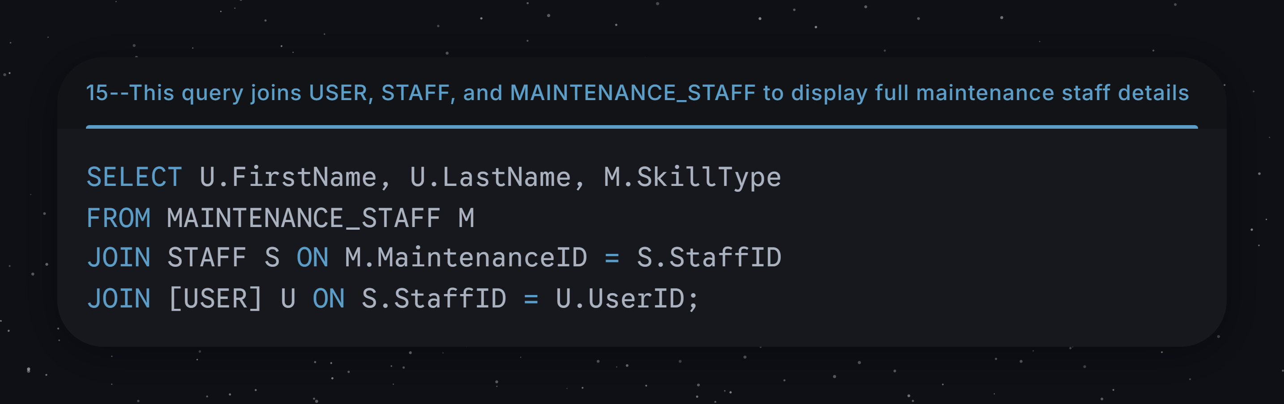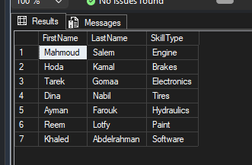

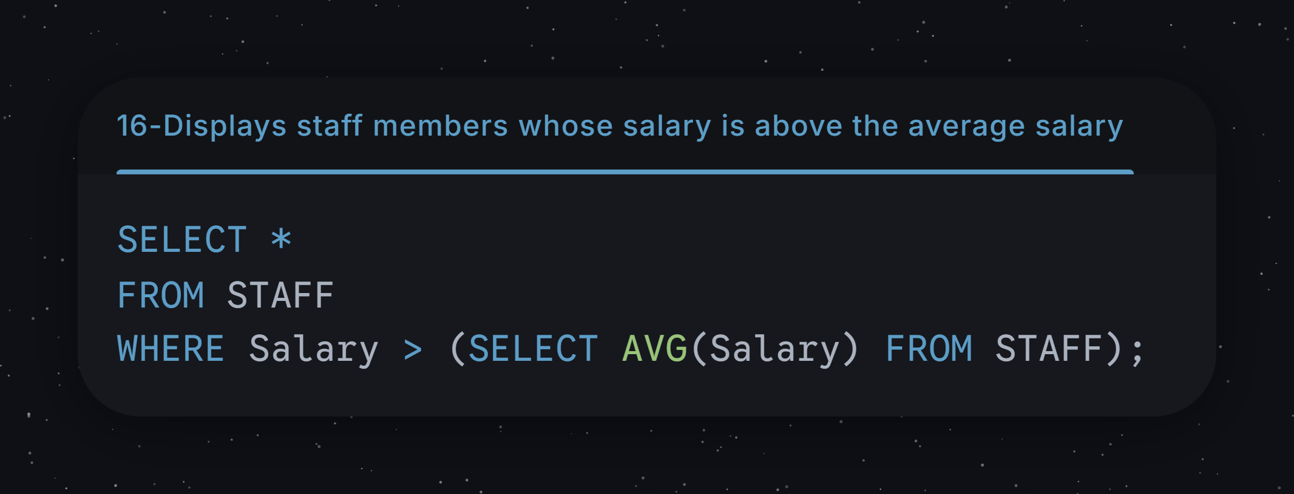
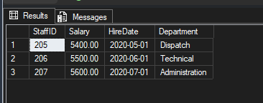
Alter Table:
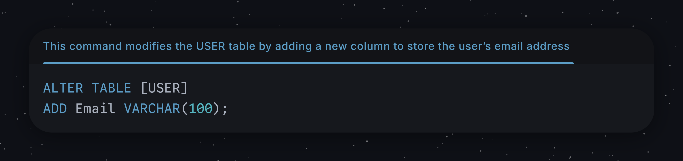
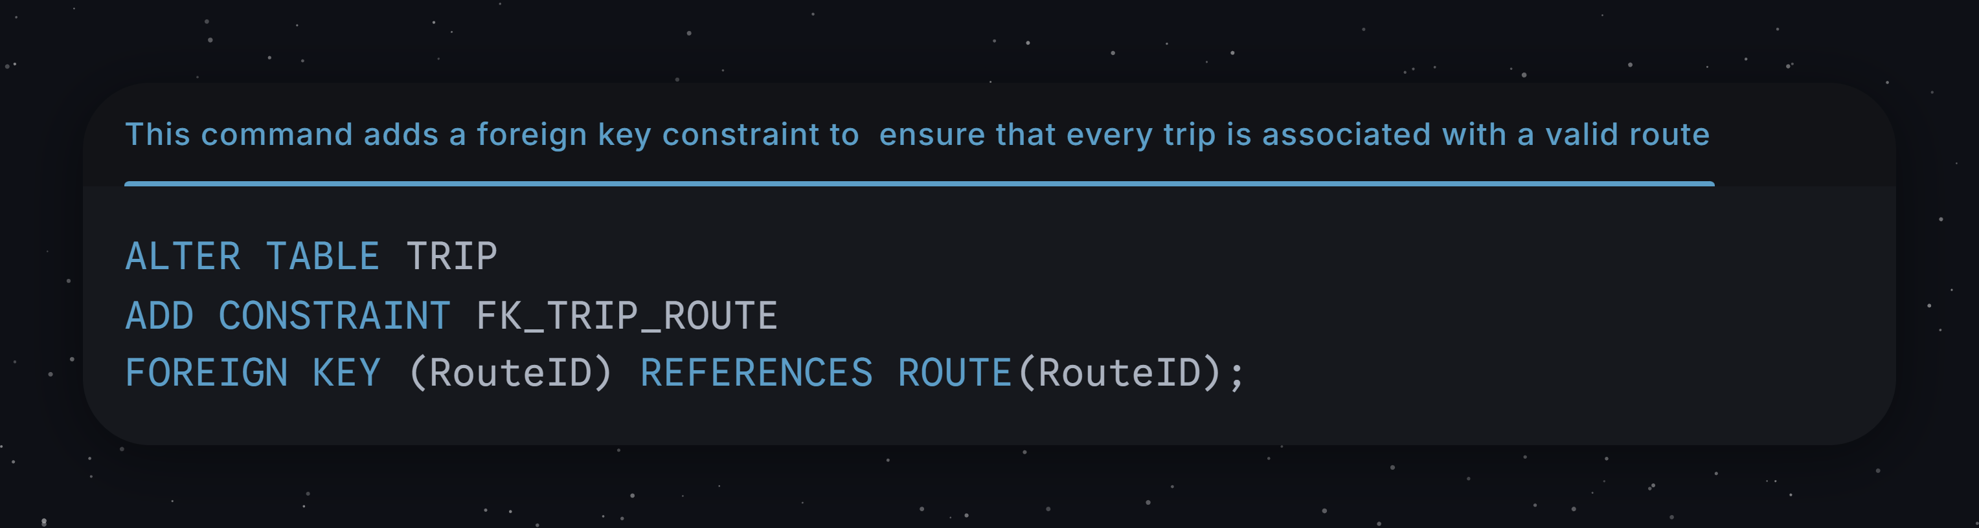

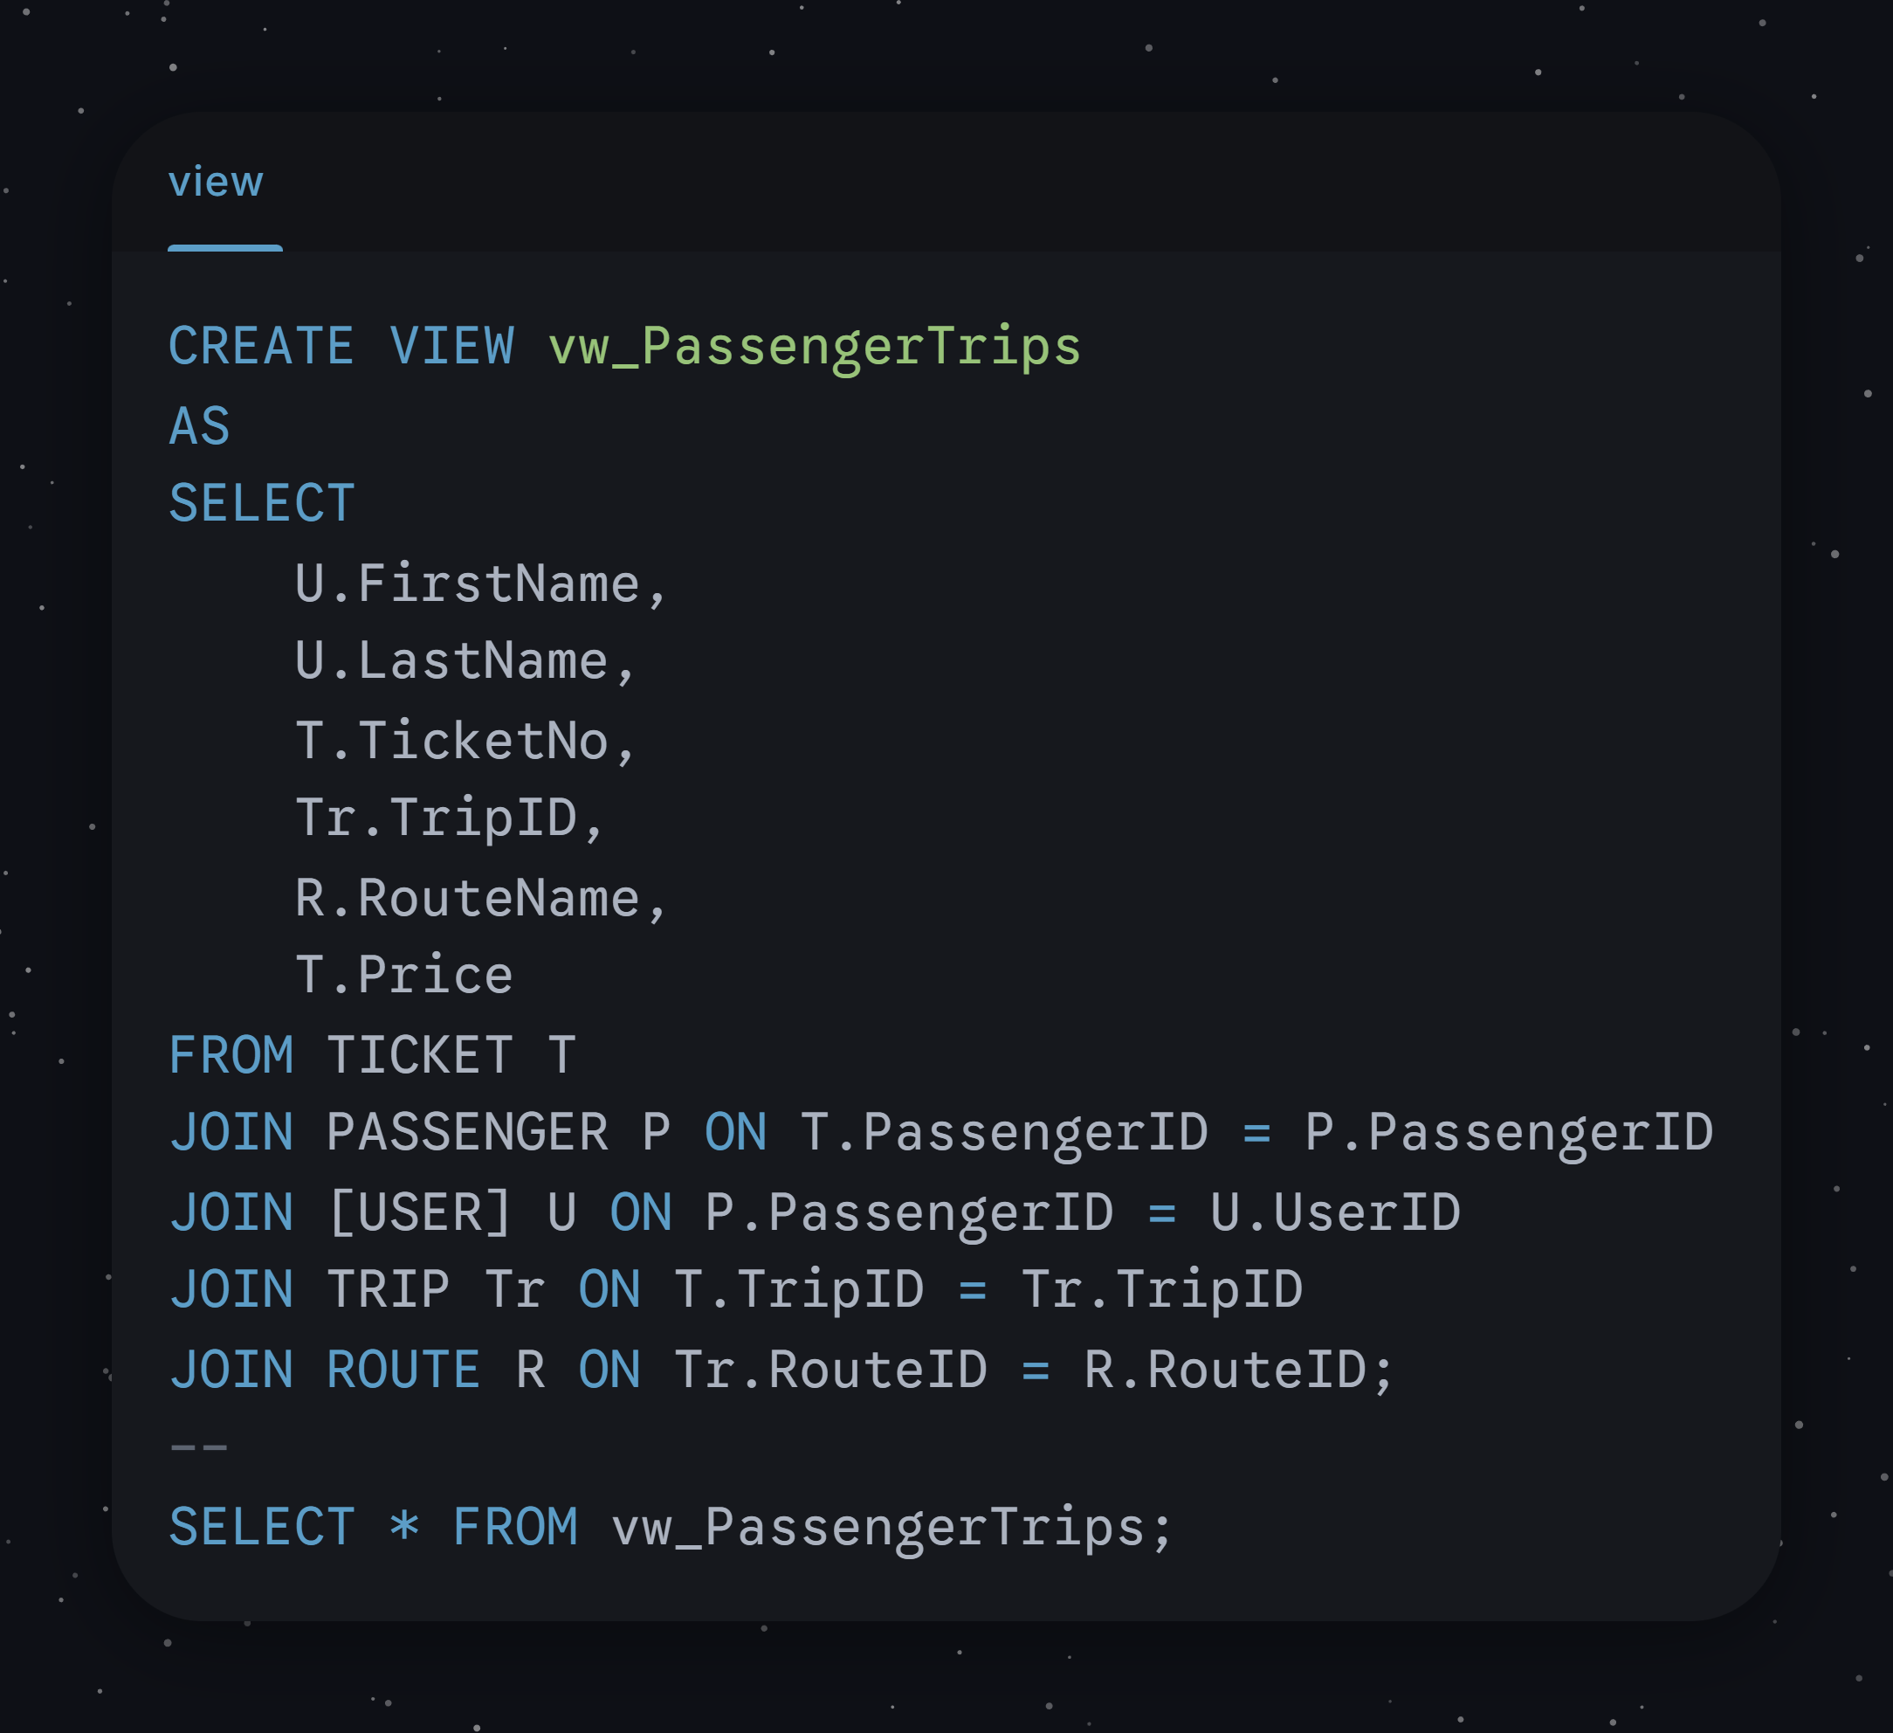
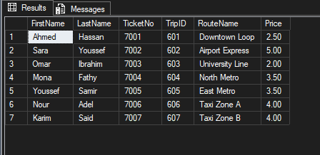
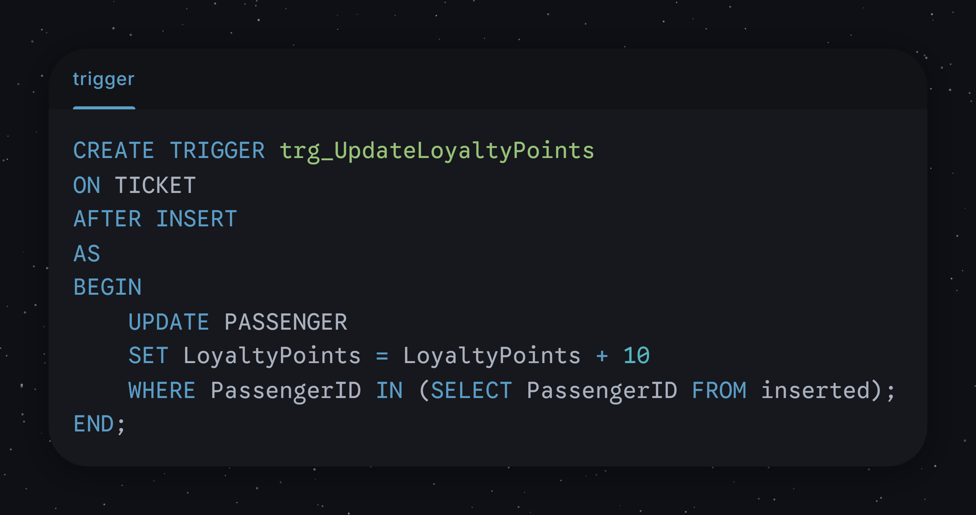

Youssef Mahmoud Ali 255322
Table Creation:
--18--(ENROLLED_IN) TABLE CREATE TABLE ENROLLED_IN ( PassengerID INT NOT NULL, ProgramID INT NOT NULL, CONSTRAINT PK_ENROLLED_IN PRIMARY KEY (PassengerID, ProgramID), CONSTRAINT FK_ENROLLED_IN_PASSENGER FOREIGN KEY (PassengerID) REFERENCES PASSENGER(PassengerID), CONSTRAINT FK_ENROLLED_IN_LOYALTY_PROGRAM FOREIGN KEY (ProgramID) REFERENCES LOYALTY_PROGRAM(ProgramID) );
--17--(LOYALTY_PROGRAM) TABLE CREATE TABLE LOYALTY_PROGRAM ( ProgramID INT NOT NULL, ProgramName VARCHAR(50) NOT NULL, TierName VARCHAR(30) NOT NULL, DiscountRate DECIMAL(4,2) NOT NULL, PointsPerTrip INT NOT NULL, CONSTRAINT PK_LOYALTY_PROGRAM PRIMARY KEY (ProgramID)
--14--(TRIP_LOCATION) TABLE CREATE TABLE TRIP_LOCATION ( TripID INT NOT NULL, [Timestamp] DATETIME NOT NULL, Latitude DECIMAL(9,6) NOT NULL, Longitude DECIMAL(9,6) NOT NULL, Speed DECIMAL(6,2) NOT NULL, CONSTRAINT PK_TRIP_LOCATION PRIMARY KEY (TripID, [Timestamp]), CONSTRAINT FK_TRIP_LOCATION_TRIP FOREIGN KEY (TripID) REFERENCES TRIP(TripID)

Table Insertion:
/* 14. TRIP_LOCATION */
INSERT INTO TRIP_LOCATION (TripID, [Timestamp], Latitude, Longitude, Speed)
VALUES
(601,'2025-12-20 08:15',34.0525,-118.2440,25.5), (602,'2025-12-20 09:30',33.9600,-118.3900,60.2), (603,'2025-12-20 10:45',34.0700,-118.4500,30.0), (604,'2025-12-20 11:25',34.1000,-118.2000,40.8), (605,'2025-12-20 12:30',34.0800,-118.1600,38.5), (606,'2025-12-20 13:10',34.0510,-118.2480,22.0), (607,'2025-12-20 14:15',34.0520,-118.2400,24.3);
/* 17. LOYALTY_PROGRAM */
INSERT INTO LOYALTY_PROGRAM (ProgramID, ProgramName, TierName, DiscountRate, PointsPerTrip) VALUES
(901,'CityRider','Bronze',5.00,10), (902,'CityRider','Silver',10.00,15), (903,'CityRider','Gold',15.00,20), (904,'EcoTrans','Basic',4.00,8), (905,'EcoTrans','Plus',8.00,12), (906,'StudentPass','Discount',20.00,5), (907,'SeniorRide','Priority',25.00,5);
/* 18. ENROLLED_IN */
INSERT INTO ENROLLED_IN (PassengerID, ProgramID) VALUES
(101,901), (102,906), (103,903), (104,902), (105,905), (106,904), (107,907);

Queries:
Queries for TRIP_LOCATION:

SELECT *
FROM TRIP_LOCATION;

Description:
Retrieves all records from the TRIP_LOCATION table, showing every stored location update for all trips.

SELECT *
FROM TRIP_LOCATION
WHERE TripID = 601
ORDER BY Timestamp;

Description:
Displays all location updates related to TripID 601, ordered chronologically based on the timestamp.

SELECT TripID, MAX(Speed) AS MaxSpeed
FROM TRIP_LOCATION
GROUP BY TripID;

Description:
Finds the maximum speed recorded for each trip by grouping location data by TripID.

SELECT TripID, AVG(Speed) AS AverageSpeed
FROM TRIP_LOCATION
GROUP BY TripID;

Description:
Calculates the average speed for each trip using all recorded location updates.

SELECT MAX(Speed) AS HighestRecordedSpeed
FROM TRIP_LOCATION;

Description:
Shows the fastest speed reached by any vehicle at any time.

SELECT *
FROM TRIP_LOCATION
WHERE Speed > 30;

Description:
Retrieves all trip location records where the recorded speed exceeds 30 units, indicating high-speed movement.

SELECT *
FROM TRIP_LOCATION
WHERE Latitude BETWEEN 30.00 AND 30.10
AND Longitude BETWEEN 31.20 AND 31.30;

Description:
analyze movement in a specific city zone.

SELECT TripID, MAX(Timestamp) AS LastUpdate
FROM TRIP_LOCATION
GROUP BY TripID;

Identifies the most recent location update timestamp.

SELECT T.TripID, T.Status, TL.Timestamp, TL.Speed
FROM TRIP T
JOIN TRIP_LOCATION TL
ON T.TripID = TL.TripID
ORDER BY T.TripID, TL.Timestamp;

Description:
Joins the TRIP and TRIP_LOCATION tables to display trip status along with corresponding location timestamps and speeds, ordered by trip and time.
Queries for LOYALTY_PROGRAM:

SELECT *
FROM LOYALTY_PROGRAM;

Description:
Retrieves all records from the LOYALTY_PROGRAM table, showing all programs and tiers.

SELECT ProgramName, TierName, DiscountRate
FROM LOYALTY_PROGRAM;

Description:
Displays each loyalty program along with its tier name and associated discount rate.

SELECT *
FROM LOYALTY_PROGRAM
WHERE DiscountRate > 10;

Description:
Retrieves loyalty program tiers that offer a discount rate greater than 10%.

SELECT TOP 1 *
FROM LOYALTY_PROGRAM
ORDER BY PointsPerTrip DESC;

Description:
Finds the loyalty program tier that awards the highest number of points per trip.

SELECT AVG(DiscountRate) AS AverageDiscount
FROM LOYALTY_PROGRAM;

Description:
Calculates the average discount rate across all loyalty program tiers.

SELECT COUNT(*) AS TotalPrograms
FROM LOYALTY_PROGRAM;

Description:
Counts the total number of loyalty program tiers stored in the database.

SELECT ProgramName, TierName, DiscountRate
FROM LOYALTY_PROGRAM
ORDER BY DiscountRate DESC;

Description:
Lists loyalty programs and tiers ordered from highest to lowest discount rate.

SELECT *
FROM LOYALTY_PROGRAM
WHERE PointsPerTrip BETWEEN 10 AND 16;

Description:
Retrieves loyalty program tiers that award points per trip within the range of 10 to 16.

SELECT ProgramName, COUNT(*) AS NumberOfTiers
FROM LOYALTY_PROGRAM
GROUP BY ProgramName;

Description:
Counts the number of tiers available for each loyalty program.
Queries for ENROLLED_IN

SELECT *
FROM ENROLLED_IN;

Description:
This query retrieves all records from the ENROLLED_IN table, showing the relationship between passengers and the loyalty programs they are enrolled in.

SELECT ProgramID
FROM ENROLLED_IN
WHERE PassengerID = 101;

Description:
This query identifies the loyalty program in which passenger 101 is enrolled.

SELECT E.PassengerID, E.ProgramID
FROM ENROLLED_IN E
JOIN LOYALTY_PROGRAM L
ON E.ProgramID = L.ProgramID
WHERE L.ProgramName = 'CityRider';

Description:
This query retrieves the IDs of passengers who are enrolled in any tier of the CityRider loyalty program.

SELECT E.PassengerID, L.ProgramName, L.DiscountRate
FROM ENROLLED_IN E
JOIN LOYALTY_PROGRAM L
ON E.ProgramID = L.ProgramID
WHERE L.DiscountRate >= 20;

Description:
This query returns passengers who are enrolled in loyalty programs offering a discount rate of 20% or higher.

SELECT E.PassengerID, L.TierName
FROM ENROLLED_IN E
JOIN LOYALTY_PROGRAM L
ON E.ProgramID = L.ProgramID;

Description:
This query shows each passenger along with the tier of the loyalty program they are enrolled in.

SELECT L.ProgramName, COUNT(*) AS PassengerCount
FROM ENROLLED_IN E
JOIN LOYALTY_PROGRAM L
ON E.ProgramID = L.ProgramID
GROUP BY L.ProgramName;

Description:
This query counts how many passengers are enrolled in each loyalty program, allowing comparison of program popularity.

SELECT E.PassengerID, P.LoyaltyPoints, L.ProgramName
FROM ENROLLED_IN E
JOIN PASSENGER P ON E.PassengerID = P.PassengerID
JOIN LOYALTY_PROGRAM L ON E.ProgramID = L.ProgramID;

Description:
This query combines enrollment data with passenger loyalty points and program names to provide a complete overview of passenger benefits.

SELECT L.ProgramName, L.TierName
FROM ENROLLED_IN E
JOIN LOYALTY_PROGRAM L
ON E.ProgramID = L.ProgramID
WHERE E.PassengerID = 107;

Description:
This query retrieves the loyalty program name and tier for passenger 107.

SELECT PassengerID
FROM PASSENGER
WHERE PassengerID NOT IN (
SELECT PassengerID
FROM ENROLLED_IN
);

Description:
This query checks for passengers who are not enrolled in any loyalty program, helping verify data completeness and integrity.
Alter table:
-- Add a 'SignalStrength' column to TRIP_LOCATION to support IoT fleet monitoring ALTER TABLE TRIP_LOCATION ADD SignalStrength TINYINT CHECK (SignalStrength BETWEEN 0 AND 100);

Ibrahim Moustafa 257511
Table Creation:
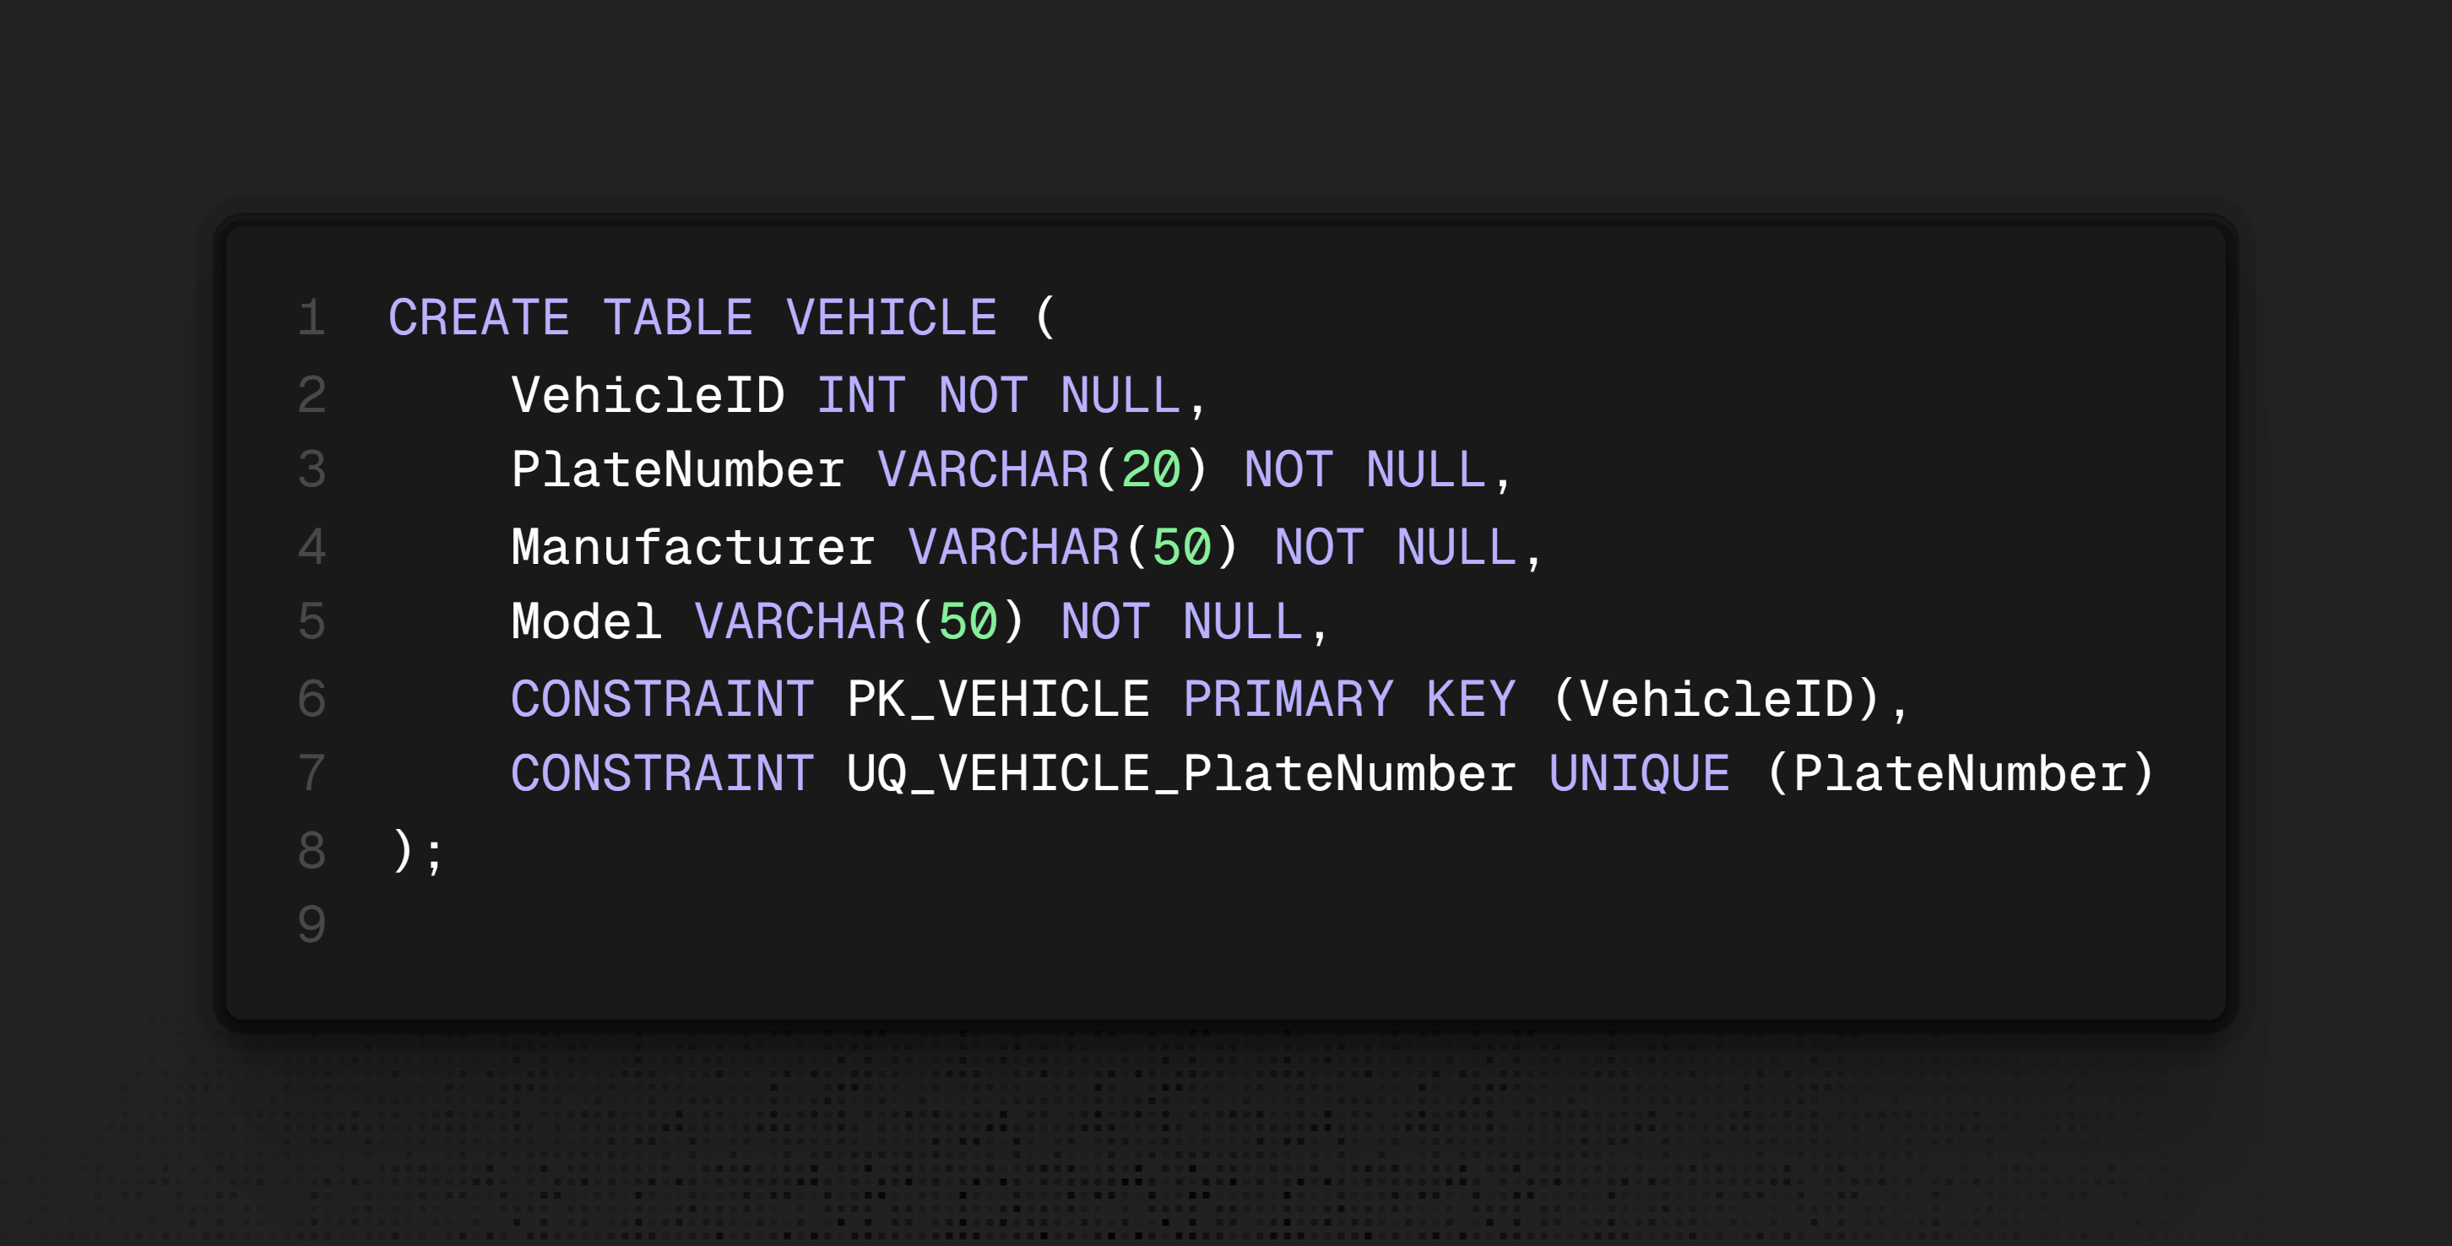
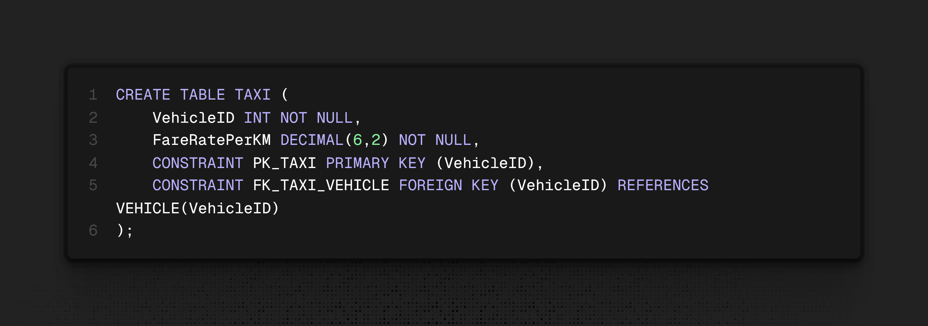

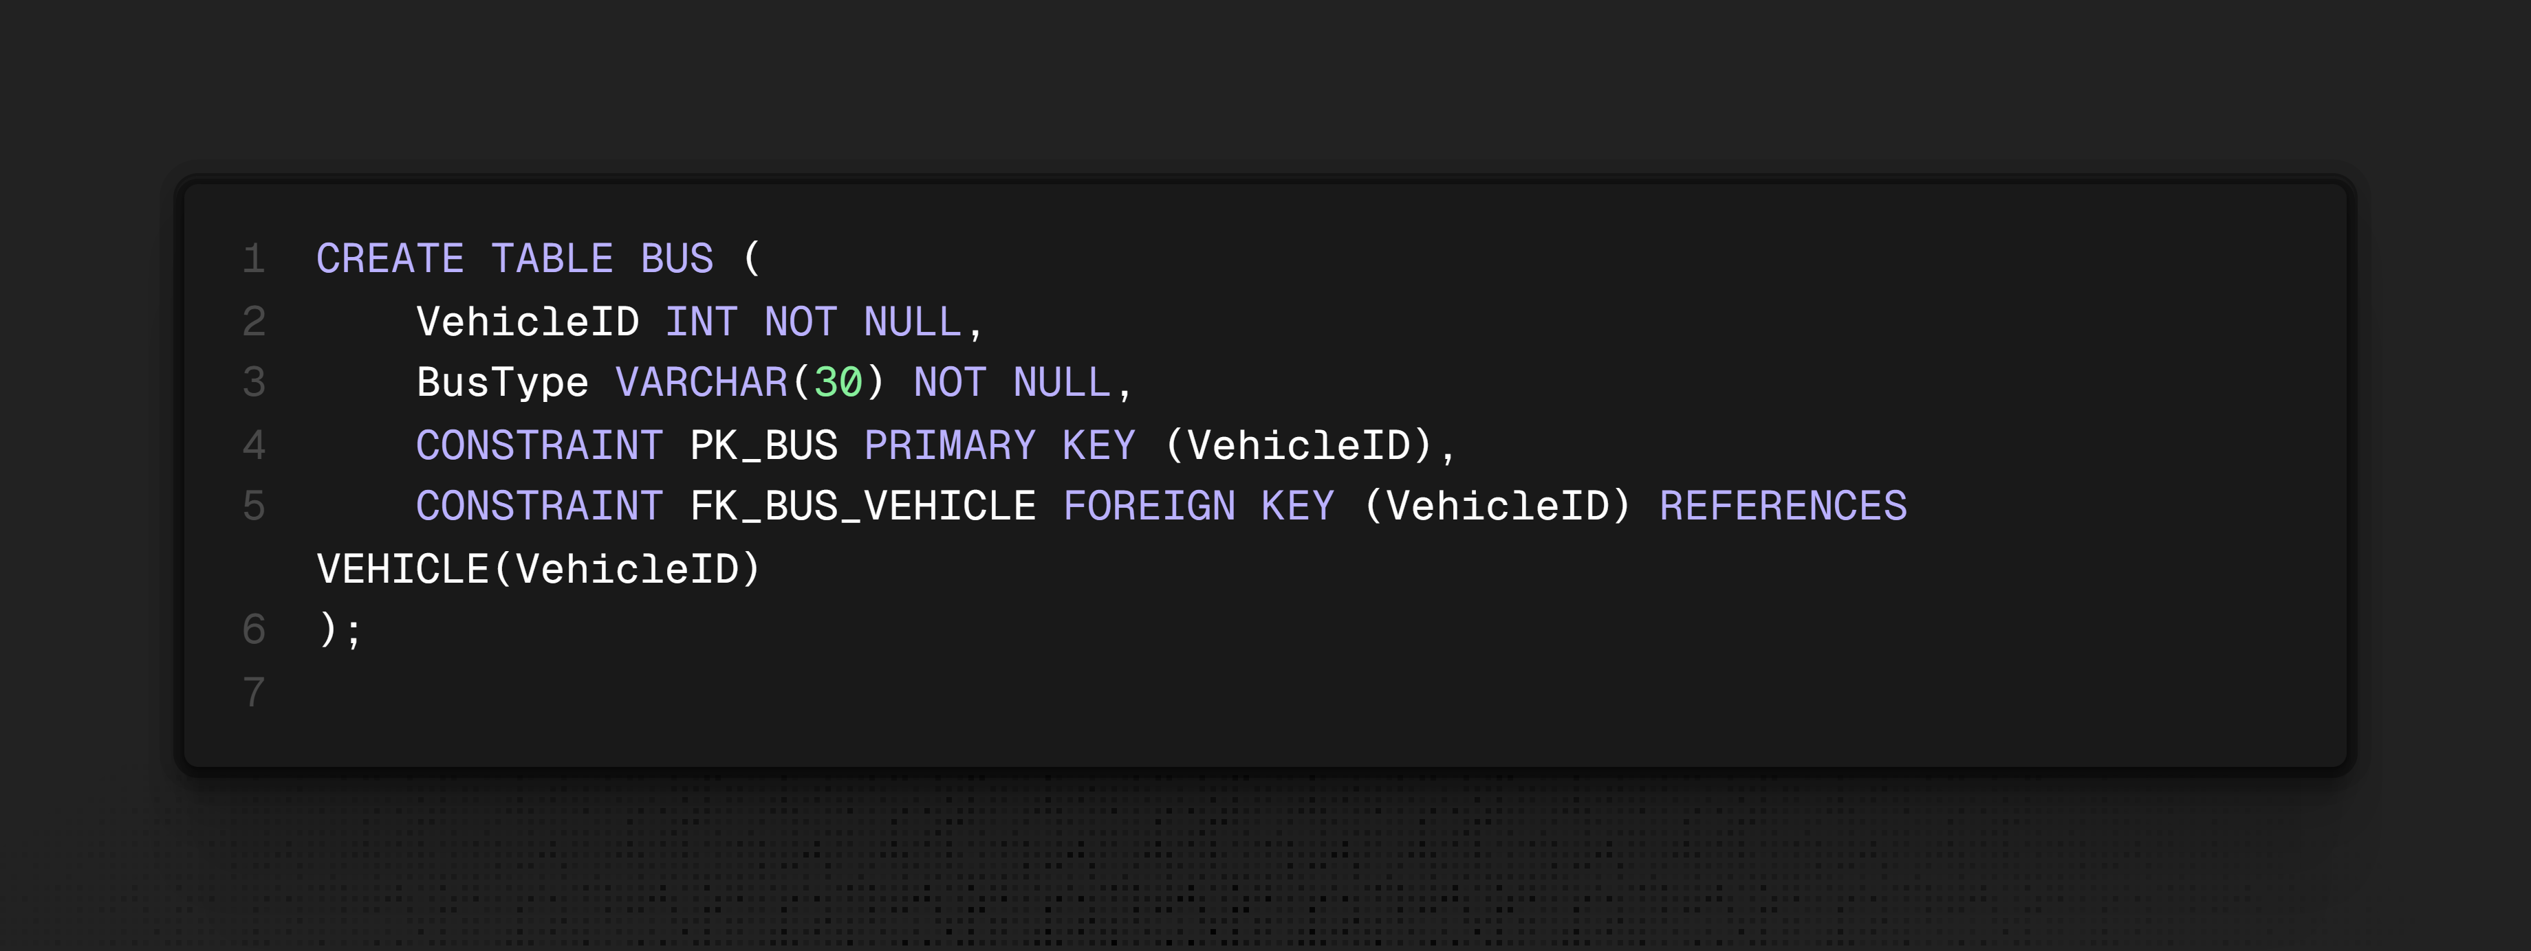
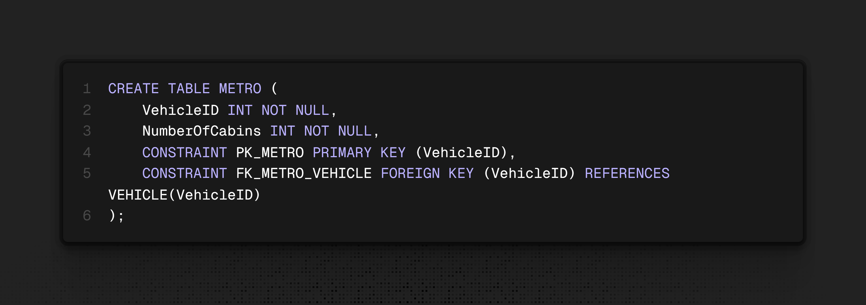
Table Insertion:

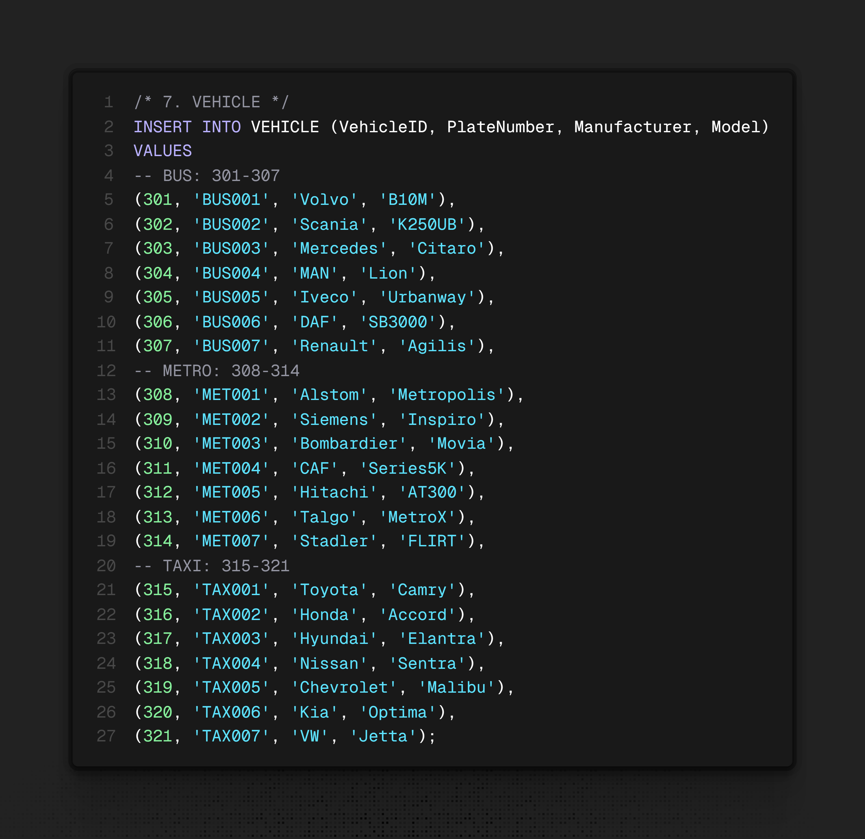

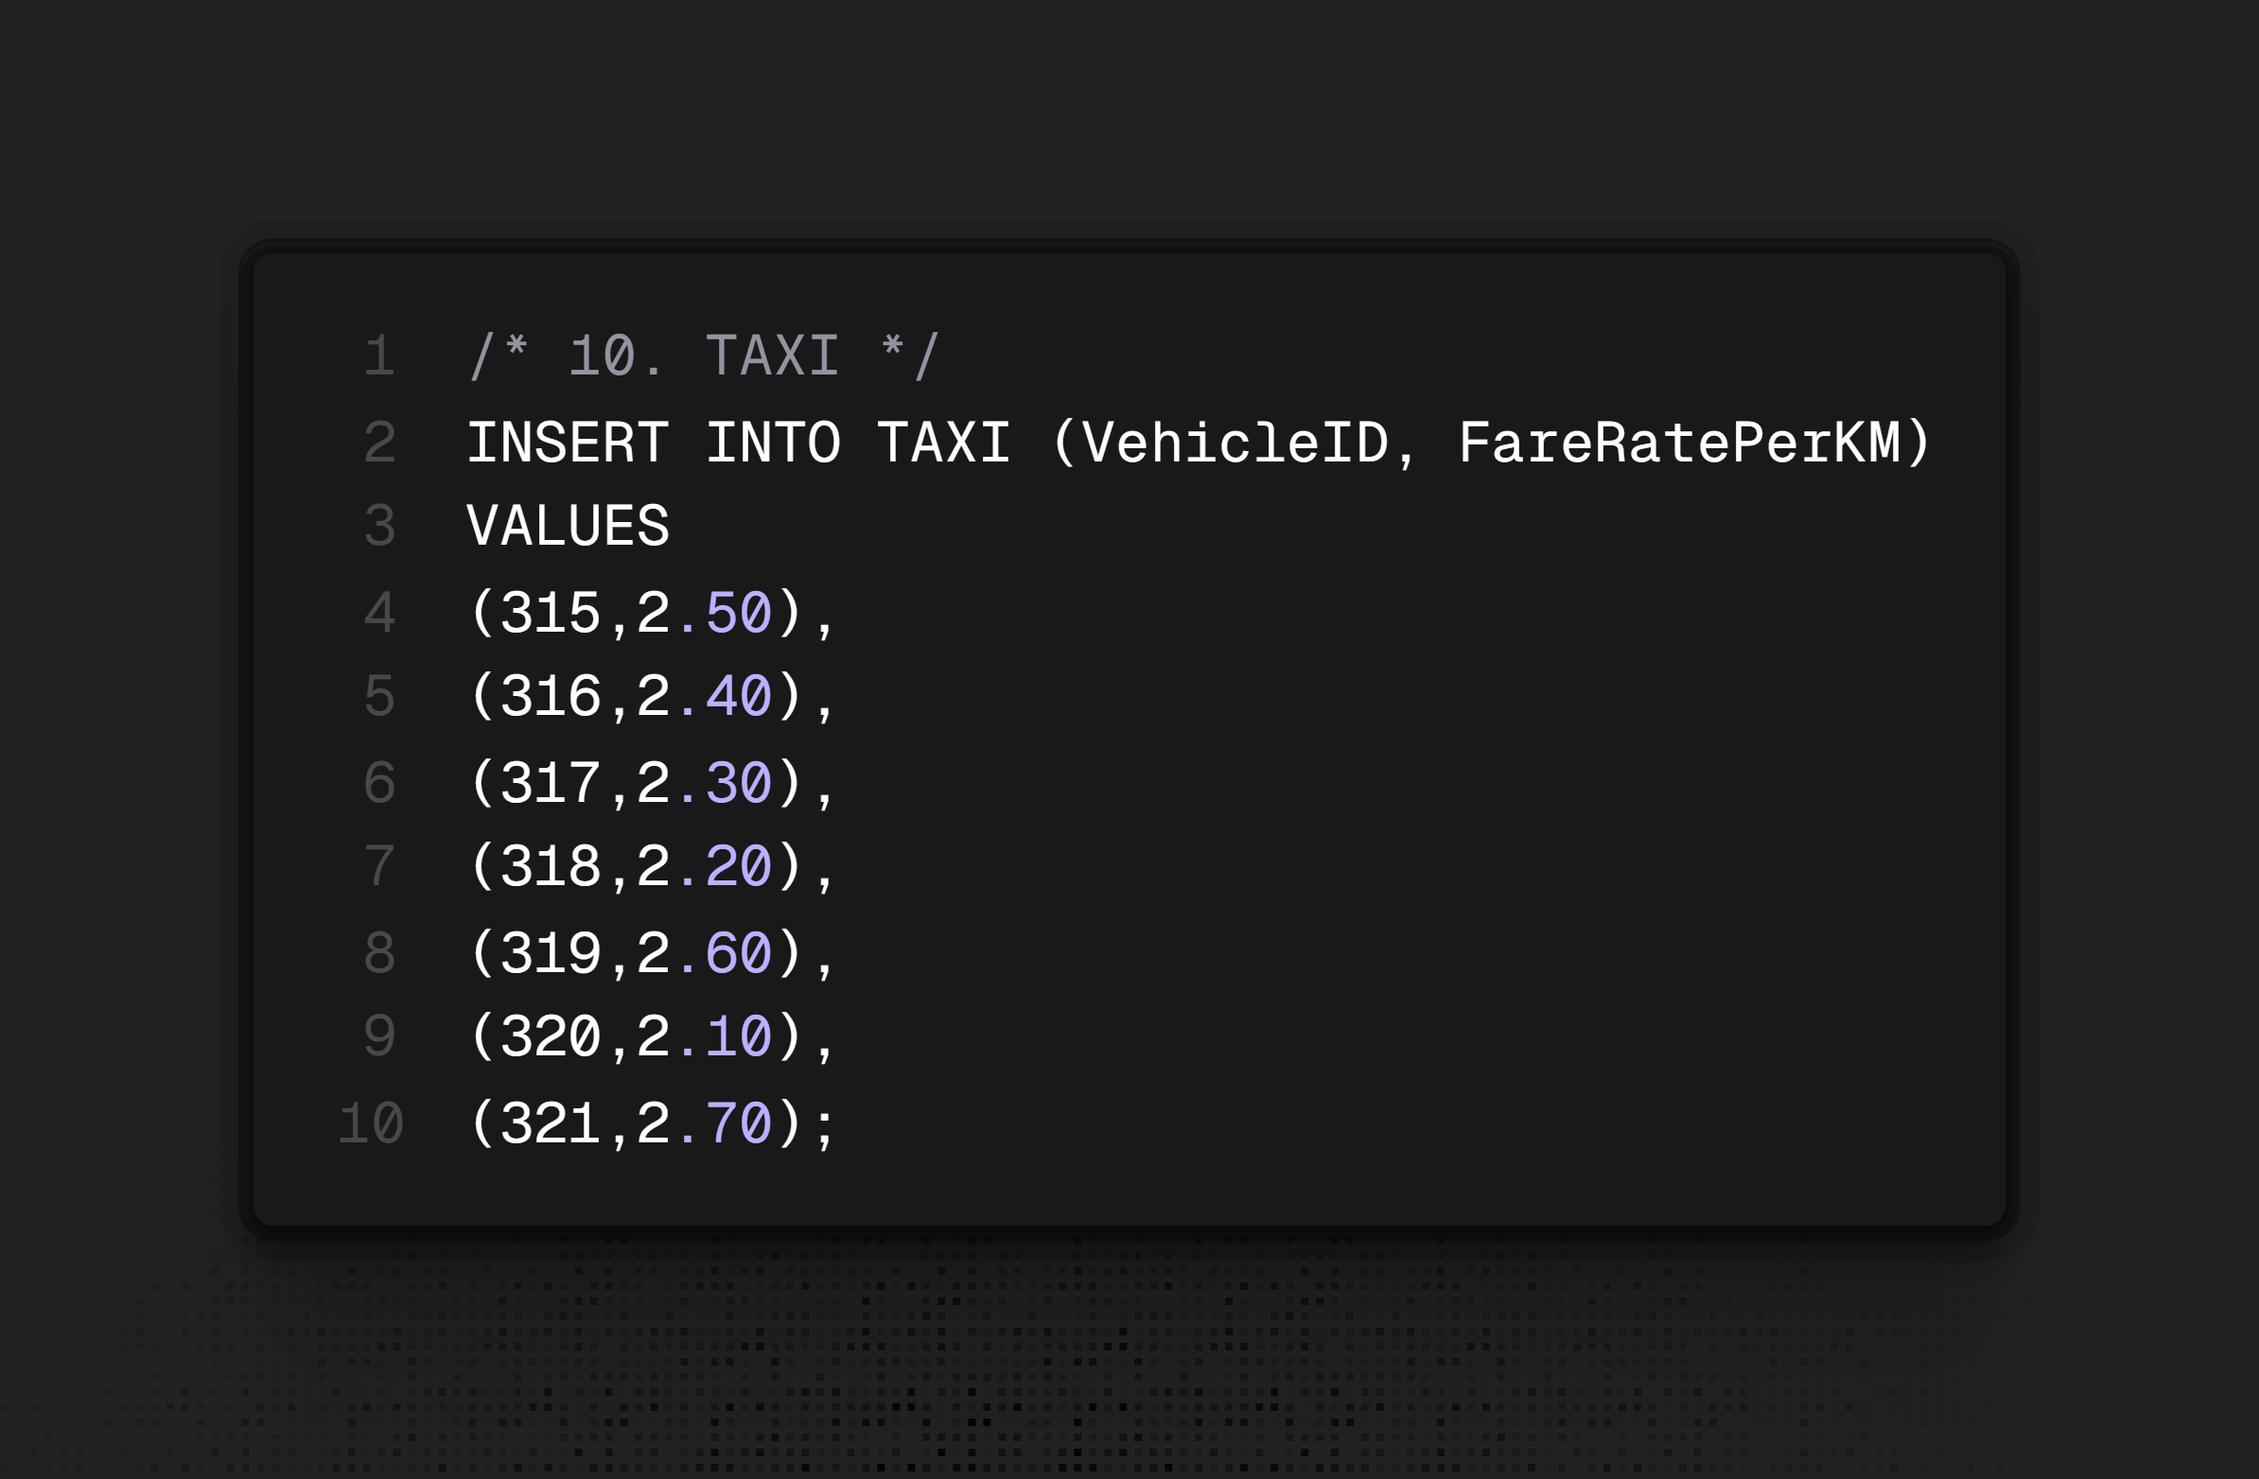

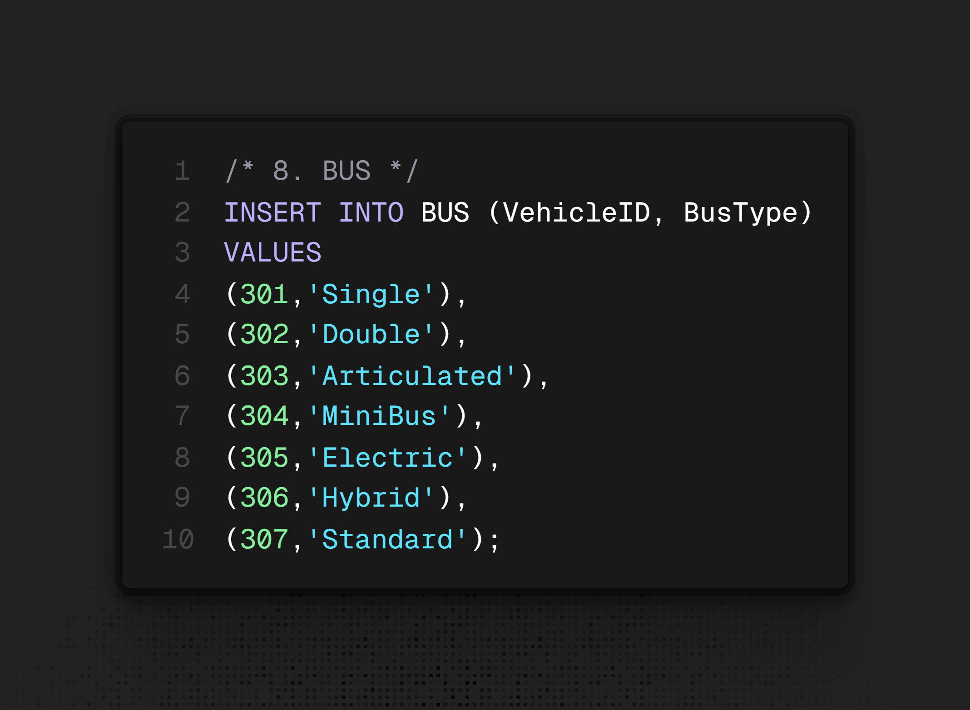
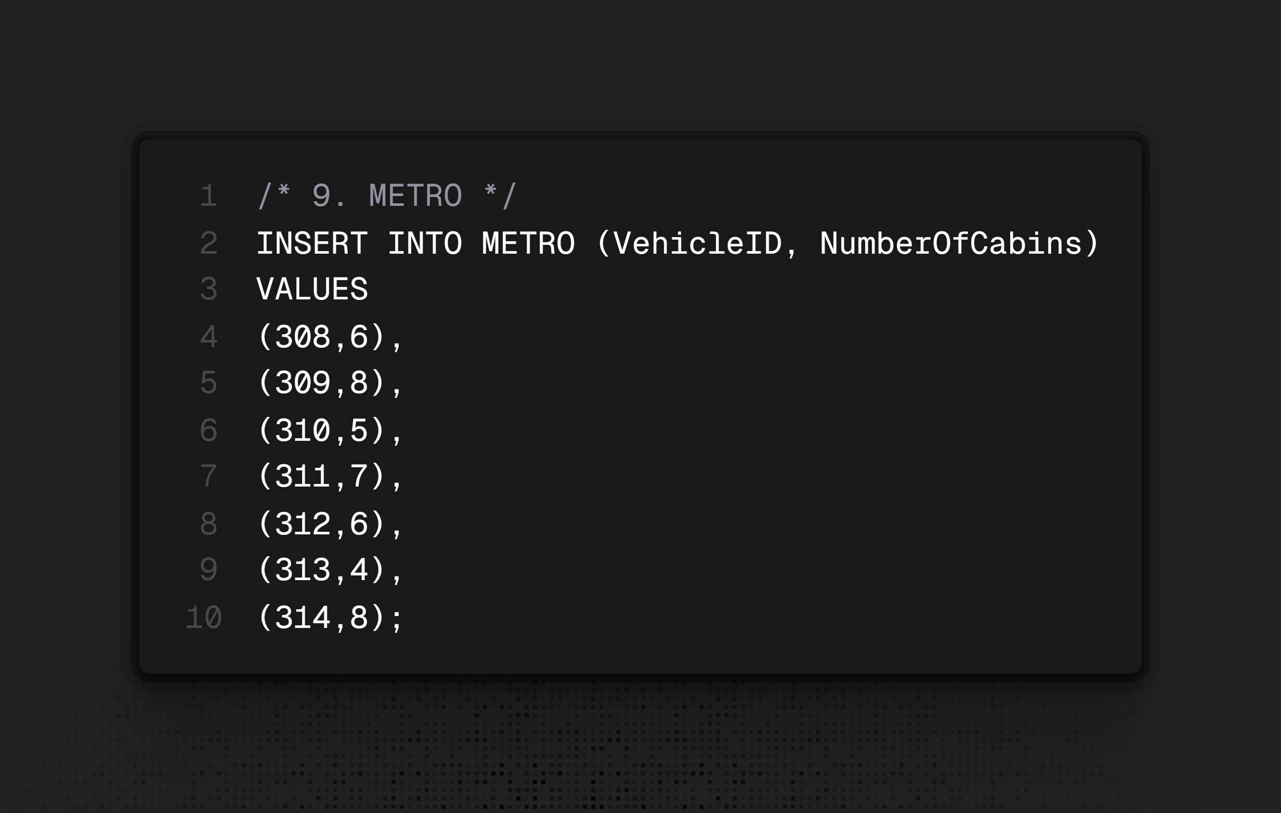
Queries:
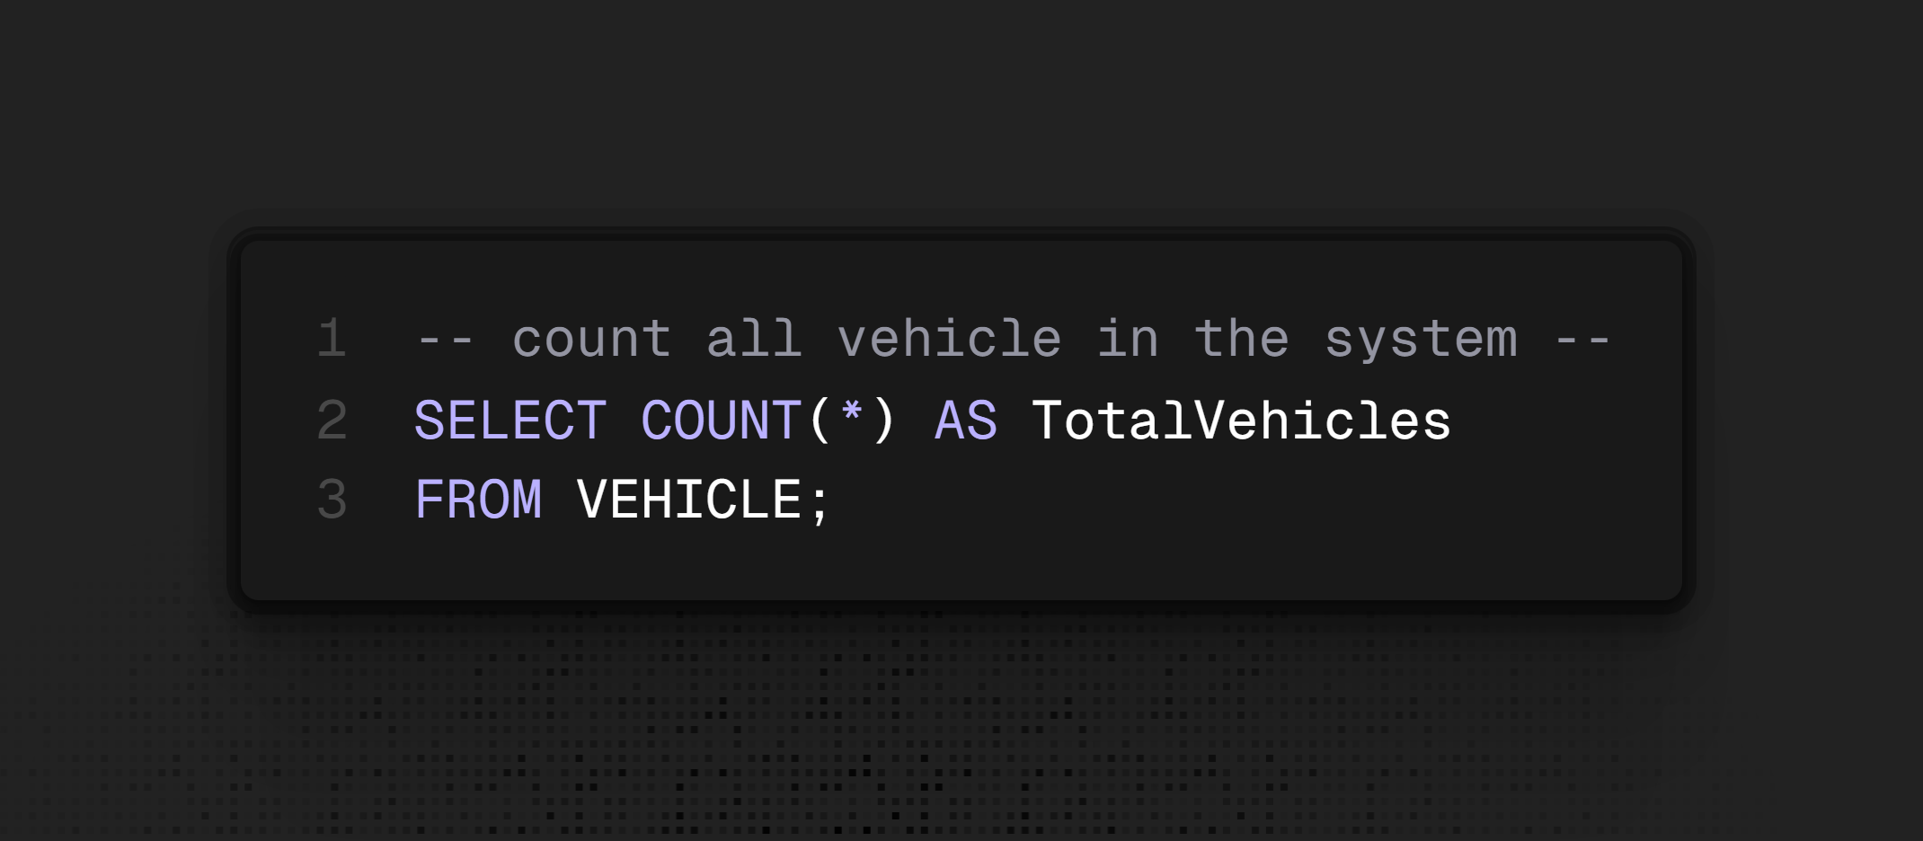
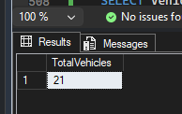

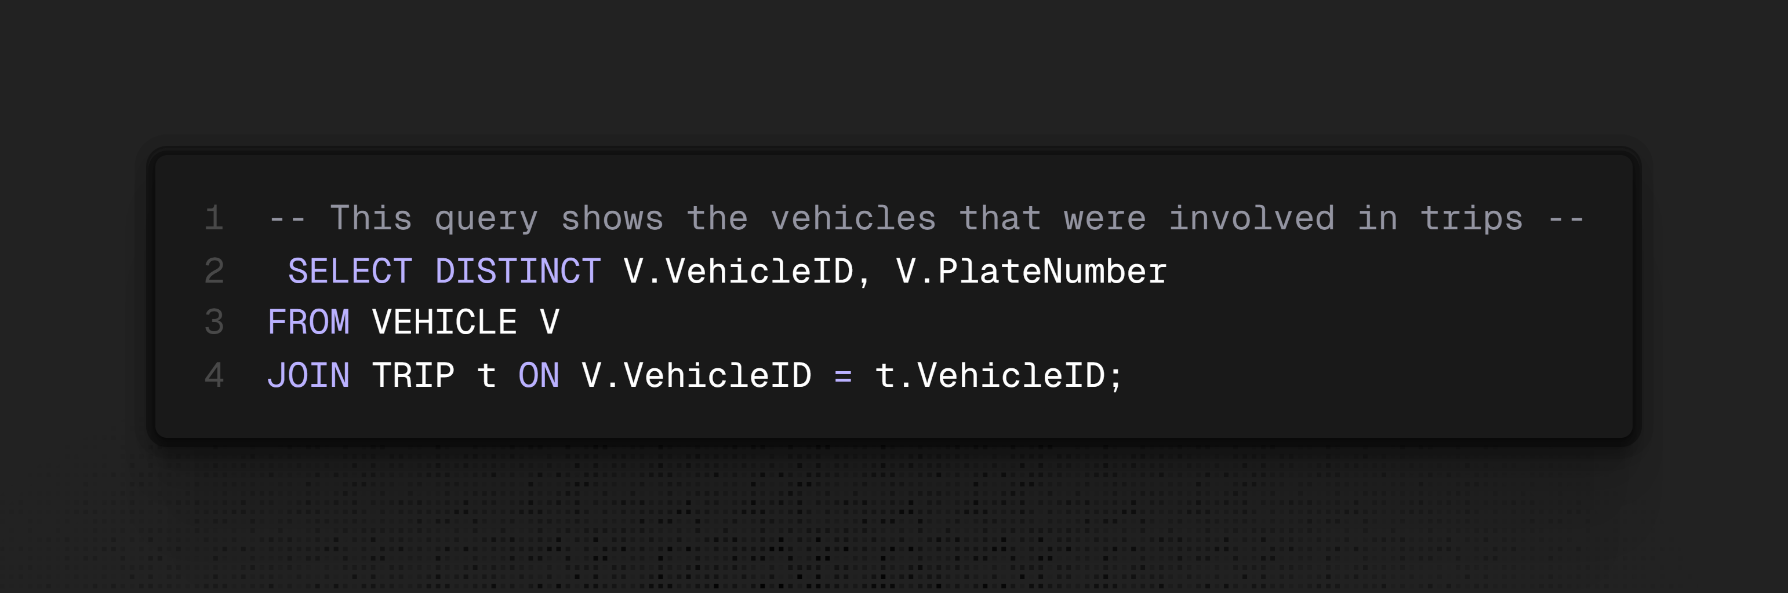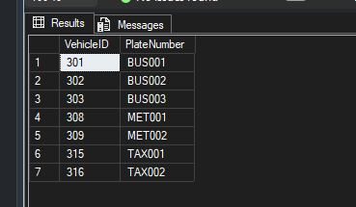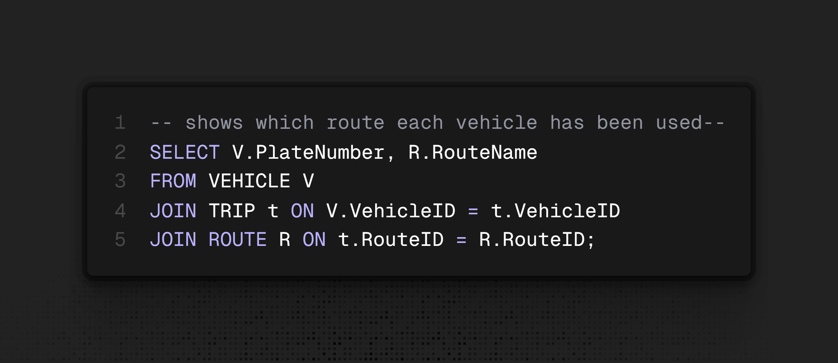
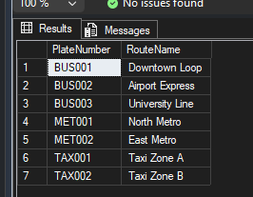
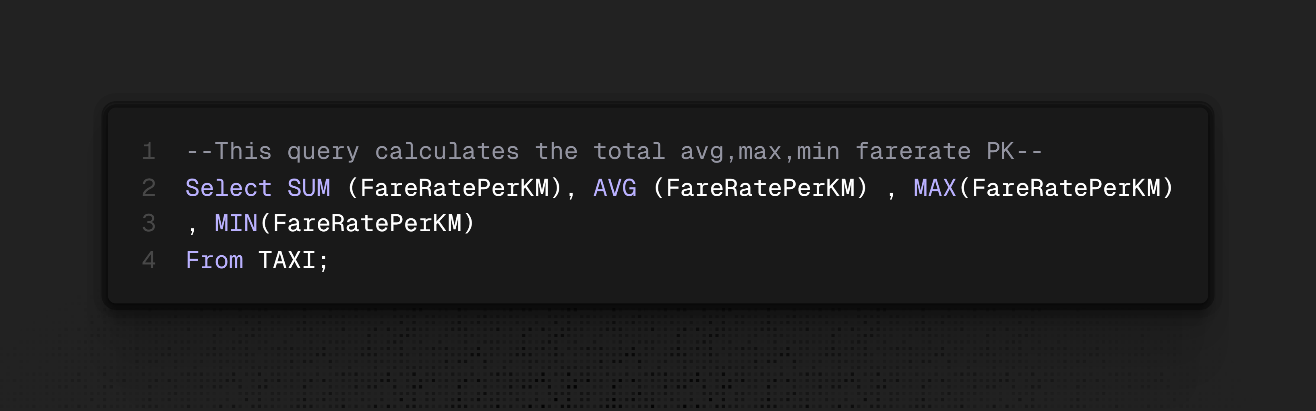
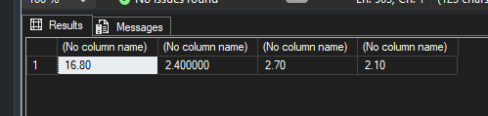

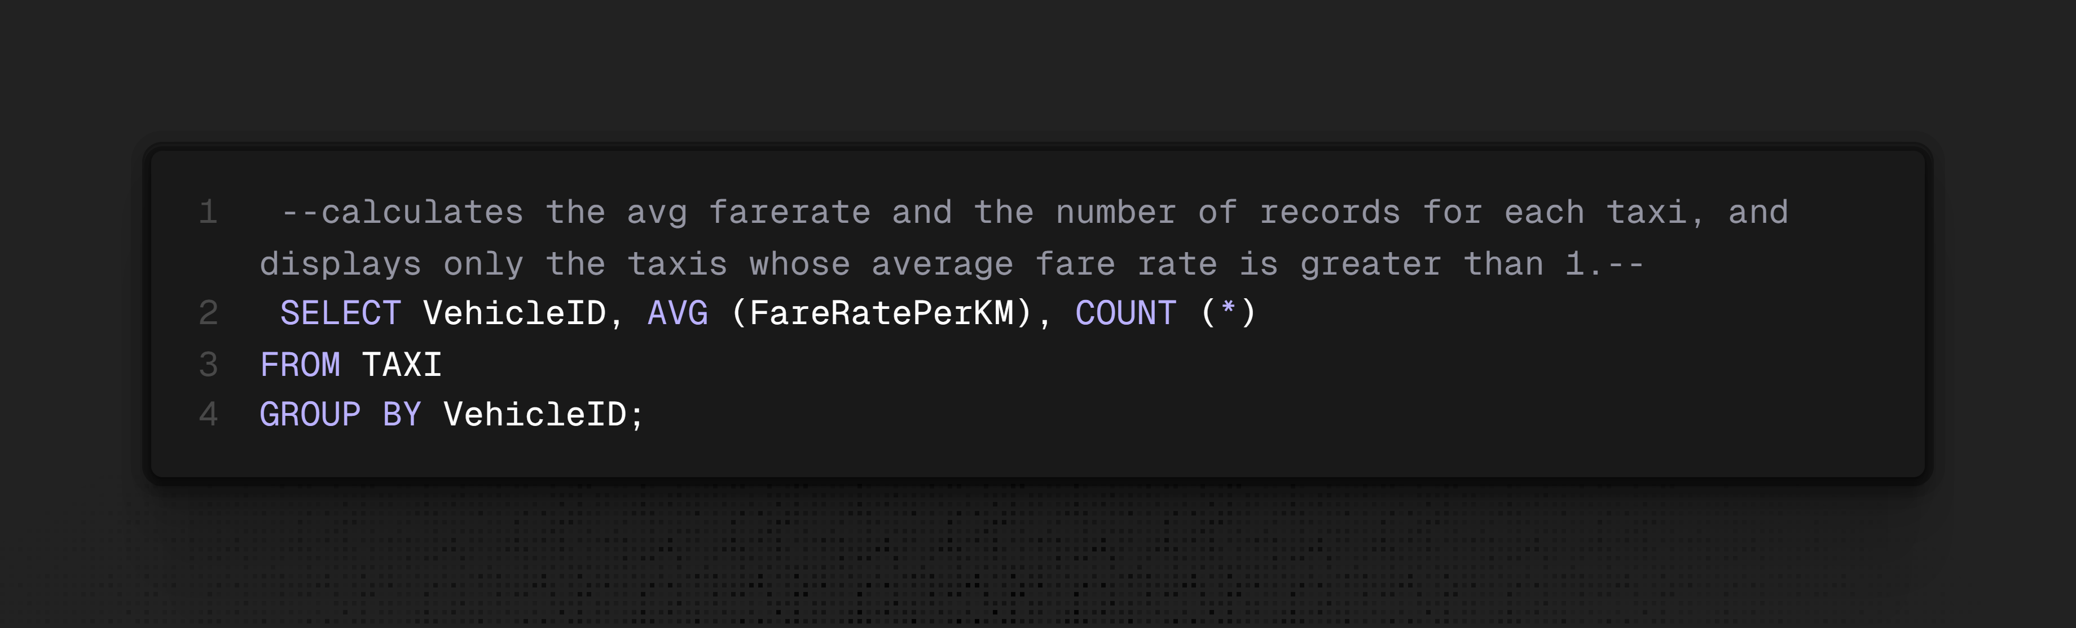
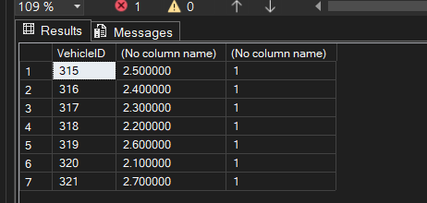
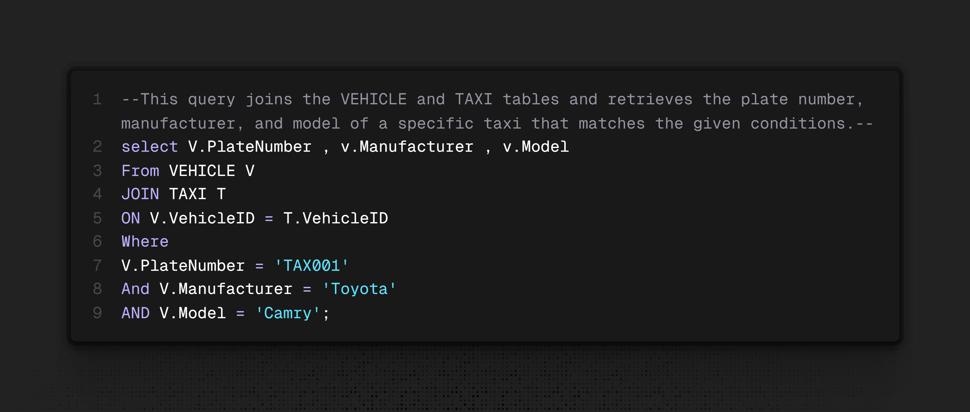
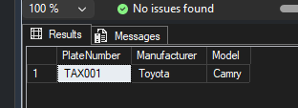
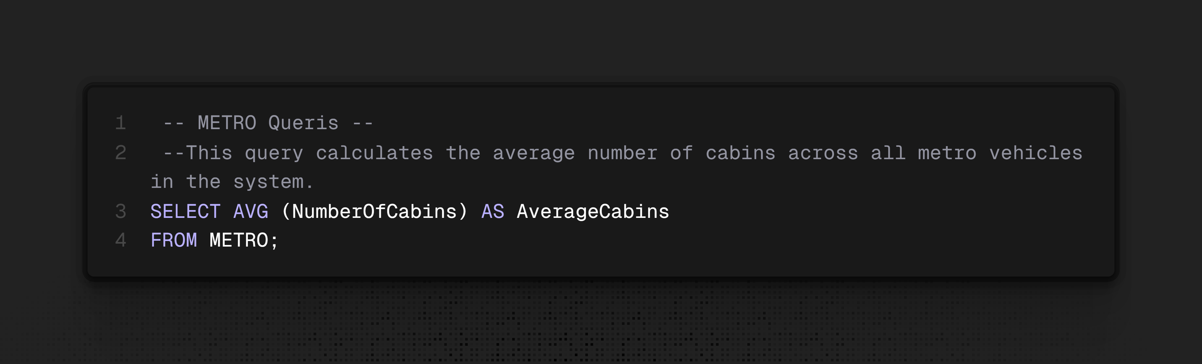
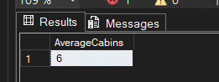

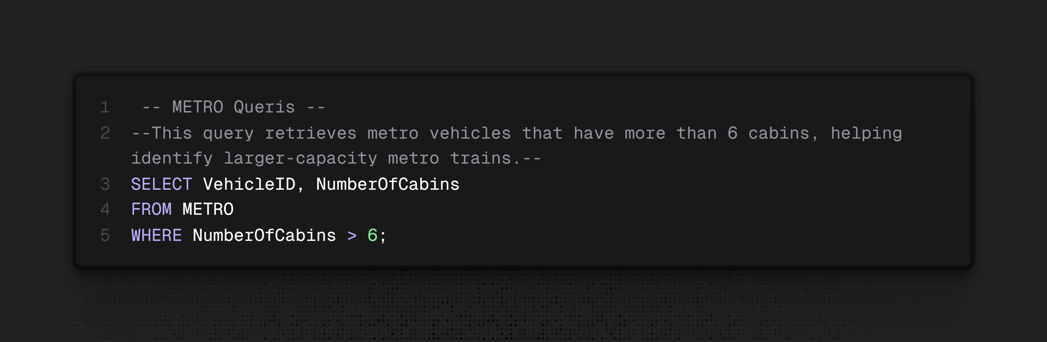
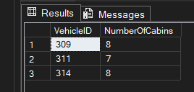

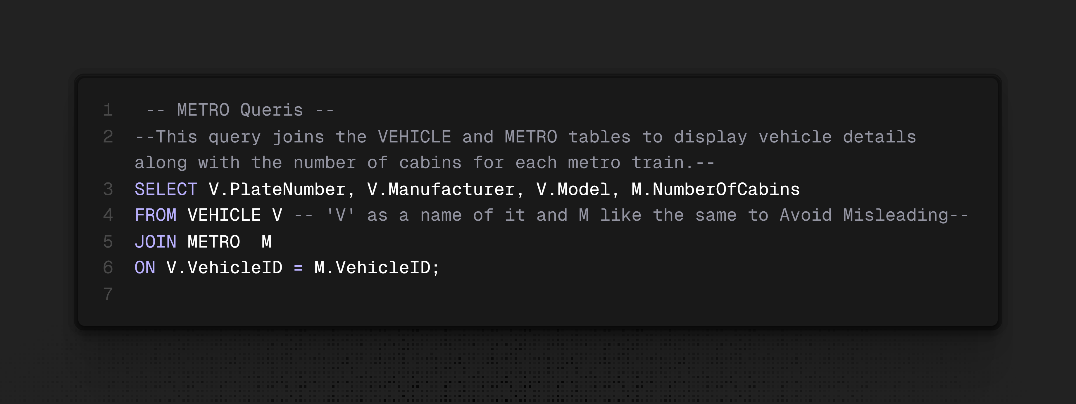
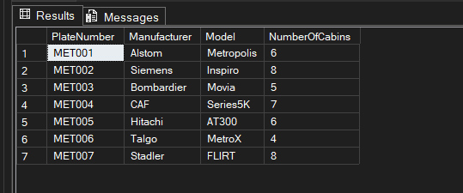
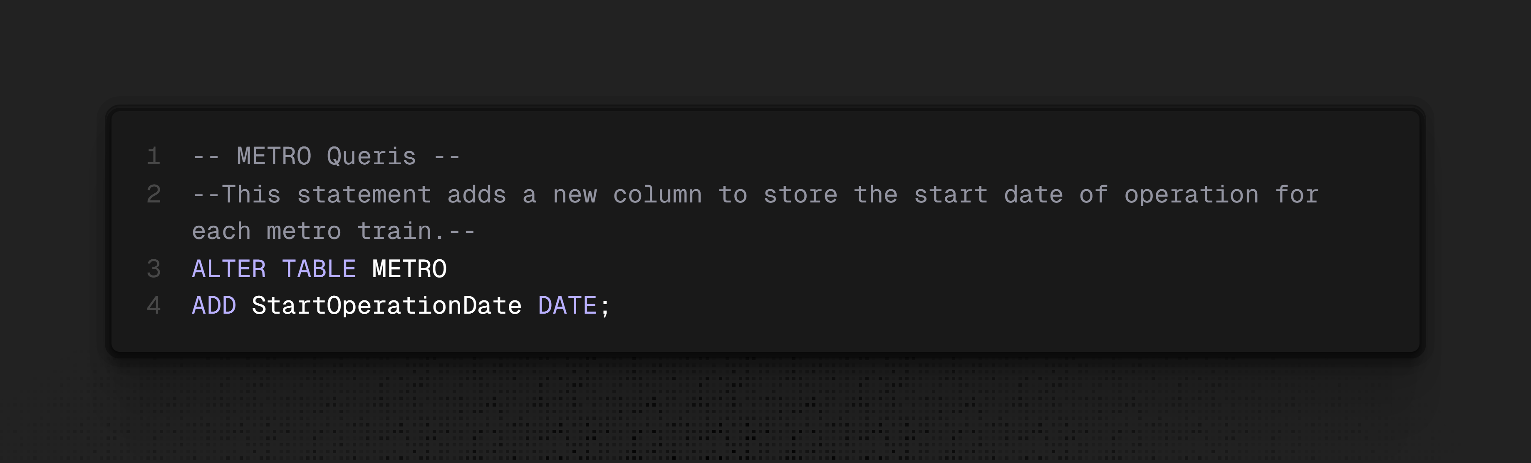

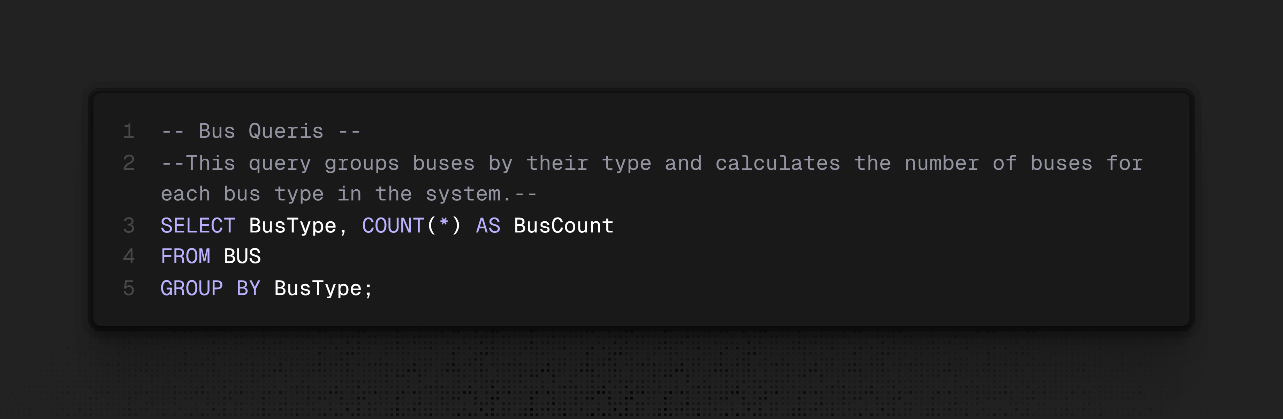
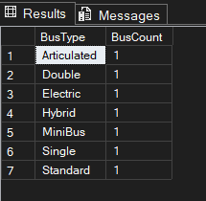
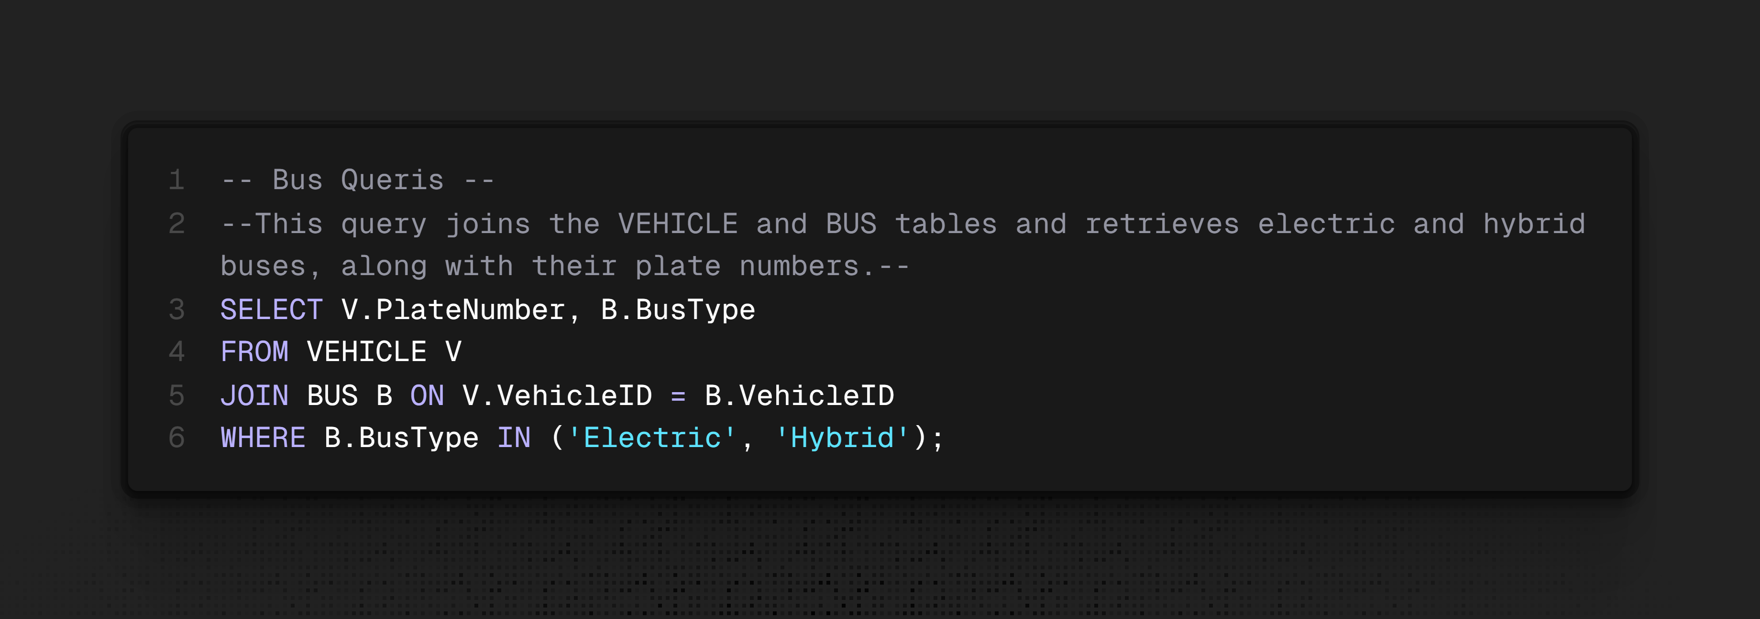
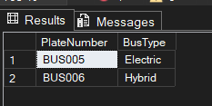

Seif Adel Mahmoud 258748
Table Creation: 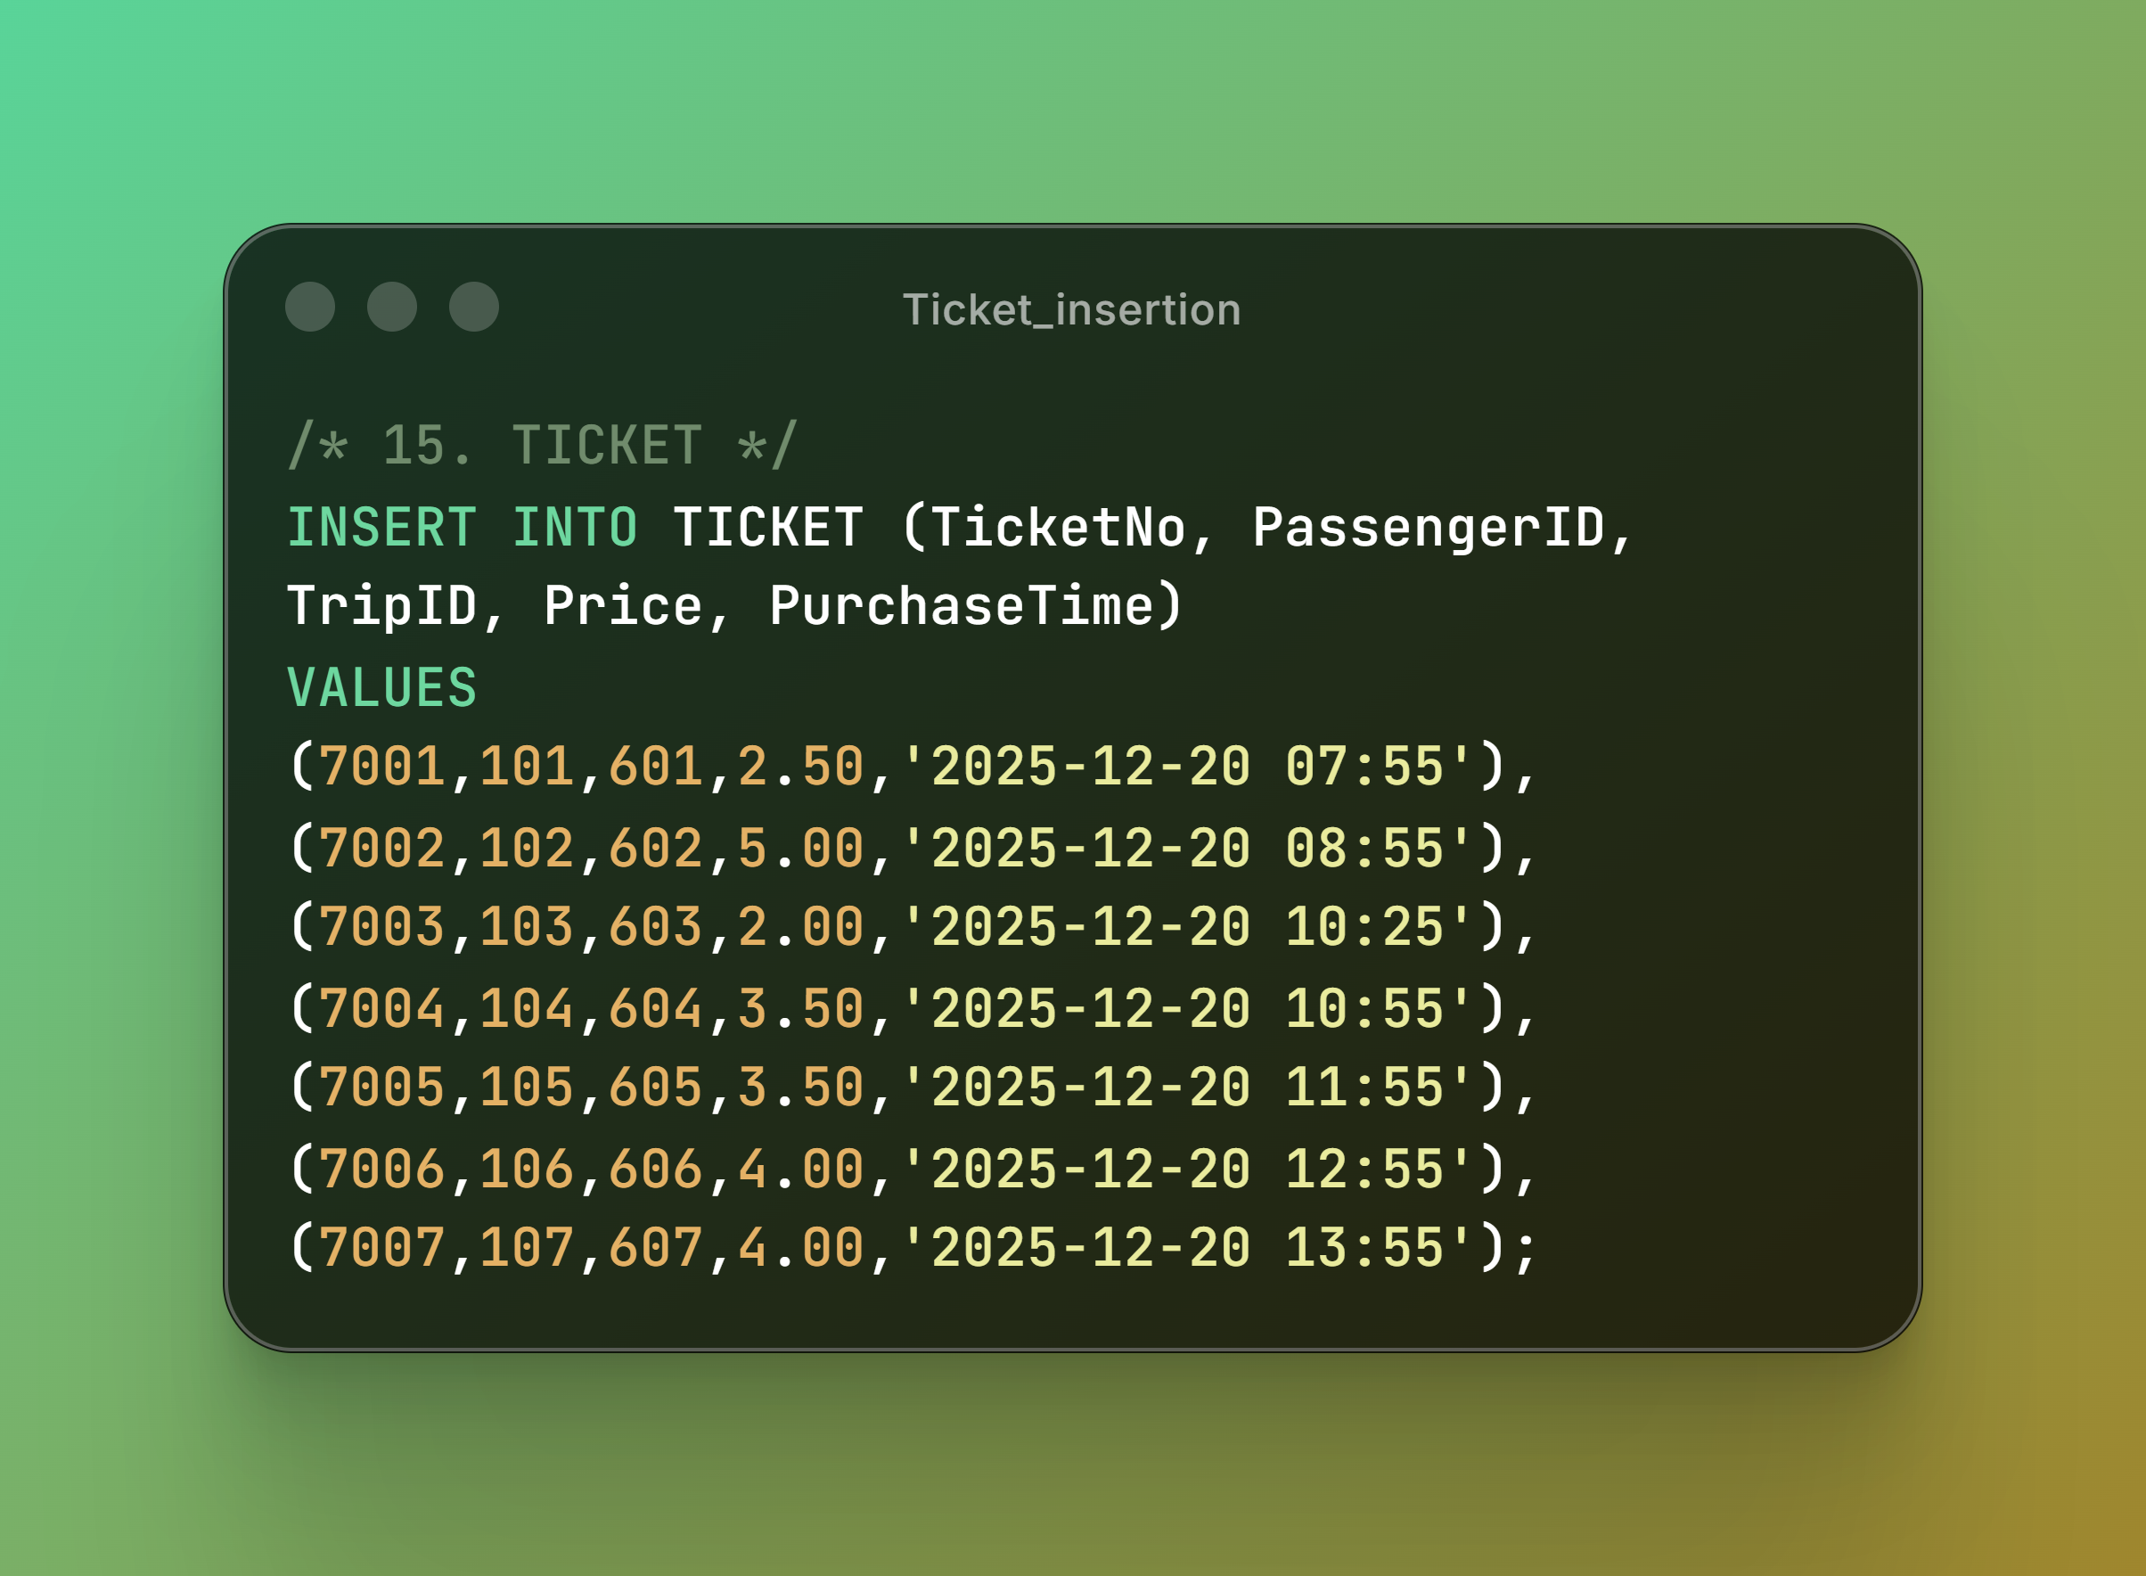
Table Insertion:
Queries:

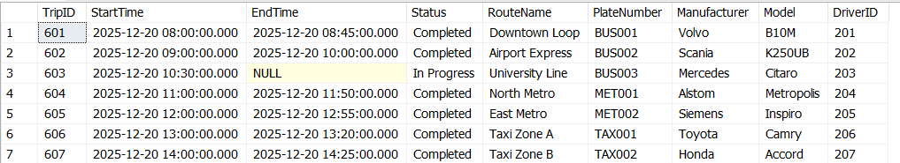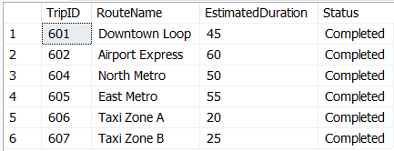
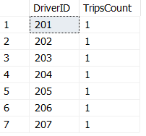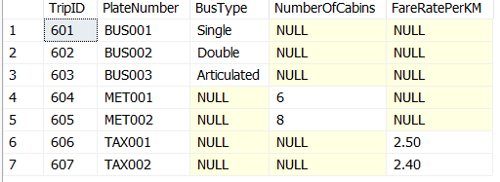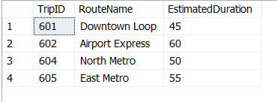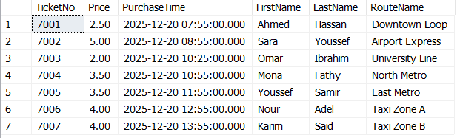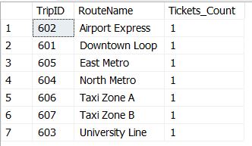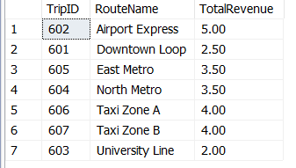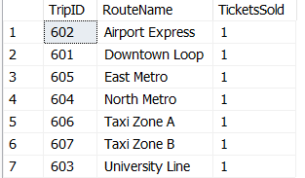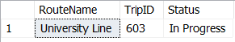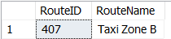
Alter Table: 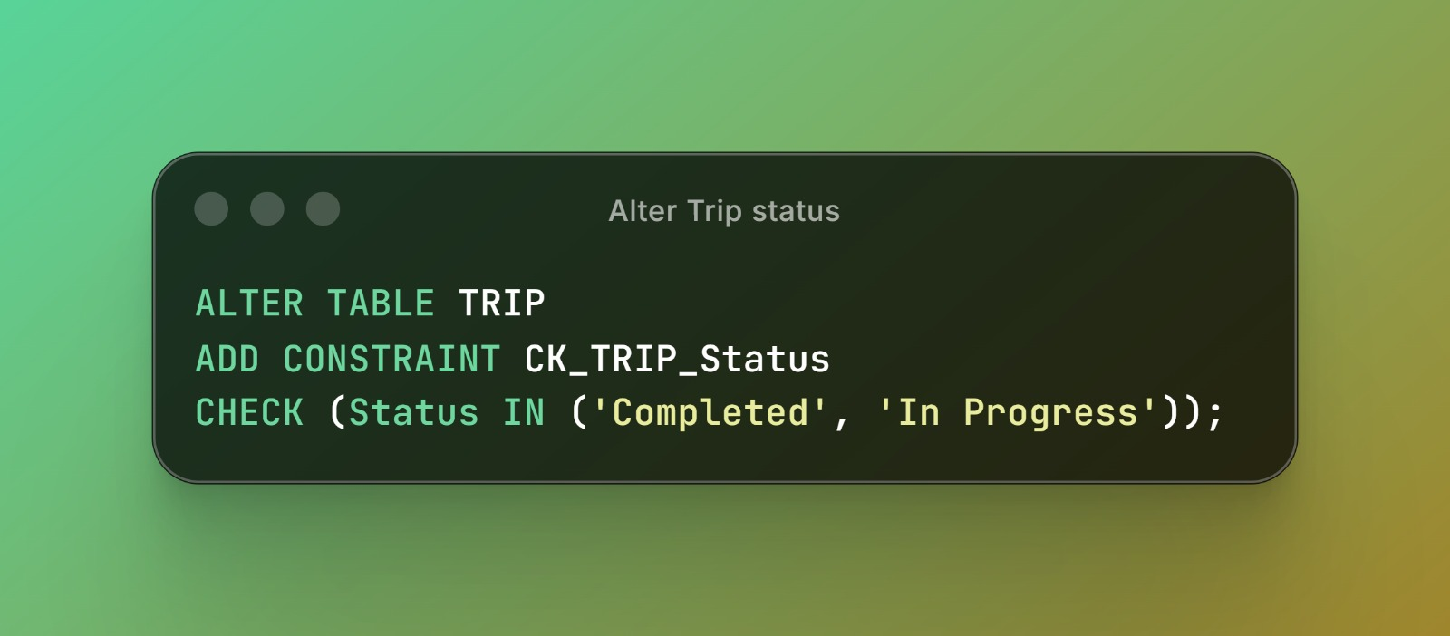
Hassan Moustafa Nosir 255444
Table Creation:

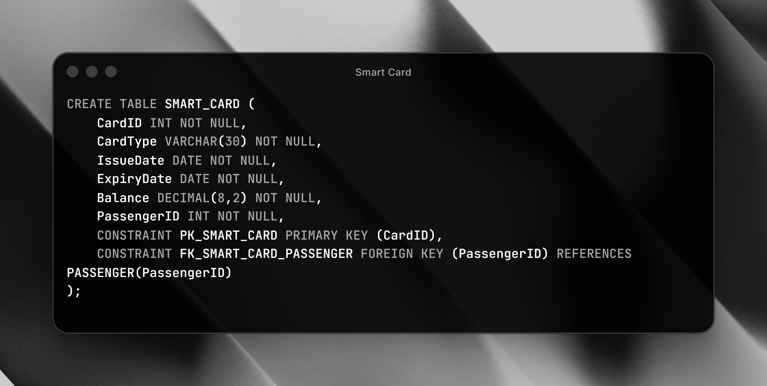

Table Insertion:
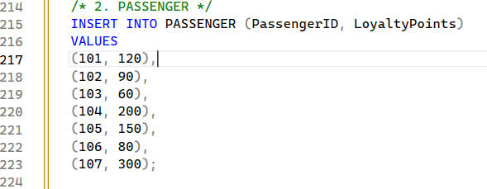
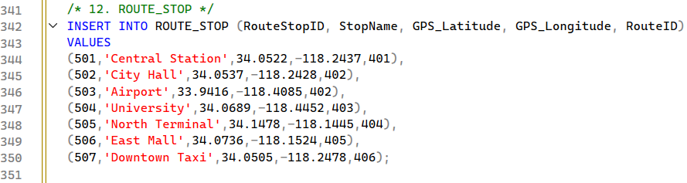
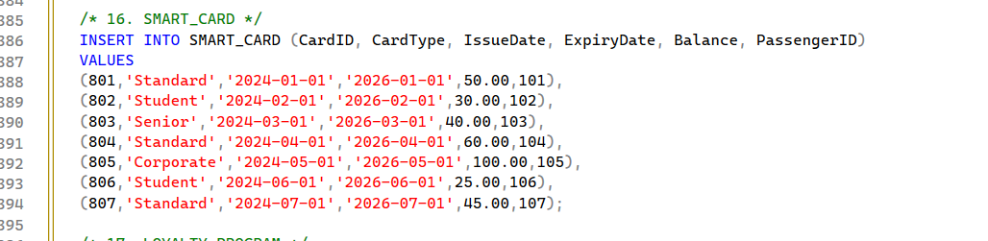

Queries:
