****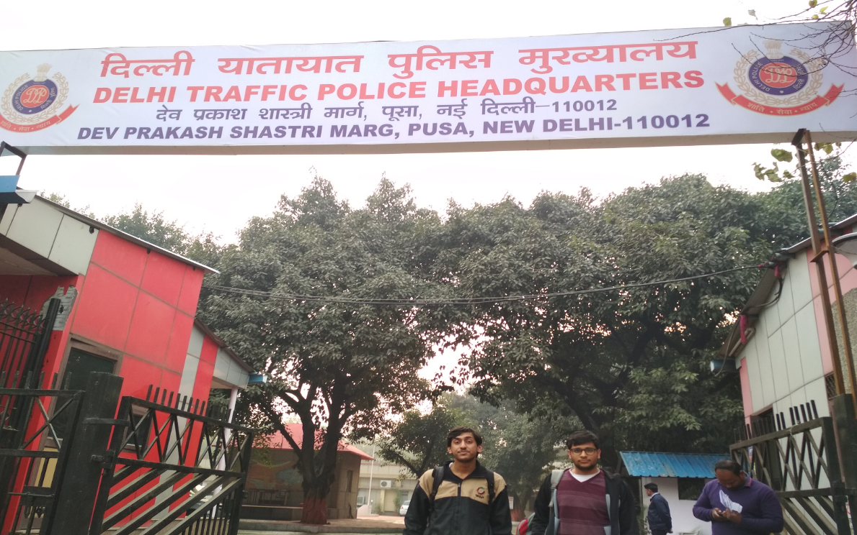

Authors

**Mukul Garg**

[**m4mukulgarg@live.com**](mailto:m4mukulgarg@live.com)

**Sajal Garg**

[**mrgarg2@gmail.com**](mailto:mrgarg2@gamil.com)

**Samridhi Jain**

[**samridhijain27@gmail.com**](mailto:samridhijain27@gmail.com)

**Saurav Panwar**

[**panwar.saurav1998@gmail.com**](mailto:panwar.saurav1998@gmail.com)

**A Trek to Delhi Traffic Police Headquarters**

Abstract

Mobility on Indian roads has been on the rise in the last few decades and will continue to increase further. This has caused some serious issues like traffic congestion on narrow road stretches and unsafe roads and driving conditions. The frequency of accidents caused due to crashes increases due to traffic congestion. It also leads to road rage. Therefore, controlling traffic on roads, highways and especially on narrow and busy streets is the need of the hour. This report focuses on the idea of switching the traffic lights according to vehicle density on road. In further stages multiple traffic lights can be synchronized with each other with an aim of even less traffic congestion and free flow of traffic. Moreover, the system can also be programmed for emergency scenarios such as passing of ambulance vehicles and fire-trucks, providing green corridors that require virtually zero congestion.

**INTRODUCTION AND MOTIVATION**

Delhi is the Capital city of our country and one of the most populated cities of the world. With increasing population the no. of motor vehicles is also increasing rapidly. Despite being the NCT, the traffic control system is not up to speed. Out of approximately 70 traffic circles (regions of traffic policing) of the state, there’s hardly any where there is no traffic congestion.

In this trek we aim to find out the root cause of the problems faced by the city in regard to smooth traffic flow. It came to our attention that most of the issues were:

1. **Roadside encroachment** by e-Rickshaw, TSR, *gramin seva* vehicles and street vendors who take up most of the road and leave no space for other vehicles to pass. Also roadside parking which renders the roads blocked and cause congestion.
2. **Slow moving vehicles in fast lane,** public transport vehicles, commercial goods vehicles block potential fast movers, e.g. motor-bikers, private cars etc. which causes road rage and accidents.
3. **Traffic signal offenders**, drivers who rather than stopping at yellow lights, accelerate so they don’t have to wait for the signal to turn back green, thereby risking the life of others along with their own.

Observing these situations in the National Capital Territory itself, we decided to pay a visit to the Delhi Traffic Police Headquarters to find out more about the situation from the people who have one-on-one experience of dealing with these situations.

**SOCIO-ECONOMIC BACKGROUND**

According to the Economic Survey of Delhi, 2015 “The total number of motor vehicles on road in NCT of Delhi as on 31st March, 2015 was 88.27 lakh, showing an increase of 6.4 per cent over previous year. The category wise number of motor vehicles in Delhi is presented in Statement 12.1”

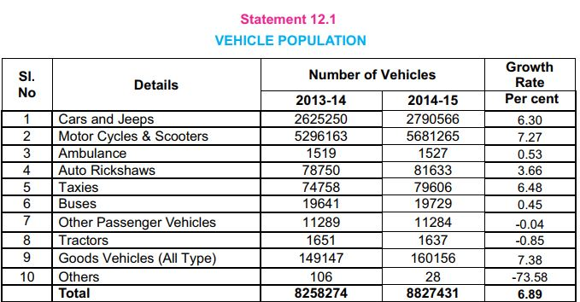

“The annual growth of vehicles in Delhi increased from 4.72 per cent in 1999-2000 to 6.89 per cent in 2014-15. During the same period the number of vehicles per thousand population increased considerably; from 253 to 487.”

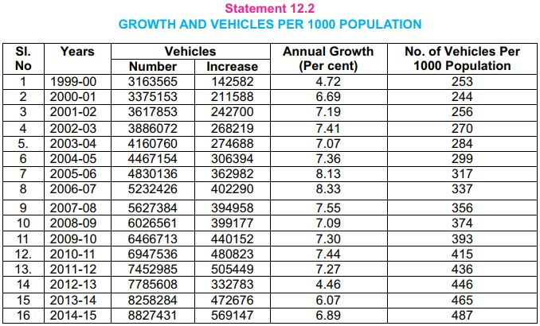

**EXPERIENCE of INTERACTION**

To get deeper perspective of the traffic flow in the city we went around the city to talk to different traffic cops.

Most of the cops were busy in their job and could not spare few moments for us.

The first cop we talked to was **Mr. Ram Swaroop** who was kind enough to give us a few moments of his time. Let’s take a look on some of question we asked him.

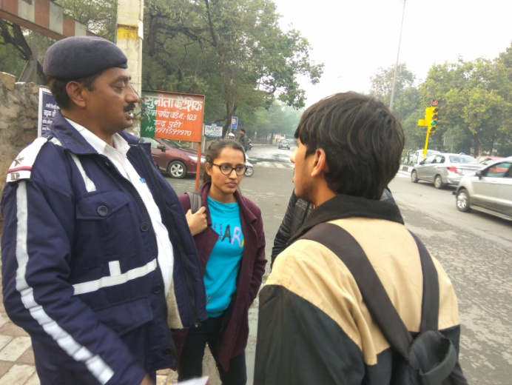

**SUMMARY OF INTERACTION WITH TRAFFIC COP**

**Q: What is the most basic problem you suffered in Delhi traffic?**

**A:** The most basic problem we see is that people don’t want to obey the traffic rules, many people only follow the traffic rules whenever they see a traffic cop. **(He showed us the example of a distant biker riding without helmet who took a U-turn as soon as he saw the cop).**

**Q: What do you think how can we solve this problem?**

**A:** Strictness of traffic rules and fines should be increased.

After this we went to *Hauz Khas* where we got to talk to talk to **Mr. Rohit.** He met us at a junction near *Hauz Khas* Metro Station.

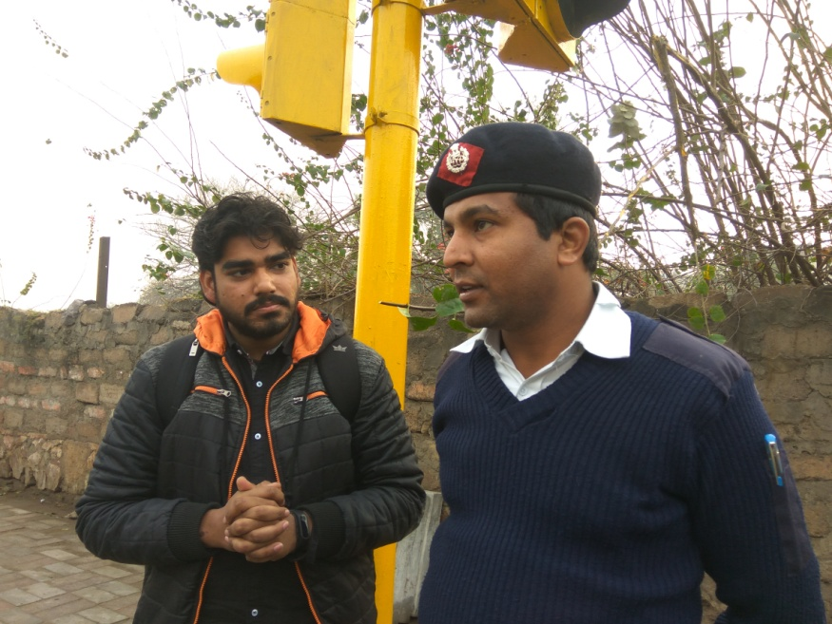

**SUMMARY OF INTERACTION WITH MR.ROHIT**

**Q: How traffic light works?**

**A:** He explained that at every junction we have traffic lights which are connected to a timing circuit, the switching of the lights take according to the **timer alone**.

**Q: Is there any problem with this traffic light system?**

**A:** In peak hours when there is high mobility of traffic to off-peak hours with low mobility of traffic it was observed that switching time remains the same and he needs to update the time manually for smooth flow.

**(By talking them we realized that no automated system for switching of traffic lights according to vehicle density is available)**.

After talking to Traffic cops we went to traffic headquarter on *PUSA Road*, while reaching there only we saw the adverse conditions of traffic. It took more than 30 min. to get a cab from metro station to headquarter.

Finally on reaching there we talked to **Mr. Dhanvir**. He looked like an army man and was a complete gentleman. He welcomed all of us provided us with refreshments and gave his un-diverted attention to answer our questions. It was due to his guidance we were able to understand the major problems faced by Delhi Transport. Let’s take a look at some questions we asked.

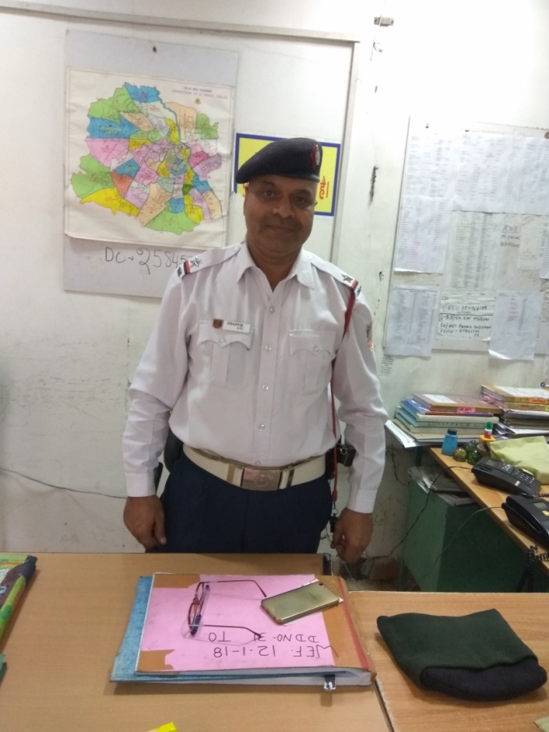

**SUMMARY OF INTERACTION WITH MR. DHANVIR**

**Q: According to you what you think is biggest problem of Indian traffic?**

**A:** According to me, the biggest problem in Indian traffic is lack of awareness of traffic rules. And after that our traffic lighting system.

**Q: What types of awareness?**

**A:** Awareness about traffic lights, U-turn, zebra crossing and encroachment.

**Q: What are the problems with traffic light camera?**

**A:** There are few problems come in using camera at traffic lights.

1. Due to reflection from sun nothing is clearly visible in camera.
2. In night also the picture is not clear because of reflection from headlight of vehicles.
3. Securities of cameras are very poor.
4. Their pixel quality is also very poor **(not more than 2-4 pixels)** which is not enough.

**PROBLEMS IDENTIFIED**

The conclusion we have drawn from our trek is as follows:

* 1. Sensitization towards road safety: The drivers in the state are not very sensitive towards rules of road safety and there is a need of educating the drivers.
  2. Traffic control: The current traffic signals are not very well equipped to handle the irregular traffic patterns of the city. In the conventional traffic lights after every preset time the light switches back to red.
  3. Ineffective enforcement: The rules are enforced by either policemen appointed on the signals/on the road or by INTERCEPTOR vans which are not very effective as the cops cannot be available at every signal or every stretch.

Problems with current Interceptor Vans are

* + 1. Extremely poor resolution of camera.
    2. Unable to detect fast-moving vehicles
    3. Reflection from the sunlight blinds the camera.
    4. Drivers turn high-beam which blinds the camera
  1. Unplanned construction: The design of roads, highways and even the metro lines is not well suited and not very well planned. There are lots of intersections where two traffic lanes merge and form bottlenecks causing congestion.