PARALLEL AND DISTRIBUTED COMPUTING
UCS645
ASSIGNMENT-1

1) Results Analysis of Answer 1(DAXPY Loop):
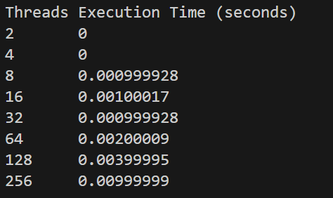
Tested DAXPY with N = 2¹⁶ = 65,536 elements and varied threads up to 256.
Observed Pattern
- For 2, 4, 8 threads → execution time = 0
- For 16 threads → ~0.001 s
- For 32–64 threads → ~0.001–0.002 s
- For 128 threads → ~0.004 s
- For 256 threads → ~0.01 s

Execution time is reported as 0 for small thread counts
For only 65,536 iterations, CPU finishes this in microseconds.
- omp_get_wtime() has finite resolution
- Execution time for 2–8 threads is below the measurable threshold
- Hence it prints 0 seconds

Execution time increases after 16 threads
After this point, performance gets worse, not better.
(a) Memory-Bound Nature of DAXPY
DAXPY performs:
- 2 memory loads
- 1 memory store
- Only 1 multiply + 1 add
This makes it memory-bound, not compute-bound.
- Memory bandwidth becomes the bottleneck
- More threads compete for the same memory

(b) Thread Oversubscription
When you run:
- 64, 128, 256 threads
But your CPU likely has:
- 8 or 16 physical cores
Result:
- Threads are time-sliced
- Heavy context switching
- More overhead than useful work

(c)OpenMP Parallel Overhead Dominates
For small loops:
- Thread creation
- Scheduling
- Synchronization
These overheads exceed computation time when thread count is high.

(d) Cache & NUMA Effects
With many threads:
- Cache line invalidation increases
- Memory access latency rises
- Cache locality worsens

Sno. | No. of Threads | Time of execution | Interpretation
1 | 2 | 0 | Phase 1: 2–8 threads  - Execution time below timer resolution  - Parallelism effective  - No visible overhead yet
2 | 4 | 0
3 | 8 | 0.000999928
4 | 16 | 0.00100017 | Phase 2: ~16 threads (best point)  - Maximum achievable speedup  - Threads ≈ physical cores  - Balanced computation vs overhead
5 | 32 | 0.000999928
6 | 64 | 0.00200009 | Phase 3: 32–256 threads  - Execution time increases  - Memory bandwidth saturation  - Thread management dominates  - Performance degradation observed
7 | 128 | 0.00399995
8 | 256 | 0.00999999

Execution time of 32 threads is less than that of 16 threads
The slightly lower execution time at 32 threads compared to 16 threads is due to measurement noise, OS scheduling effects, and very small workload size, not because 32 threads are actually faster.

2)Results Analysis of Matrix Multiplication

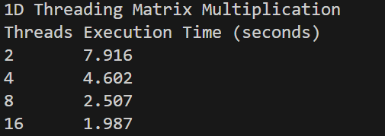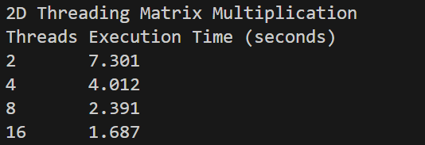

Sno. | No. of Threads | 1D | 2D
1 | 2 | 7.916 | 7.301
2 | 4 | 4.602 | 4.012
3 | 8 | 2.507 | 2.391
4 | 16 | 1.987 | 1.687

1)Strong and Consistent Speedup Observed
Matrix multiplication is compute-bound:
- Each output element performs 1000 multiply-adds
- High arithmetic intensity
- Threads spend more time computing than waiting for memory
Which leads to:
- Execution time reduces consistently
- Speedup increases almost linearly up to 16 threads
2)Execution Time Decreases with Threads
As threads increase:
- Workload is divided among threads
- Each thread computes fewer elements of matrix C
- CPU cores are efficiently utilized
This matches ideal parallel scaling behavior.
3)Why 2D Threading Is Faster Than 1D Threading
At every thread count, 2D threading outperforms 1D threading.
Reason 1: Better Load Balancing
- 1D threading assigns full rows to threads
- If thread count increases, some threads may get:
  - More rows
  - Or finish earlier and stay idle
- 2D threading (collapse(2)):
  - Distributes (i, j) pairs evenly
  - All threads stay busy longer
Reason 2: Improved Cache Utilization
- 2D decomposition:
  - Smaller working sets per thread
  - Better cache reuse
  - Reduced cache thrashing
Reason 3: Reduced Thread Idle Time
- 2D threading ensures:
  - Fine-grained task distribution
  - Better scheduling by OpenMP runtime
4)Scaling Efficiency Comparison
At 16 threads:
- 1D Efficiency ≈ 3.98 / 16 ≈ 25%
- 2D Efficiency ≈ 4.33 / 16 ≈ 27%
➡ 2D threading uses hardware resources more efficiently.
5)Why Speedup Is Not Perfectly Linear
Even though matrix multiplication scales well, speedup is not ideal due to:
(a) Memory Hierarchy Effects
- Cache misses
- Shared memory bandwidth
(b) Thread Management Overhead
- Scheduling
- Synchronization
(c) Amdahl’s Law
- Some parts remain serial (loop setup, memory allocation)

3)Result Analysis of Question-3(Pi Calculation)
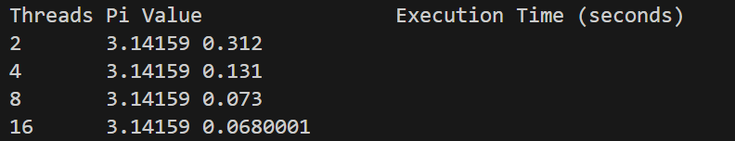
1)Accuracy of π Remains Constant
The value of π remains 3.14159 for all thread counts.
- Parallelization does not affect numerical correctness
- OpenMP reduction(+:sum) ensures:
  - Each thread computes a private partial sum
  - All partial sums are safely combined
2) Execution Time Decreases with Threads
Execution time reduces significantly as thread count increases:
- 2 → 4 threads: ~2.4× speedup
- 2 → 8 threads: ~4.3× speedup
- 2 → 16 threads: ~4.6× speedup
This shows strong parallel scalability.
3)Speedup Improves Rapidly Initially
- Loop iterations are fully independent
- Computation is compute-bound
- Minimal memory contention
- Very little synchronization (only at reduction)
Thus, threads are utilized efficiently.
4)Why Speedup Saturates After 8 Threads
From 8 → 16 threads, speedup increases only slightly:
- 0.073 s → 0.068 s
(a) Core Saturation
- Likely number of physical cores ≈ 8
- Additional threads use hyper-threading
- Limited extra performance
(b) Reduction Overhead
- Final reduction step incurs synchronization cost
- More threads → more reduction overhead
(c) Amdahl’s Law
- Loop setup and reduction are serial components
- Limits maximum achievable speedup

