UCS645 Assignment No. 6
(A)Device Query Code
CODE
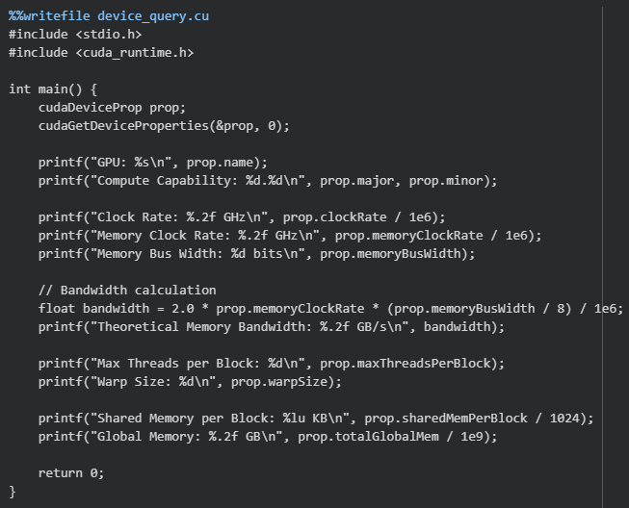
OUTPUT
GPU: Tesla T4
Compute Capability: 7.5
Clock Rate: 1.59 GHz
Memory Clock Rate: 5.00 GHz
Memory Bus Width: 256 bits
Theoretical Memory Bandwidth: 320.06 GB/s
Max Threads per Block: 1024
Warp Size: 32
Shared Memory per Block: 48 KB
Global Memory: 15.64 GB

INTERPRETATION
The GPU used is NVIDIA Tesla T4 with a compute capability of 7.5, indicating support for modern CUDA features. It operates at 1.59 GHz with a memory clock of 5.00 GHz, resulting in a high theoretical memory bandwidth of 320.06 GB/s.
The maximum threads per block (1024) and warp size (32) enable efficient parallel execution. The GPU provides 48 KB shared memory per block (fast, on-chip) and 15.64 GB global memory (large but slower).
Overall, the GPU is well-suited for parallel workloads, but performance for simple operations is expected to be memory bandwidth-bound rather than compute-bound.
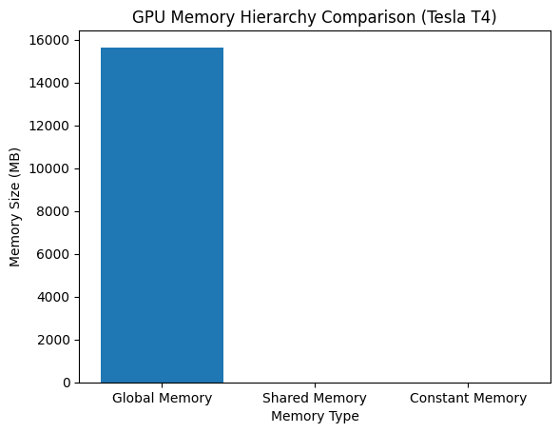
The graph shows that global memory is significantly larger than shared and constant memory. However, shared memory is much faster and is used for performance optimisation, while global memory is slower but necessary for storing large datasets.

(B) Sum of the Elements in an Array
CODE
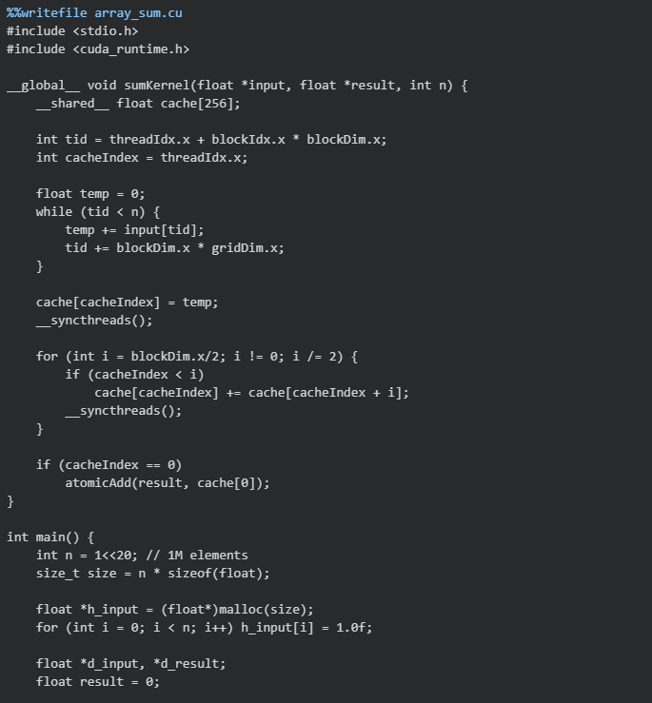
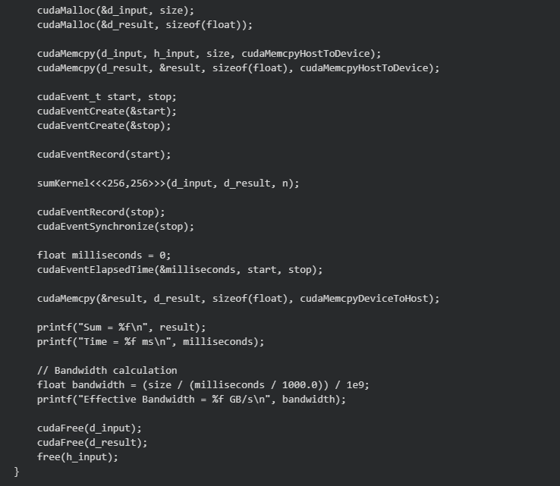
OUTPUT
Sum = 1048576.000000
Time = 16.715488 ms
Effective Bandwidth = 0.250923 GB/s

INTERPRETATION
The computed sum is 1048576, which matches the expected result, confirming the correctness of the CUDA implementation.
The kernel execution time is 16.72 ms, indicating that the computation is relatively fast due to parallel execution on the GPU. However, the achieved effective memory bandwidth is only 0.25 GB/s, which is significantly lower than the theoretical bandwidth of ~320 GB/s (from Part A).
This large gap suggests that the kernel is not fully utilising the GPU’s memory bandwidth. The performance is limited due to factors such as kernel launch overhead, atomic operations, and non-optimal memory access patterns. Additionally, the problem size may be too small to fully exploit the GPU’s parallel capabilities.
Overall, the result demonstrates correct parallel computation, but highlights that optimization is required to achieve higher performance and better bandwidth utilization.

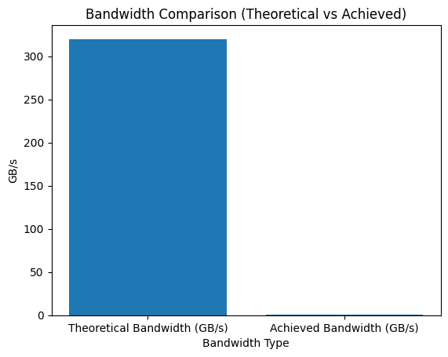
The graph compares the theoretical memory bandwidth of the GPU (320 GB/s) with the achieved bandwidth (0.25 GB/s). The large gap indicates that the CUDA kernel is not utilizing the GPU efficiently. This suggests that the implementation is limited by factors such as memory access patterns, kernel overhead, and reduction inefficiencies.

(C) Matrix Addition
CODE
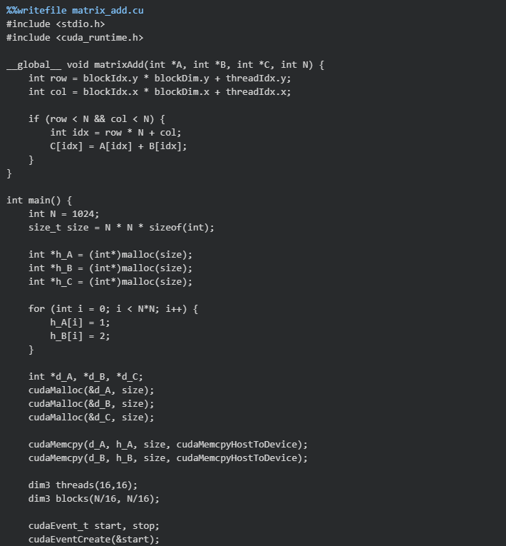
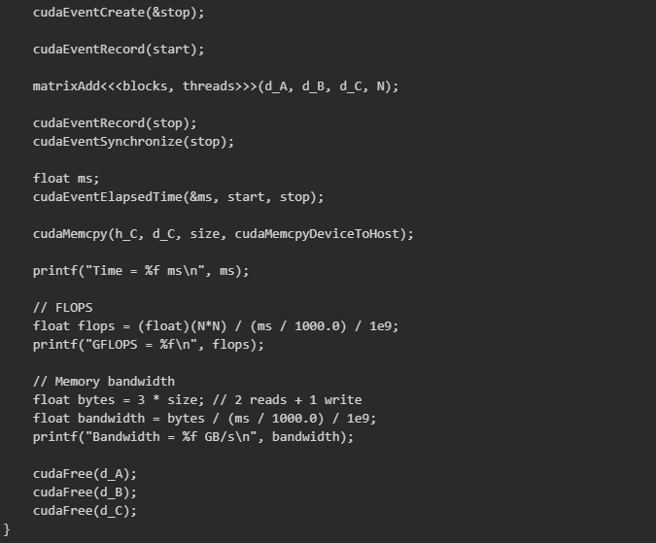
OUTPUT
Time = 0.194464 ms
GFLOPS = 5.392134
Bandwidth = 64.705612 GB/s

INTERPRETATION
The kernel execution time is 0.194 ms, which is significantly lower than the array summation case, indicating highly efficient parallel execution for matrix addition.
The achieved performance is 5.39 GFLOPS, reflecting the rate of floating-point operations performed by the GPU. However, since matrix addition involves only one operation per element, the overall computational intensity is low.
The measured memory bandwidth is 64.71 GB/s, which is substantially higher than the array summation case (~0.25 GB/s) but still well below the theoretical maximum (~320 GB/s). This indicates improved memory utilization, but not full efficiency.
Overall, the matrix addition kernel performs better than the reduction kernel due to simpler memory access patterns and the absence of synchronization or atomic operations. However, it remains memory-bound, as performance is primarily limited by data transfer rather than computation.
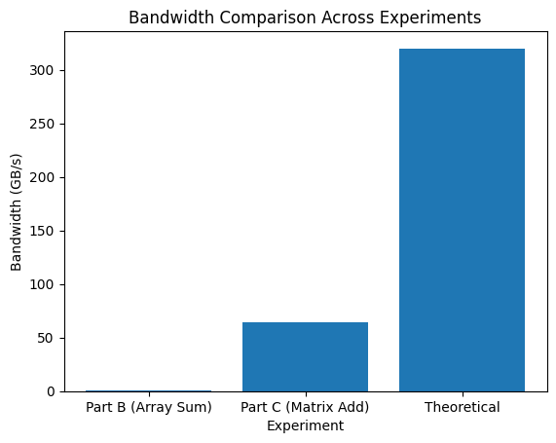

The graph compares the achieved memory bandwidth for array summation (Part B) and matrix addition (Part C) with the theoretical GPU bandwidth.
The array summation kernel achieves only 0.25 GB/s, which is extremely low compared to the theoretical 320 GB/s, indicating poor utilization of GPU resources. This is mainly due to reduction overhead, atomic operations, and inefficient memory access patterns.
In contrast, the matrix addition kernel achieves 64.7 GB/s, which is significantly higher and demonstrates better memory access efficiency and parallel execution. However, it still does not reach the theoretical limit, showing that there is room for optimization.
Overall, the graph clearly shows that kernel design and memory access patterns have a major impact on GPU performance, even when running on the same hardware

CONCLUSION
The experiments demonstrate that while the GPU hardware (Tesla T4) provides high theoretical performance, actual performance depends heavily on kernel implementation and memory access efficiency.
The device query results show strong hardware capabilities, including high memory bandwidth and parallel execution support. However, the array summation kernel performs poorly due to synchronization overhead and inefficient reduction strategy, resulting in very low bandwidth utilization.
On the other hand, the matrix addition kernel achieves significantly better performance due to its simple and parallel-friendly structure, although it remains memory-bound due to low computational intensity.
In conclusion, efficient utilization of GPU resources requires careful consideration of memory access patterns, thread organization, and minimizing synchronization overhead to approach the theoretical performance limits.

