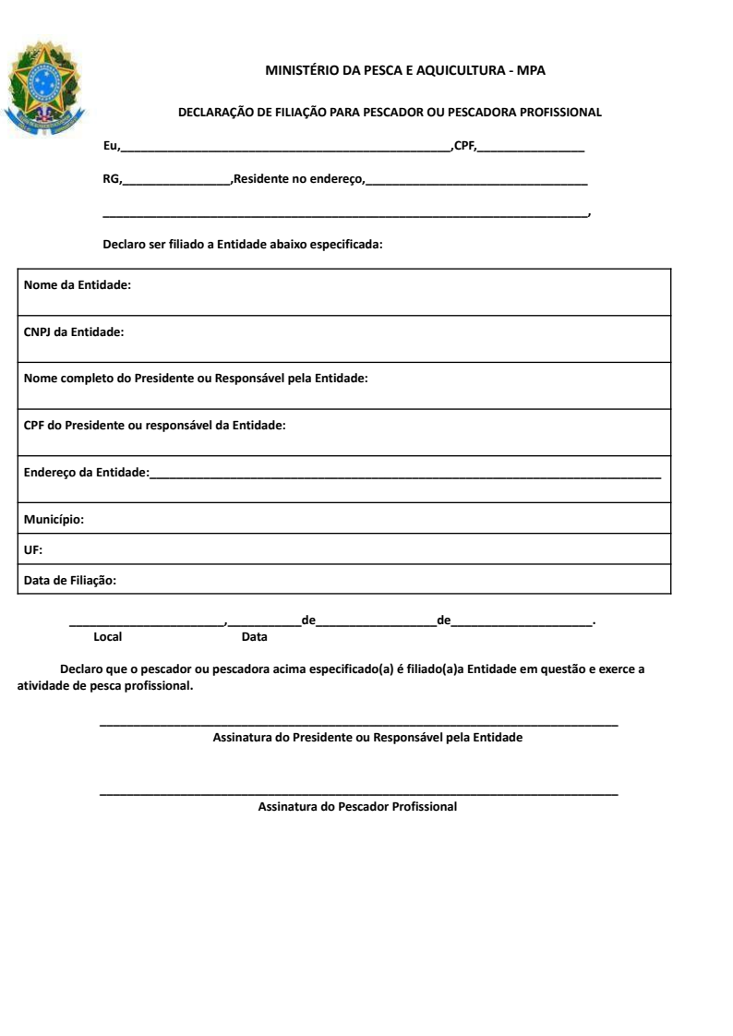

${NAME}

${CPF}

${RG}

${ADDRESS}

${AFFILIATION}

${STATE}

${CITY_HALL}

${ADDRESS}

${PRESIDENT_CPF}

${PRESIDENT_NAME}

${COLONY_CNPJ}

${CITY}

${SOCIAL_REASON}