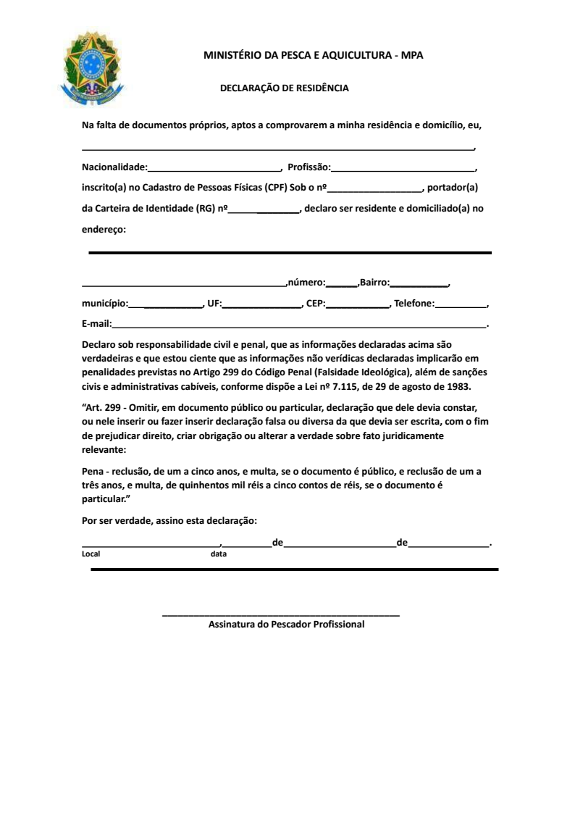

${NUMBER}

${ADDRESS_CEP}

${STATE}

${EMAIL}

${CITY}

${PHONE}

${NEIGHBORHOOD}

${NAME}

${ADDRESS}

${CITY}

${RG}

${CPF}

${PROFESSION}

brasileiro