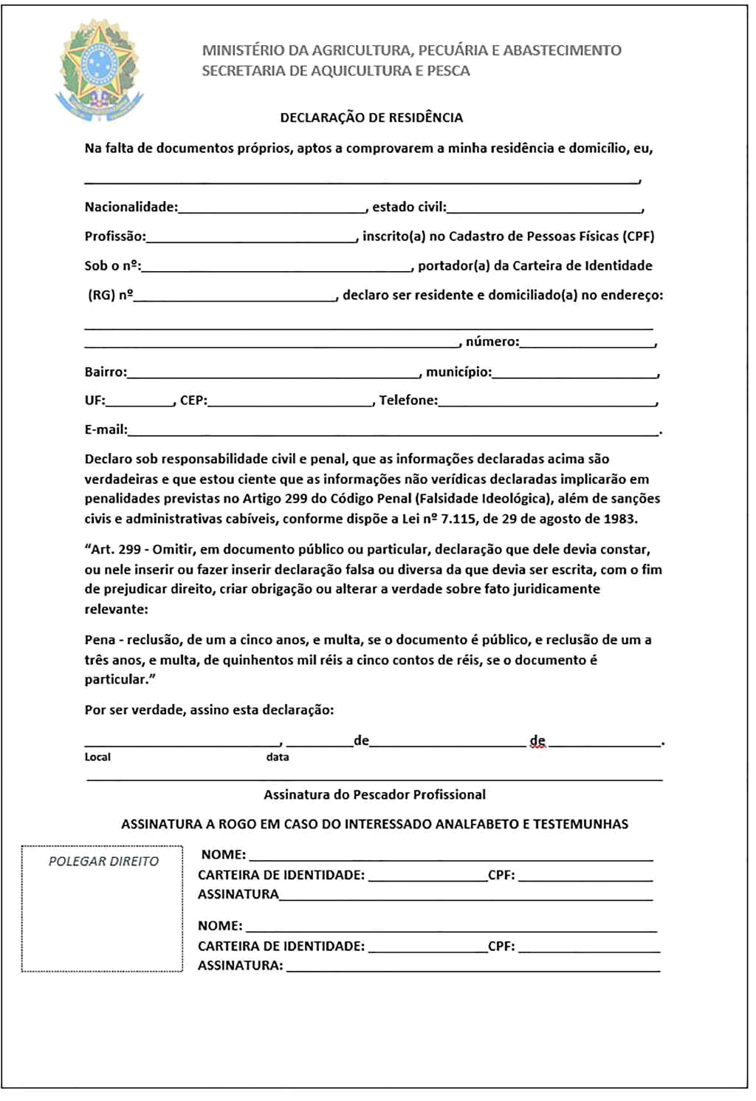

${DATE_D}

${DATE_Y}

${DATE_M}

${MARITAL_STATUS}

${NEIGHBORHOOD}

NOME__

: ${NAME}

brasileira

${PROFESSION}

${CPF}

${RG}

${ADDRESS}

${NUMBER}

${CITY_HALL}

${STATE}

${CITY_CEP}

${PHONE}

${EMAIL}

${COLONY}