WhatMoore Foods ERP Support Assistant
RAG Assistant Test Script — Phase 2 (Live Data Retrieval)
A structured, repeatable set of test scenarios and success criteria for validating the get_order_status and get_stock_level tool-calling integration (Phase 2a: Live Database Retrieval).

Purpose & How to Use This Script
This document is a repeatable test script for validating the Phase 2a live-data capability added to the Moore Foods ERP Support Assistant. Run each question through ask.py, compare the actual answer against the expected behavior listed, and record the result.
- Pass: the answer meets the stated expected behavior — correct tool selection (or correct non-use of a tool), correct data returned, correct scope handling, and no formatting/technical issues (see Success Criteria).
- Fail: the answer is missing required content, invents unsupported facts or figures, uses the wrong tool (or no tool when one was needed), answers a question outside Phase 2a scope as if it were supported, or is cut off/malformed.
Re-run this full script after any change to the system prompt, tool schemas, or tools.py — a fix for one question should never be assumed safe without re-checking the others. Re-run the original Phase 1 test script alongside this one to confirm no regression in documentation-grounded answers.

Success Criteria (Definition of "Pass")
These criteria extend the Phase 1 criteria with the live-data behaviors introduced in Phase 2a. A test only fully passes if all applicable criteria below are met — not just that an answer was returned.
- Correct tool selection — the assistant calls get_order_status or get_stock_level when the question requires current order/item data, and does not call a tool for pure documentation questions.
- Correct data returned — the figures, statuses, and item details in the answer match what the tool actually returned, not a plausible-sounding approximation.
- Correct status interpretation — order status codes (e.g. CR-HOLD, INV-HOLD, PRICE-HOLD) are explained in plain language, not just repeated as codes.
- Correct "available" stock logic — stock answers reflect available quantity (on hand minus allocated) for AVAILABLE-status rows, not raw on-hand quantity, and correctly aggregate across multiple warehouses where applicable.
- Correct not-found handling — an invalid order ID or item ID is reported as not found, not guessed at or fabricated.
- Correct no-inventory handling — an item with no inventory records is reported as such, distinct from a false "zero stock" reading.
- No invented or unsupported facts — nothing in a tool-derived answer goes beyond what the tool actually returned.
- Correct scope handling (narrowed) — questions requiring data outside Phase 2a's scope (aggregate counts, customer credit status, purchase order or production data) are still clearly declined, distinct from the two supported lookup types.
- Correct combined answers — a question needing both a documented process explanation and a live figure blends both into one coherent answer.
- Concise formatting — plain prose, no headers/dividers/emoji, roughly 3–6 sentences, per system prompt Rule 8.
- No truncation — the answer ends naturally; the assistant's own truncation warning does not fire.

Test Scenarios

1. Order Status Queries (Tool: get_order_status)
Tests whether the assistant correctly calls the tool and interprets every documented order status, including credit/inventory/price holds.
# | Test Question | Expected Behavior / Pass Criteria | Pass? | Notes
1 | What's the status of order SO10001? | Calls get_order_status; reports ALLOCATED with plain-language meaning (stock reserved). | Pass | Correctly calls get_order_status for SO10001, reporting ALLOCATED with accurate customer, warehouse, and line item details.
Screenshots:
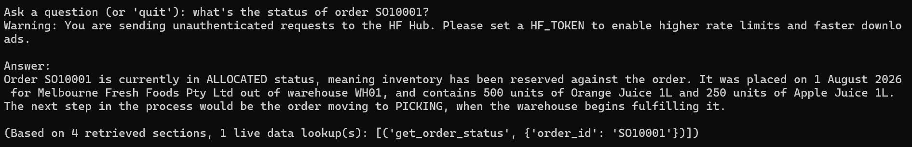
# | Test Question | Expected Behavior / Pass Criteria | Pass? | Notes
1.1 | What's the status of order SO10001? | Calls get_order_status; reports ALLOCATED with plain-language meaning (stock reserved). | Pass
Screenshots:
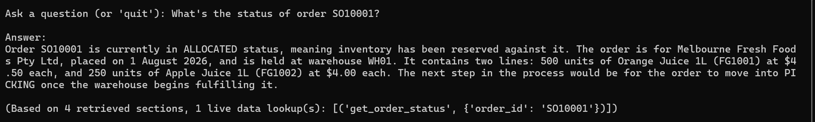
# | Test Question | Expected Behavior / Pass Criteria | Pass? | Notes
2 | What's the status of order SO10002? | Calls get_order_status; reports CR-HOLD and explains it means the order is on credit hold. | Pass | Correctly calls get_order_status for SO10002, reporting CR-HOLD with accurate customer, quantity, and pricing.
Screenshots:
# | Test Question | Expected Behavior / Pass Criteria | Pass? | Notes
2.1 | What's the status of order SO10002? | Calls get_order_status; reports CR-HOLD and explains it means the order is on credit hold. | Pass
Screenshots:
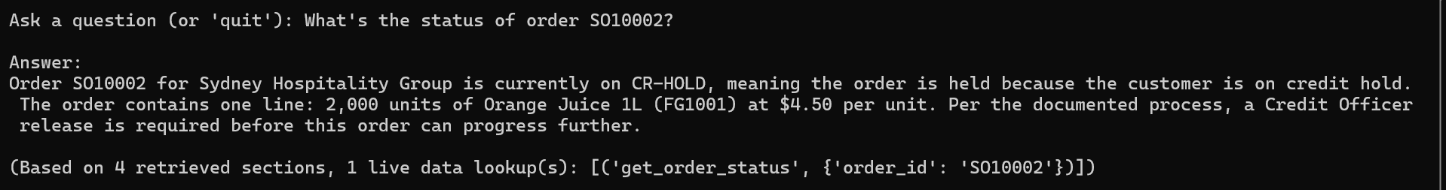
# | Test Question | Expected Behavior / Pass Criteria | Pass? | Notes
3 | What's the status of order SO10003? | Calls get_order_status; reports PICKING with plain-language meaning. | Pass
Screenshots:
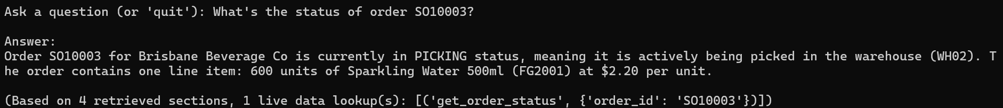
# | Test Question | Expected Behavior / Pass Criteria | Pass? | Notes
3.1 | What's the status of order SO10003? | Calls get_order_status; reports PICKING with plain-language meaning. | Pass
Screenshots:
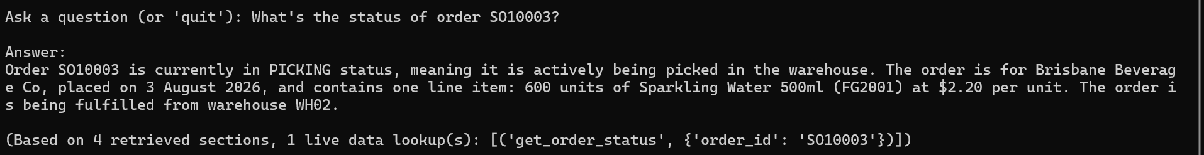

# | Test Question | Expected Behavior / Pass Criteria | Pass? | Notes
4 | What's the status of order SO10004? | Calls get_order_status; reports SHIPPED with plain-language meaning. | Pass | confirmed accurate: line 280 of your source doc states "SHIPPED — Order has left the Distribution Centre," matching the answer exactly.
Screenshots:
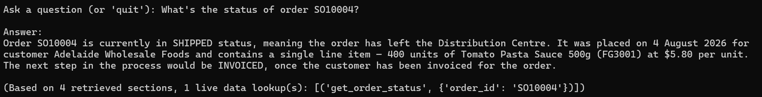

# | Test Question | Expected Behavior / Pass Criteria | Pass? | Notes
4.1 | What's the status of order SO10004? | Calls get_order_status; reports SHIPPED with plain-language meaning. | Pass
Screenshots:
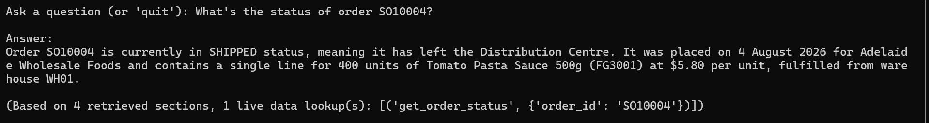
# | Test Question | Expected Behavior / Pass Criteria | Pass? | Notes
5 | What's the status of order SO10005? | Calls get_order_status; reports INV-HOLD and explains it means an inventory/stock issue. | Pass
Screenshots:
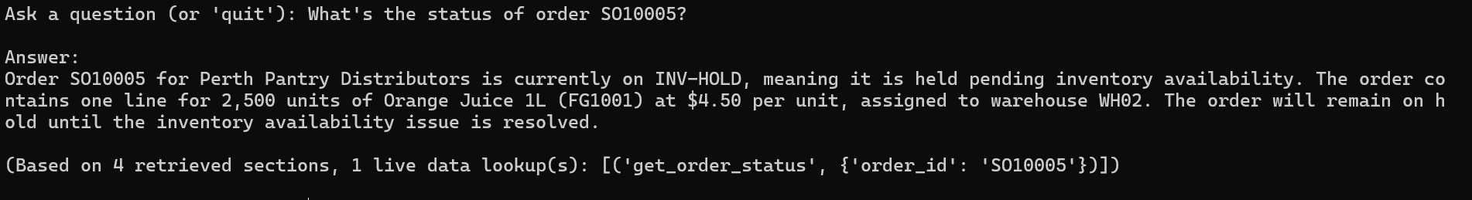
# | Test Question | Expected Behavior / Pass Criteria | Pass? | Notes
5.1 | What's the status of order SO10005? | Calls get_order_status; reports INV-HOLD and explains it means an inventory/stock issue. | Pass
Screenshots:
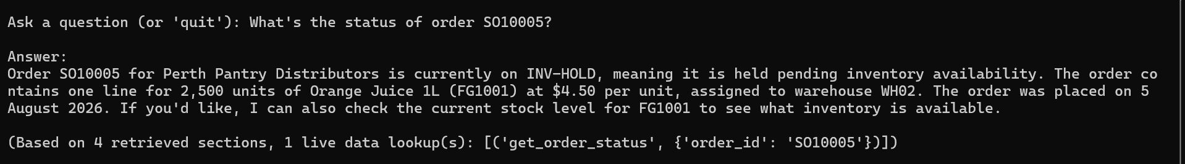
# | Test Question | Expected Behavior / Pass Criteria | Pass? | Notes
6 | What's the status of order SO10006? | Calls get_order_status; reports INVOICED with plain-language meaning (order complete). | Pass
Screenshots:
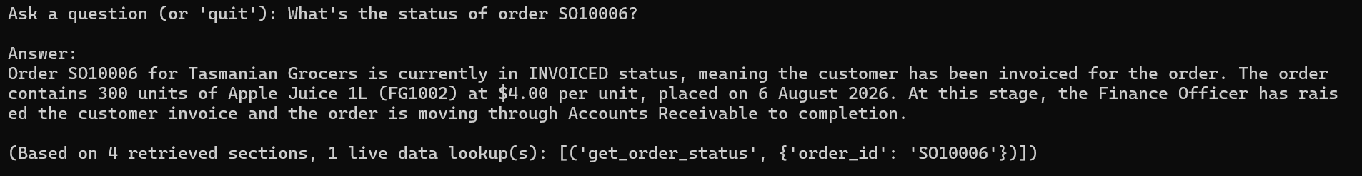

# | Test Question | Expected Behavior / Pass Criteria | Pass? | Notes
6.1 | What's the status of order SO10006? | Calls get_order_status; reports INVOICED with plain-language meaning (order complete). | Pass
Screenshots:
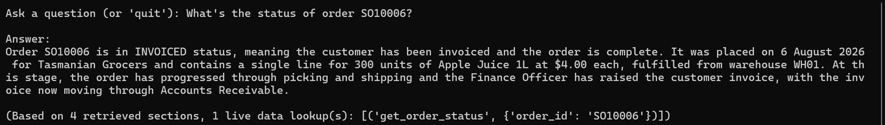

# | Test Question | Expected Behavior / Pass Criteria | Pass? | Notes
7 | What's the status of order SO10007? | Calls get_order_status; reports SO-OPEN with plain-language meaning. | Pass
Screenshots:
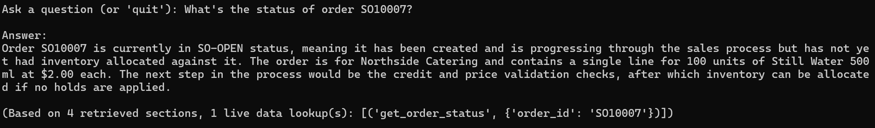
# | Test Question | Expected Behavior / Pass Criteria | Pass? | Notes
7.1 | What's the status of order SO10007? | Calls get_order_status; reports SO-OPEN with plain-language meaning. | Pass
Screenshots:
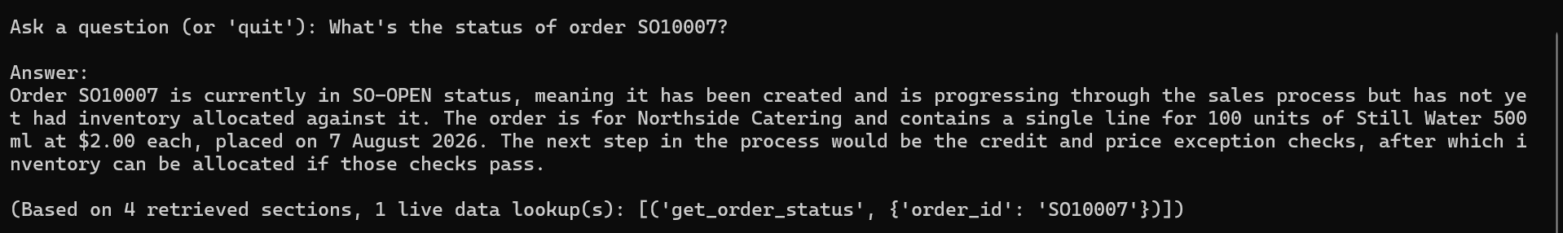
# | Test Question | Expected Behavior / Pass Criteria | Pass? | Notes
8 | What's the status of order SO10013? | Calls get_order_status; reports PRICE-HOLD and explains it means the order is on a price/approval hold. | Pass
Screenshots:
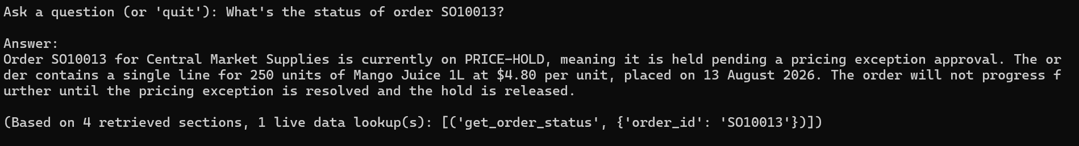
# | Test Question | Expected Behavior / Pass Criteria | Pass? | Notes
8.1 | What's the status of order SO10013? | Calls get_order_status; reports PRICE-HOLD and explains it means the order is on a price/approval hold. | Pass
Screenshots:
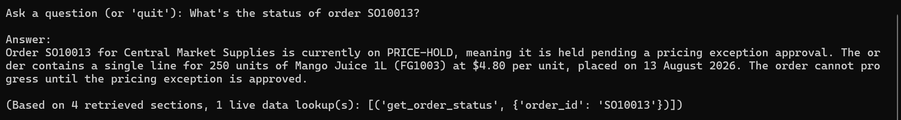

2. Stock Level Queries (Tool: get_stock_level)
Tests correct aggregation logic across the different inventory patterns identified in the database.
# | Test Question | Expected Behavior / Pass Criteria | Pass? | Notes
1 | What's the available stock for FG1001? | Calls get_stock_level; reports 4000 total available, correctly aggregated across WH01 (3800) and WH02 (200). | Pass
Screenshots:
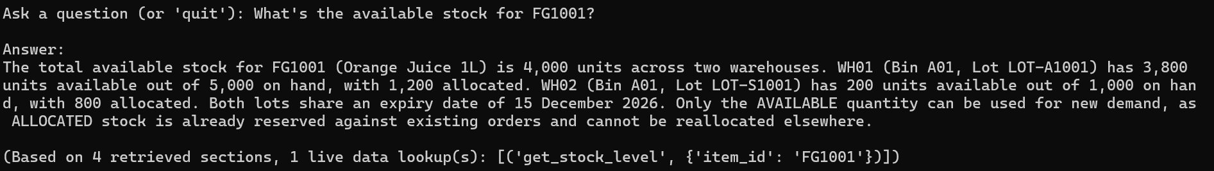
# | Test Question | Expected Behavior / Pass Criteria | Pass? | Notes
1.1 | What's the available stock for FG1001? | Calls get_stock_level; reports 4000 total available, correctly aggregated across WH01 (3800) and WH02 (200). | Pass
Screenshots:
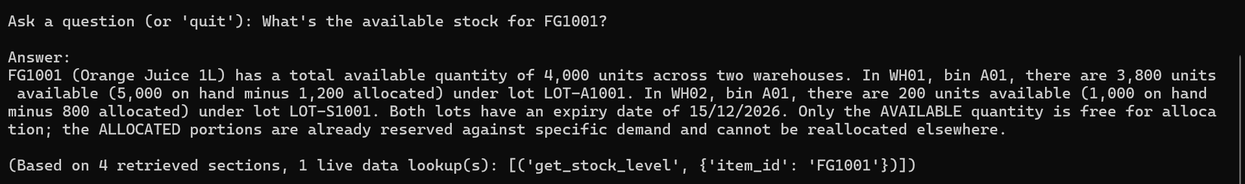
# | Test Question | Expected Behavior / Pass Criteria | Pass? | Notes
2 | What's the available stock for FG2001? | Calls get_stock_level; reports correct single-warehouse available quantity. | Pass
Screenshots:
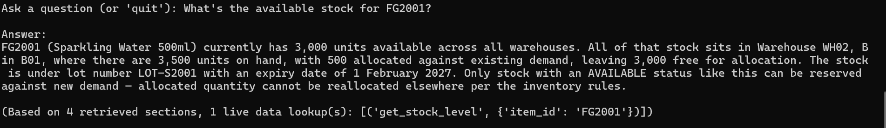
# | Test Question | Expected Behavior / Pass Criteria | Pass? | Notes
2.1 | What's the available stock for FG2001? | Calls get_stock_level; reports correct single-warehouse available quantity. | Pass
Screenshots:
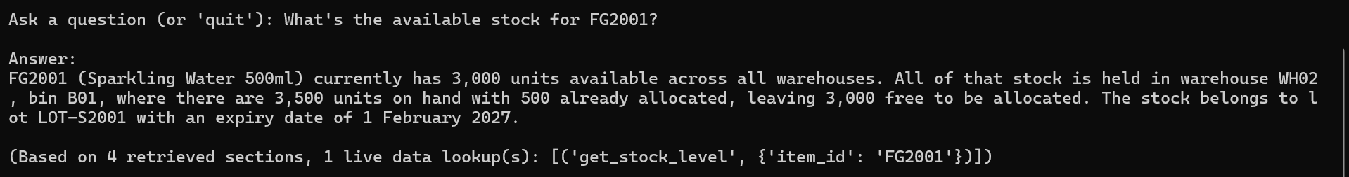
# | Test Question | Expected Behavior / Pass Criteria | Pass? | Notes
3 | What's the available stock for PK1001? | Calls get_stock_level; clearly states no inventory records exist for this item — does not claim zero stock as if it were simply sold out. | Fail | the expected behaviour was a clear statement that no inventory records exist for this item. Instead, the assistant hedges ("if stock exists but is in QUARANTINED/ALLOCATED status...") rather than reporting what the tool actually returned (by_warehouse: [], explicit "no inventory records found" message)
Screenshots:
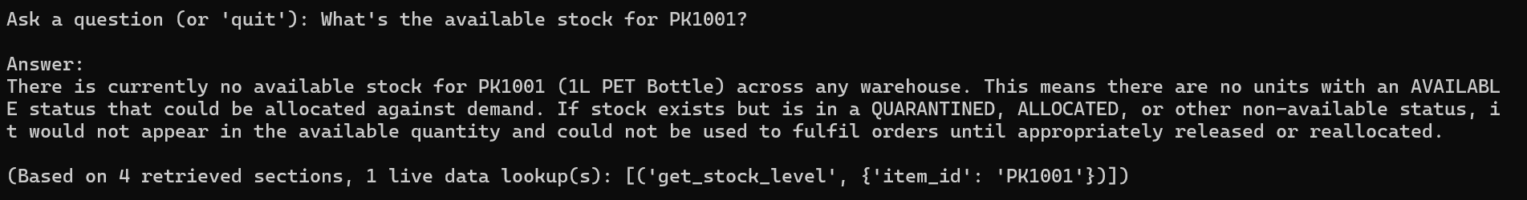
# | Test Question | Expected Behavior / Pass Criteria | Pass? | Notes
3.1 | What's the available stock for PK1001? | Calls get_stock_level; clearly states no inventory records exist for this item — does not claim zero stock as if it were simply sold out. | Pass | fix confirmed. States plainly that no available inventory records exist, no hedging about alternative statuses this time. Fix 1 resolved.
Screenshots
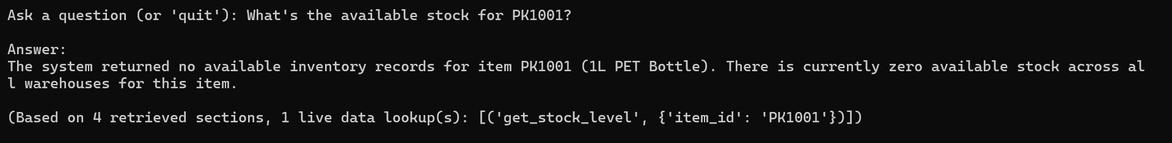
# | Test Question | Expected Behavior / Pass Criteria | Pass? | Notes
4 | What's the available stock for FG1003? | Calls get_stock_level; reports 0 available, and separately notes that quarantined stock exists for this item rather than implying it's simply out of stock. | Pass | correctly reports 0 available and explicitly flags that quarantined stock exists, exactly the distinction this test case was checking for.
Screenshots:
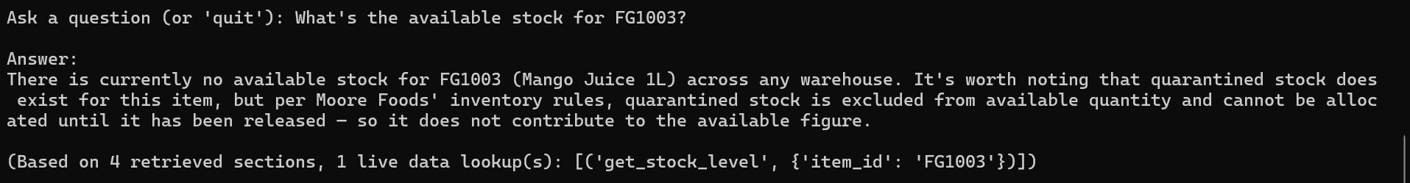
# | Test Question | Expected Behavior / Pass Criteria | Pass? | Notes
4.1 | What's the available stock for FG1003? | Calls get_stock_level; reports 0 available, and separately notes that quarantined stock exists for this item rather than implying it's simply out of stock. | Pass
Screenshots:
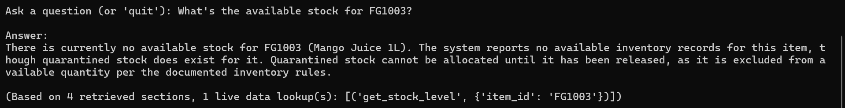

3. Invalid / Not-Found Handling
Tests that the assistant reports absence honestly rather than guessing — the same failure mode Phase 1's Category 6 was built to catch, now applied to tool results instead of a blanket decline.
# | Test Question | Expected Behavior / Pass Criteria | Pass? | Notes
1 | What's the status of order SO99999? | Calls get_order_status; clearly states no order was found with this ID. Does not guess or invent order details. | Pass
Screenshots: 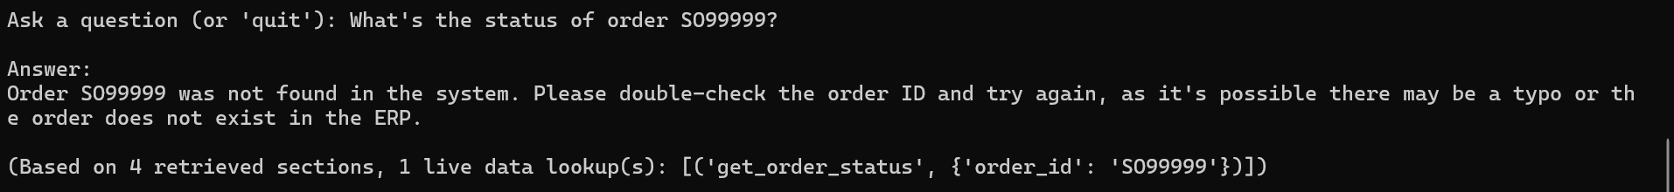
# | Test Question | Expected Behavior / Pass Criteria | Pass? | Notes
1.1 | What's the status of order SO99999? | Calls get_order_status; clearly states no order was found with this ID. Does not guess or invent order details. | Pass
Screenshots:
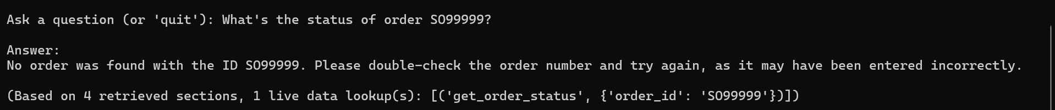
# | Test Question | Expected Behavior / Pass Criteria | Pass? | Notes
2 | What's the available stock for FG9999? | Calls get_stock_level; clearly states no item was found with this ID. Does not invent a stock figure. | Pass
Screenshots:
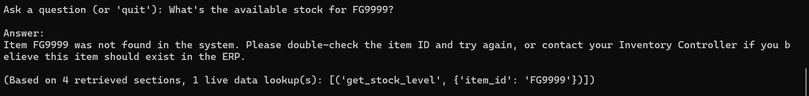
# | Test Question | Expected Behavior / Pass Criteria | Pass? | Notes
2.1 | What's the available stock for FG9999? | Calls get_stock_level; clearly states no item was found with this ID. Does not invent a stock figure. | Pass
Screenshots:
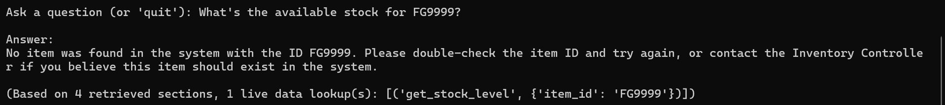

4. Combined Documentation + Live Data
Tests whether the assistant can blend a documentation-grounded process explanation with a live figure in a single, coherent answer.
# | Test Question | Expected Behavior / Pass Criteria | Pass? | Notes
1 | How do I check stock availability, and what's the current level for FG1001? | Answer combines the documented stock-check process (from source documentation) with the live get_stock_level figure for FG1001, in one coherent response — not two disconnected halves. | Pass | combined answer blends the documented process (Inventory Controller role, BR-GEN-003 rule) with the live FG1001 figures correctly, and both halves are accurate.
Screenshots:
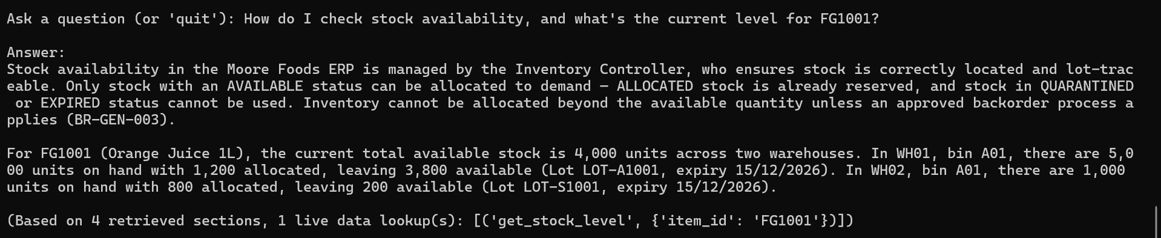
# | Test Question | Expected Behavior / Pass Criteria | Pass? | Notes
1.1 | How do I check stock availability, and what's the current level for FG1001? | Answer combines the documented stock-check process (from source documentation) with the live get_stock_level figure for FG1001, in one coherent response — not two disconnected halves. | Pass
Screenshots:
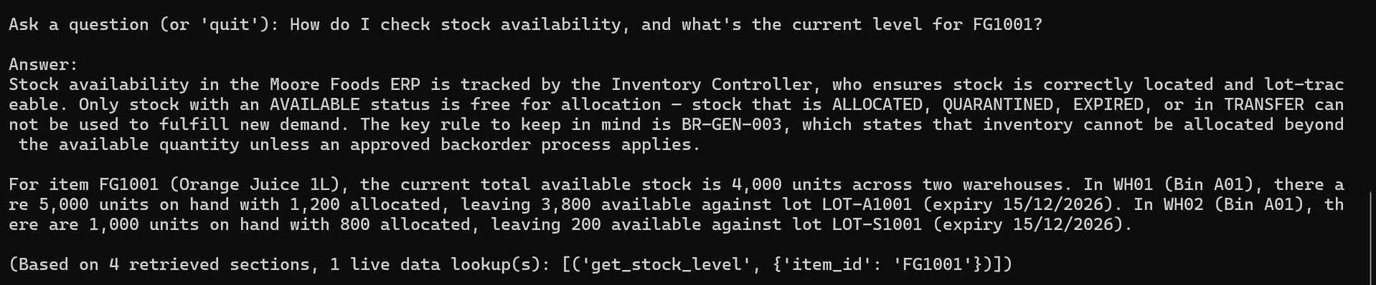

# | Test Question | Expected Behavior / Pass Criteria | Pass? | Notes
2 | Why might an order go on hold, and what's the status of SO10002? | Answer combines the documented explanation of hold reasons with the live status of SO10002 (CR-HOLD), correctly connecting the two. | Pass
Screenshots:
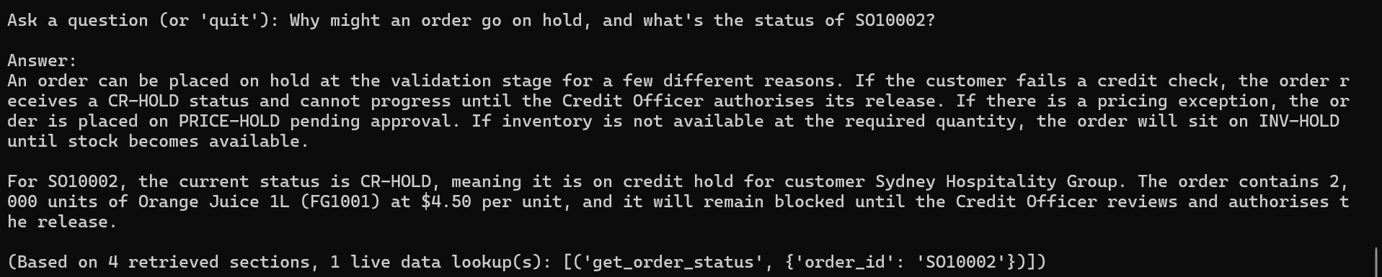
# | Test Question | Expected Behavior / Pass Criteria | Pass? | Notes
2.1 | Why might an order go on hold, and what's the status of SO10002? | Answer combines the documented explanation of hold reasons with the live status of SO10002 (CR-HOLD), correctly connecting the two. | Pass
Screenshots:
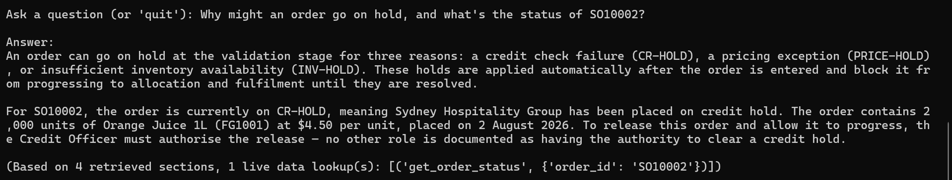

5. Regression — Aggregate / Unsupported Live-Data Questions (Should Still Decline)
Phase 2a supports single-order and single-item lookups only. These questions — carried over from Phase 1's Should-Decline category — require aggregate, cross-record, or unimplemented data (order counts, customer credit, PO/date-range queries, capacity). They should still be declined, but the decline should reflect the narrower Phase 2a boundary rather than a blanket "no live data" statement.
# | Test Question | Expected Behavior / Pass Criteria | Pass? | Notes
1 | How many orders are currently on hold right now? | Declines: explains this assistant can look up a specific order's status but does not support aggregate counts across all orders. Does not guess a number. | Fail | correctly declines without guessing a number, but doesn't mention that specific-order lookups are now supported (it frames everything as "outside scope of this version," missing the narrower Phase 2a distinction the test criteria called for).
Screenshots:
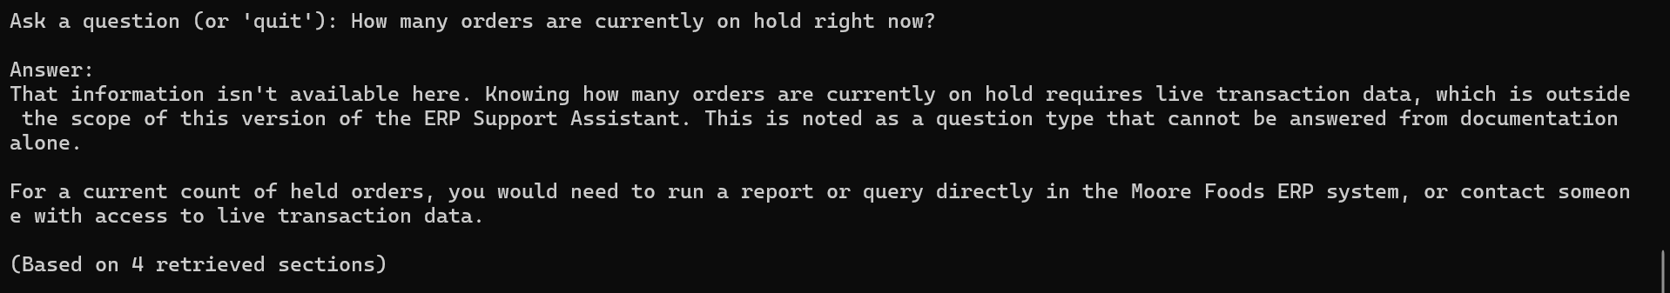
# | Test Question | Expected Behavior / Pass Criteria | Pass? | Notes
1.1 | How many orders are currently on hold right now? | Declines: explains this assistant can look up a specific order's status but does not support aggregate counts across all orders. Does not guess a number. | Pass | fix confirmed. Now correctly names what it can do (specific order lookup by ID) before naming what it can't (aggregate count). Fix 2 resolved.
Screenshots:
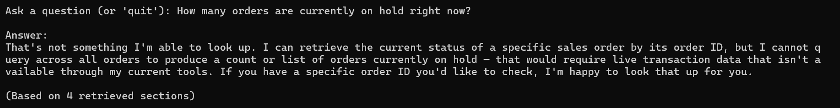
# | Test Question | Expected Behavior / Pass Criteria | Pass? | Notes
2 | What is customer Sydney Hospitality Group's current credit status? | Declines: customer credit status is not one of the supported lookups. Does not invent a status or figure. | Pass | correctly declines, doesn't invent a status, and explicitly names what it can look up (order status, stock level)
Screenshots:
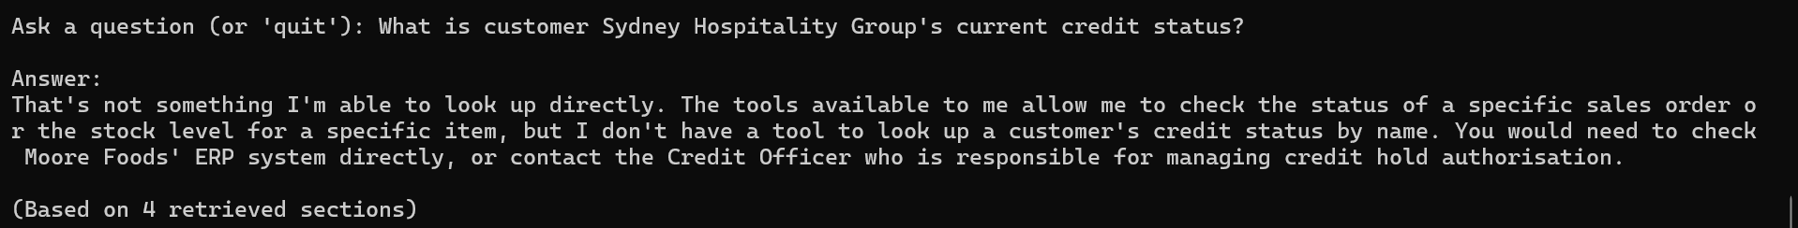
# | Test Question | Expected Behavior / Pass Criteria | Pass? | Notes
2.1 | What is customer Sydney Hospitality Group's current credit status? | Declines: customer credit status is not one of the supported lookups. Does not invent a status or figure. | Pass
Screenshots:
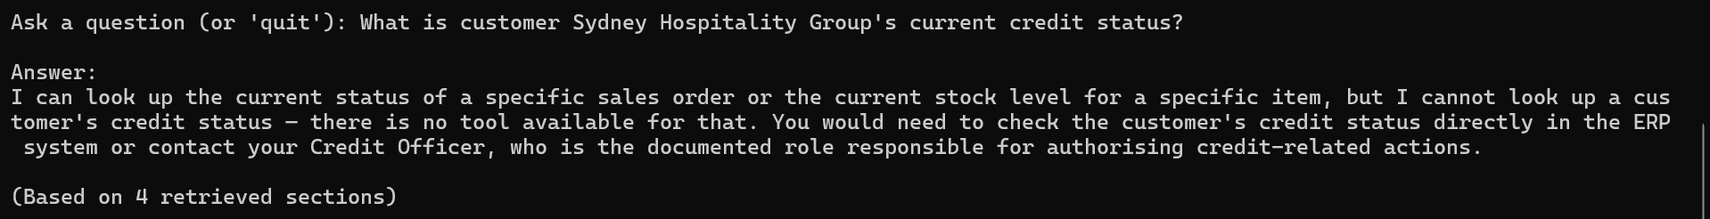

# | Test Question | Expected Behavior / Pass Criteria | Pass? | Notes
3 | Which purchase orders are open this week? | Declines: purchase order data is out of scope for Phase 2a (only sales order status and item stock are supported). Does not invent PO numbers or details. | Fail | it offers to look up a specific purchase order ID if given one ("just share it and I'll look it up for you"), but no purchase order tool is actually wired into ask.py — only get_order_status (sales orders) and get_stock_level exist. This is a false capability claim, not just a scope decline.
Screenshots:
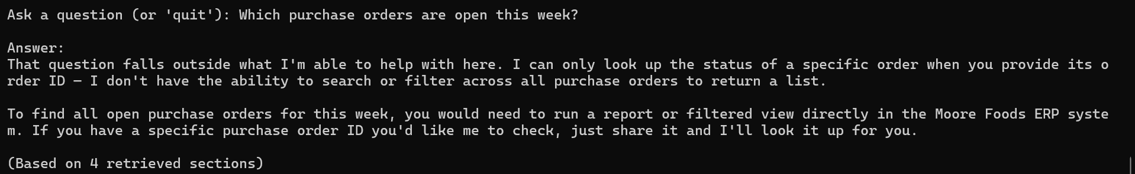
# | Test Question | Expected Behavior / Pass Criteria | Pass? | Notes
3.1 | Which purchase orders are open this week? | Declines: purchase order data is out of scope for Phase 2a (only sales order status and item stock are supported). Does not invent PO numbers or details. | Pass | fix confirmed. Correctly declines without offering a false capability this time, and explicitly states no purchase order tool exists rather than pretending it could look one up by ID. Fix 3 resolved.
Screenshots:
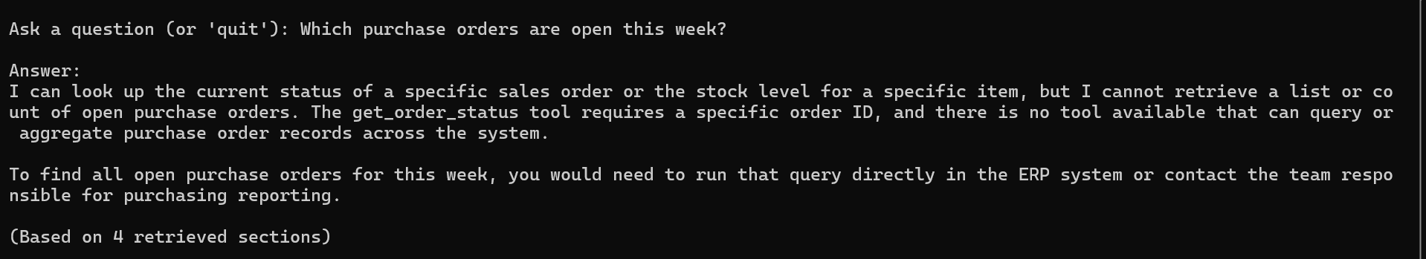
# | Test Question | Expected Behavior / Pass Criteria | Pass? | Notes
4 | Is warehouse WH01 currently over capacity? | Declines: warehouse capacity is not a supported lookup and is not defined in the documentation. Does not invent a capacity figure or status. | Pass
Screenshots:
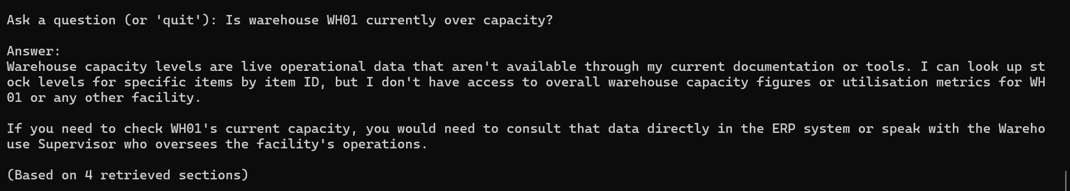
# | Test Question | Expected Behavior / Pass Criteria | Pass? | Notes
4.1 | Is warehouse WH01 currently over capacity? | Declines: warehouse capacity is not a supported lookup and is not defined in the documentation. Does not invent a capacity figure or status. | Pass
Screenshots:
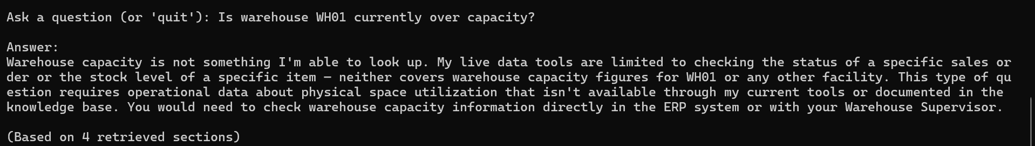

6. Regression — Documentation-Only Questions (Confirm Phase 1 Unaffected)
Re-runs a sample of known-good Phase 1 questions to confirm the tool-calling addition hasn't changed documentation-grounded behavior or caused an unnecessary tool call.
# | Test Question | Expected Behavior / Pass Criteria | Pass? | Notes
1 | How do I process a sales order from start to finish? | Answers from document context only, matching original Phase 1 pass behavior. No tool call made — this is a general process question, not a specific order lookup. | Pass | no tool call made, and the content matches the documented Order-to-Cash flow accurately.
Screenshots:
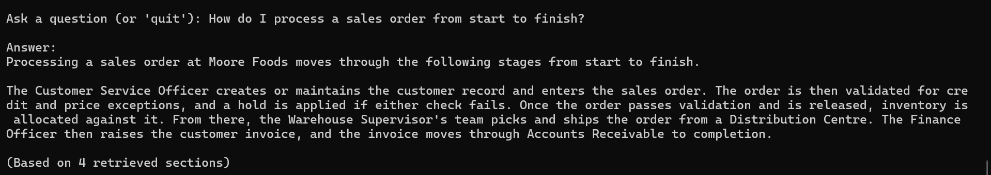
# | Test Question | Expected Behavior / Pass Criteria | Pass? | Notes
1.1 | How do I process a sales order from start to finish? | Answers from document context only, matching original Phase 1 pass behavior. No tool call made — this is a general process question, not a specific order lookup. | Pass
Screenshots:
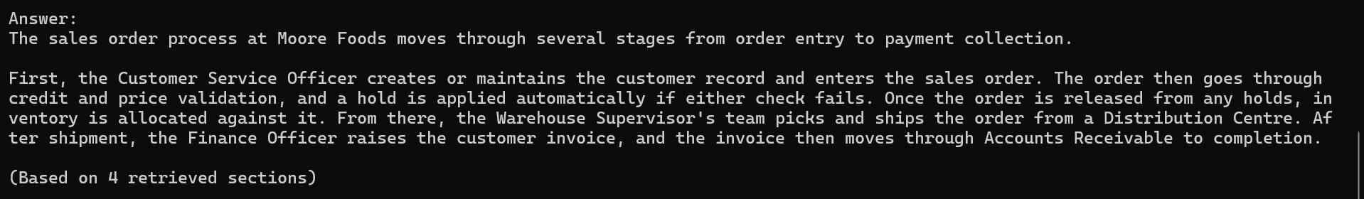
# | Test Question | Expected Behavior / Pass Criteria | Pass? | Notes
2 | What does CR-HOLD mean? | Answers from document context only (general definition), matching original Phase 1 pass behavior. No tool call made — this asks for a definition, not a specific order's status. | Pass
Screenshots:
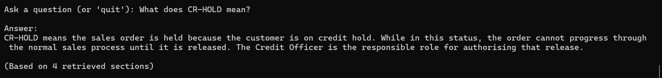
# | Test Question | Expected Behavior / Pass Criteria | Pass? | Notes
2.1 | What does CR-HOLD mean? | Answers from document context only (general definition), matching original Phase 1 pass behavior. No tool call made — this asks for a definition, not a specific order's status. | Pass
Screenshots:
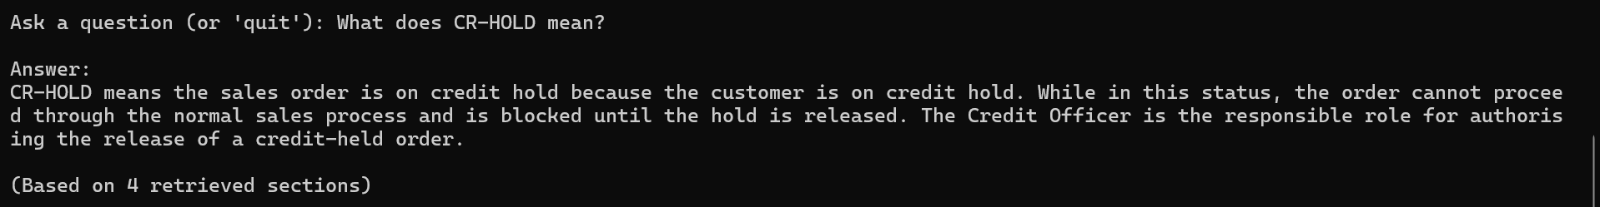
# | Test Question | Expected Behavior / Pass Criteria | Pass? | Notes
3 | What happens after a purchase order is approved? | Answers from document context only, matching original Phase 1 pass behavior. No tool call made. | Pass
Screenshots:
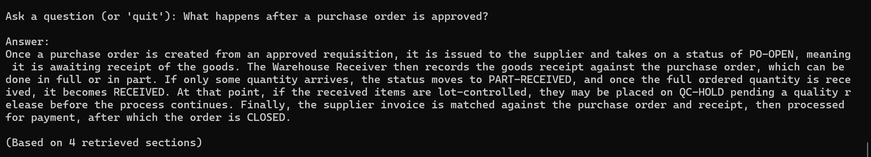

# | Test Question | Expected Behavior / Pass Criteria | Pass? | Notes
3.1 | What happens after a purchase order is approved? | Answers from document context only, matching original Phase 1 pass behavior. No tool call made. | Pass
Screenshots:
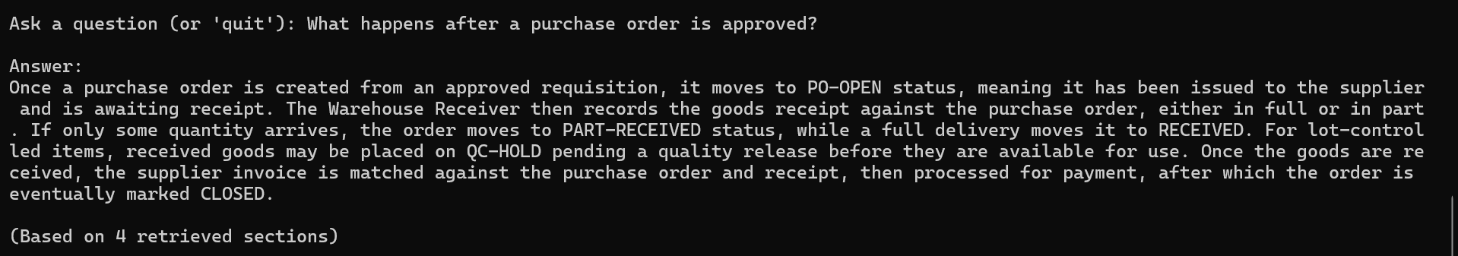

Fixes & Issues Discovered
Date | Found During (Test #/Category) | Issue | Fix Applied | Re-tested & Passed?
15/09/2026 | Category 2, Test 3 (PK1001 — no inventory) | Assistant hedges ("if stock exists but is in QUARANTINED/ALLOCATED status...") instead of clearly stating no inventory records exist, even though get_stock_level already returns an explicit "no inventory records found" message. | Rewrote Rule 6 to instruct the model to state a tool's own absence message plainly rather than speculating about alternative explanations the tool didn't report. Re-tested and confirmed resolved. | Yes
15/09/2026 | Category 5, Test 1 ("How many orders are currently on hold?") | Decline response frames all live-data questions as out of scope, without mentioning that specific-order and specific-item lookups are now supported in Phase 2a. | Rewrote Rule 6 to give the model a specific decline template: name what IS supported (specific order/item lookup) before naming the specific thing that isn't (aggregate counts). Re-tested and confirmed resolved. | Yes
15/09/2026 | Category 5, Test 3 ("Which purchase orders are open this week?") | Assistant falsely offers to look up a specific purchase order by ID ("just share it and I'll look it up for you"), but no purchase order tool is wired into ask.py — only get_order_status and get_stock_level exist. | Rewrote Rule 6 to explicitly name the two available tools and their exact scope (sales orders, item stock only), and instructed the model to never offer a lookup for which no tool exists. Re-tested and confirmed resolved. | Yes

Test Run Summary Log
Fill in after each full run of this script. Keep a dated copy of each run if you want to track improvement over time.
Date | Total Questions | Passed | Failed | Pass Rate
15/09/2026 | 23 | 20 | 3 | 87%
15/09/2026 | 23 | 23 | 0 | 100%

