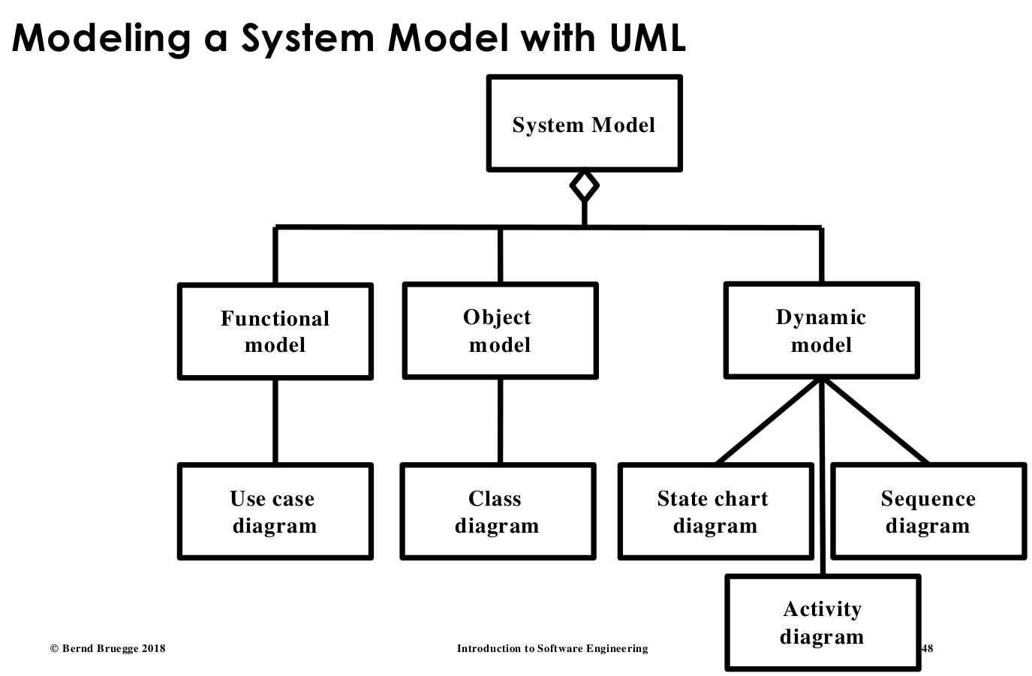
Introduction

Software Developments Models:
• Object model: What is the structure of the system?
• Functional model: What are the functions of the system?
• Dynamic model: How does the system react to external events?
• System Model: Object model + functional model + dynamic model

Software Engineering Definition:
Software Engineering is a collection of techniques, methodologies and tools that help with the production of.

Phenomenon vs Concept: vs
Phenomenon:  -an object in the world of a domain as you perceive it | Concept:  -describes the common properties of phenomena  -3-tuple: name,purpose and members

Definitions
- Abstraction: classification of phenomena into concepts
- Modeling: development of abstraction to answer specific questions about a set of phenomena

Systems, Models and Views
- model: an abstraction describing a system
- view: despicts selected aspects of a model

Model-Based Software Engineering

Definition
- Software life-cycle: set of activities and their relationships to each other (activities: Analysis, System Design)
- Software life-cycle model: abstraction representing the development if software
- defined process: given-set of inputs, same outputs are generated every time, all activities and tasks are defined

UML:
- reduces complexity by focusing on abstraction
- use:
  - Communication
  - Analysis and Design
  - Archival
Application vs Solution Domain
Application(Analysis):  -the environment in which the system is operating | Solution Domain(Design, Implementation):  -the technologies used to build the system

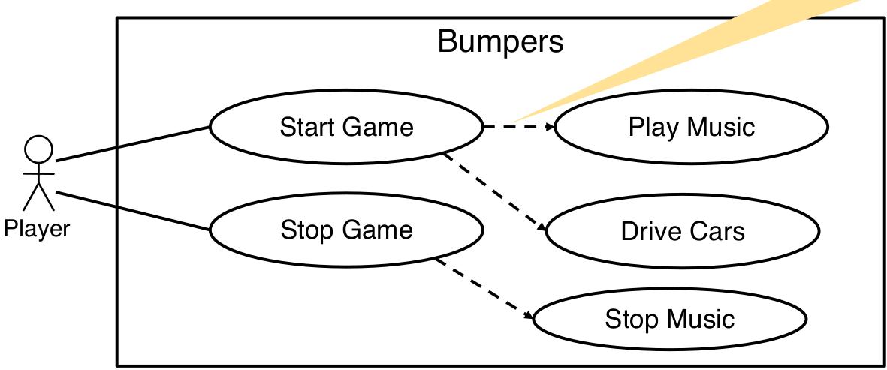
Use Case
Use Case Diagram
- Textual Use Case: {[1.Name], [2.Participating actors], [3. Entry conditions], [4. Exit Conditions], [5. Flow of events], [6. Special requirements]}
- Use Case D.: describe the functional behavior of the system as seen by the user
  - use case represents a functionality provided by the system
<<extends>> Relationship  -To model rarely invoked use cases or exceptional  functionality. The extension use case is not meaningful by its own  -The direction of the arrow in the  <<extends>> association points to base use case | <<includes>> Relationship  -To model functional behavior that is common to more  than one use case. Represents functionality needed in more than one use case  -Arrows in <<includes>>  associations point from the base use case to the  inclusion use case

Class digram


- Class D.: describe the static structure of the system
Aggregation:  -case of an association denoting a “part of” hierarchy | Composition:  -is used when the life time of component are controlled by the aggregate(parts do not exist on their own)

UML
- Entity Objects: -represents the persistent information tracked by the system
- Boundary Objects: -represents the interaction between the user and the system
- Control Objects: -represents the control tasks to be performed by the system
Actor vs Class vs Object
Actor:  -an entity outside the system. Interacting with the system | Class:  -concept from the application/solution domain  -part of the system model | Object:  -specific instance of a class

Requirements Engineering
- Requirements Elicitation: -def. of the system understood by a customer or user →”Requirements specification”
- Analysis: -def. of the system understoodby a developmer → “Analysis model”
- Requirements Engineering: -combination of these two. Activity that defines the requirements

Requirements Specification vs Analysis Model
Requ.Specification:  -uses natural language | Analysis model:  -uses a formal language

Requirements: describes the users view (identify the what of the system, not how)

Types of Requirement Elicitation:
Greenfield Engineering:  -dev. From scratch  -requirements are extracted from client and user | Re-engineering:  -requirements trigged by new technology | Interface Engineering:  -provide services of existing systems in new environment  -req. triggered by technology or new market needs

Types of Requirements
Functional Req.:  -functionality: what should the software do?  -external interfaces (actors) | Nonfunctional Req.:  -Usability, Performance(response time, availability, accuracy), Reliability(robustness, safety), Supportability(Adaptability, Maintainability),...

Techniques to Describe Requirements
Scenario:  -a concrete, focused, informal description of a single feature of the system by a single actor(→ written from end user’s point) | Use case:  -concept that describes a set of scenarios by an actor with the system | User Story:  -a functional requirement from perspective of end user

Types of Scenarios
As-is scenario:  -describes a current situation. It describes the usage of an existing system(used in re-engineering projects) | Visionary scenario:  -describes a future system  (used in all types of projects)
Evaluation scenario:  -describes user tasks against which the system will be evaluated(used in demos & acceptance tests) | Training scenario:  -guide a novice user through a system  (used in System delivery)

Requirements Validation:
- Correctness:
- Clarity: req. can only be interpreted in one way
- completeness
- consistency: no req. that contradict each other
- realism: req. can be implemented and delivered
- Traceability: system components and behavior can be traced to the functional req.

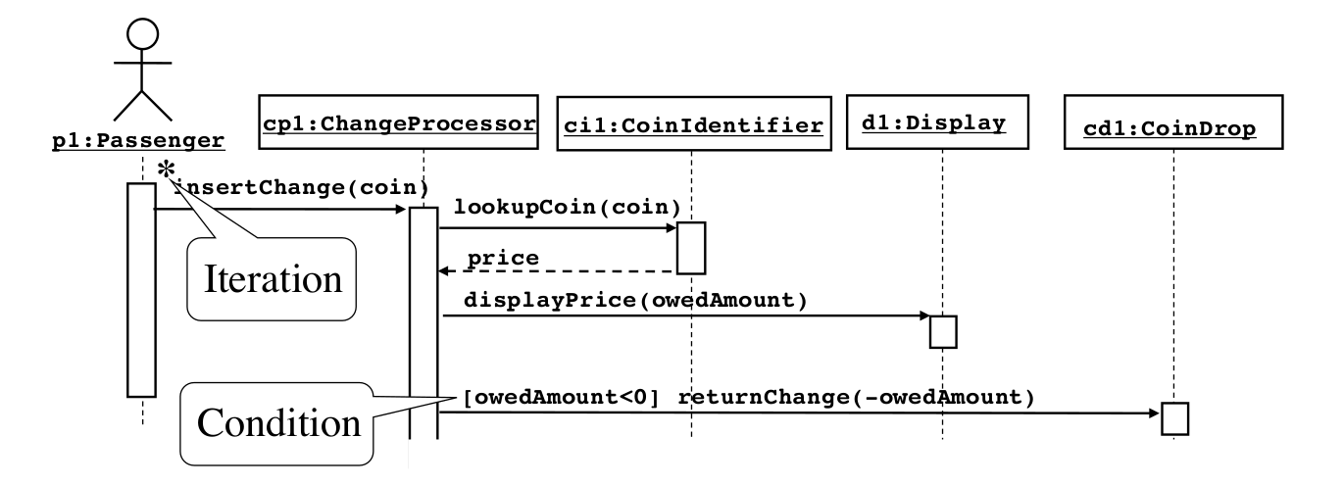
System Design
instance
dataflow
Diagrams:
Sequenz Diagrams:
- represent control flow and behavior in terms of interaction
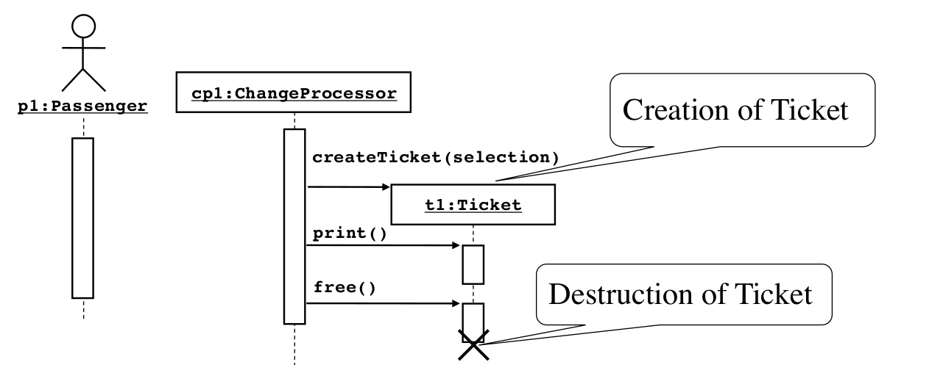
- all messages to an object must be public methods
- -time consuming to build +useful to identify missing objects
- +useful to identify public methods of a class/subsystem

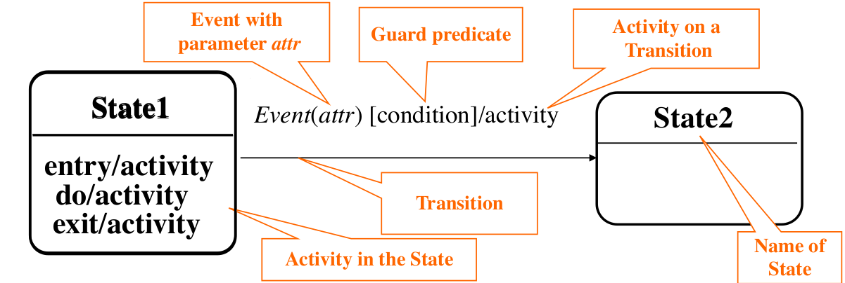
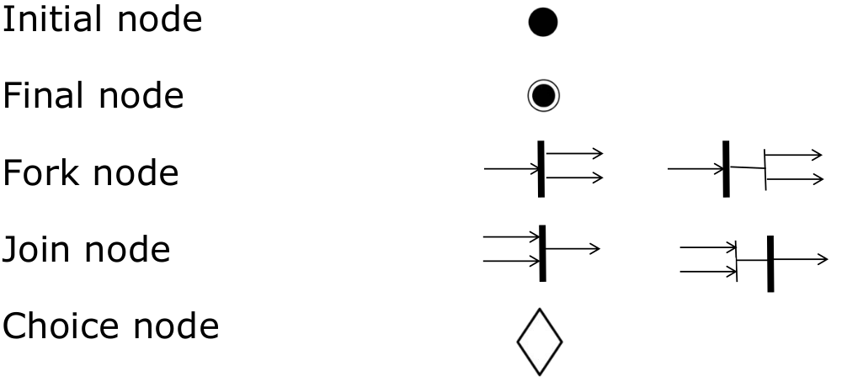
State Chart Diagrams:
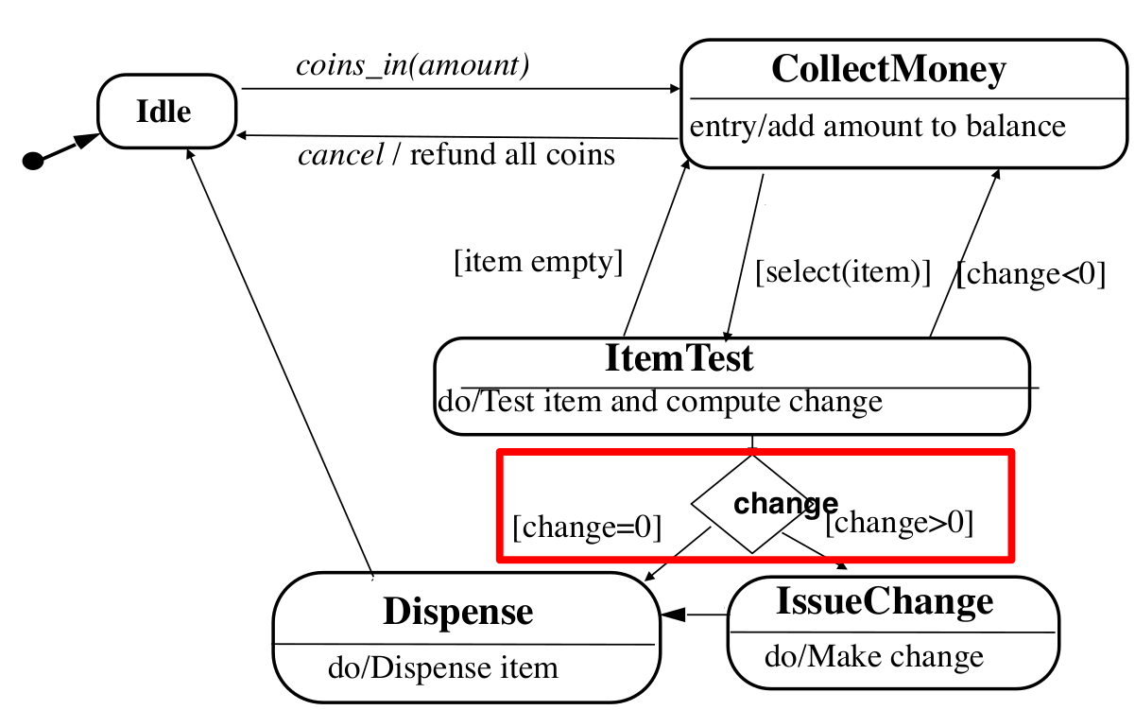
- State: abstraction of the attributes of a class, has a duration
- event /activity, [guard predicate]

State-chart vs Sequence Diagram
State-chart:  -helps to identify changes to an individual object over time | Sequence:  -helps to identify temporal relationship between objects over time  -sequence of operations as a response to one or more events

Activity Diagrams:
- nodes can describe activities and objects (Control nodes, Executable nodes(→ action node), object nodes
Object Node
Action Node
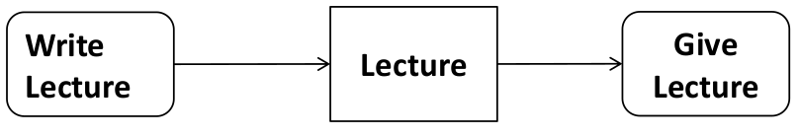
- edge directed connection between nodes
- decision with [ ]
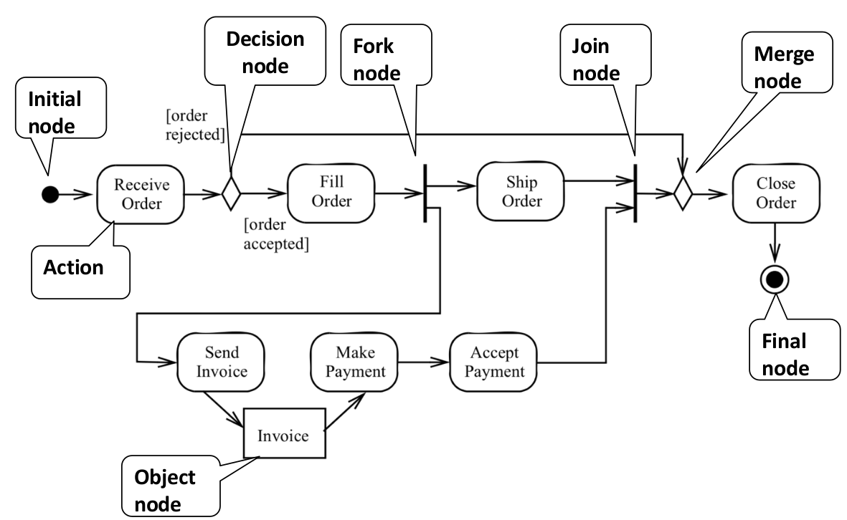
- fork node for splitting and synch.

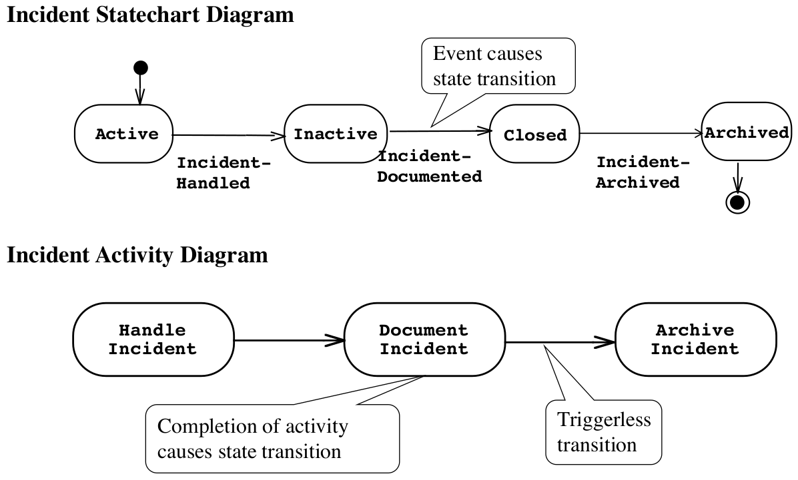
State-chart vs Activity Digram

Communication Diagram:
- visualizes interactions between objects as a flow of messages. Messages can be events or calls to operations
- describes the static structure of a system(obtained from class diagram→communication diagrams reuse layout of classes and associations)
- describes the dynamic behavior of a system(obtained from dynamic model(sequence & statechart diagram)
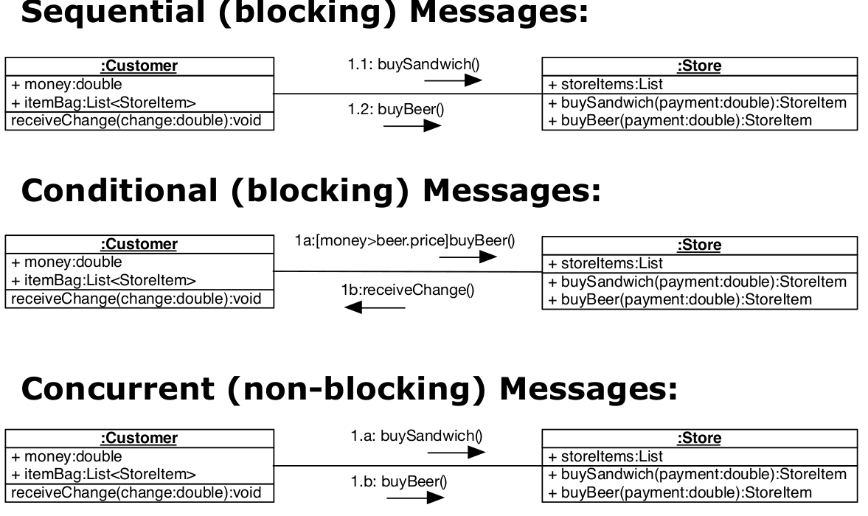
  - messages between objects are labeled with a number
- Message types:

Communication vs Class Diagrams
- Association labels, roles and multiplicities are not shown in communication diagrams. Associations between objects denote messages depicted as a labeled arrows that indicate the direction of the message, using a notation similar to that used on sequence diagrams
Communication vs Sequence Diagrams
- Both focus on the message flow between objects Sequence diagrams are good at illustrating the event flow overtime. They can show temporal relationships such as causality and temporal concurrencies
- Communication diagrams focus on the structural view of the communication between objects, not the timing.
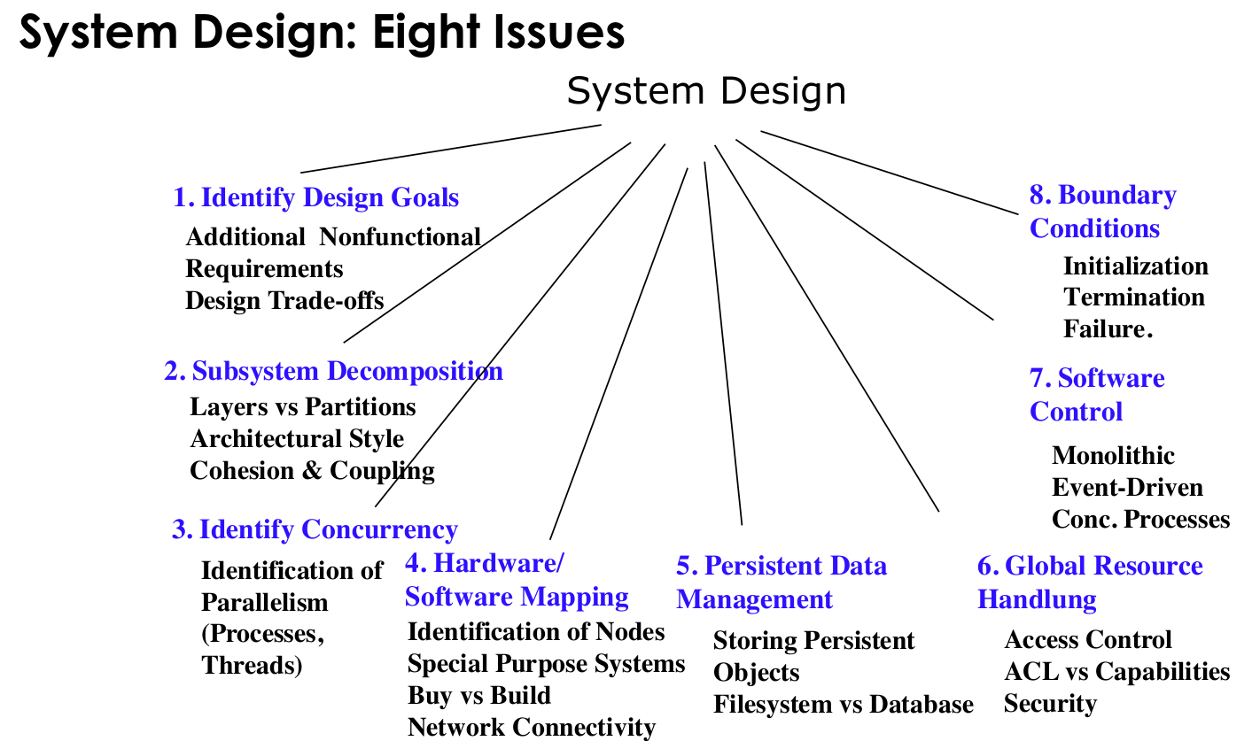
Nonfunctional Req.
Functional Model

Functional Model
Dynamic Model
Object Model
Dynamic Model

1Design Goal
- any Nonfunctional requirement is a design goal
- design goals often conflict with each other → design goal trade-offs
Design Goal Trade-offs
- functionality vs usability
- cost vs robustness
- efficiency vs portability
- rapid development vs functionality
- cost vs re-usability
- backward compatibility vs readability
2Subsystem Decomposition
Subsystems: collection of classes, associations, operations, events that are closely interrelated with each other
Service: group of externally visible operations provided by a subsystem(→subsytem interface)

Coupling vs Cohesion
Cohesion: measures dependency among classes  -high cohesion: the classes in the subsystem perform sir tasks and are related to each other via many associations  -low cohesion: lots of miscellaneous and auxiliary classes, almost no associations  Achieve high cohesion: operations work on same attributes | Coupling: measures dependency among subsystems  -high coupling: changes to one subsystem will have high impact on the other subsystem  -low coupling: a change in one subsystem does not affect any other subsystem  Achieve low coupling: smal interfaces,information hiding, no global data

Architectural Style vs Architecture
- Subsystem decomposition: -identification of subsystems, services and their relationship
- Architectural Style: -pattern fir a subsystem decomposition(e.g layered architecture: closed=can only call from layer below, open=can call from any layer below)
- Software Architecture: instance of an architectural style

System Design II
Patterns
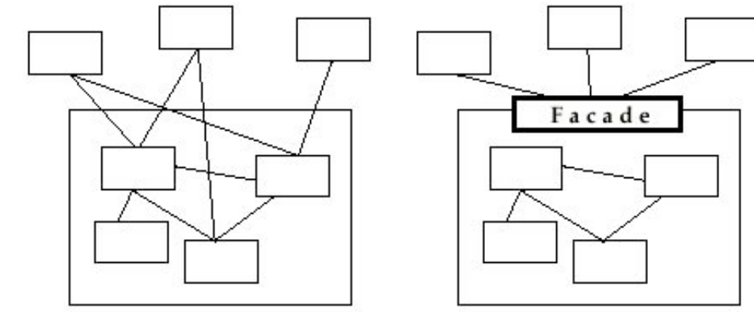
The Facade(to reduce Coupling)
- a facade defines a higher-level interface that makes the subsystem easier to use
Client/Sever Architecture(special case of layerd architectural style)
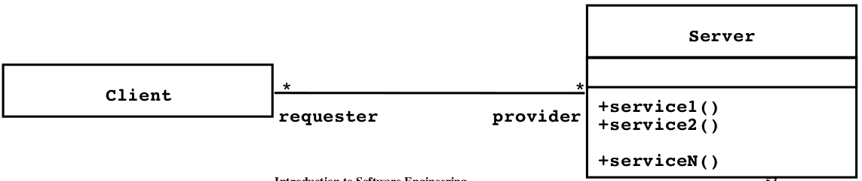
- often used in database systems
- client: input from user, front-end processing of input
- server: centralized data manegement
- problems: client/server use a req-response protocol→ peer-to-peer is often needed
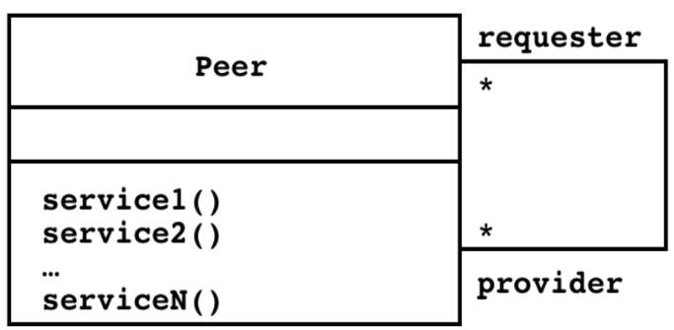
Peer-to-peer Architectural Style
- generalization of client/server Architecture but clients can be servers and servers can be clients
Model-View-Controller
- decouples data access(entity objects) and data presentation(boundary objects)
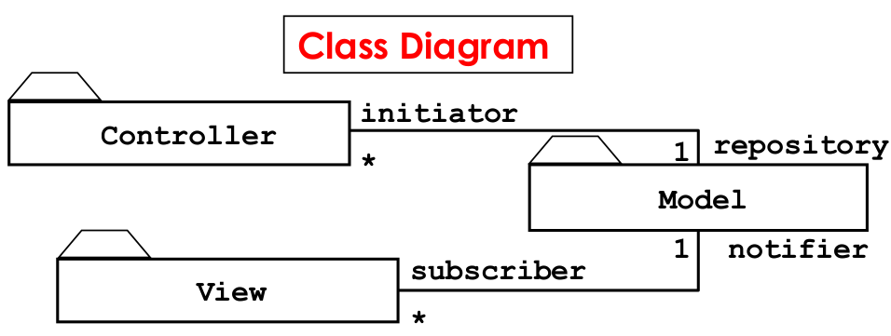
- model: -a subsystem containing boundary objects
- view: -a subsystem containing entity objects
- controller: -a subsystem mediating between the view and the models
MVC vs. 3-Tier Architectural Style
MVC:  -is nonhierachical (triangular)  -v sends updates to c, c updates m, v is directly updated from m | 3-tier:  -is hierarchical(linear)  -presentation layer never communicates directly with data layer  -all communication must pass through middleware layer
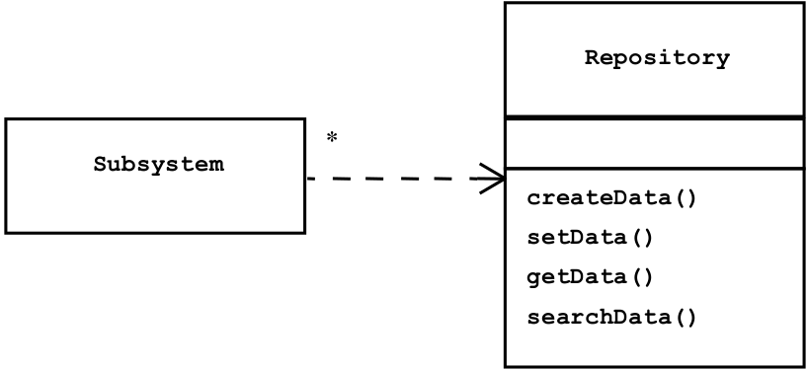
Repository Architectural Style
- support a collection of independent programs(=Subsystems) that work cooperatively on common data structure (=Repo.)
Elements of an Architectural Style
- Components(Subsystems): units with a specified interfaces
- Connectors(Communication): interactions between the components
3Concurrency
- used to address nonfunctional req. such as: performance, response time… using threads
4Hardware Software Mapping
- Control Objects → Processor
- Entity Objects → Memory
- Boundary Objects → I/O Devices
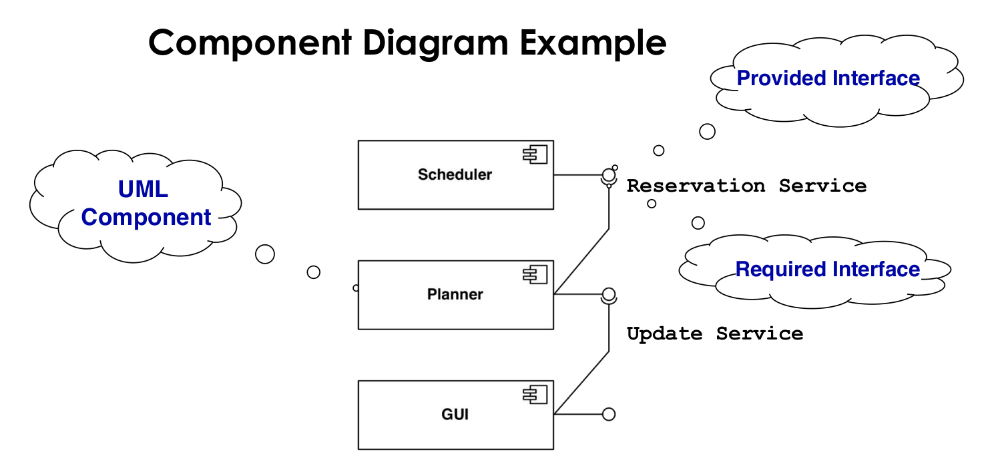
Component Diagram
- shows dependencies between components at design, compilation and run-time
- UML interface describes a group of operations provided or required by a component

Deployment Diagram
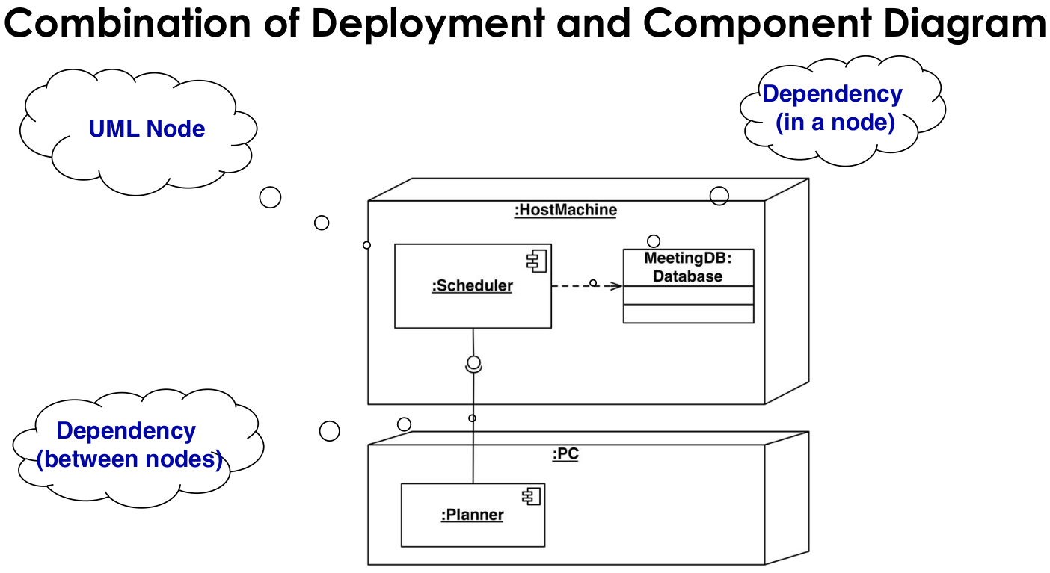
- shows the distribution of components at run-time
- uses nodes and connections to depict the physical resources in the system

5Persistent Data Management
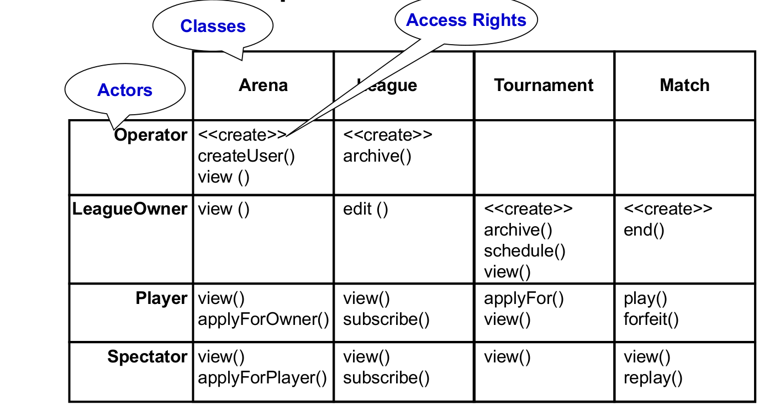
- persistency: a class is persistent, if the values of their attributes have a lifetime beyond a single execution(can be done with a file system or a database
6Global Resource Handling
- addresses access control→ done with an access matrix(rows=actors, column=classes)
7Software Control
- implicit software control(=role-based systems, logic programming)
- explicit software control(=centralized control,decentralized control)
- 2 sequence diagram structures to determine decentrilasation
Illustration 2: Stair Diagram
Illustration 1: Fork Diagram
8Boundary Conditions
- Initialization: -system is brought from a non-initial state to a steady-state
- Termination
- Failure

Object Design
- Purpose: -prepare for the implementation, transform the system model
Consists of 4 Activities:
- Reuse: Identification of existing solutions: -use of inheritance, use of design patterns
- Interface specification: -describes precisely each class interfaces
- Object model restructuring
- Object model optimization

Reuse in Object Design
- Composition (also called black box reuse) = A new class is created by the aggregation of the existing classes. The new class offers the aggregated functionality of the existing classes
- Inheritance (also called white box reuse)= A new class is created by subclassing. The new class reuses the functionality of the superclass and may offer new functionality.
Interface Specification
- Implementation Inheritance: reuse: implemented functionality in the super class
- Delegation: reuse: implemented functionality in an existing object
- Specification Inheritance: reuse: specified functionality in the superclass, but functionality in the object
Implementation Inheritance vs Delegation
Implementation Inheritance:  -extends a superclass with a subclass containing a new operation or overriding an existing operation | Delegation:  -catches an operation and sens it to another object

Design Patterns
- Structural Patterns: -reduce coupling between, -introduce an abstract class for future extensions, -encapsulate complex structures
- Behavioral Pattern: -allow choice between algorithms
- Creational Patterns: -allow to abstract from complex instantiation processes
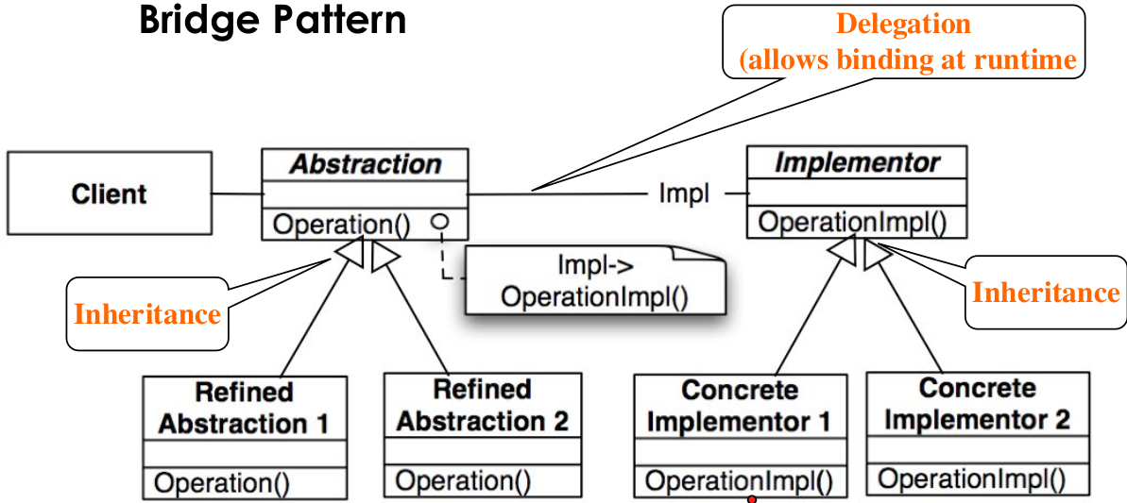
Bridge Pattern
- Problem: many design decisions are made final at design or compile time
- Bridge pattern allows to delay the binding between an interface and its subclass to the start-up time of the system

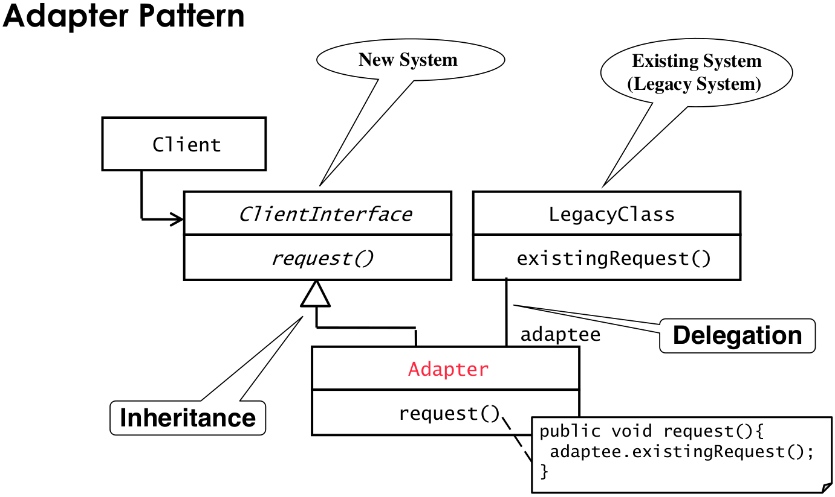
Adapter Pattern
- connects incompatible components(=wrapper)
- Proxy Pattern
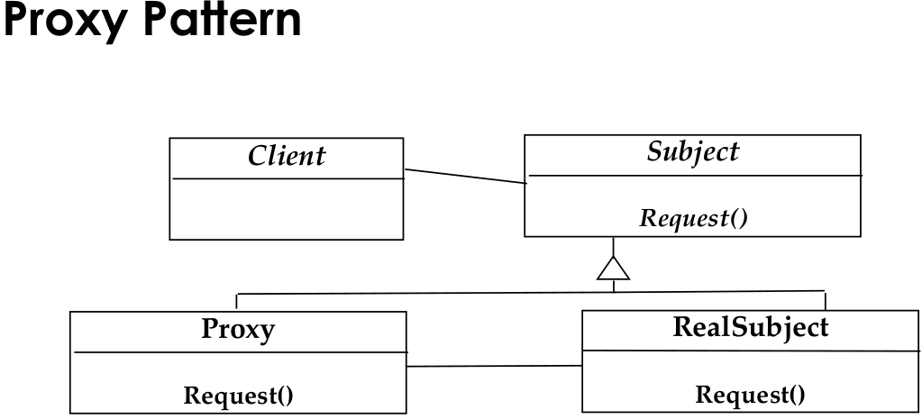
- real subject is expensive to acces or to create→ proxy-object acts as a representative for the remote object and access the remote object only if really needed
- applicability: -caching(remote proxy), -substitute(virtual proxy)=object is expensive to create or to download, -access control(protection proxy)

Adapter vs Bridge
-both hide the details of the underlying implementation
Adapter:  -adapter pattern making unrelated components work together  -applied to systems that are already designed  →inheritance followed by delegation | Bridge  -is used up-front in a design to let abstractions and implementations vary independently  →delegation followed by inheritance

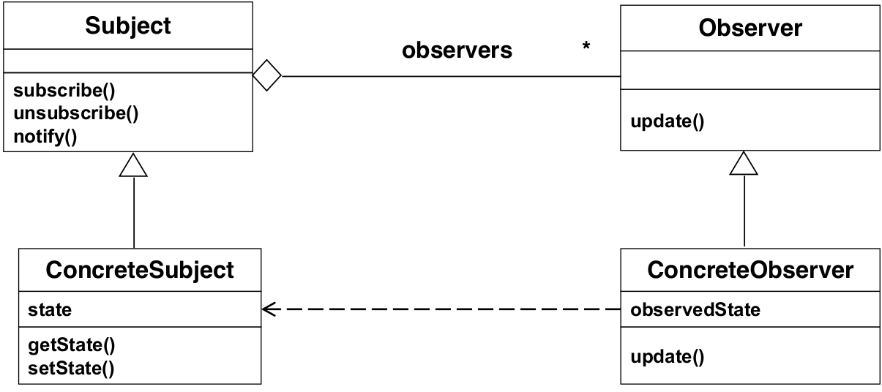
Observer Pattern (Publish and Subscribe)
- problem: object that changes its state quite often
- models a 1-to-many dependency between objects: -connects the state of an observed object(=subject) with many observing objects(=observers)
- usage: -maintaining consistency across redundant states
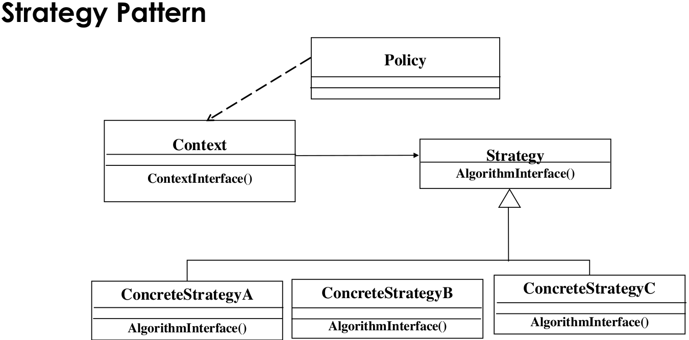
Strategy Pattern
- problem: different algorithms exist for a specific task → switch between algorithms at run time
- policy decides which “ConcreteStrategy” is best in a given context

Model Transformations and Refactoring

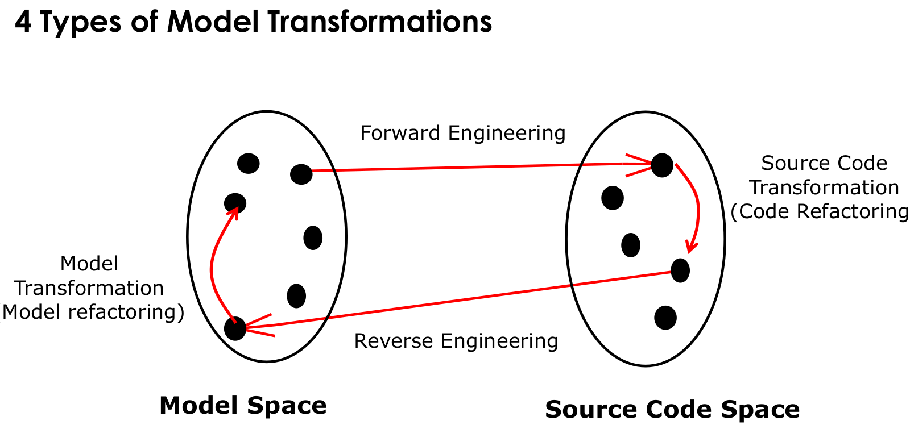
Model Based Software Engineering
- application of modeling to support req. , design, analysis
Refactoring
- a change made to the internal structure of source code to make it: -easier to understand, -without changing its observable behavior
Refactor
- to restructure source code by applying a series of refactoring

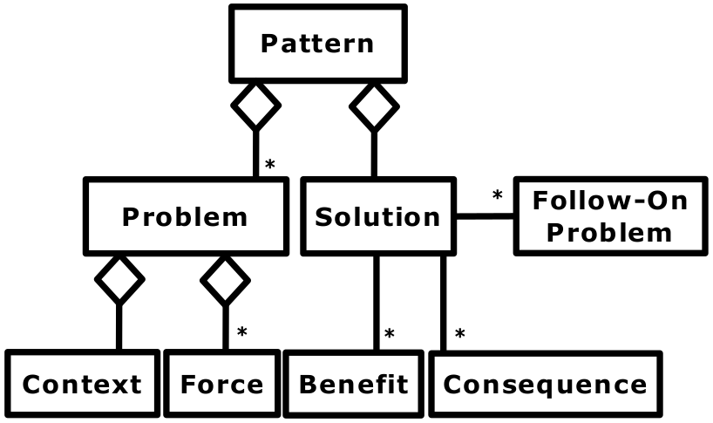
Pattern Based Development
UML
Pattern in UML
- Context: sets stage where pattern takes place
- Forces: describes why problem is difficult to solve
Examples
- Text: “must interface with an existing object” → Adapter Pattern
- Text: “must interface to several systems, some of them to be developed in the future”, “an early prototype must be demonstrated”, “must provide backward compatibility” → Bridge Pattern
- Text: “must interface to existing set of objects”, “must interface to existing API”, “must interface to existing service” →Façade Pattern
- Text: “complex structure”, “must have variable depth and width” → Composite Pattern
- Text: “must provide a policy independent from the mechanism”, “must allow to change algorithms at runtime” →Strategy Pattern
- Text: “must be location transparent” → Proxy Pattern
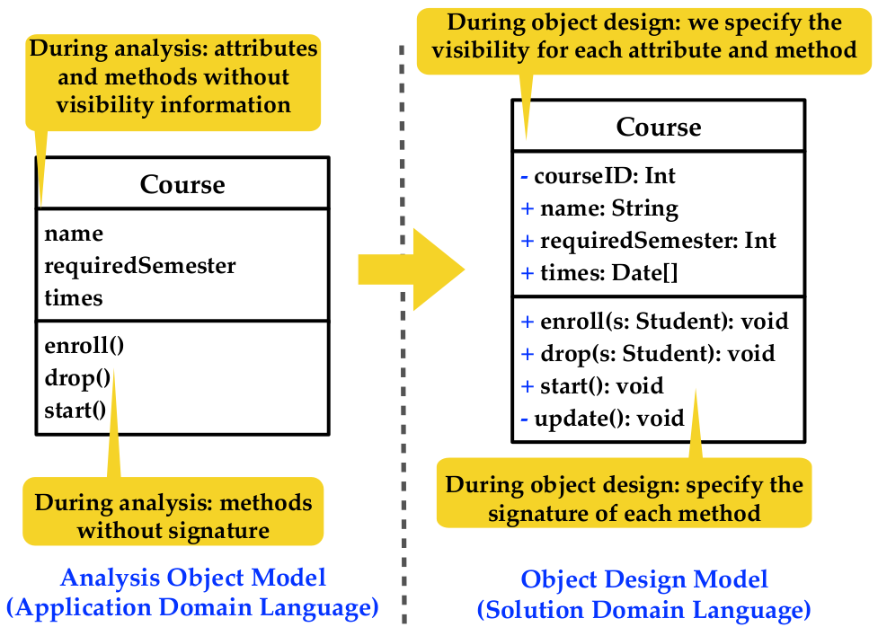
- Text: “must be extensible”, “must be scalable” →Observer Pattern (MVC Architectural Pattern)

Software Life Cycle Models

Software life cycle:
Analysis Object Model vs Object Design Model
- set of activities and their relationships to each other
Software life cycle model:
- abstraction representing the development of software
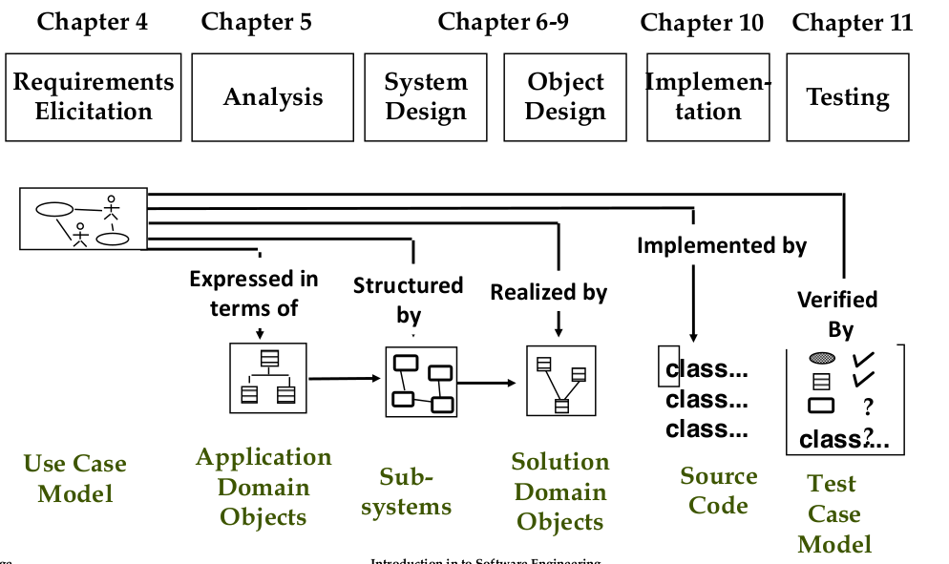
Major Views of Software Life Cycle
- Activity-oriented view: software dev. Consists of a set of development activities (first: problem definition activity and system dev. Activity, then system operation activity)
- Entity-oriented view: software dev. Consists of the creation of a set of deliverables(market survey, system specification documents, executable system, lessons learned document)
Tailoring: -adjusting a life-cycle model to fit a project(naming, cutting, ordering)
Software lifecycle activities
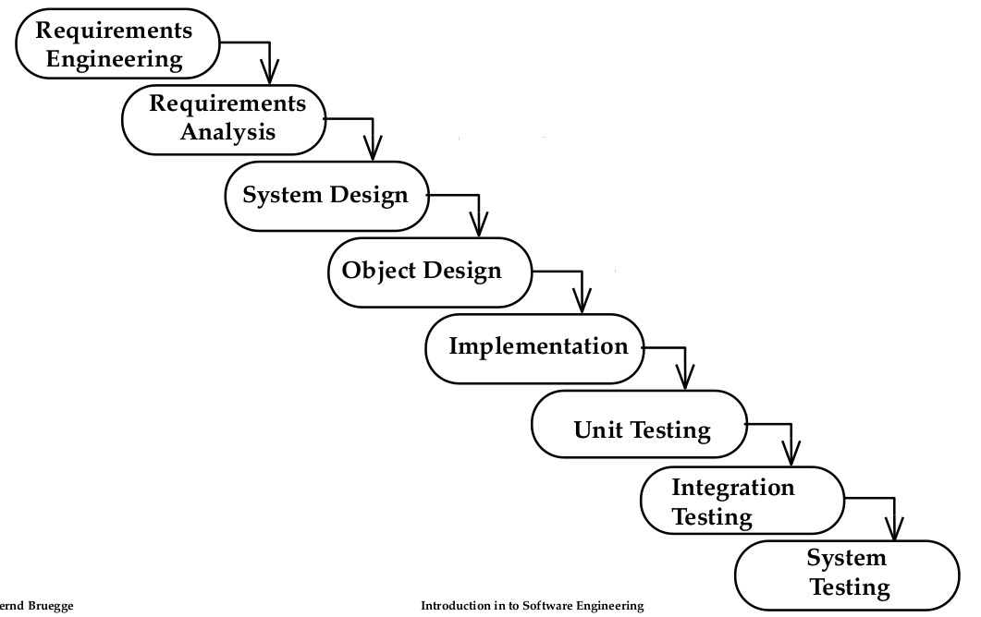
← Waterfall Model (activity diag.)
Properties:
-linear system
-always one activity at a time
-easy to check progress during development
Problems:
-software dev. Is not linear

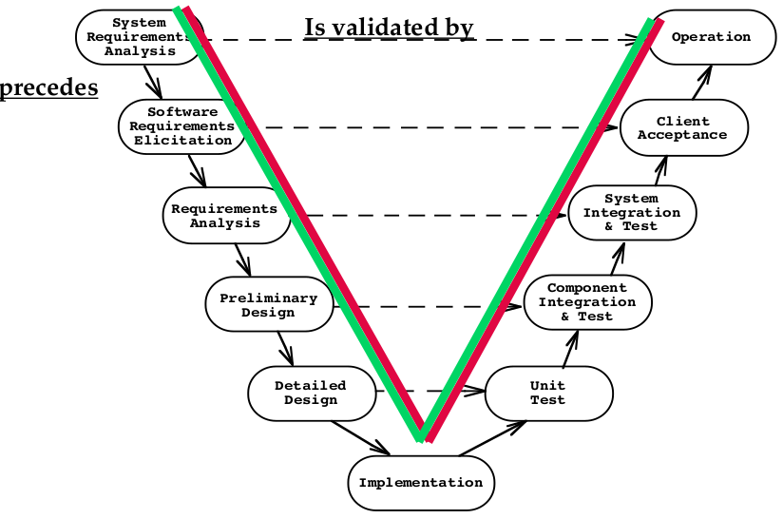
Spiral Model
V-model→
- iterative model with 4 activities(are applied iteratively in each of 9 rounds)
- rounds:(1. Concept of Operations, 2. Software req. , 3. Software Product Design, 4. Detailed design, 5. Code, 6. Unit Test, 7. Integration and Test, 8. Acceptance Test, 9. Implementation)
- each round goes through this activities: 1. Define objects, alternatives, constraints ; 2. Evaluate alternatives, identify and resolve risks; 3. Develop and verify a prototype, 4. Plan the next round
Unified Process
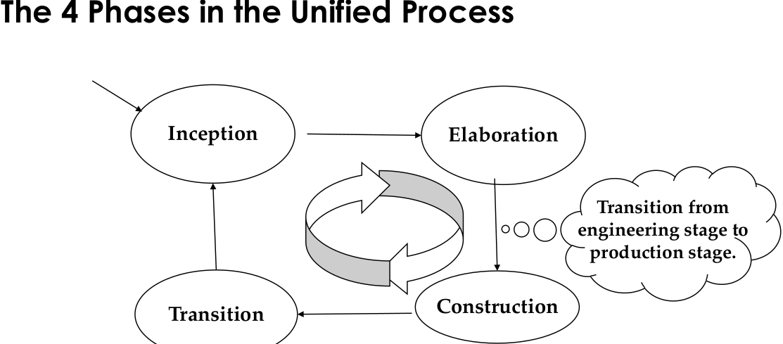
- each cycle consist of 2 stages and 4 phases
- stages: -Engineering stage(smaller teams,focusing in design activities) with 2 phases(Inception, Elaboration), -Production stage(lager teams, focusing on construction, test and deployment activities) with 2 phases(construction and transition)
Linear and Spiral Model Limitation
- both don’t deal with frequent change
Frequency of Change
- no change during project → linear model(waterfall, v)
- infrequent changes during project → iterative models (spiral, unified process)
- changes are frequent → agile model (scrum)

Incremental vs Iterative vs Adaptive
Incremental(=add onto something)  -improves your process | Iterative(=redo something)  -improves your product | Adaptive(=react to changing requirements)  -improves the reaction to changing customer needs

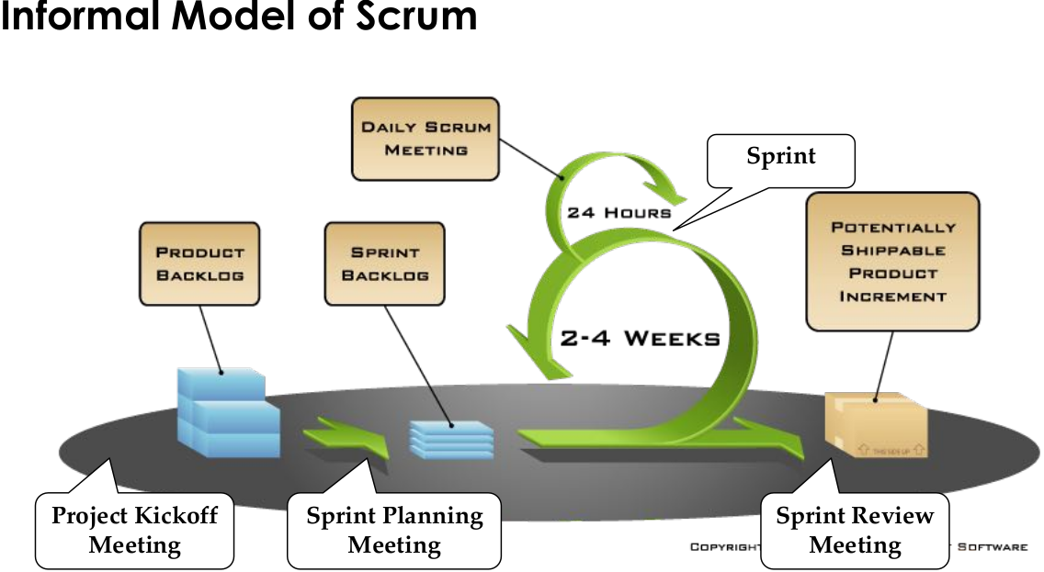
Scrum
- Scrum is a technique to manage and control software and product development when the requirements and the technology may be rapidly changing during the project.
Core Components
- 3 Artifacts(Product and Sprint Backlog, PSPI)
- 4 Meeting Activities(Kickoff Meeting, Sprint Planing Meeting: list of prioritized features, Daily Scrum, Sprint Review Meeting)
- 3 Roles(Scrum Master: responsible for process, Product Owner: responsible for product, Developer: responsible for realization of the PSPI)
Scrum Roles
- Scrum Master: -should moderate and coach the team, -main job is to remove impediments
- Product Owner: knows what need to be build and in what order, responsible for product, value and prioritzation
- Scrum Team: 5-6 people, cross-functional (analyst, programmer,designer, tester), team is self-organizing

Software Configuration Management
- Set of management disciplines within a software engineering process to develop a baseline
Configuration Management Activities
- Configuration item identification: modeling the system as a set of evolving components
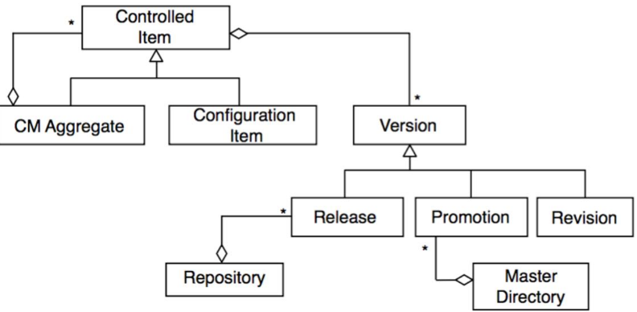
Illustration 3: Object Model for Configuration Management
- Change management: management of change requests (e.g repository architecture)
- Promotion management: creation of versions for other developers
- Branch management: management of concurrent development
- Release management: creation of versions for clients and end users
- Variant management: management of coexisting versions
Git
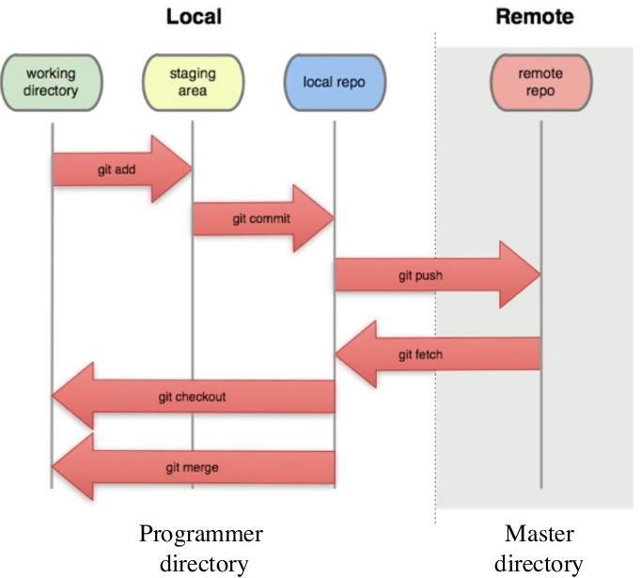
Merge Conflict: happen if two persons work on the same lies in the same file at the same time
Continuous Integration: technique where members of a team integrate their work frequently
Continuous delivery: team keeps producing valuable software in short cycles and ensure that software ca reliable released
Continuous deployment: every change that passes automated test is deploey automatically

Testing

Requirements Elicitation and Analysis
Ganz bestimmte relation, die nur einmal geerbt wird, zb “no charge” kann nur von “ColectMoney” extenden
Nicht spezifische relation, kann von mehreren erben “purchase card” muss nicht nur von “collect money” erben
Deutsch: Lastenheft
Hindernisse

