CSIS 3701:Advanced Object-Oriented Programming

Object-Oriented Unit Testing

Introduction

In the previous section, we put a great deal of emphasis on decomposing a complex project into simpler modules, each of which can be implemented by an individual programmer/group, with a minimum of communication after the initial design. Of course, an important part of implementing an individual module is testing it – your individual modules should be completely debugged before integrating it with the other modules. This is called unit testing.

Unit Tests

Glass Box Testing

Glass box testing is based on the structure of the methods. These are the kind of tests that you probably performed in 2610, such as:
- At least one test case for each branch.
- Several tests for each loop.

These kinds of tests are often also based on your internal representation. For example, if you are testing methods in the Student class, and you are using some sort of list to store the courses, then you should probably test case where there are no courses in the list, one course in the list, and many courses in the list.

These test cases will be created by the developer, as they are based on the internal representation of the methods and class.

Black Box Testing

Black box testing is based on the requirements for the class – that is, what the class methods are required to do by other classes.

The best source of back box tests are the scenarios created during the design and specifications. There should be at least one test case for each scenario in which the method takes part.

For example, the following types of tests should be applied to the addCourse method of the Student class:

Purpose | State | Call | Desired Result
successful add | course 0632 open, not in list | addCourse(0632) | 0632 added to list  nothing returned or thrown
course closed | course 0633 closed, not in list | addCourse(0633) | CourseClosedException thrown, no state change
already in course | course 0632 open, in list | addCourse(0632) | AlreadyInCourseException thrown, no state change
no such course | no such course as 0001 | addCourse(0001) | NoSuchCourseException thrown, no state change

These tests are often developed by the users of the class. Since they are the ones who depend on those methods, they are often the best to determine when all of the requirements are met. These tests are often developed during the design and specification stage, often directly from the scenarios created during that stage.

Test Harnesses

As mentioned in the section on Design and Debugging, we often have to write code to test our classes (since they generally can’t run on their own). These pieces of code are often referred to as test harnesses. We have already seen a couple of these:
- Debugging inspectors, which print the state of the object, usually to standard output.
- Class drivers, which execute all constructors and methods, under as many circumstances as possible.

When using any type of debugger, it is a good idea to make a list of tests (like that above) in order to make sure that all requirements are tested. It is also necessary to retest all test cases after any modification in order to make sure the modification had no adverse affect on any of the code (this is called regression testing).

Stub Classes

Another major problem is how to test methods which contain calls to methods in other classes being created by other developers – methods we currently have no access to. For example, consider the Student class again, this time from the point of view of the developer of the StudentInterface class. Their code will contain calls to the methods addCourse and getCourses. How can they test (or even compile) their code, given that some other developer is currently writing those methods?
In order to debug code that contains calls to methods which are not available, we will need to create "temporary" classes and methods to take their place. These are usually refered to as "stubs".
Stub functions are often used in place of functions called by a function we are currently testing. For example, in C++ if we are testing the function f1, which includes a call to the (currently unavailable) function f2:
void f1(int x) {
...
f2();
...
}
We might test it by creating a stub version of f2 which does nothing:
void f2() {} // stub function

Most of the time, however, we have it print diagnostic messages to help with the debugging -- in particular, to confirm that f1 correctly calls f2:
void f2() {cout << "f2 called\n";}

If f2 takes any input parameters, we usually print them as well:
void f2(int a, int b) {
cout << "f2 called with " << a << " and " << b << "\n";
}
And finally, if f2 returns or throws anything, we can either return a dummy value, or prompt for the value to be returned:
int f2(int a, int b) {
cout << "f2 called with " << a << " and " << b << "\n";
int c;
cout "What value should f2 return: ";
cin >> c;
return c;
}

In order to debug a class which sends messages to other objects, we will need to create a stub class for those objects, in order to create "temporary" objects for the purpose of testing. Such a stub class must contain:
- A (very simple) constructor.
- Stubs for each method that will be invoked by our class.
This stub class will probably not contain any state variables.
For example, consider once more the StudentInterface class. Suppose that we wished to test and debug our code for it, but had no actual code for the Student class. We will have to create a stub class which takes its place, giving stub methods for the addCourse and getCourses methods.
Since standard input in Java is not particularly reliable, the simplest way to implement a stub class is to use dialog boxes (specifically, input dialogs). A dialog box can display all of the input data passed to the methods in the stub, and prompt for input corresponding to the desired value to return or throw.
The following is a simple stub class to take the place of the Student class:
public class Student { // stub class used to test StudentInterface
public Student() {
JOptionPane.showMessageDialog(null, “Student constructor called”);
}

// Stub addCourse method
public void addCourse(int coursecode) {
// Create a string which displays parameters and prompts for input
String display = “addCourses called with “ + coursecode
+ “\nShould it:”
+ “\n1) return nothing (successful add)”
+ “\n2) throw CourseClosedException”
+ “\n3) throw AlreadyInCourseException”
+ “\n4) throw NoSuchCourseException”;

// Display the dialog
String response = JOptionPane.showInputDialog(null, display);

// Execute one of the following 4 results
if (response.equals(“1”)) return;
if (response.equals(“2”)) throw new CourseClosedException();
if (response.equals(“3”)) throw new AlreadyInCourseException();
if (response.equals(“4”)) throw new NoSuchCourseException();
}

// Stub getCourses method
public String getCourses() {
// Print diagnostic message
System.out.println(“getCourses called“);
// Here we just return a simple default value
return “1551\n2610\n”;
}

}
For example, calling the method in this stub class might display the following:
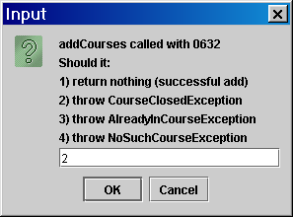

Interactive Test Harnesses
Finally, we might consider a simple visual application to act as a driver class (as opposed to using a main as shown in earlier sections). It would allow the tester to choose which methods to call with what parameter values, and to display (perhaps in a textarea) return values.
For example, when testing the Student class, we might consider creating a simple stub class to act as a CourseInventory object, implementing the addStudent method. As before, it would primarily use dialog boxes:

// This is a very simple stub for a course inventory, based on
// dialog boxes. It displays the parameters passed, and
// allows a response to be chosen.

import javax.swing.*;
import java.awt.*;

public class CourseInventory {

public CourseInventory() {}

// This stub method displays the parameters and returns nothing
// or throws an exception based on what is chosen.

public void addStudent(int coursecode, String name) {

// Display parameters
String display = “addStudent called with “ + coursecode + “ and “ + name
+ “\nShould addStudent:”
+ “\n1) return nothing (success)”
+ “\n2) throw a CourseClosedException”
+ “\n3) throw a NoSuchCourseException”;

String reply = JOptionPane.showInputDialog(null, display);

if (reply.equals("1")) return;
if (reply.equals("2")) throw new CourseClosedException();
if (reply.equals("3")) throw new NoSuchCourseException();
}

}

The driver would be a minimal StudentInterface class, which just gets a course code to add, and displays the result of the test in a textarea:
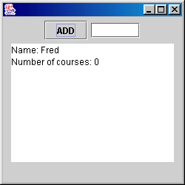

// This simple application acts as a driver for testing the Student class

import javax.swing.*;
import java.awt.event.*;

public class StudentInterface extends JFrame implements ActionListener {

private JButton addButton;
private JTextField courseField; // Type in course code here
private JTextArea responseArea; // Display results here

private Student s; // Student object to test

public StudentInterface() {
addButton = new JButton("ADD");
courseField = new JTextField(6);
responseArea = new JTextArea(10, 20);
JPanel p = new JPanel();
getContentPane().add(p);
p.add(addButton);
p.add(courseField);
p.add(responseArea);
addButton.addActionListener(this);
setSize(250, 250);
setVisible(true);

// Construct a Student object to test
s = new Student("Fred");

// Display its initial state
responseArea.setText(s.inspect());

// Construct a new CourseInventory stub and pass it to the Student
s.setInventory(new CourseInventory());

}

public void actionPerformed(ActionEvent e) {

// Call method for testing and display results of call
try {
s.addCourse(Integer.parseInt(courseField.getText()));
responseArea.setText("Course added");
}
catch (AlreadyInCourseException ex) {
responseArea.setText("Already in course");
}
catch (CourseClosedException ex) {
responseArea.setText("Course closed");
}
catch (NoSuchCourseException ex) {
responseArea.setText("No such course");
}

// Display current course state
responseArea.append("\n"+s.inspect());
}

public static void main(String[] args) {
StudentInterface si = new StudentInterface();
}

}

Also note that we have defined a simple state inspector method for the actual Student class we are testing – this allows the driver to constantly display the state of the test object.

// This class is one currently being developed with the help
// of driver and stub classes. Users can add classes to a list.

public class Student {

private String name;
private int[] courses;
private int numCourses;
private CourseInventory inventory; // Course inventory object (currently stub)

public Student(String n) {
name = n;
courses = new int[20];
numCourses = 0;
}

public void addCourse(int coursecode)
throws AlreadyInCourseException,
CourseClosedException,
NoSuchCourseException {

// Check whether already in this course (can do here).
for (int i = 0; i < numCourses; i++)
if (courses[i] == coursecode)
throw new AlreadyInCourseException();

// Try adding course to course inventory.
// For now, this will involve calling a stub method.
inventory.addStudent(coursecode, name);

// If successful, add to list.
courses[numCourses] = coursecode;
numCourses++;
}

public void setInventory(CourseInventory i) {
inventory = i;
}

// This tool returns all data about current state of object
public String inspect() {
String reply = "Name: " + name + "\nNumber of courses: " + numCourses;
for (int i = 0; i < numCourses; i++) reply = reply + "\n" + courses[i];
return reply;
}

}

Running our four major scenarios might proceed as follows:
Testing a successful add
Enter some course code (say, 1111) into the driver, and then enter 1 into the dialog box created by the stub.
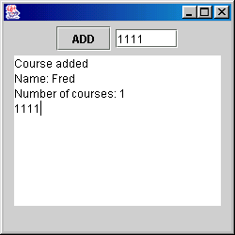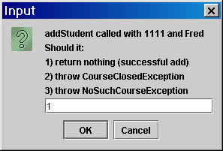
Note that the driver now displays the result of the successful add, and the new state of the Student object, and that the stub displays the information passed to it.
Testing a closed course (no such course is similar)
Enter some course code (say, 2222) into the driver, and enter a 2 in the reply field of the stub, so it indicates a closed course:
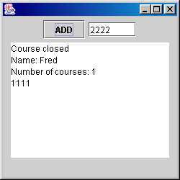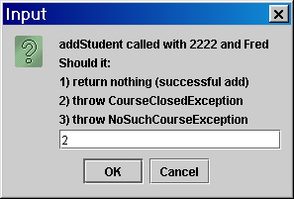
Note that the driver now displays the result of the unsuccessful add, and the unchanged state of the Student object, and that the stub displays the information passed to it.
Testing already in course
Enter a course already added (1111) into the driver:

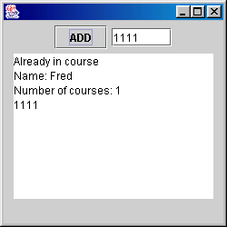

Note that the driver now displays the result of the unsuccessful add, and the unchanged state of the Student object. Also note that no dialog box appears (a correct result!), as it was never called in this test.

Copyright © 2000 by Dr. John R. Sullins

