|  |  |
| --- | --- |
| **ID:** *HE-01* | **Problem** |
| **Name:**  Visibility of system status in an access controlled elevator panel. | |
| **Evidence:**  Elevator control system in the cargo elevator at 300 s. Craig St. building. After five o’clock pm the elevators in 300 s Craig St. do not work without a valid ID card. When using the elevator there is no indication that is requirement is necessary. An elevator can be summoned and boarded without ID. However, once on board a valid ID must be passed through a card reader before the elevator will move to the desired floor. At no point during this process is any indication of system status given to the user. The issue is further complicated by a lack of feedback from the system. Although a valid card swipe will cause the reader light to quickly switch from red to green and back to red again, the state of the elevator is never indicated.  *See Appendix: HE-01* | |
| **Explanation:**  This real world system violates the heuristic principle of a clearly visible status. Without prior knowledge of the system, users are not given any indication as to why the elevator does not work. There is no visual or auditory feedback so the user is left to experiment with the system in order to get it to work. | |
| **SeverityRating:**  *2 – Minor: Low Priority*    **Justification (Frequency, Impact, Persistence):**  *Frequency – Every time the elevator is used between 5pm and 6am. Can be confusing for new users and existing users.*  *Impact –Can be difficult to overcome, often leaving users with the impression that they do not have permission to use elevator.*  *Persistence – The problem can be overcome, but requires additional long term memory to recall the proper steps.* | |
| **Possible solution and/or Trade-offs:**  Provide an auditory alert indicating that the floor button being pressed is unavailable. | |
| **Relationships:**  None. | |

|  |  |
| --- | --- |
| **ID:** *HE-02* | **Problem** |
| **Name:**  Alert message that appears without context | |
| **Evidence:**  This warning appears on my computer every time I perform a fresh boot. | |
| **Explanation:**  This message offers no indication of why it appears or what I can do to resolve the issue. This message violates the second heuristic: “Match between system and the real world”. All of the text that appears in this window is system oriented and cryptic. The window provides no context on what is causing it or what it means. | |
| **SeverityRating:**  *2 – Minor: Low Priority*    **Justification (Frequency, Impact, Persistence):**  *Frequency – Every time the computer is booted, would affect anyone who used this computer.*  *Impact –Easy to overcome. Clicking the OK button removes the window and no further issues are apparent.*  *Persistence – The problem occurs after every fresh system boot, without further information it is impossible to avoid.* | |
| **Possible solution and/or Trade-offs:**  The window should provide a descriptive explanation of the issue with a clear path to resolution. | |
| **Relationships:**  None. | |

|  |  |
| --- | --- |
| **ID:** *HE-03* | **Problem** |
| **Name:**  Oracle installer provides a cancel button but does not allow cancellation | |
| **Evidence:**  The following message is received during the installation of an Oracle database. A cancellation button is interactive, however when clicked a message appears saying that the operation cannot be canceled.    *See Appendix: HE03* | |
| **Explanation:**  This interaction violates the heuristic principle of user control and freedom. Although the system offers an ‘emergency exit’, the exit does not actually work. | |
| **SeverityRating:**  *2 – Minor: Low Priority*    **Justification (Frequency, Impact, Persistence):**  *Frequency – Issue occurs whenever a user performs a bounce operation on a database. This issue will impact all users.*  *Impact – This issue is difficult to overcome, users must wait for a lengthy period of time and perform a different operation to roll back the changes that were made.*  *Persistence – This issue is unavoidable.* | |
| **Possible solution and/or Trade-offs:**  To resolve this issue the cancel button should be designed to work. Undo operations should be added to the process so that when a cancellation is made by the user the work can be rolled back to an originating state. | |
| **Relationships:**  None. | |

|  |  |
| --- | --- |
| **ID:** *HE-04* | **Problem** |
| **Name:**  Inconsistent icon use in settings window | |
| **Evidence:**  The extensions settings dialog for the Windows version of the VirtualBox software application inexplicably uses icons which break the consistency of the rest of the application. A full screenshot and comparison screenshot are included in the appendix.    *See Appendix: HE-04* | |
| **Explanation:**  On every other settings page the icons used to indicate ‘Add’ and ‘Remove’ use a representative image overlaid with a ‘+’ and ‘-‘ symbol. However, on the extensions screen this convention is not used, even though they perform the same functions as their counterparts on other screens. This breaks the heuristic of consistency and standards. Upon first use, users are not immediately certain as to the intent of these controls. | |
| **SeverityRating:**  *2 – Minor: Low Priority*    **Justification (Frequency, Impact, Persistence):**  *Frequency – This problem occurs for all users, however expert users may not be affected.*  *Impact – The problem is easy to overcome since it is merely a failure of visual cueing. The control functions properly when used.*  *Persistence – The problem will exist upon each use of the application, but is avoidable. Users that are unsure of the intent can hover over the control to view a tooltip that describes its functionality.* | |
| **Possible solution and/or Trade-offs:**  Modify the icons to use the same +/- overlay that is used by the rest of the Add/Remove icons in the application. | |
| **Relationships:**  None. | |

|  |  |
| --- | --- |
| **ID:** *HE-05* | **Problem** |
| **Name:**  Error prevention | |
| **Evidence:**  When uninstalling WebEx software running on Microsoft Windows XP the following message is displayed. | |
| **Explanation:**  This message box violates the error prevention heuristic by not providing the user with a functional confirmation option. It is good that an attempt to prevent a mistake is in place, but the result is confusing and unclear. If the user decides they do not want to uninstall the software (good), the interface here does not provide any way to cancel the process. | |
| **SeverityRating:**  *2 – Minor: Low Priority*    **Justification (Frequency, Impact, Persistence):**  *Frequency – This message will appear for all users attempting to uninstall this application.*  *Impact –It is difficult to overcome. The only path forward is to perform the uninstall operation or access the system process manager to kill the process.*  *Persistence – The problem will occur whenever this particular application is uninstalled. However, it is unlikely that users will face this condition on more than one occasion due to the rare need to uninstall the application.* | |
| **Possible solution and/or Trade-offs:**  Replace the “OK” button with “Yes” and “No” buttons. | |
| **Relationships:**  None. | |

|  |  |
| --- | --- |
| **ID:** *HE-06* | **Problem** |
| **Name:**  High level of recognition required when adding data to a Compiz setting | |
| **Evidence:**  The following interface is displayed on Linux systems running a UI modification program called Compiz. The input forms in this UI do not provide any contextual clues as to what type of information should be entered into the input fields.    *See Appendix: HE-06* | |
| **Explanation:**  The interface violates the heuristic principle of “Recognition rather than recall”. The input field depicted in the evidence requires a very specific format in order to provide the desired functionality. However, there is no information associated with the application that explains what that format should look like. Therefore either deep recall capability is required by the user or frequent web searches are necessary in order to add the value in correct format. | |
| **SeverityRating:**  *3 – Major: Medium Priority*    **Justification (Frequency, Impact, Persistence):**  *Frequency – This problem is common and occurs for new and casual users. Users that are experts with the system may have the knowledge stored in long term memory.*  *Impact – The problem is moderately easy to overcome. As a frequent question in public spaces, the answer is quickly discoverable with a web search.*  *Persistence – The problem is unavoidable, it occurs whenever the application is used.* | |
| **Possible solution and/or Trade-offs:**  Add a brief formatting example under the input or as a tooltip. | |
| **Relationships:**  None. | |

|  |  |
| --- | --- |
| **ID:** *HE-07* | **Problem** |
| **Name:**  Missing month of December in event calendar. | |
| **Evidence:**  The month of December is missing when setting an event for a person in Android 4.2.    *See Appendix: HE-07* | |
| **Explanation:**  This error violates the heuristic principle of flexibility and ease of use. The month selector is an accelerator that should make selecting dates quick and easy. A user expects the month of December to appear in the calendar. | |
| **SeverityRating:**  *4 – Catastrophe*  **Justification (Frequency, Impact, Persistence):**  *Frequency – Every time, for all users.*  *Impact – Difficult to overcome, impossible to set an event in December.*  *Persistence – This problem appears every time a user needs to set an event.* | |
| **Possible solution and/or Trade-offs:**  Fix the event calendar to include the month of December. | |
| **Relationships:**  None. | |

|  |  |
| --- | --- |
| **ID:** *HE-08* | **Problem** |
| **Name:**  Unnecessary and repetitive information on account management page. | |
| **Evidence:**  The following image depicts a section from the Verizon Wireless account management page. This image is repeated multiple times on a page, forcing a user into unnecessary scrolling to view account data.    A full screenshot of the image above can be viewed in the appendix.  *See Appendix: HE-08* | |
| **Explanation:**  The Verizon Wireless account management page makes poor use of space violating the heuristic for aesthetic and minimalist design. Each section starts with a repetitive header, taking up valuable screen real estate. | |
| **SeverityRating:**  *2 – Minor: Low Priority*    **Justification (Frequency, Impact, Persistence):**  *Frequency – Appears for all users.*  *Impact –Easy to overcome, yet excessively time consuming when compared against value of the information being displayed.*  *Persistence – Users will encounter this problem whenever accessing their account management page.* | |
| **Possible solution and/or Trade-offs:**  Redesign the page to be more compact with less redundancy. The first step in this process should be to only show the account phone section depicted in evidence one time. | |
| **Relationships:**  None. | |

|  |  |
| --- | --- |
| **ID:** *HE-09* | **Problem** |
| **Name:**  Confusing error message provides poor solution. | |
| **Evidence:**  An error page for the ASUS USA website. The error is displayed without any other information and states: “You visit page not exist or have error – Please check back later. Sorry for the inconvenience!”    *See Appendix: HE-09* | |
| **Explanation:**  The error message violates the heuristic for providing users with useful and plain language error recovery options. This message does not provide and helpful explanation of why a user would be receiving it. It does not offer any options for recovery or any direction on what the user should do so recover from the error. | |
| **SeverityRating:**  *2 – Minor: Low Priority*    **Justification (Frequency, Impact, Persistence):**  *Frequency – Occurs for all English based users.*  *Impact –It is difficult to overcome; users have no path to resolution so must start over or give up.*  *Persistence – Unclear. If the error is a default error message for the entire ASUS website then it is likely that this error will be seen by many users.* | |
| **Possible solution and/or Trade-offs:**  This error page will most likely cause users to navigate away from the ASUS website. To be more helpful and prevent unnecessary bounce, update the page to include links to helpful pages. Additionally, the language used is cryptic and not helpful to English reading users. Update the copy with a clear and concise message. | |
| **Relationships:**  None. | |

|  |  |
| --- | --- |
| **ID:** *HE-10* | **Problem** |
| **Name:**  Confusing help system that doesn’t work offline. | |
| **Evidence:**  Help system for TurboTax desktop software.  *See Appendix: HE-10* | |
| **Explanation:**  Clicking the ‘Help Center’ link launches a web site. There is no indication that this will happen. If working offline, it is impossible to find simple answers about the product. Considering this is a desktop application, there should at least be a minimal set of documents available. | |
| **SeverityRating:**  *2 – Minor: Low Priority*    **Justification (Frequency, Impact, Persistence):**  *Frequency – Occurs for all users that use the desktop versions of TurboTax.*  *Impact – The impact is minor if a connection to the Internet is available. However, without a high speed connection the software would not have any help documentation.*  *Persistence – The problem occurs every time the software is used and therefore unavoidable.* | |
| **Possible solution and/or Trade-offs:**  Incorporate a minimal set of help documents with the desktop version of the software. While having access to up-to-date live help is valuable, it should not be relied on as the sole source of guidance for users. | |
| **Relationships:**  None. | |

# Appendix

### HE-01

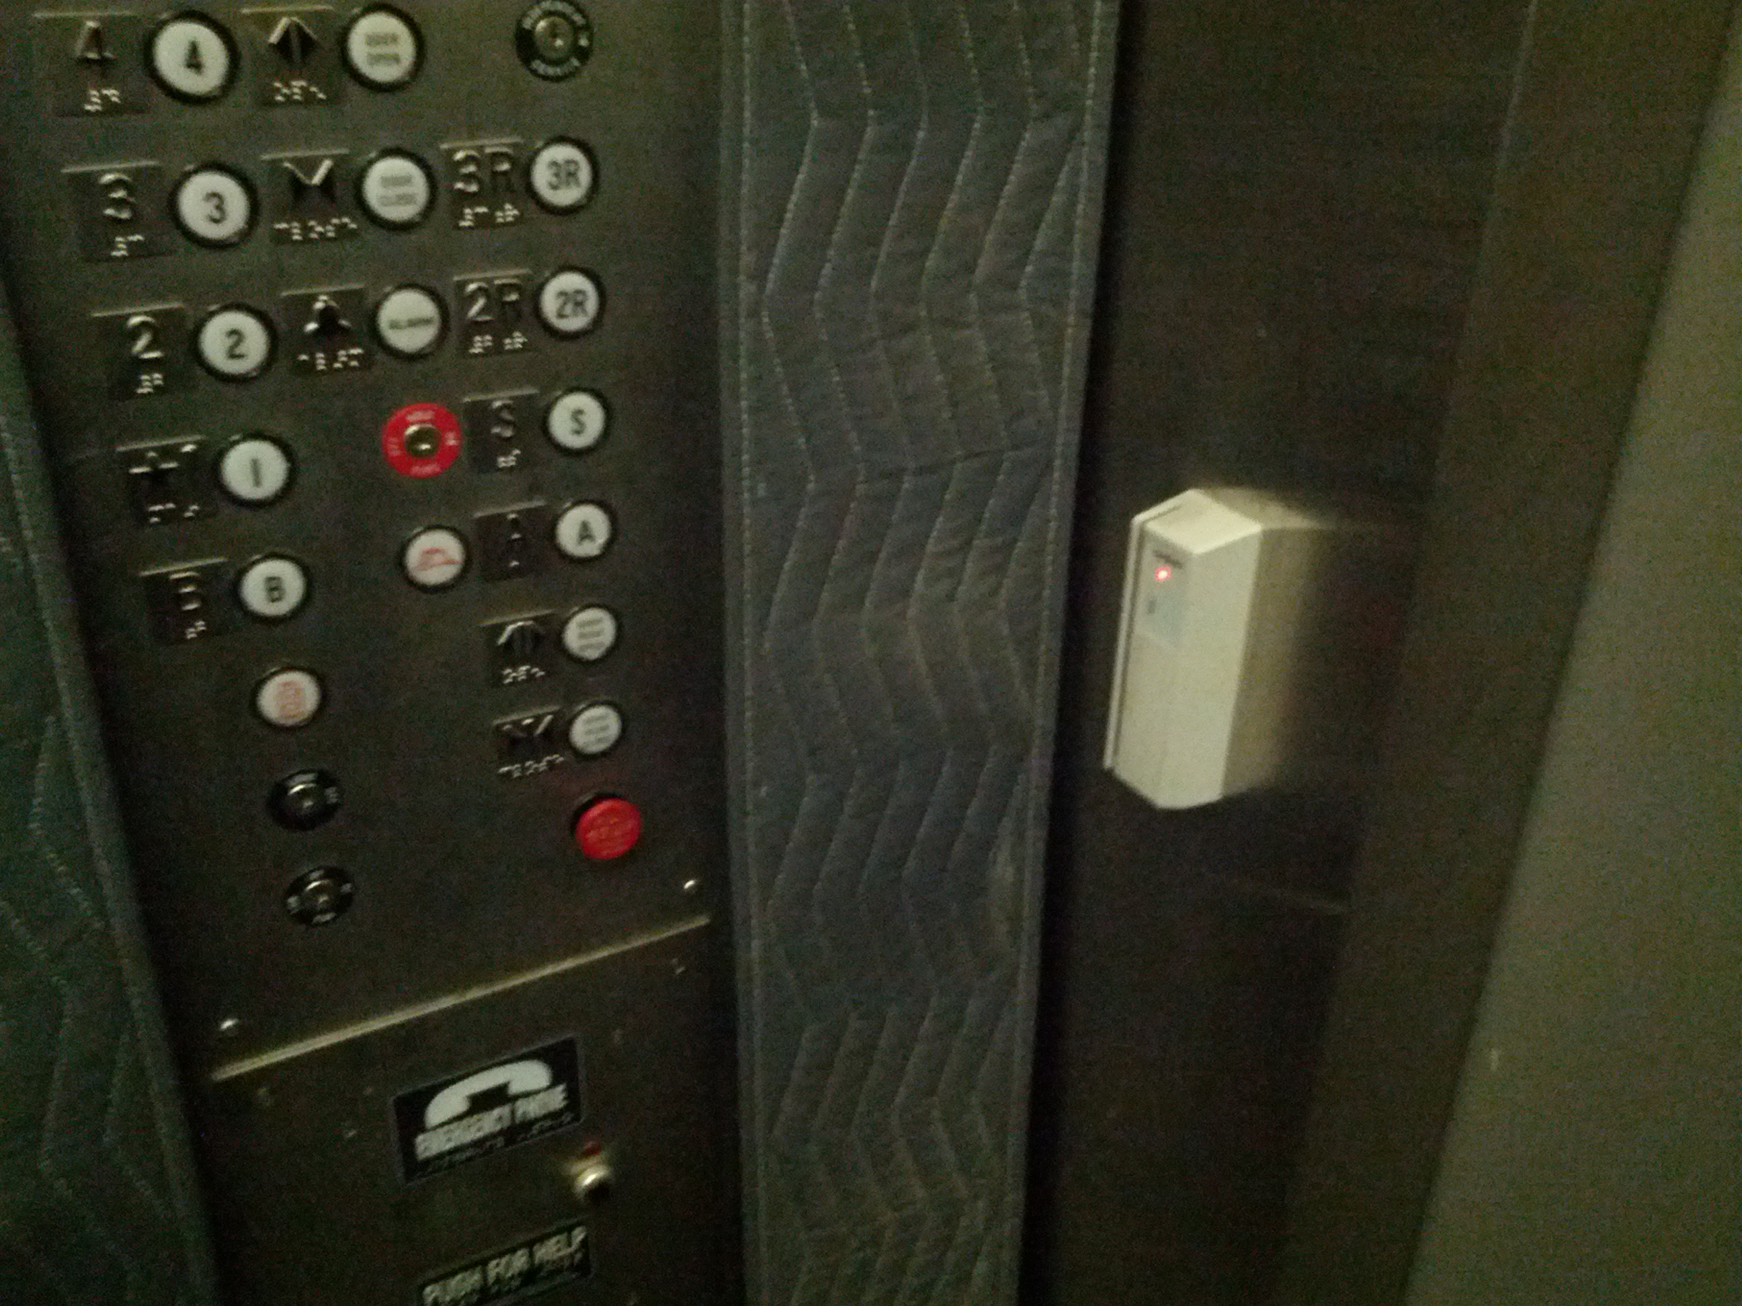

### HE-03

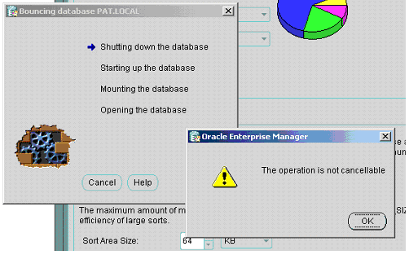

### HE-04

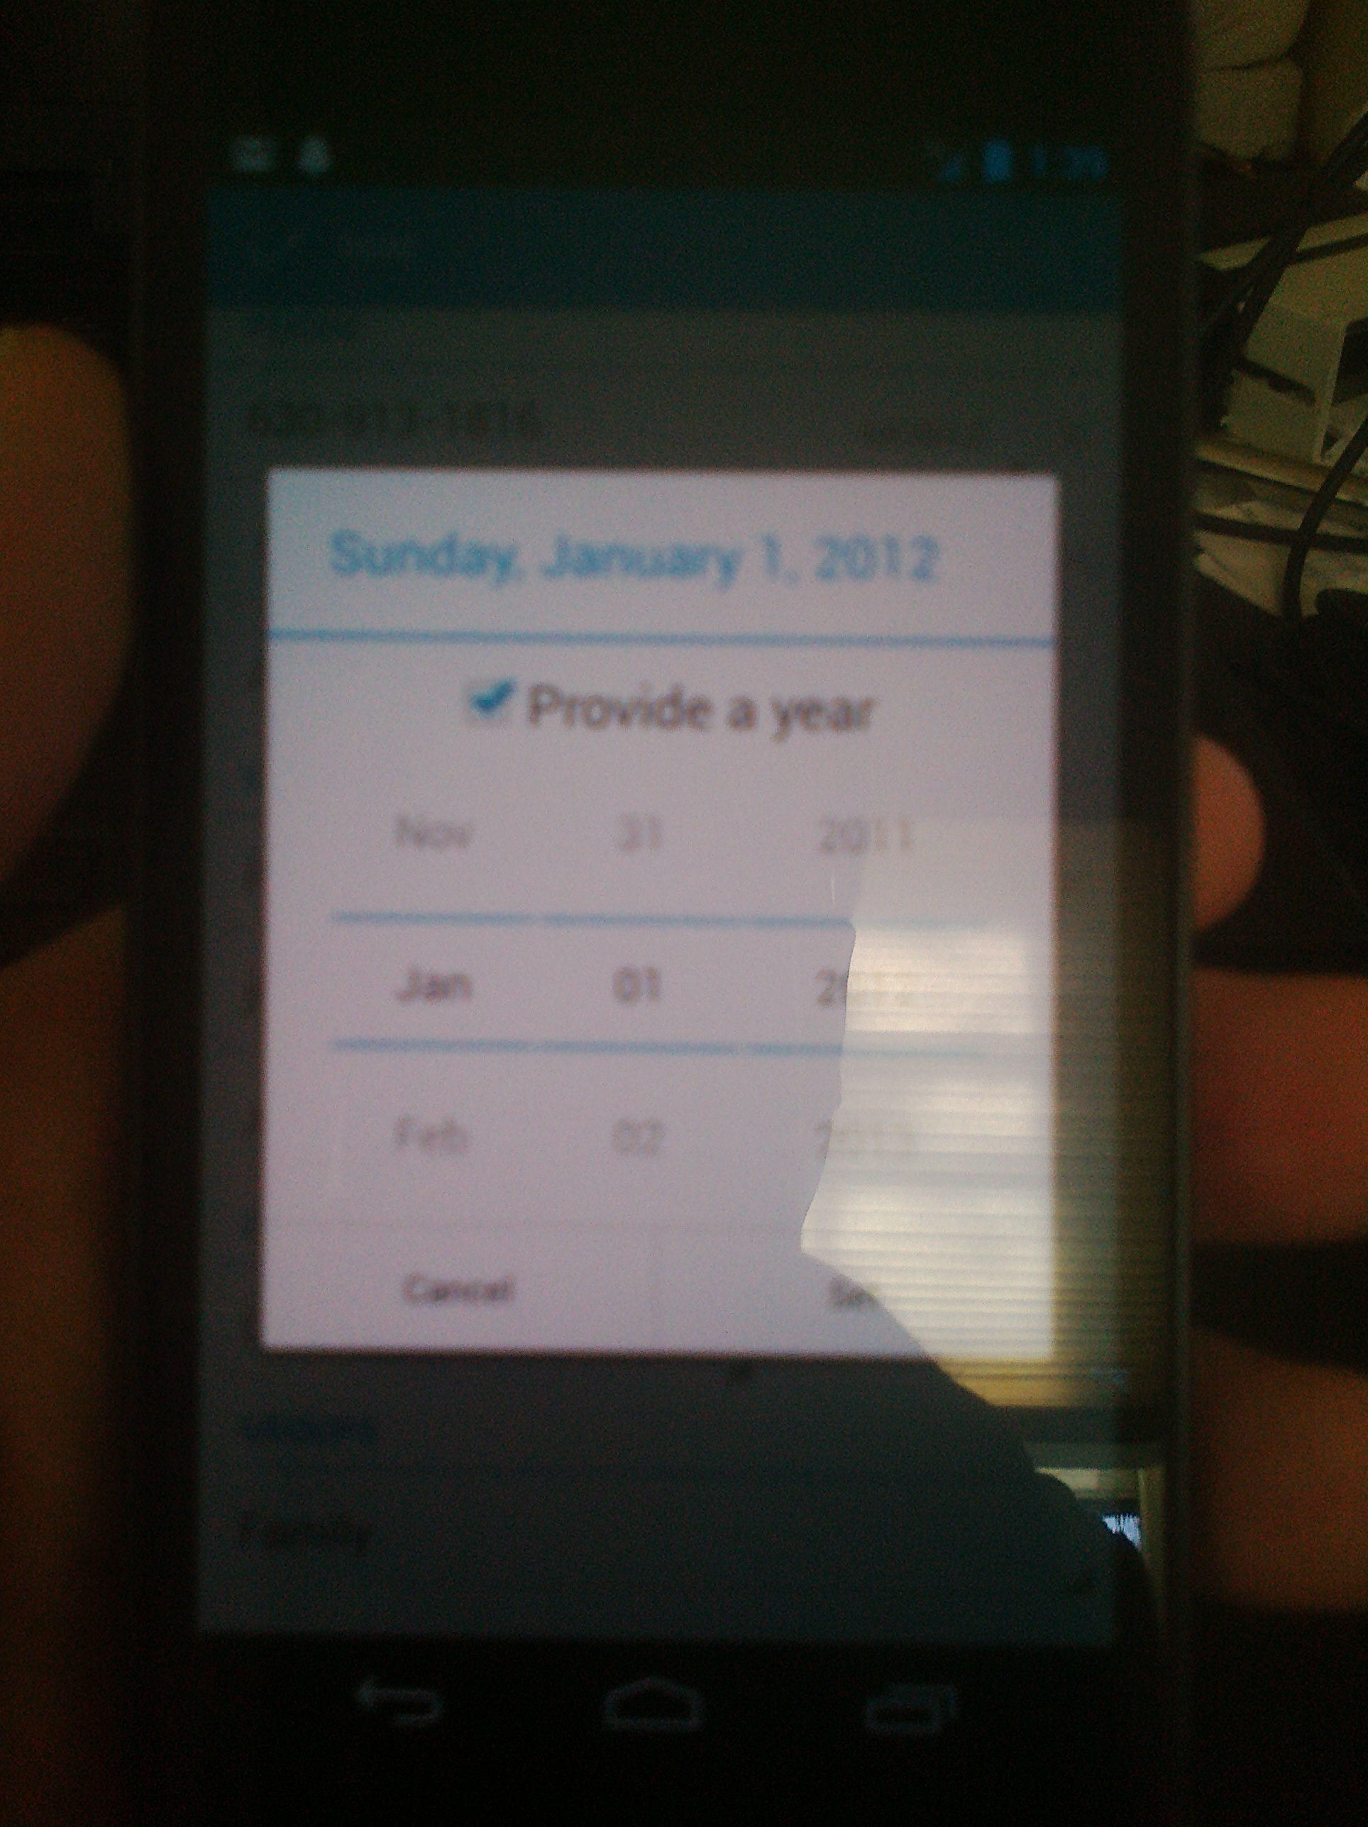

### HE-05

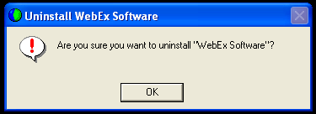

### HE-06

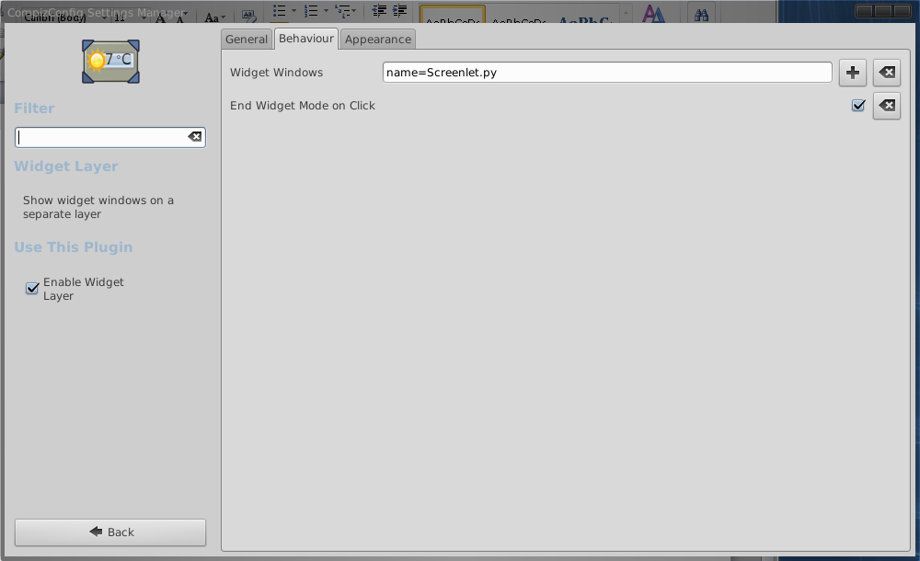

### HE-07

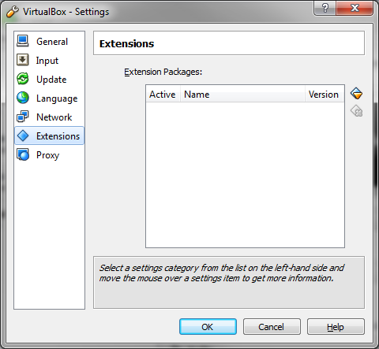

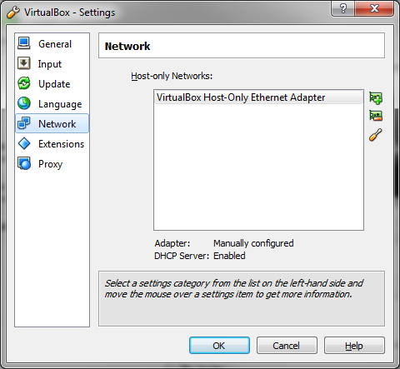

### HE-08

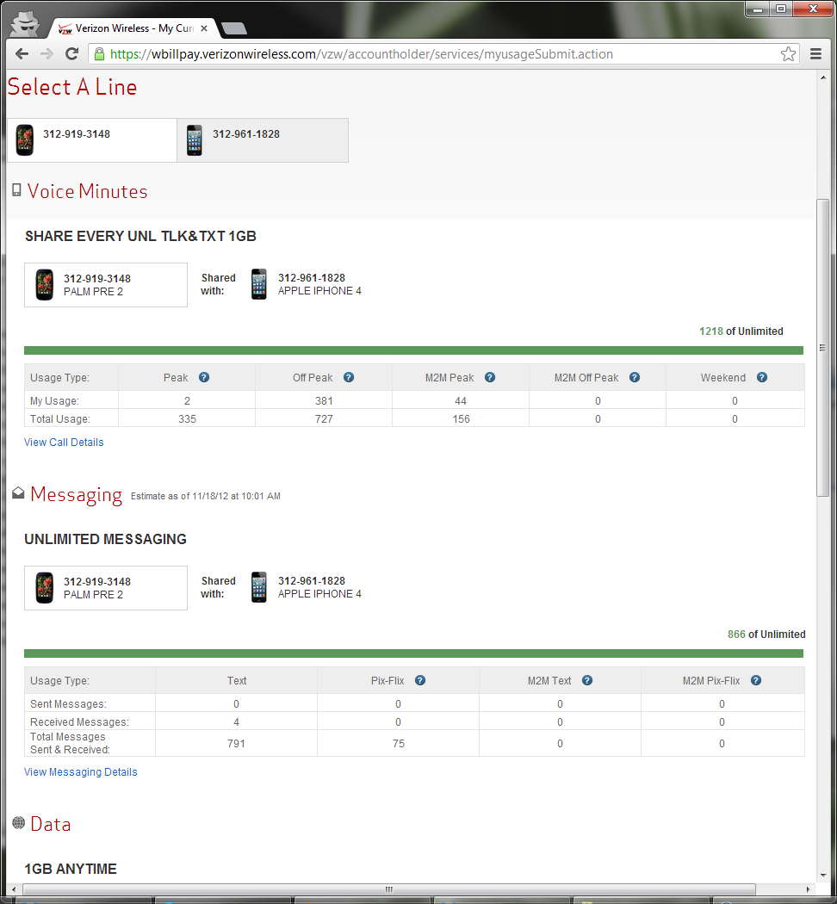

### HE-09

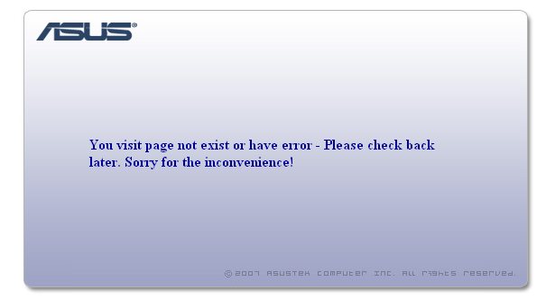

### HE-10

