**M5Stack Embedded Software Test Report (Trial Version V1.1)**

|  |  |  |  |  |
| --- | --- | --- | --- | --- |
| Project Name | Software version | SKU. No | Tester | Testing time |
| Step Motor Driver | V1.1 | M039 | Pandian | 2023.04.18 |

* Test items (such as hardware development requirements are all test items)
  1. Four limit switch inputs can be read(bit operation) – 0x00, Refer to i2c register map
  2. Drive enable output is can be read and write(bit operation) – 0x01, Refer to i2c register map
  3. Three fault inputs can be read(bit operation) – 0x04, Refer to i2c register map
  4. Three reset outputs can be read and write(bit operation) – 0x05, Refer to i2c register map
  5. X,Y,Z Pulse steps outputs and Pulse freq is depends on stepper motor
  6. X,Y,Z Motor direction outputs(forward & reverse)

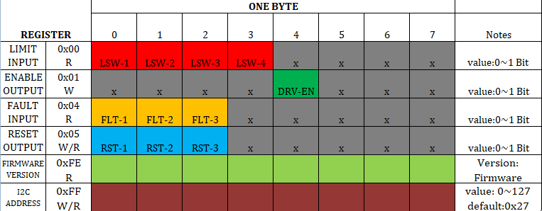**I2C REGISTER MAP**

* Test preparation (machines or external devices that need to be prepared, required firmware, etc., can be equipped with pictures)
  1. Step motor driver module
  2. Core basic
  3. Stepper motors x 4
  4. RS485 communication x 1
  5. External limit switch x 4
  6. Arduino Firmware bin file

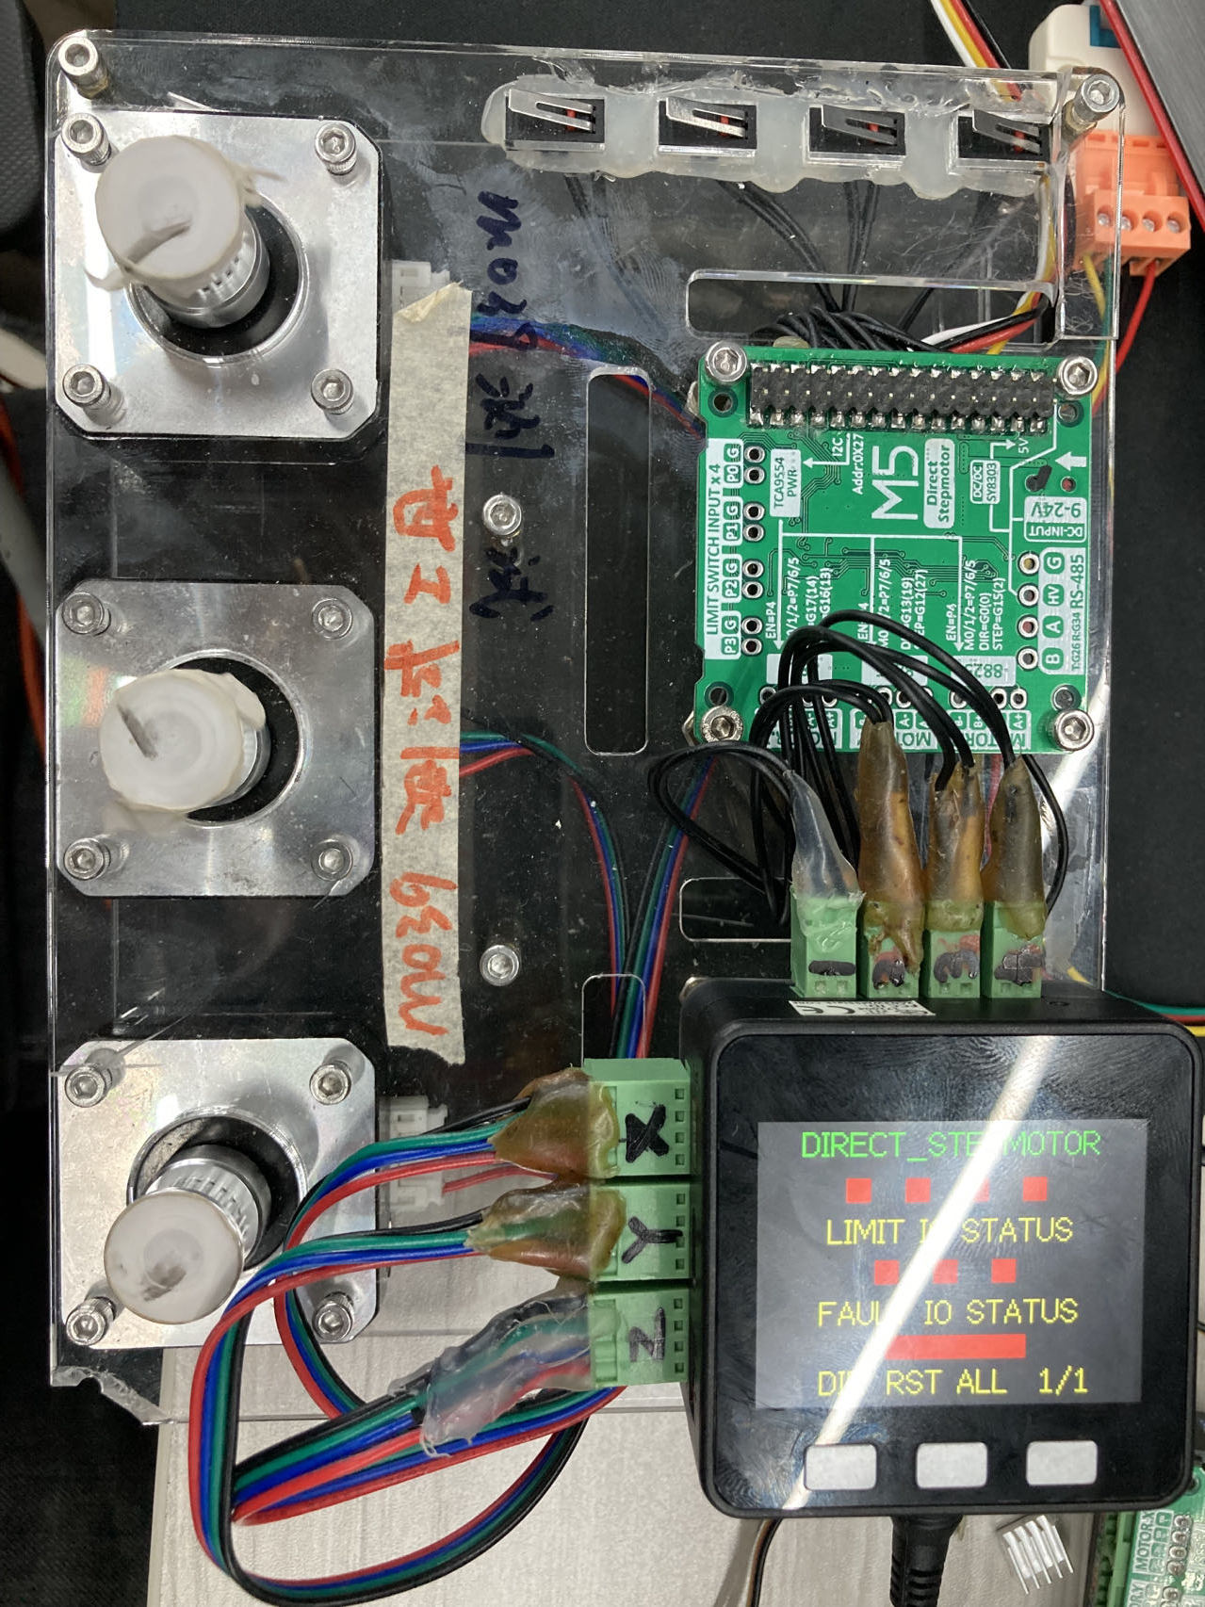

Test Method:

1. A limit switch input can be read and if the switch is pressed the color of the square box will be changed to green or if the switch is not pressed then the color of the square box will be changed to red
2. A fault switch input can be read and if the motor or drive is faulty the color of the square box will be changed to green or if the motor or drive is not faulty then the color of the square box will be changed to red
3. Send 'Y' message through rs485 communication. If getting the same message in rs485 communication the color of the square box will be changed to green or If not getting the same message in rs485 communication the color of the square box will be changed.
4. Pressing the A button (Core Basic) will change the direction of the motor
5. Pressing the B button (Core Basic) disables all motors reset function
6. Pressing the C button (Core Basic) toggles motor run and stop one by one