PowerHub PMIC(STM32)
User Manual

DATE | CONTENT | VERSION
2025-02-27 | Firmware update | 2.0
2025-10-16 | Adds input detection. | 2.1
2025-11-11 | Modify the description of register 0xC6. | 2.2

Table of Contents
I、Power Enable Reg 2
1. LED Power Enable 2
2. USB Power Enable 2
3. Grove Red Power Enable 2
4. Grove Blue Power Enable 2
5. PWR485&PWRCAN Power Enable 3
6. VAMeter Power Enable 3
7. Charge Power Enable 3
II、USB Mode 3
III、PWR485&PWRCAN Config 3
1. Voltage（LSB&MSB） 4
2. Current Limit Value 4
3. Power Output Control 4
4. Power Direction Control 4
IV、Voltage&Current Monitor 4
V、Detect Status 5
VI、LED Color 5
VII、LED Brightness 6
VIII、Button 6
IX、Wakeup Source 6
1. nSTBY_WKUP 6
2. VIN_DET 6
3. VUSB_DET 7
X、RTC Time 7
XI、RTC Alarm 7
XII、Bootloader Version 8
XIII、Firmware Version 8
XIV、I2C Address 8

I、Power Enable Reg
Address | 0x00 - 0x06
Access | W/R
Function | Enables or disables the LED power, USB power, Grove Red port power, Grove Blue port power, PWR485 & PWRCAN power, voltage/current meter power, and charging power.
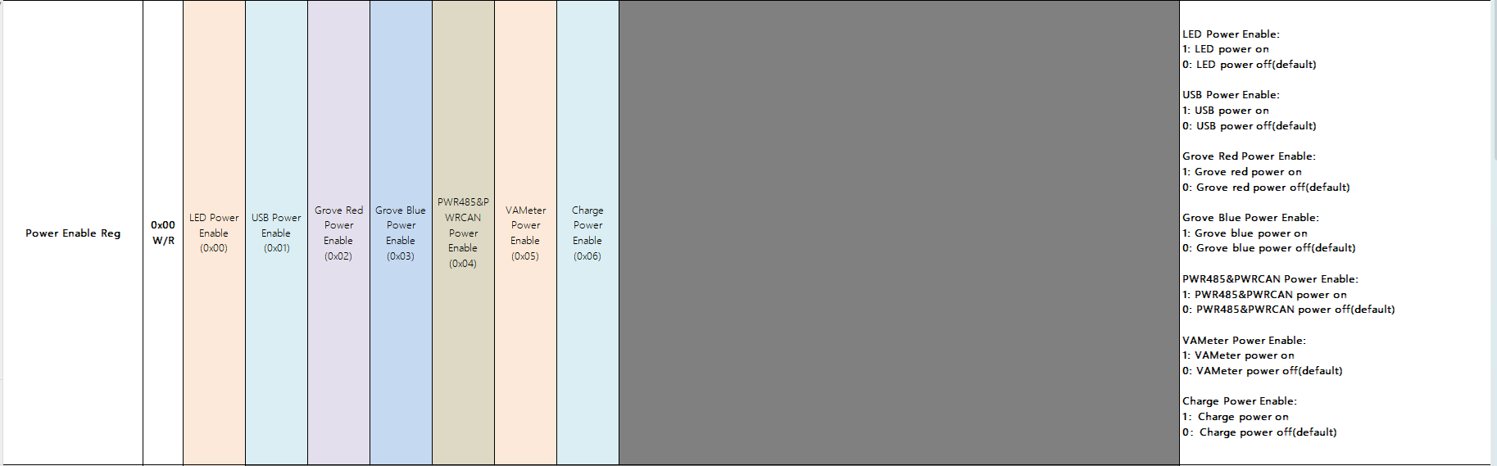

LED Power Enable
Controls the power enable of the RGB LED. Write 1 to turn on, write 0 to turn off. The default state is off.

USB Power Enable
Controls the power enable of the USB port. Write 1 to turn on, write 0 to turn off. The default state is off.

Grove Red Power Enable
Controls the power enable of the Grove Red port. Write 1 to turn on, write 0 to turn off. The default state is off.

Grove Blue Power Enable
Controls the power enable of the Grove Blue port. Write 1 to turn on, write 0 to turn off. The default state is off.

PWR485&PWRCAN Power Enable
Controls the power enable of the PWR485 & PWRCAN port. Write 1 to turn on, write 0 to turn off. The default state is off.

VAMeter Power Enable
Controls the power enable of the voltage/current meter. Write 1 to turn on, write 0 to turn off. The default state is off.

Charge Power Enable
Controls the charging enable. Write 1 to turn on, write 0 to turn off. The default state is off.

II、USB Mode
Address | 0x10
Access | W/R
Function | Controls the USB port mode, switching between device mode and host mode.

0：Slave mode，USB->ESP32(default)
1：Host mode(USB TypeA)，ESP32->USB TypeA device
2：Host mode(USB TypeC)，ESP32->USB TypeC device

III、PWR485&PWRCAN Config
Address | 0x20 - 0x24
Access | W/R
Function | Controls the SC8721 voltage, maximum current, power switch (physical switch), and power direction (output or input).

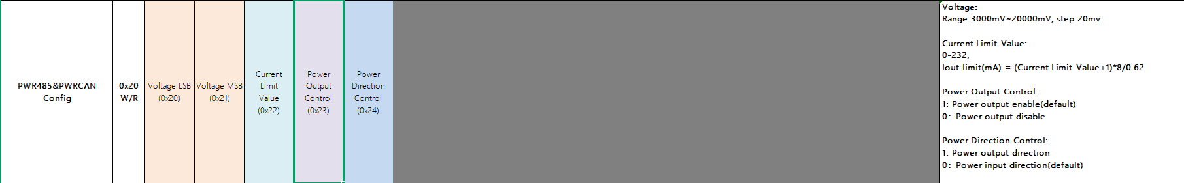

Voltage（LSB&MSB）
Configures the output voltage of the SC8721, range 3000 mV to 20000 mV, with a step size of 20 mV.

Current Limit Value
Calculation formula: Iout limit (mA) = (Current Limit Value + 1) * 8 / 0.62
Example: To set the current limit to 1000 mA, Current Limit Value = 1000 * 0.62 / 8 - 1 = 76

Note: The total output power must not exceed 20 W. If the output voltage is set high, the output current register will be limited to a lower value.

Power Output Control
Configures the SC8721 output using a MOSFET for physical switching. Write 1 to turn on the power output, write 0 to turn off. The default state is off. (Note: When the power direction is set to output, it will be automatically turned on.)

Power Direction Control
Configures the input/output direction of the SC8721. Write 1 to set the direction to output, write 0 to set the direction to input. The default state is input.

IV、Voltage&Current Monitor
Address | 0x30 - 0x47
Access | R
Function | Retrieves the voltage and current from the INA226 on each channel.

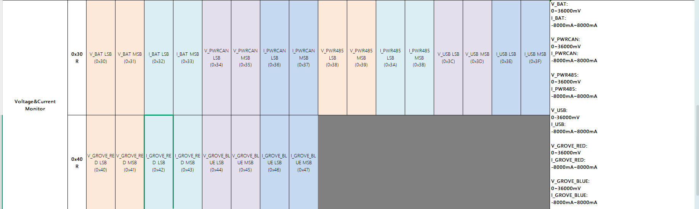

V、Detect Status

Address | 0x50~0x51
Access | R
Function | Retrieves the charging status and power input status.

1、Charge Status
0：no charge
1：charging
2：error
2、VIN Status
0：no input
1：input present

VI、LED Color
Address | 0x60 - 0x7F
Access | W/R
Function | Controls the color of 8 LEDs.

Updates the color of the corresponding LED by writing the corresponding RGB values.

VII、LED Brightness
Address | 0x80 - 0x87
Access | W/R
Function | Controls the brightness of 8 LEDs.

Updates the brightness of the corresponding LED by writing the corresponding RGB values.

VIII、Button

Address | 0xA0
Access | R
Function | Retrieves the button status.

0:press;
1:no press

IX、Wakeup Source
Address | 0xB0 - 0xB2
Access | W/R
Function | Configures the wake-up source.

nSTBY_WKUP
Configures whether to enable RTC clock wake-up. Write 0 to disable, write 1 to enable. The default state is enabled.

VIN_DET
Configures whether to enable VIN insertion wake-up. Write 0 to disable, write 1 to enable. The default state is enabled.

VUSB_DET
Configures whether to enable VUSB insertion wake-up. Write 0 to disable, write 1 to enable. The default state is enabled.

Note: At least one of the three wake-up sources must be enabled. If all three wake-up sources are disabled, sleep will not be allowed.

X、RTC Time
Address | 0xC0 - 0xC6
Access | W/R
Function | Configures the RTC clock.

Sec: 0-59
Minute: 0-59
Hour: 0-23
Day: 1-31
Month: 1-12
Year: 0-168
Week Day:01, Sunday; 02, Monday; 04, Tuesday; 08, Wednesday;
10: Thursday; 20: Friday; 40: Saturday; 80: Sunday

XI、RTC Alarm
Address | 0xD0 - 0xD3
Access | W/R
Function | Configures the RTC alarm.

Minute: 0-59
Hour: 0-23
Day: 1-31
Alarm Enable: 1: Alarm Enable; 0: Alarm Disable

XII、Bootloader Version
Address | 0xFC
Access | R
Function | Retrieves the bootloader version number.

XIII、Firmware Version
Address | 0xFE
Access | R
Function | Retrieves the firmware version number.

XIV、I2C Address
Address | 0xFF
Access | W/R
Function | Sets the I2C address.

