**Subject: PRF192- PFC**

**Workshop 01**

Name: Mai Thế Hùng SE160033

Class: SE1610

**Objectives:**

1. Reviewing for number systems
2. Exploring memory of a C program

**Recommendations**

Part 1: Students do exercises using notebooks

Part 2: Students develop programs, run them, write down their memory structure to notebooks.

**Part 1: Number systems**

**Exercise 1** **(2 marks): Convert decimal numbers to binary ones**

|  |  |  |  |  |  |
| --- | --- | --- | --- | --- | --- |
| **Decimal** | **4-bit Binary** | **Decimal** | **8-bit Binary** | **Decimal** | **16-bit Binary** |
| 9 | 1001 | 7 | 0000 0111 | 255 | 0000 0000 1111 1111 |
| 7 | 0111 | 34 | 0010 0010 | 192 | 0000 0000 1100 0000 |
| 2 | 0010 | 125 | 0111 1101 | 188 | 0000 0000 1011 1100 |
| 15 | 1111 | 157 | 1001 1101 | 312 | 0000 0001 0011 1000 |
| 12 | 1100 | 162 | 1010 0010 | 517 | 0000 0010 0000 0101 |
| 11 | 1011 | 37 | 0010 0101 | 264 | 0000 0001 0000 1000 |
| 6 | 1000 | 66 | 0100 0010 | 543 | 0000 0010 0001 1111 |
| 5 | 0101 | 77 | 0100 1101 | 819 | 0000 0011 0011 0011 |
| 8 | 1000 | 88 | 0101 1000 | 1027 | 0000 0100 0000 0011 |
| 13 | 1101 | 99 | 0110 0011 | 2055 | 0000 1000 0000 0111 |
| 14 | 1110 | 109 | 0110 1101 | 63 | 0000 0000 0011 1111 |

**Exercise 2(2 marks): Convert decimal numbers to binary and hexadecimal ones**

|  |  |  |  |  |  |
| --- | --- | --- | --- | --- | --- |
| **Decimal** | **Binary** | **Hexa.** | **Decimal** | **16-bit Binary** | **Hexadecimal** |
| 9 | 1001 | 9 | 255 | 0000 0000 1111 1111 | 00FF |
| 127 | 0111 1111 | 9F | 192 | 0000 0000 1100 0000 | C0 |
| 125 | 0111 1101 | 7D | 188 | 0000 0000 1011 1100 | BC |
| 157 | 1001 1101 | 9D | 312 | 0000 0001 0011 1000 | 138 |
| 162 | 1010 0010 | A2 | 517 | 0000 0010 0000 0101 | 205 |
| 37 | 0010 0101 | 25 | 264 | 0000 0001 0000 1000 | 108 |
| 66 | 0100 0010 | 42 | 543 | 0000 0010 0001 1111 | 21F |
| 77 | 0100 1101 | 4D | 819 | 0000 0011 0011 0011 | 333 |
| 88 | 0101 1000 | 58 | 1027 | 0000 0100 0000 0011 | 403 |
| 99 | 0110 0011 | 63 | 2055 | 0000 1000 0000 0111 | 807 |
| 109 | 0110 1101 | 6D | 63 | 0000 0000 0011 1111 | 3F |

**Exercise 3(2 marks): Compute**

(b: binary, q: octal, h: hexadecimal)

**3245q + 247q = 3514q = 011101001100b**

**1A7Bh + 26FE7h = 28A62h = 00101000101001100010b**

**1101101101b - 10110111b =001010110110b**

**3654q – 337q =3315q = 011011001101b**

**3AB7h – 1FAh = 38BDh = 0011100010111101b**

**36Ah – 576q = 1F3 h = 000111110011b**

**64AEh – 1001101b= 62141 q**

101101111 b

+ 100111011 b

110110001 b

110001101b

10111101000b

1011010 b* 1011b = 001111011110b

1101000b + 2AB h + 345 q = 3F8 h = 1770 q

3AFh / 1Ch =00100001 b = 33d

3ACh – 562q = 001000111010b = 570 d

3FFA h / 327q = 01001100b = 76 d

**Exercise 4 (2 marks)**

1. Show binary formats of 1-byte unsigned numbers:

251->1111 1011 ,

163->1010 0011,

117->0111 0101

1. Show binary formats of 2-byte unsigned numbers:

551 -> 0000 0010 0010 0111,

160 -> 0000 0000 1010 0000,

443 -> 0000 0001 1011 1011

1. Show binary formats of 1-byte signed numbers:

-51->11001101 ,

-163 ->01011101,

-117->10001011,

320->01000000

1. Show the decimal values of 1-byte unsigned representations: :

01100011 b -> 99,

10001111 b -> 143 ,

11001010 b -> 202,

01001100 b -> 76

**Part 2: Explore memory structure of programs**

**Complete the code of following program then draw it’s memory structure**

**(2 marks)**

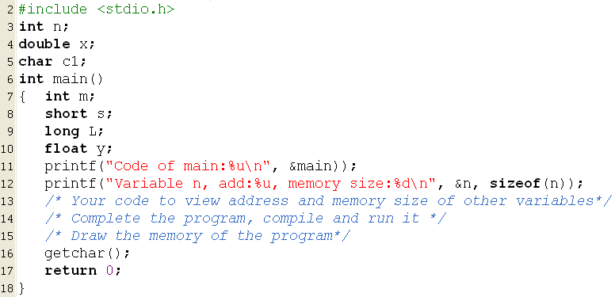

**Answer:**

