Subject: PRF192- PFC

Workshop 04

# Part1:

## Exercise 1 (1 mark) : Explain outputs:

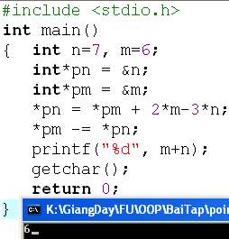

Answer: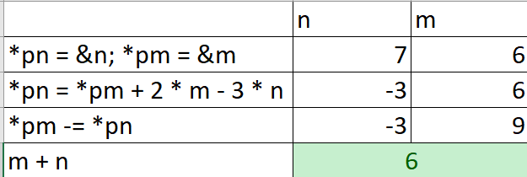

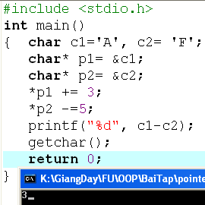

Answer:

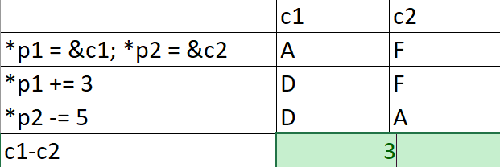

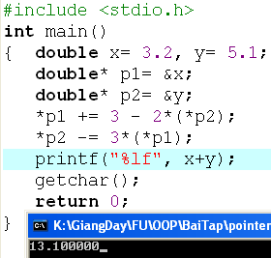

Answer:

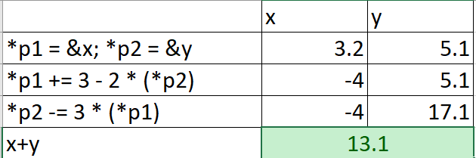

## Exercise 2: (1 marks) What are outputs:

int n=7,m=8;

int* p1= &n, *p2=&m;

*p1 +=12-m+ (*p2);

*p2 = m + n- 2*(*p1);

printf(“%d”, m+n);

What is the output?

* ANSWER: 32

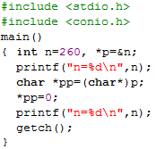

* ANSWER: 256

## Exercise 3: (2 marks) Walkthroughs:

