**Impact of duration of antibiotics on emergence of antimicrobial resistance in the hospital setting**

*Equation and parameter review*

**A. Entry into the ward**

***Model 1***

1. Probability of carrying different types of *E coli* on day 1 of admission
   1. State R: carry ESBL-producing *E coli*,
   2. State S: carry high abundance of sensitive *E coli* and no ESBL-producing *E coli*

* 1. State s: carry reduced abundance of sensitive *E coli* and no ESBL-producing *E coli*

1. Probability of being prescribed narrow spectrum antibiotics on day 1 of admission,
2. Number of beds,
3. Mean length of stay, - exponential distribution
4. Mean duration of narrow spectrum antibiotics, – normal distribution

***Model 2***

1. Probability of carrying different types of *E coli* on day 1 of admission
   1. Probability of carrying any ESBL-producing *E coli*,
   2. State S: carry high abundance of sensitive *E coli* and no ESBL-producing *E coli*

* 1. State s: carry reduced abundance of sensitive *E coli* and no ESBL-producing *E coli*

* 1. State Sr: carry high abundance of sensitive *E coli* and low abundance of ESBL-producing *E coli*
  2. State sr: carry low abundance of sensitive *E coli* and low abundance of ESBL-producing *E coli*

* 1. State sR: carry low abundance of sensitive *E coli* and high abundance of ESBL-producing *E coli*

1. Probability of being prescribed antibiotics on day 1 of admission
   1. narrow spectrum antibiotics,
   2. broad spectrum antibiotics,
2. Daily probability of being prescribed broad spectrum antibiotics after admission to the ward,
3. Number of beds,
4. Mean length of stay, - exponential distribution
5. Mean duration of antibiotics
   1. Mean duration of narrow spectrum antibiotics, - normal distribution
   2. Mean duration of broad spectrum antibiotics, - normal distribution

***Model 3***

1. Total carrying capacity in the gut of an individual,
2. Initial carriage of ESBL-producing *E coli* on day 1 of admission (Based on Rene’s data on stool samples taken on admission)
   1. Total amount of bacteria in gut – normal distribution

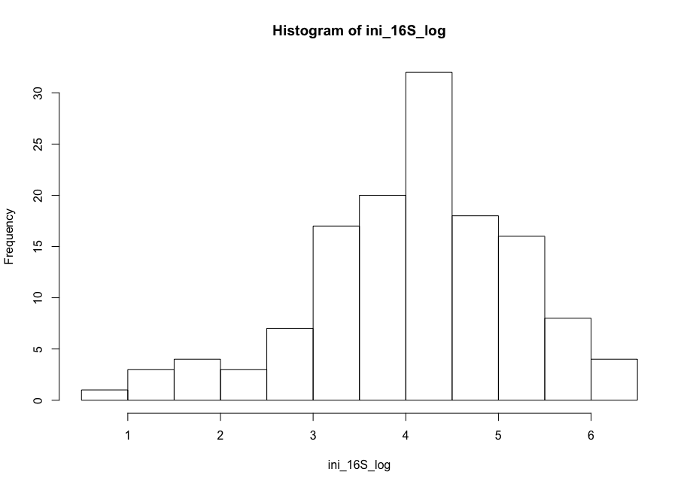  
Number of total bacteria in the gut, where

* 1. Total amount of CTXM in gut –normal distribution

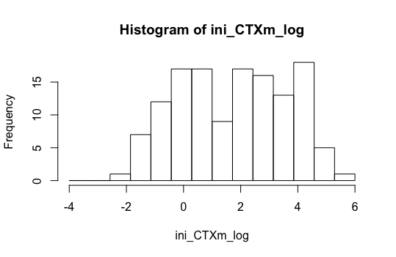

Number of ESBL-producing *E coli* in the gut, where

Number of sensitive *E coli* in the gut,

* 1. Ratio of CTX/16S

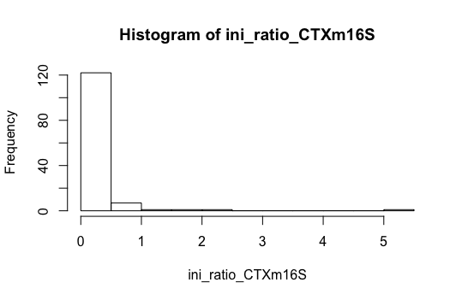

1. Probability of being prescribed antibiotics on day 1 of admission
   1. narrow spectrum antibiotics,
   2. broad spectrum antibiotics,
2. Daily probability of being prescribed broad spectrum antibiotics after admission to the ward,
3. Number of beds,
4. Mean length of stay, - exponential distribution
5. Mean duration of antibiotics
   1. Mean duration of narrow spectrum antibiotics, - normal distribution
   2. Mean duration of broad spectrum antibiotics, - normal distribution

**A. Daily updates**

***Model 1***

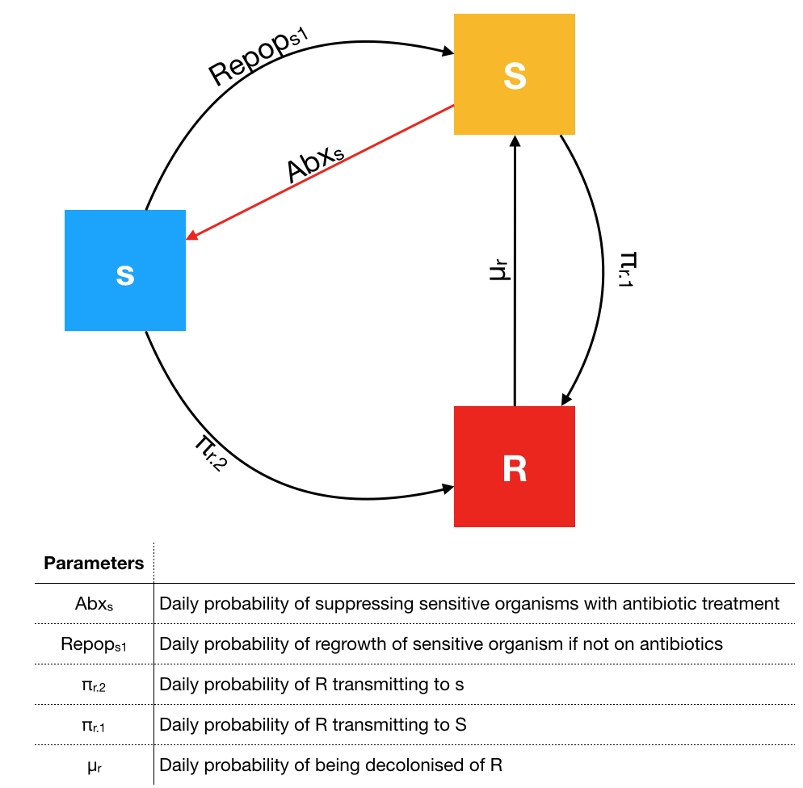

1. Daily probability of being transmitted R:

2.

***Model 2***

1. Daily probability of being transmitted R:

2.

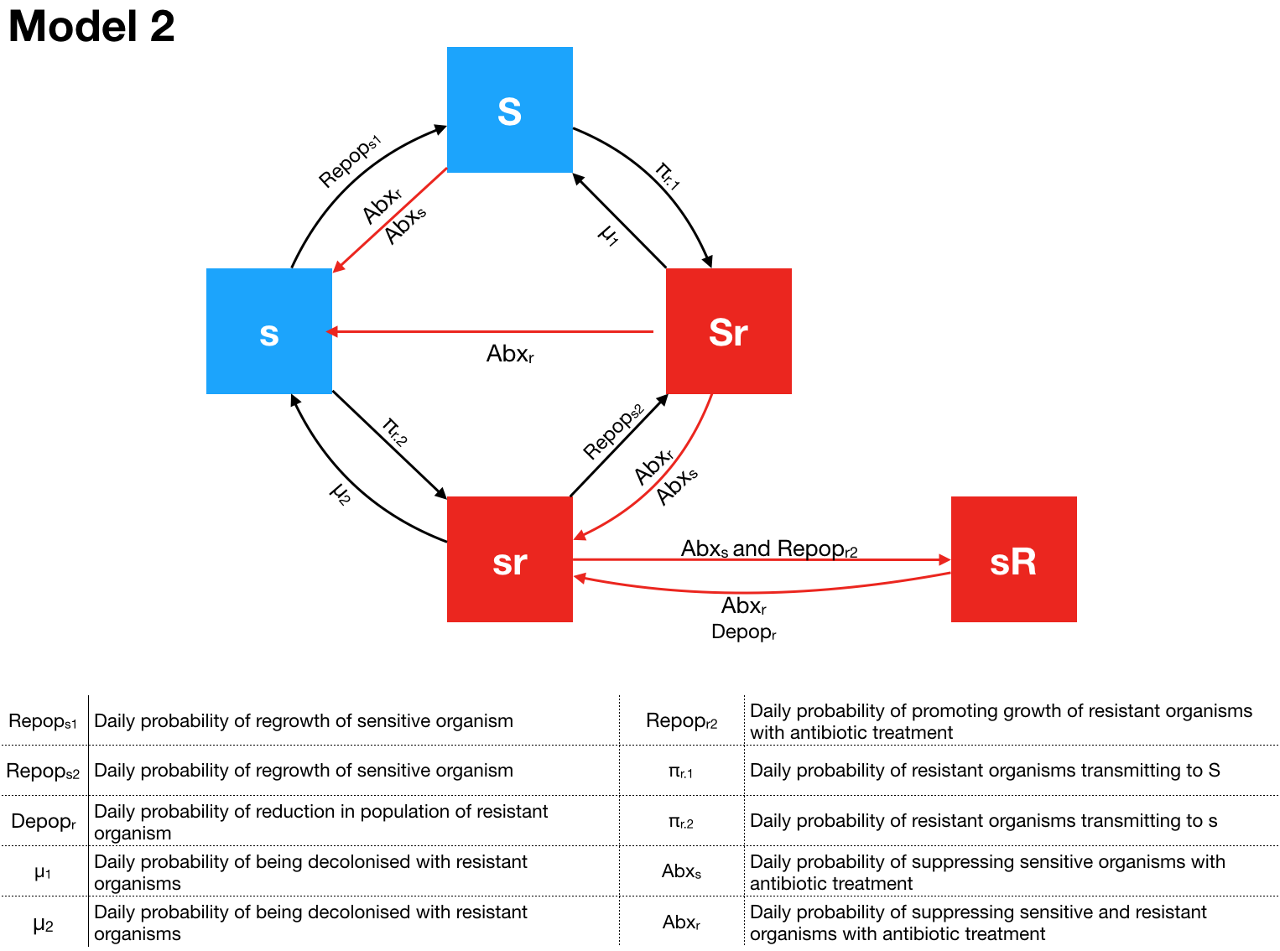

**Model 3**

1. Number of *E coli* killed by broad spectrum antibiotics,
2. Number of *E coli* killed by narrow spectrum antibiotics,
3. Number of ESBL *E coli* transmitted,
4. Threshold of number of ESBL *E coli* being able to transmit to others,
5. Daily probability of ESBL *E coli* transmitting from one patient to another,
6. Daily probability of being transmitted ESBL *E coli* from another patient,
7. Daily change in number of sensitive *E coli* (depending on types of antibiotics present the previous day)
8. Daily change in number of ESBL *E coli* (depending on antibiotics present the previous day and if transmission occurs)