Implement Client Script & UI Policy (Incident)
Step-by-Step Implementation Guide with Example Screenshots

Problem Statement
Incident records often require consistent and accurate data entry to ensure effective triage, routing, and resolution. Relying only on manual checks can lead to incomplete, inconsistent, or incorrect data. This project uses ServiceNow UI Policies and Client Scripts to control field behavior and validate Incident records before submission.

Objective
The objective is to demonstrate how ServiceNow client-side controls can enforce data integrity on Incident records. The implementation makes fields mandatory, auto-populates values, controls field behavior, and prevents invalid record submission when defined conditions are not met.

Skills
- Incident Management
- UI Policy
- UI Policy Actions
- Client Scripts
- Form Validation

Task 1: Create UI Policy on Incident

Activity 1: Create UI Policy
1. Log in to the ServiceNow instance with administrative or configuration access.
2. Navigate to System UI → UI Policies.
3. Click New to create a new UI Policy record.
4. Fill in the details:
- Name: High Impact Control
- Table: Incident
- Active: true
5. Configure the condition:
- Field: Impact
- Operator: is
- Value: 1 – High
This condition ensures the UI Policy is triggered when the Incident Impact is High.
6. Configure the UI Policy Action for Assignment group and check Mandatory.
7. Set Reverse if false to true so the field behavior is reverted when the condition is no longer true.
8. Review the configuration and click Submit.
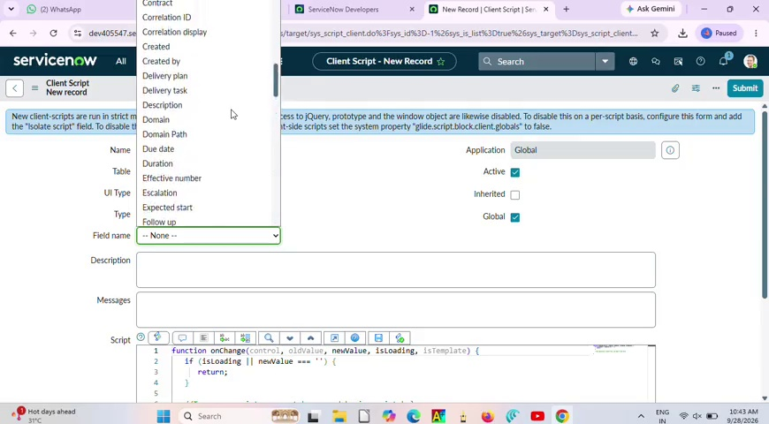
Example Screenshot – ServiceNow configuration screen from the walkthrough (reference view).

Task 2: Create UI Policy Action – Urgency

Activity 1: Configure the Urgency Field
1. Open the High Impact Control UI Policy.
2. Scroll to the UI Policy Actions related list and click New.
3. Fill in the Action Details:
- Field name: Urgency
- Read-only: true
- Visible: Leave unchanged
4. Click Submit to save the UI Policy Action.
5. Verification: Open an Incident, set Impact to High, and confirm that Urgency becomes read-only. Change Impact to another value to confirm the behavior can be reversed.
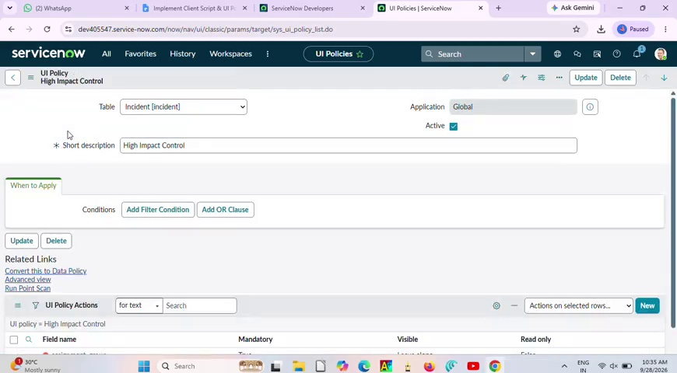
Example Screenshot – UI Policy / related-list configuration shown in the video.

Task 3: Create onChange Client Script

Activity 1: Create Client Script
1. Navigate to System UI → Client Scripts.
2. Click New.
3. Fill in:
- Name: Auto set urgency for high impact
- Table: Incident
- Type: onChange
- Field name: Impact
- Active: true
4. Paste the following script into the Script field:
function onChange(control, oldValue, newValue, isLoading) {
if (isLoading || newValue == '') {
return;
}
if (newValue == '1') {
g_form.setValue('urgency', '1');
g_form.addInfoMessage('Urgency set to High for High impact incident.');
}
}
5. Click Submit. Verify by opening an Incident and changing Impact to High; Urgency should update automatically.
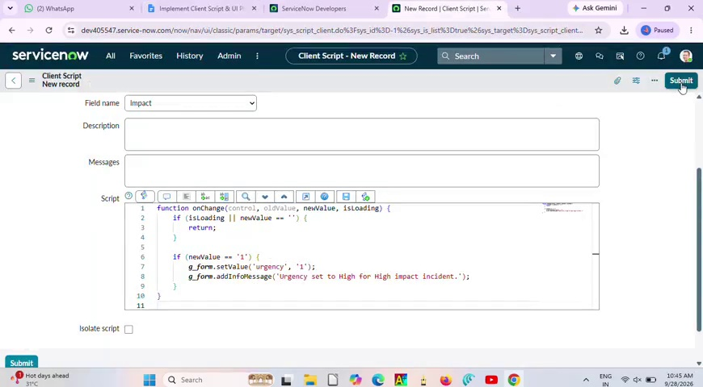
Example Screenshot – Client Script form shown in the walkthrough.
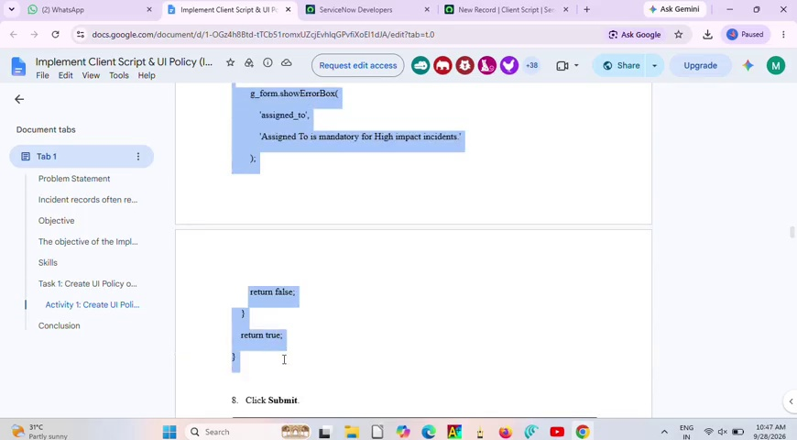
Example Screenshot – Script editor showing the onChange logic.

Task 4: Create onSubmit Client Script (Save Validation)

Activity 1: Create Client Script
1. Navigate to System UI → Client Scripts and click New.
2. Fill in:
- Name: Prevent save if Assigned To missing
- Table: Incident
- Type: onSubmit
- Active: true
3. Paste the validation script into the Script field:
function onSubmit() {
if (g_form.getValue('impact') == '1' &&
g_form.getValue('assigned_to') == '') {
g_form.showErrorBox(
'assigned_to',
'Assigned To is mandatory for High impact incidents.'
);
return false;
}
return true;
}
4. Click Submit. Verify by trying to save a High Impact Incident without Assigned To. The save should be prevented and a warning should appear.
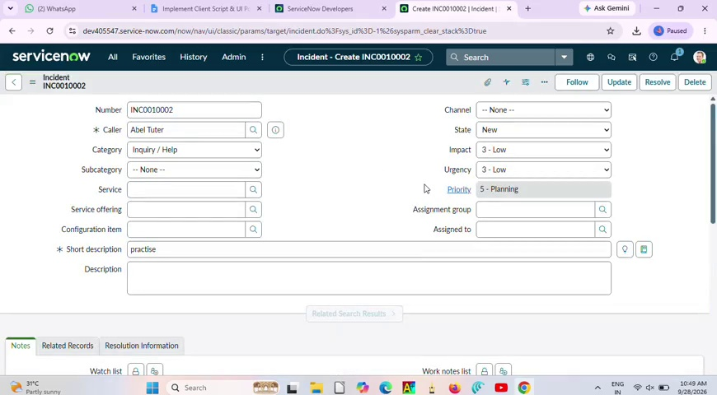
Example Screenshot – Incident form used during configuration/testing.

Task 5: Create onCellEdit Client Script

Activity 1: Create Client Script
1. Navigate to System UI → Client Scripts and click New.
2. Fill in:
- Name: Prevent state change via list edit
- Table: Incident
- Type: onCellEdit
- Field name: State
- Active: true
3. Paste the following script:
function onCellEdit(sysIDs, table, oldValues, newValue, callback) {
alert('State cannot be updated using list editing. Please open the Incident.');
callback(false);
}
4. Click Submit.
5. Verify by opening an Incident list and attempting to change State directly in the list. The change should be blocked.
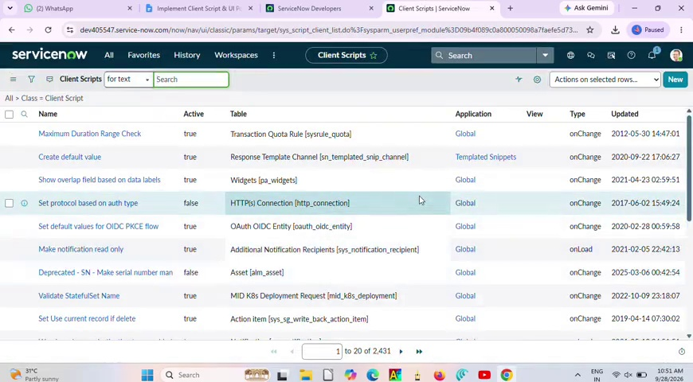
Example Screenshot – Client Scripts list showing configured scripts.
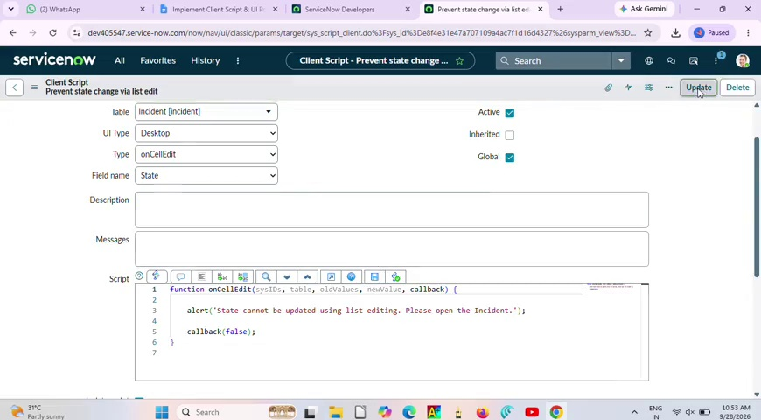
Example Screenshot – Client Script editor shown in the walkthrough.

Task 6: Testing the Configuration

Activity 1: Test Mandatory Enforcement
1. Go to Incident → Create New.
2. Set Impact to High.
3. Leave Assigned To empty.
4. Click Submit.
5. Verify that the Incident is not saved and an error indicates that Assigned To cannot be empty.
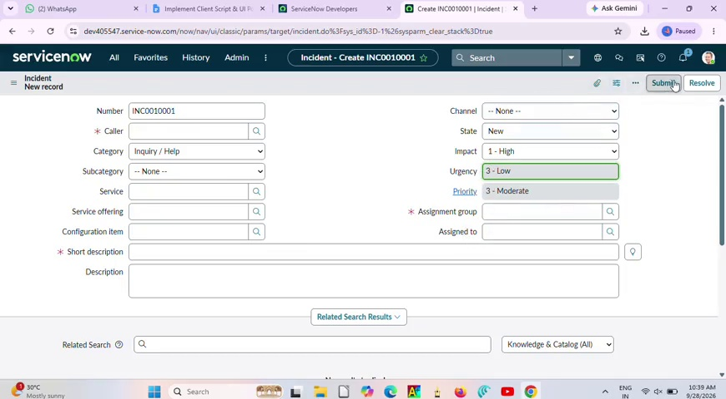
Example Screenshot – Incident form during testing.

Activity 2: Test Successful Save
1. Fill the Assigned To field with a user.
2. Click Submit.
3. Verify that the Incident saves successfully without errors.
4. Confirm that Urgency auto-setting, read-only behavior, and State restrictions continue to work as configured.

Activity 3: Reverse Condition Test
1. Open an existing Incident where Impact is High.
2. Change Impact from High to Medium.
3. Verify that Assigned To is no longer mandatory and Urgency becomes editable.
4. Click Submit and confirm the record saves successfully.

Activity 4: Test List Edit Blocking
1. Go to Incident → All.
2. Locate an Incident and double-click the State field.
3. Verify that an alert indicates direct State changes through list editing are not allowed.
4. Confirm that the State value remains unchanged.
Example Screenshot – Incident list / Client Script configuration view.

Activity 5: Test Form-Based Update
1. Open the same Incident record.
2. Change the State on the Incident form.
3. Click Update.
4. Verify that the State change is saved successfully and other UI Policy and Client Script rules still apply.

Conclusion
The Implement Client Script & UI Policy (Incident) project demonstrates how UI Policies and Client Scripts can work together to enforce dynamic field behavior, automate updates, and prevent incorrect data submission. The onChange, onSubmit, and onCellEdit scripts work alongside UI Policy actions to maintain consistent Incident data and improve form usability.

Note About Screenshots
The screenshots in this document are example frames captured from the supplied walkthrough video. They are included to show the relevant ServiceNow screens and configuration stages in the same step-by-step style as the reference document.

