Enoch Masih

9/9/20

Week 1-CentOS

Please follow the Instructions displayed on screen and in this document. Observe the screenshots included for further assistance.

1. Please make sure you have VMware installed and running. The home page should look like this.

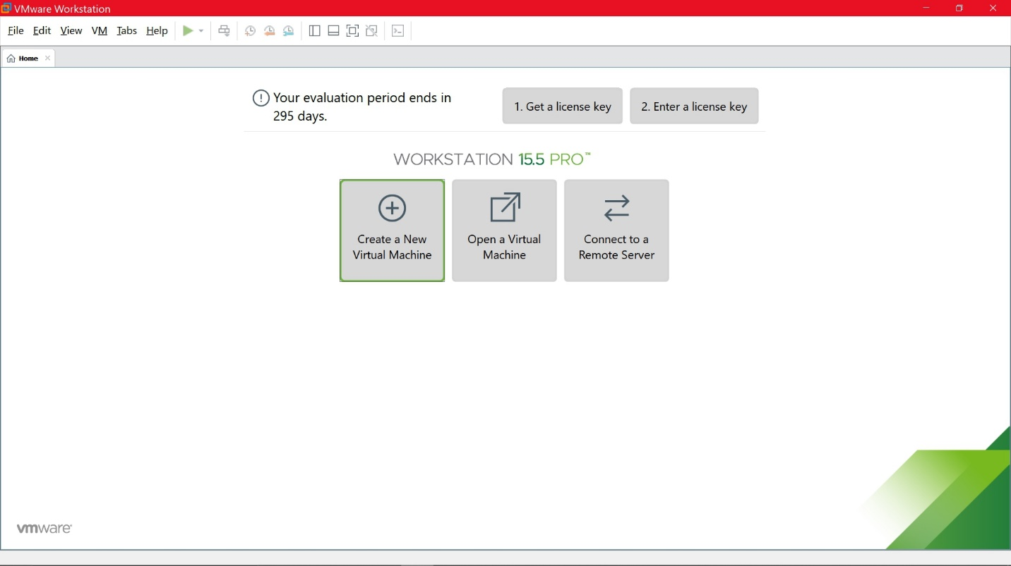

1. Please visit the CentOS website (<https://www.centos.org/download/>) and download and save the latest version of CentOS to your local desktop.
2. On VMware, click create a new virtual Machine and select the ISO file that was downloaded.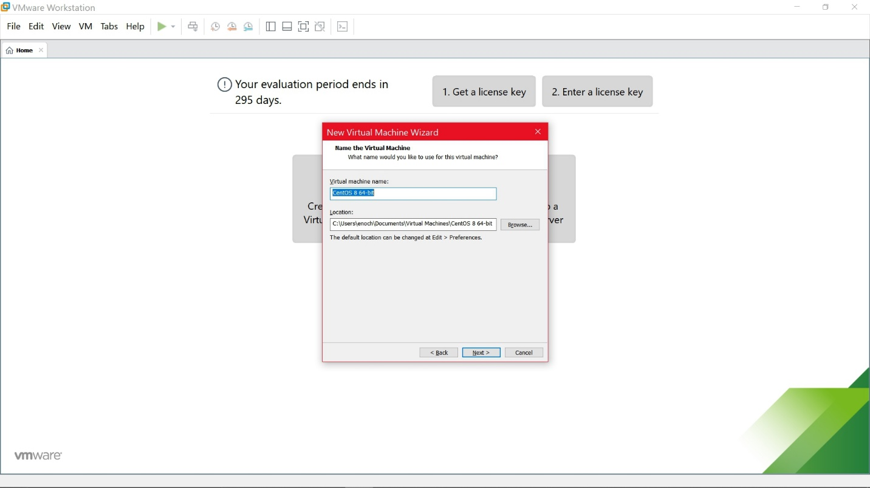
3. Read and follow the instructions presented on the screen. Please select 25GB of storage for the operating system. Follow all instructions displayed on screen until you get to the following screen.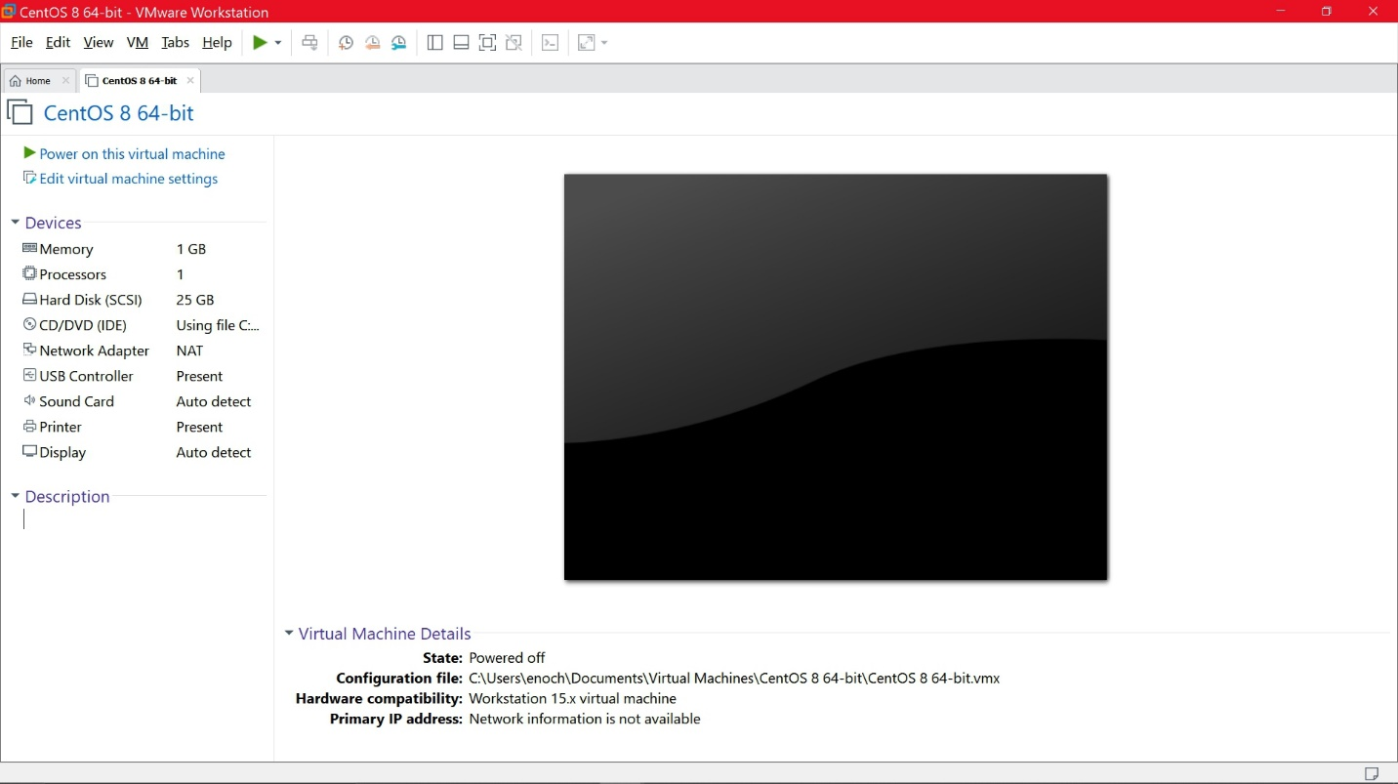
4. Now that you have the ISO mounted on the VMware, Click the Green play button next to the help button on the top left to begin the install.
5. Select the First option which is Install the OS. (Notice in the picture below that the second option is selected indicated by white highlight, but select the first option to install)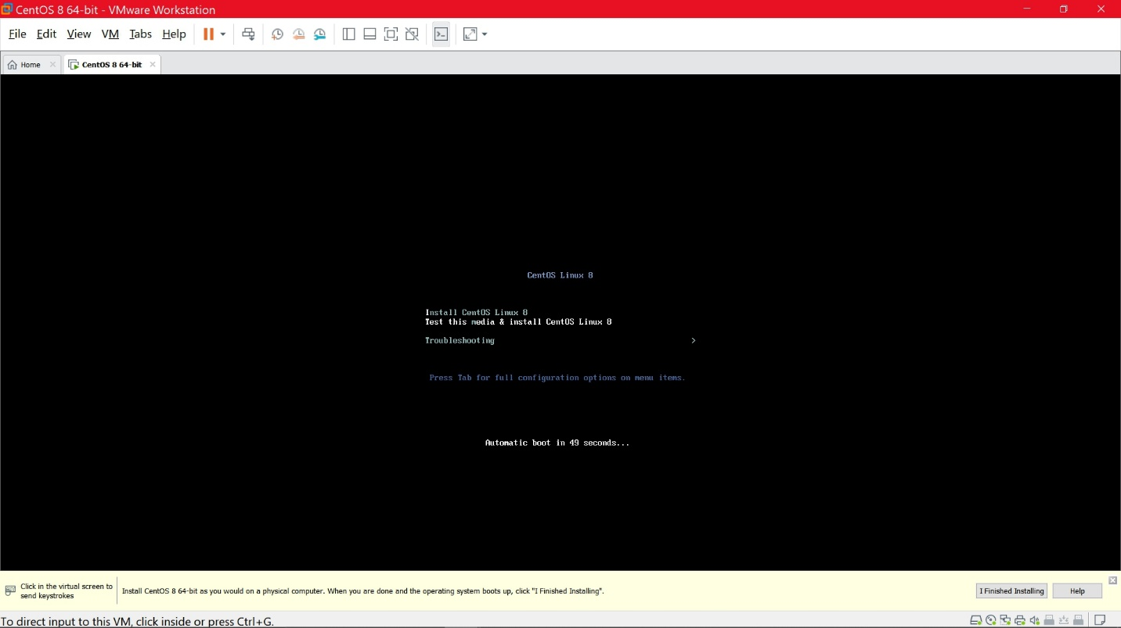
6. Allow it time to install. Read and follow the instructions as displayed.
7. Once you are at the installation summary, select software selection. Check the following options below. Make sure Server without GUI is selected. I also opted to download container management software.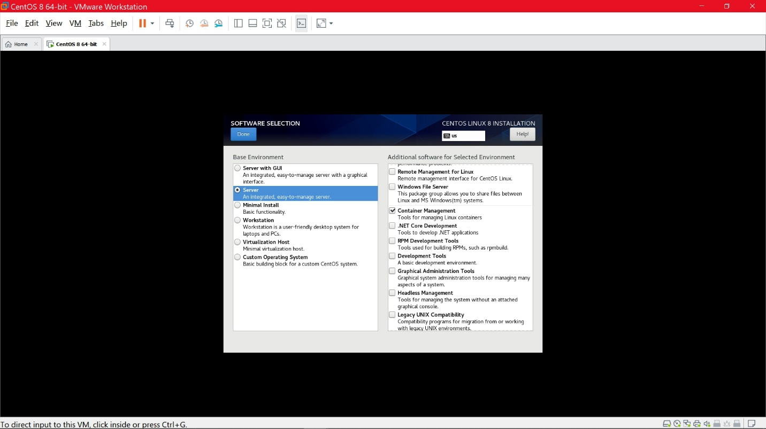
8. Go back to Installation page and make sure that network connection is present.
9. Please select the drive allotted by VMware to install the software.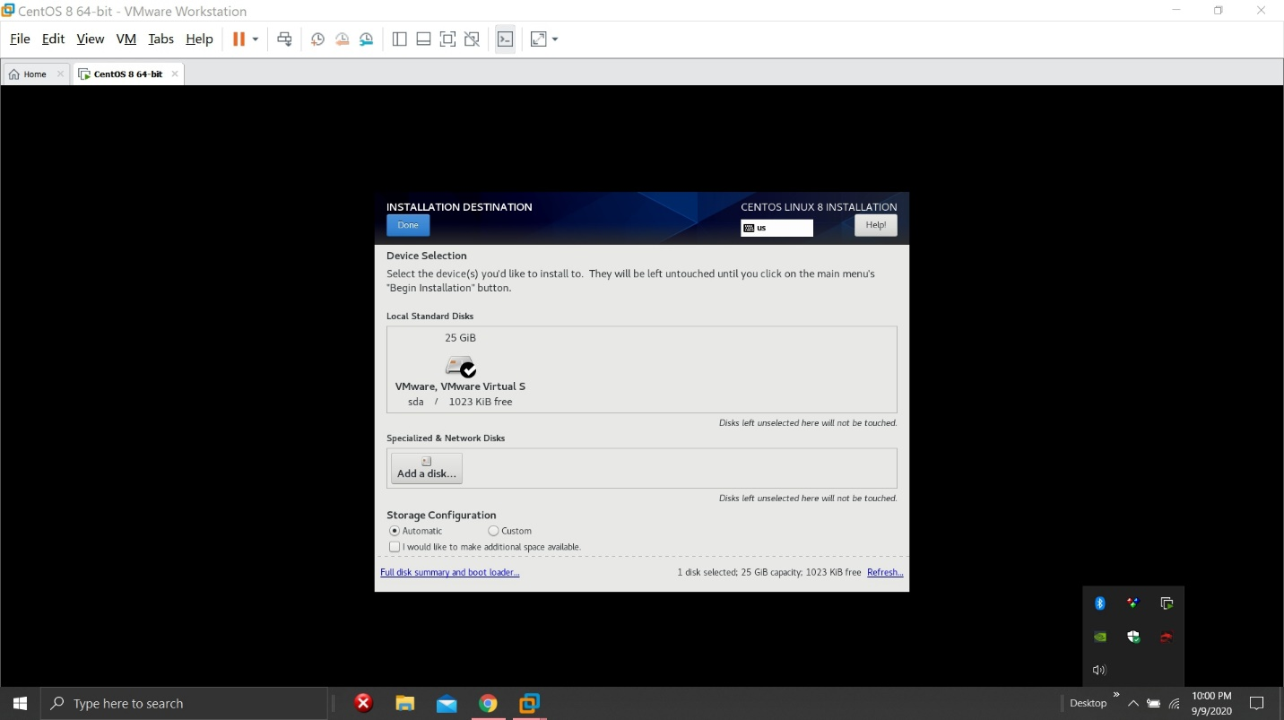
10. Once you have completed all highlighted task, the begin installation button will become available to select like the screenshot below. 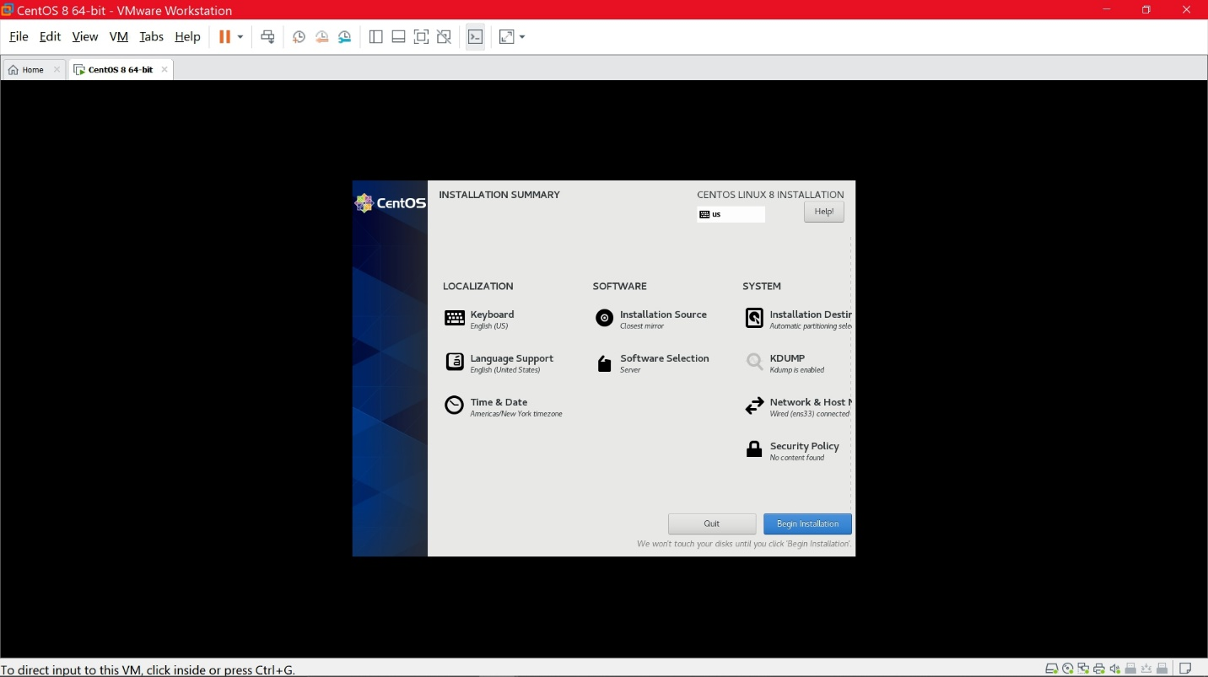
11. Allow it time to install the OS. Create the username and password as per the displayed instructions.
12. Once finished, the following screen will be displayed. Login with your username and password. 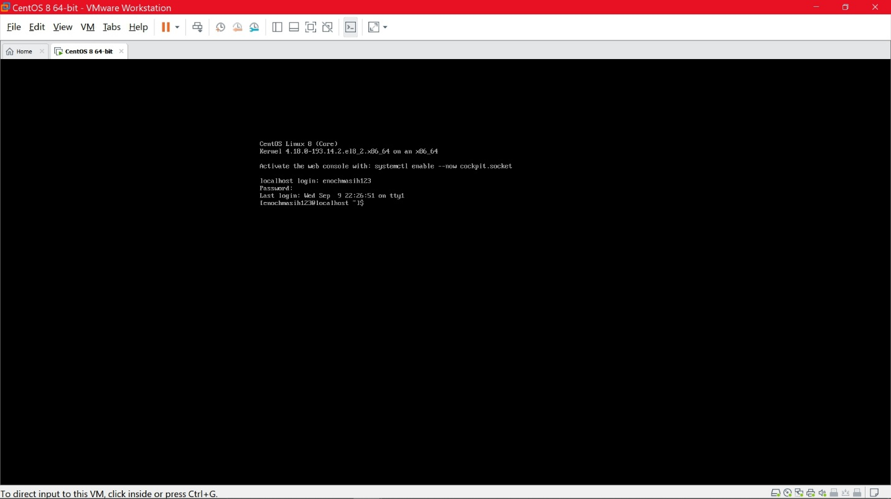
13. Congratulations! You have installed the CentOS Server without a GUI, with more than required storage as per instructions. (Use the poweroff command to powerdown the server)