Enoch Masih

9/11/20

Week 1- Debian Install

1. In order to install Debian please download the ISO file from a legitimate resource. One resource is (https://cdimage.debian.org/mirror/cdimage/release/current/amd64/iso-dvd/) . Once downloaded onto your desktop continue on to step 2.
2. Open up VMware and click on to create a new virtual machine
3. select the ISO file when prompted.
4. Once the ISO is booted and ready to be installed click on the play button as picture below. 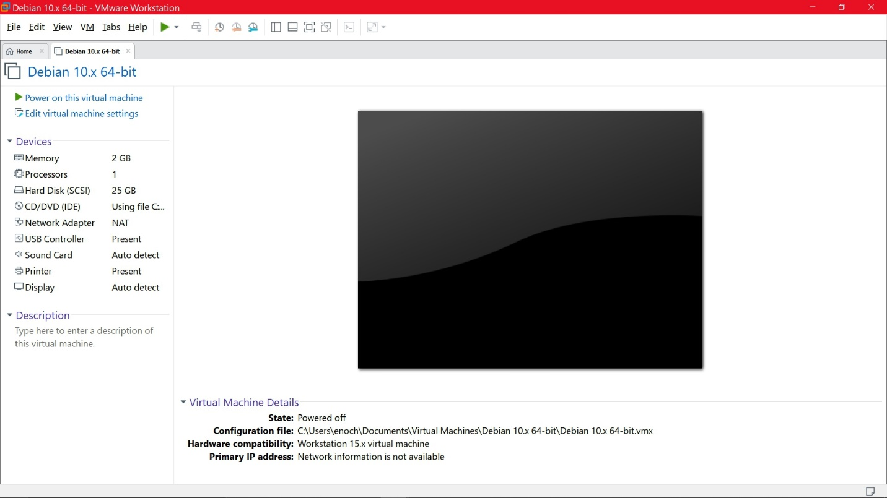
5. Read the instructions for the install as presented. Select language region and other options accordingly to your preference.
6. When presented the option to select networking, please select to mirror the network as this is a virtual machine.
7. When given the option to select the software installation as pictured bellow avoid slecting any Graphic display if you do not want a GUI. 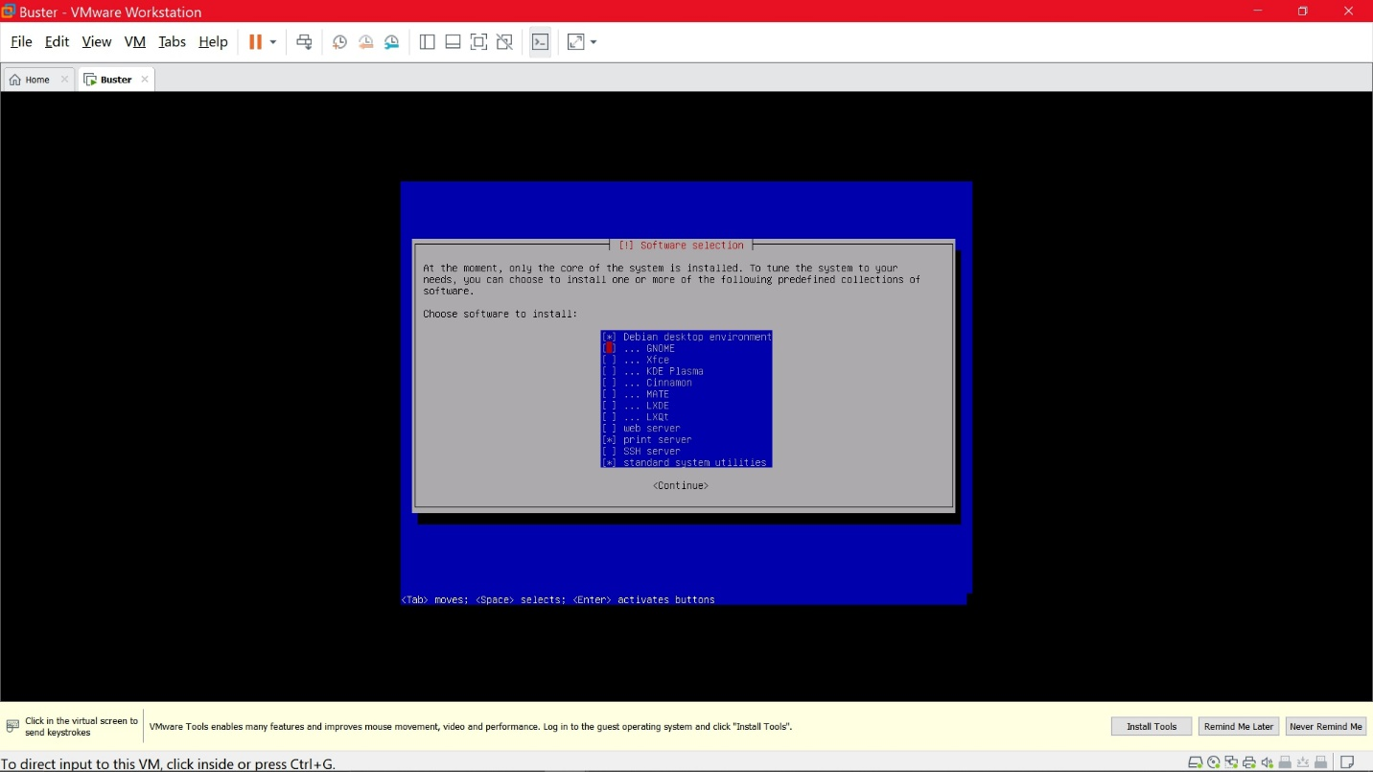
8. Please select the user name and password as well as the root password.
9. Allow time to load the settings and continue to follow the display prompts as instructed.
10. Once complete, You will be brought to the home screen which prompts you to login and enter your password (Pictured Below) 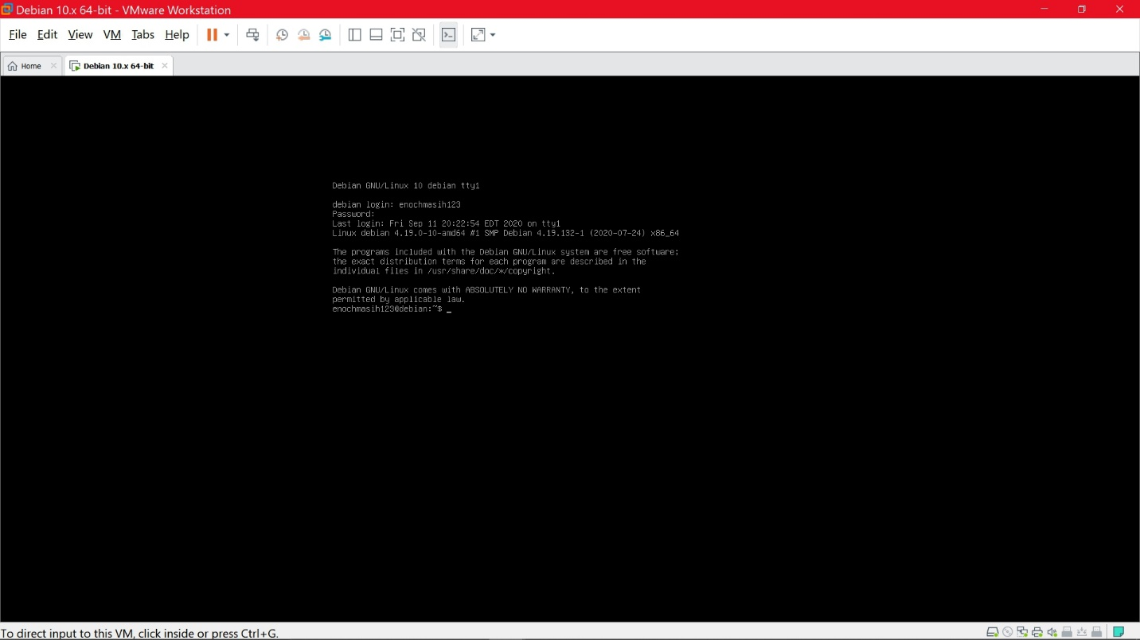
11. Once the username and password is accepted you will have access to the server.