Data Communi & Comp. Network 1

IPv4 addressing Scheme:
Subnet name | Hosts number | Network Address | Default Gateway | Subnet mask | Broadcast address
Store | 520 | 172.25.0.0/22 | 172.25.0.1/22 | 255.255.252.0 | 172.25.3.255
Reception | 380 | 172.25.4.0/23 | 172.25.4.1/23 | 255.255.254.0 | 172.25.5.255
Logistics | 170 | 172.25.6.0/24 | 172.25.6.1/24 | 255.255.255.0 | 172.25.6.255
Finance | 150 | 172.25.7.0/24 | 172.25.7.1/24 | 255.255.255.0 | 172.25.7.255
Sales | 60 | 172.25.8.0/26 | 172.25.8.1/26 | 255.255.255.192 | 172.25.8.63
HR | 55 | 172.25.8.64/26 | 172.25.8.65/26 | 255.255.255.192 | 172.25.8.127
IT | 35 | 172.25.8.128/26 | 172.25.8.129/26 | 255.255.255.192 | 172.25.8.191
Admin | 10 | 172.25.8.192/28 | 172.25.8.193/26 | 255.255.255.240 | 172.25.8.207
WAN1 | - | 172.25.8.208/30 | - | 255.255.255.252 | 172.25.8.211
WAN2 | - | 172.25.8.212/30 | - | 255.255.255.252 | 172.25.8.215
WAN3 | - | 172.25.8.216/30 | - | 255.255.255.252 | 172.25.8.219
Unused Range: 172.25.8.220 – 172.25.255.255
Statically assigned IPs:
Device | IPv4 | Subnet mask | IPv6 | IPv6 Default Gateway
Switch 1st  (VLAN 10) | 172.25.5.254/23 | 255.255.254.0 | - | -
Switch 1st  (VLAN 11) | 172.25.3.254/22 | 255.255.252.0 | - | -
Switch 1st  (VLAN 12) | 172.25.6.254/24 | 255.255.255.0 | - | -
Switch 2nd  (VLAN 20) | 172.25.7.254/24 | 255.255.255.0 | - | -
Switch 2nd  (VLAN 21) | 172.25.8.126/26 | 255.255.255.192 | - | -
Switch 2nd  (VLAN 22) | 172.25.8.62/26 | 255.255.255.192 | - | -
Switch 3rd  (VLAN 30) | 172.25.8.206/28 | 255.255.255.240 | - | -
Switch 3rd  (VLAN 31) | 172.25.8.190/26 | 255.255.255.192 | - | -
DNS Server | 172.25.8.130/26 | 255.255.255.192 | 2001:DB8:5678:C::2/64 | 2001:DB8:5678:C::1/64
Mail Server | 172.25.8.131/26 | 255.255.255.192 | 2001:DB8:5678:C::3/64 | 2001:DB8:5678:C::1/64
tftp Server | 172.25.8.132/26 | 255.255.255.192 | 2001:DB8:5678:C::4/64 | 2001:DB8:5678:C::1/64
ftp Server | 172.25.8.133/26 | 255.255.255.192 | 2001:DB8:5678:C::5/64 | 2001:DB8:5678:C::1/64
Web Server | 172.25.8.134/26 | 255.255.255.192 | 2001:DB8:5678:C::6/64 | 2001:DB8:5678:C::1/64

Topology:
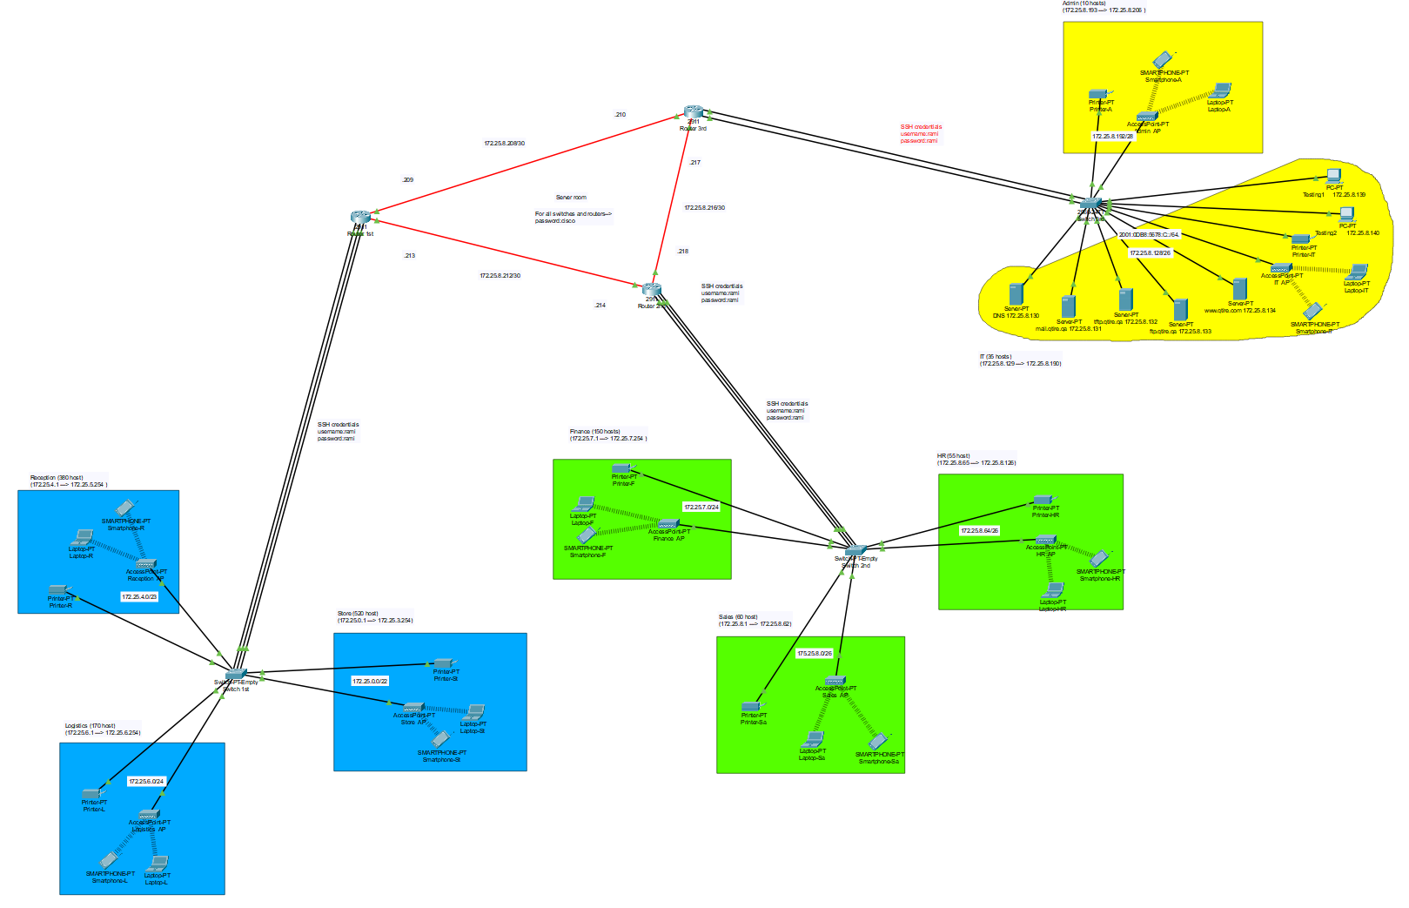

Show run for Router 1st:
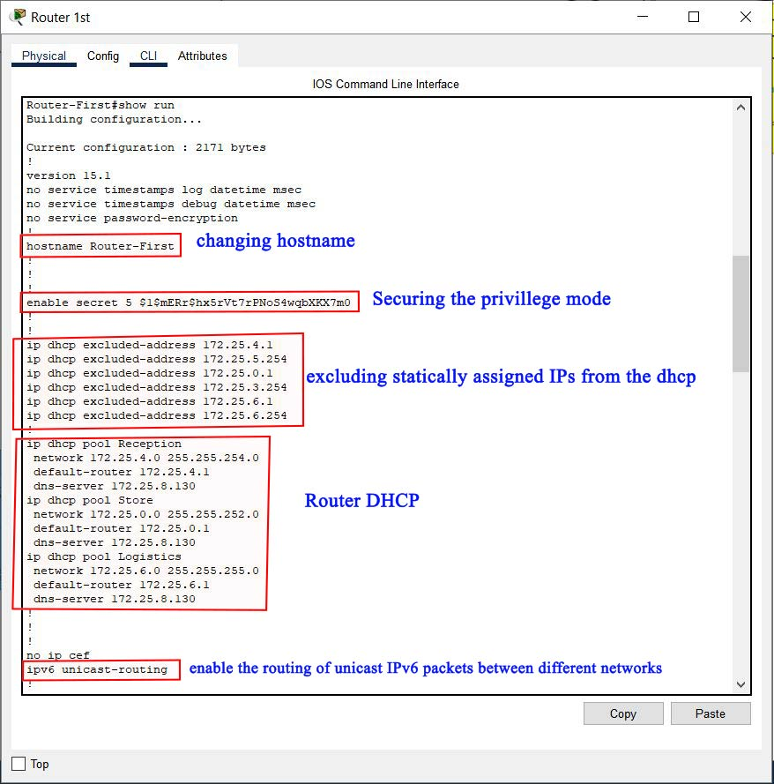
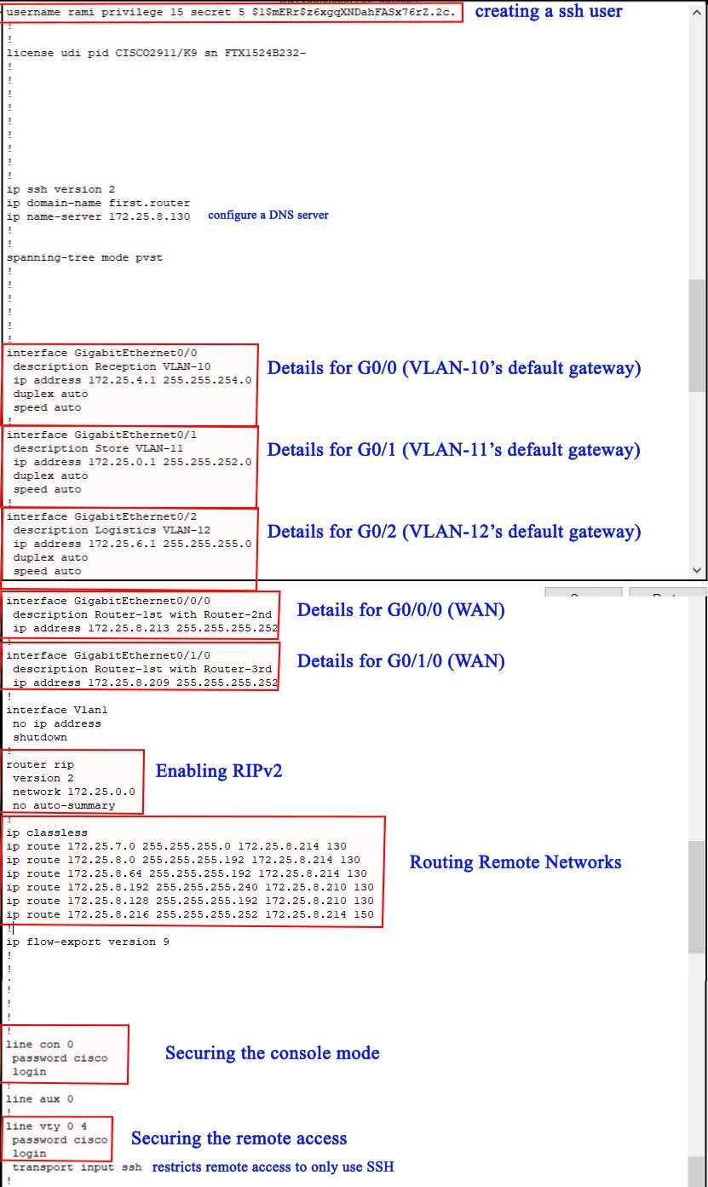
tftp backup Router 1st:
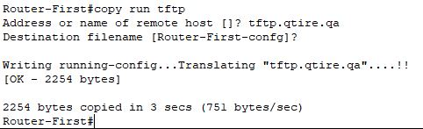
Show run for Router 2nd:
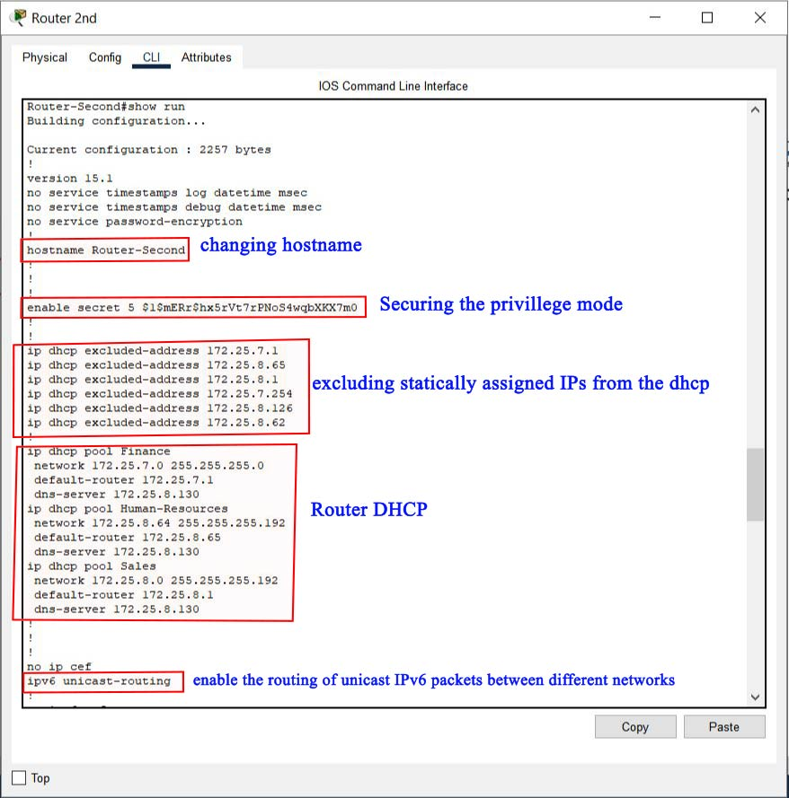
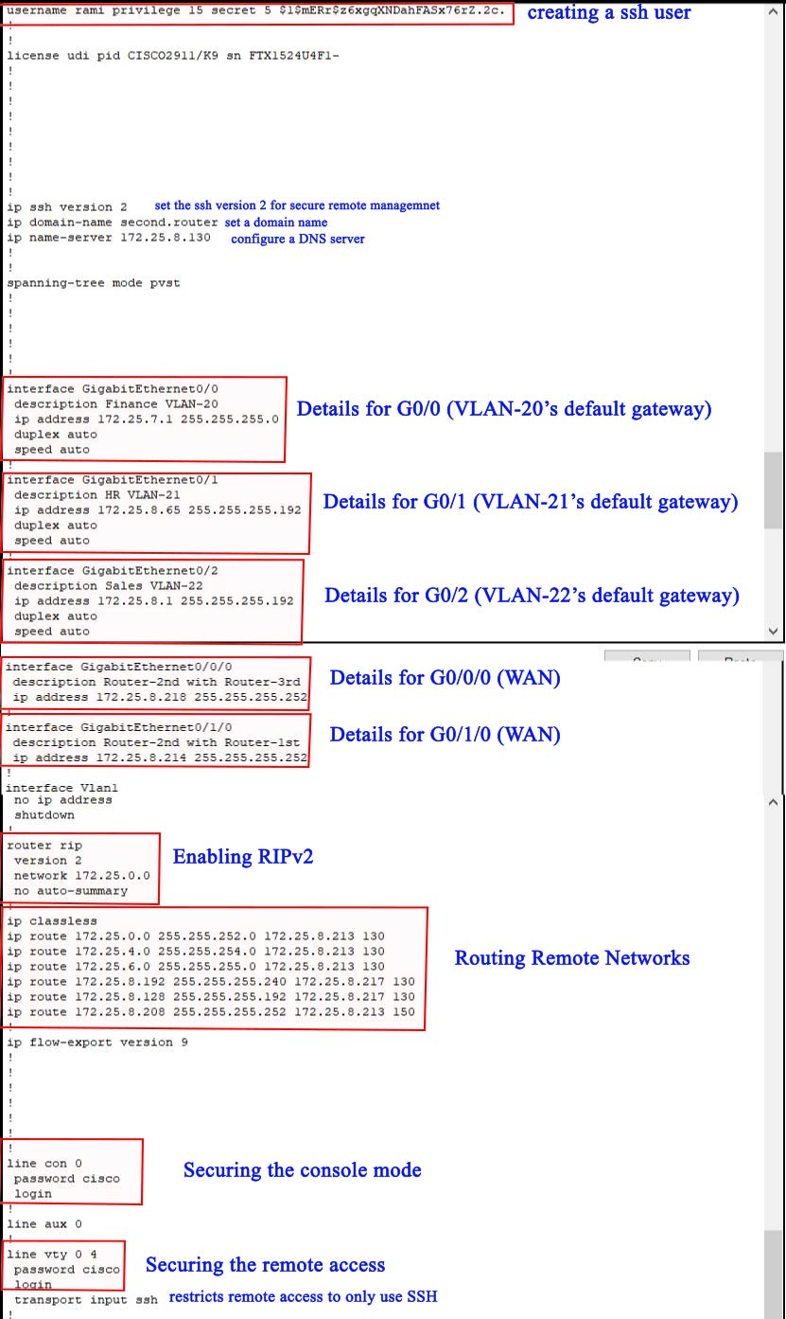
tftp backup for router 2nd:
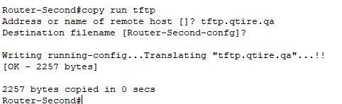

Show run for Router 3rd:
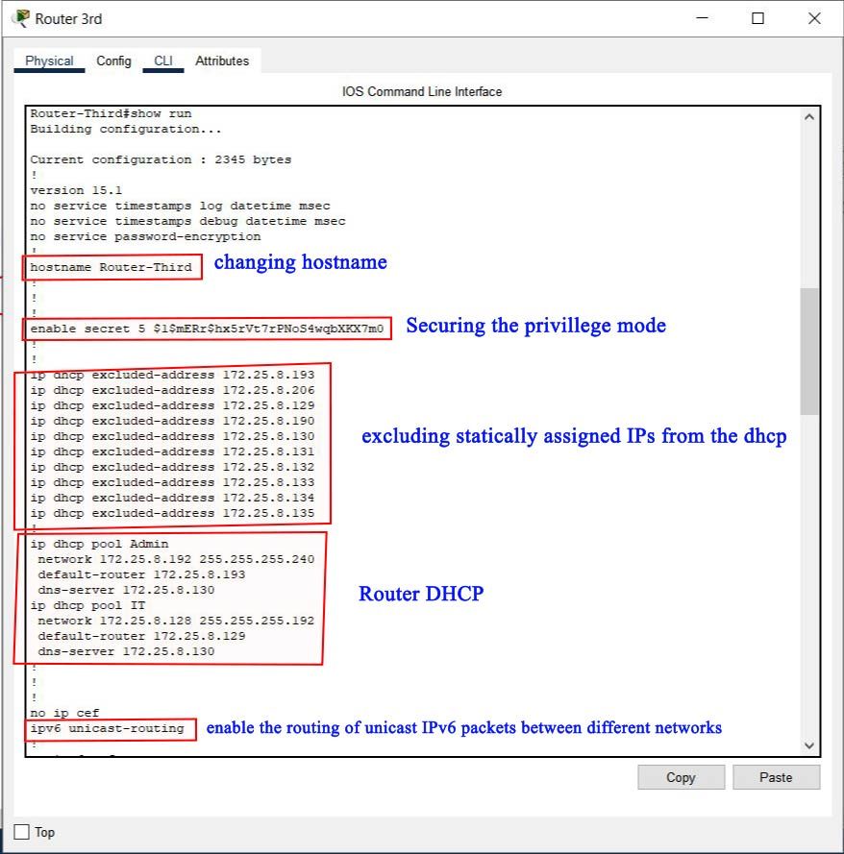
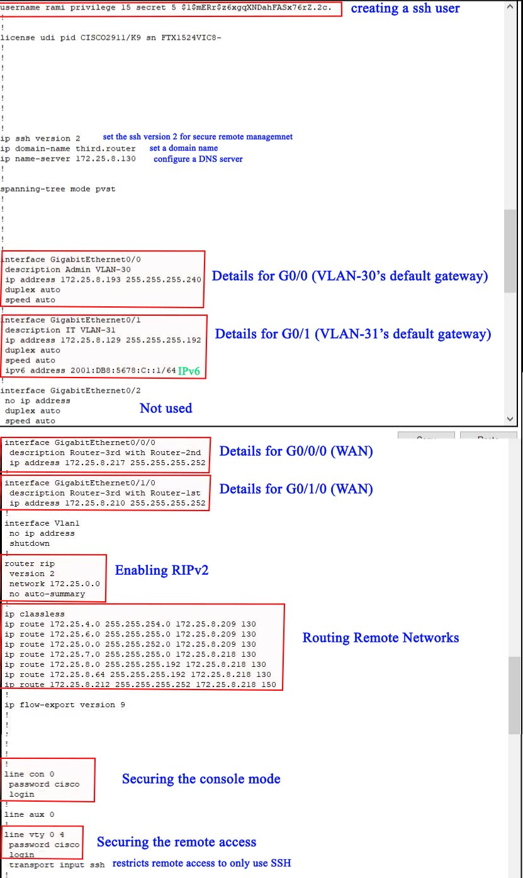
tftp backup for router 3rd:
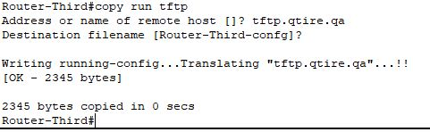

Show run for Switch 1st:
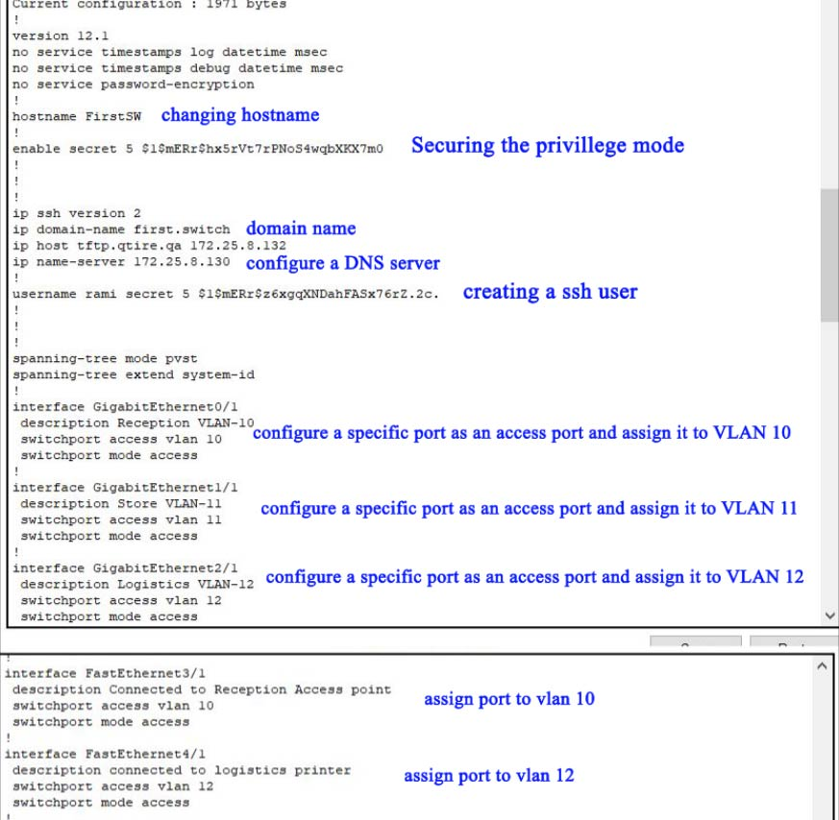
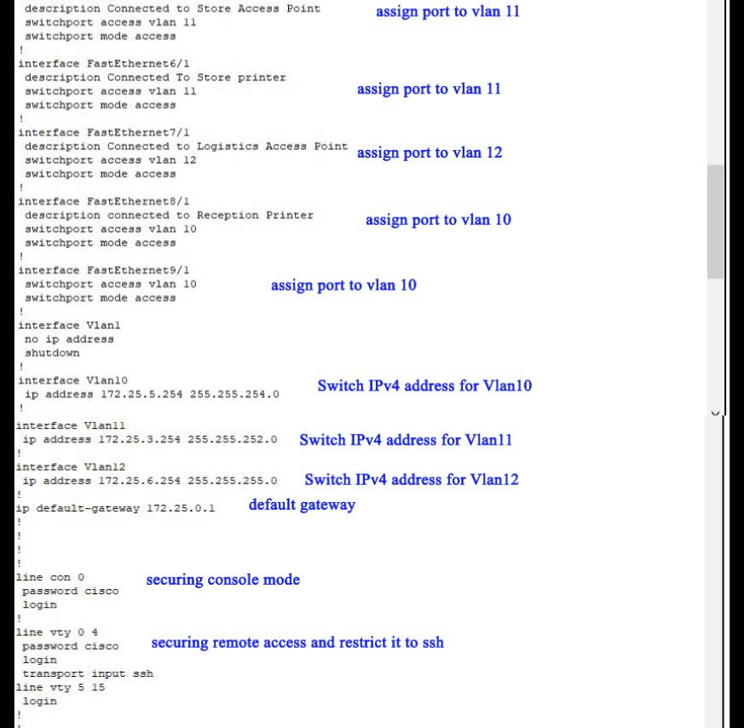
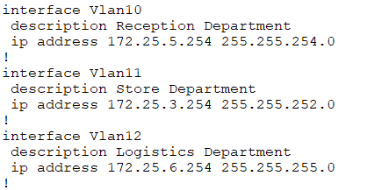
tftp backup for Switch 1st:
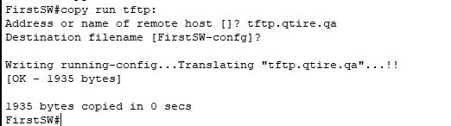

Show run for Switch 2nd: 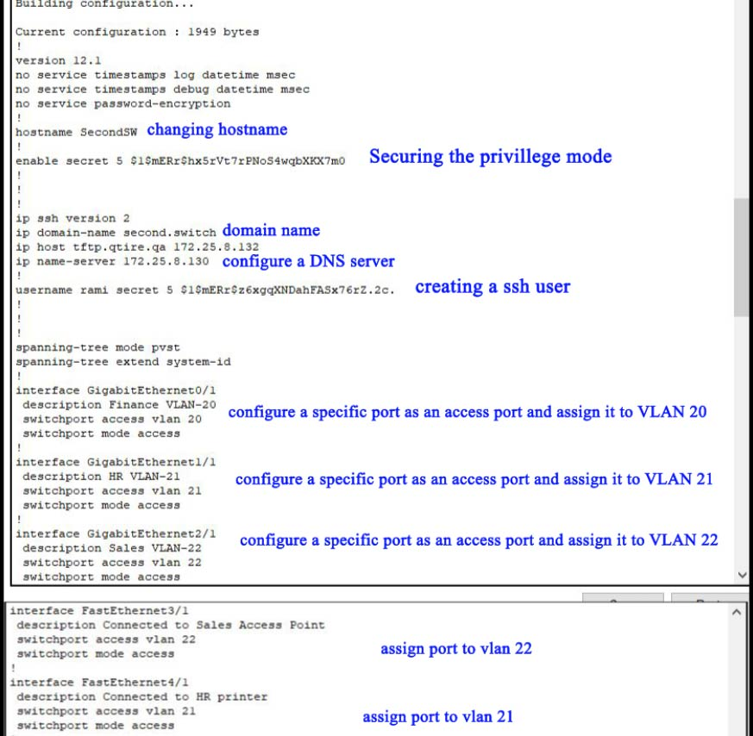
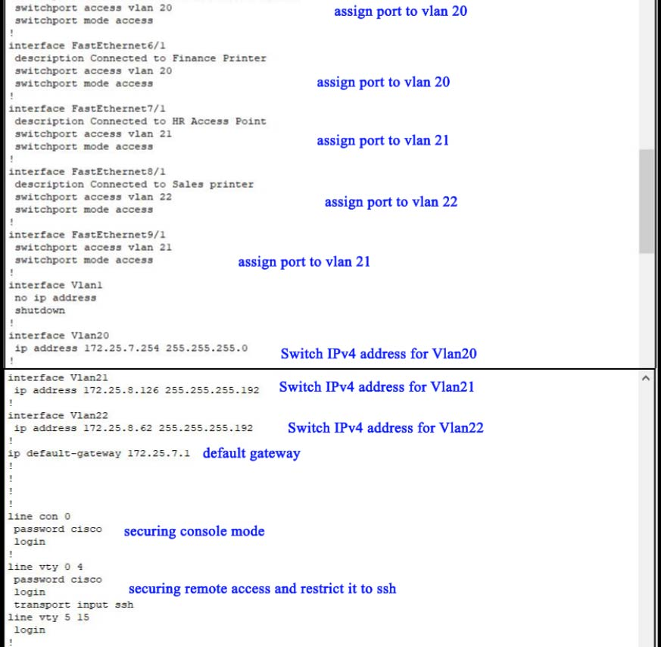
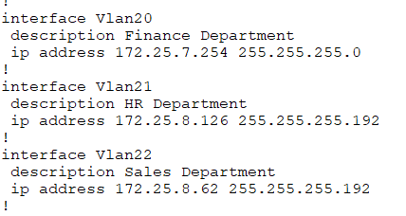
Tftp backup for switch 2nd:
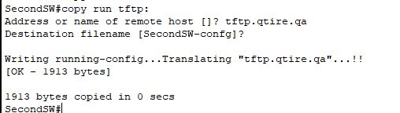

Show run for Switch 3rd:
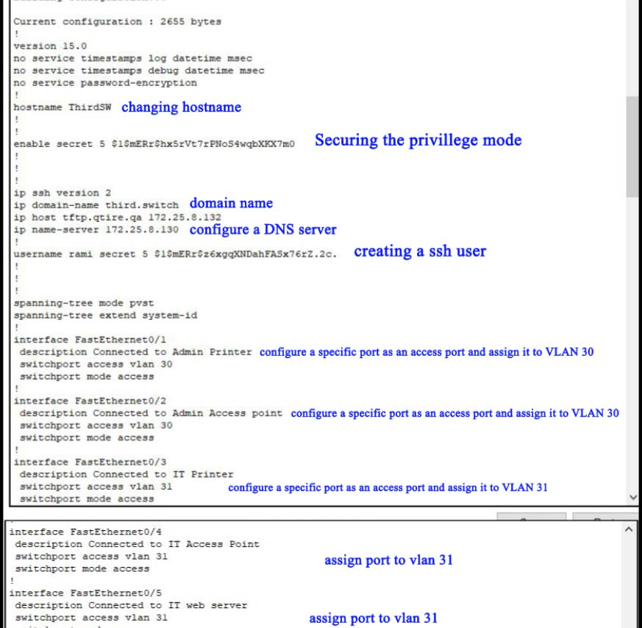
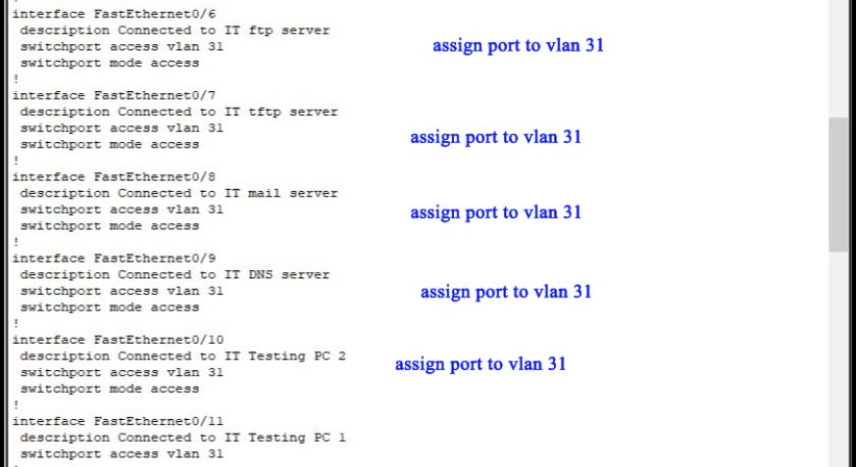
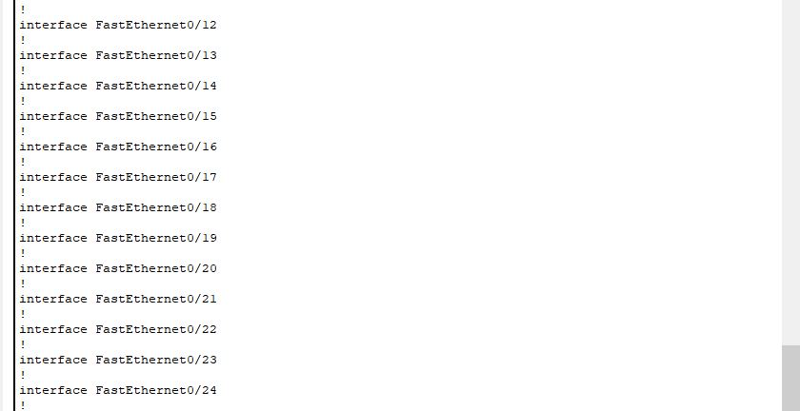
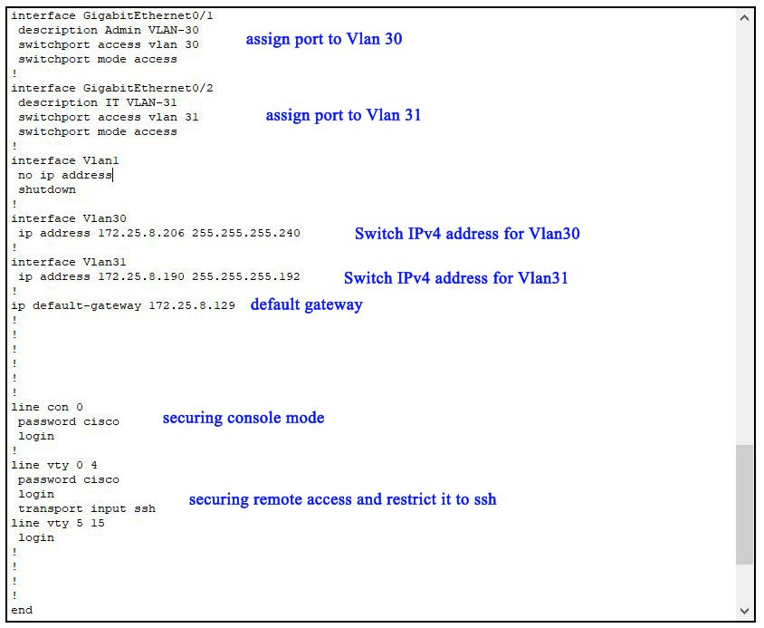
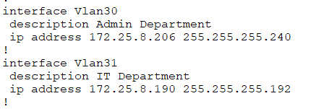
Tftp backup for switch 3rd:
