Smart Classroom Control System

Table of Contents
1. Problem Statement and High Level Architecture 3
2. Design Details 3
2.1. Hardware 3
2.2. Software 3
2.3. Sensor 3
3. Implementation and Testing 3
References 4

Problem Statement and High-Level Architecture
Modern classrooms may struggle with inconsistent environmental conditions due to manual control of lighting, airflow, and ambient color. These settings can vary depending on instructor preferences, time of day, or class activities. Today’s classrooms can make an instructor uncomfortable, lacking simple room customization. The objective of this project is to design and implement an automated Smart Classroom Control System capable of adjusting lighting intensity, RGB ambience, and fan speed based on user-selected presets or manual settings through a MATLAB–Arduino interface.

The system must satisfy four measurable goals, which are: User identification, by connecting through Bluetooth Low Energy (BLE). Preset control, by supporting seasonal modes (Winter, Summer, Spring) that adjust five environmental parameters. Manual control, by allowing users to override presets via MATLAB UI sliders and buttons. Wireless actuation, by delivering commands to the actuator subsystem IR communication.

As shown in Figure 1, the system is decomposed into three major components:

- User Interface Layer (MATLAB App Designer)
  - Provides GUI for preset and manual control.
  - Sends commands to the server (Arduino R4) using serial communication.
- Control & Communication Layer (Arduino R4 + IR transmitter)
  - Receives preset/manual commands from MATLAB.
  - Identifies users via BLE.
  - Translate settings into structured IR packets.
  - Transmits wireless commands to the actuator (Arduino Mega) subsystem.
- Actuation Layer (Arduino Mega + IR Receiver + Hardware room components)
  - Receives IR packets.
  - Decodes packets
  - Drives PWM outputs for light brightness, RGB LEDs, and fan speed.

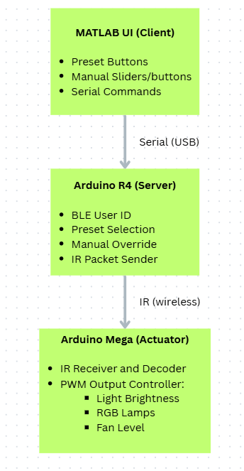
Figure 1. High-level architecture, block diagram

Design Details

Hardware

Below are the full circuit connections of the IR Receiver (Figure 2) and IR Transmitter (Figure 3) and the list of hardware components used shown in Table 1.
Note: In practical implementation, number of white LEDs and RGB LEDs is more than what is shown in Figure 2.

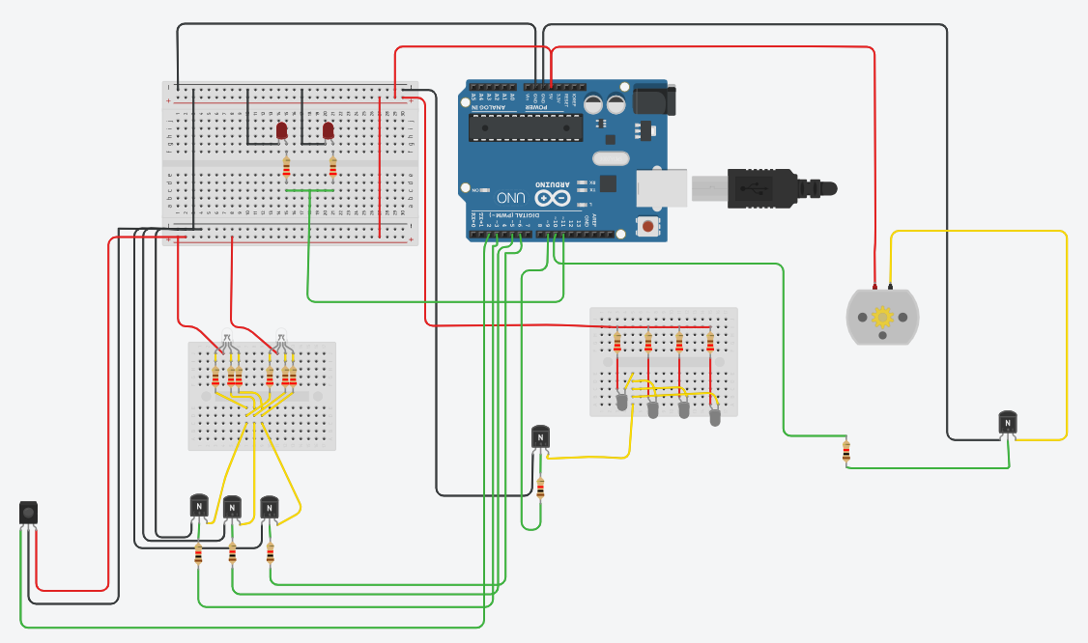
Figure 2. Arduino Mega Receiver, full circuit

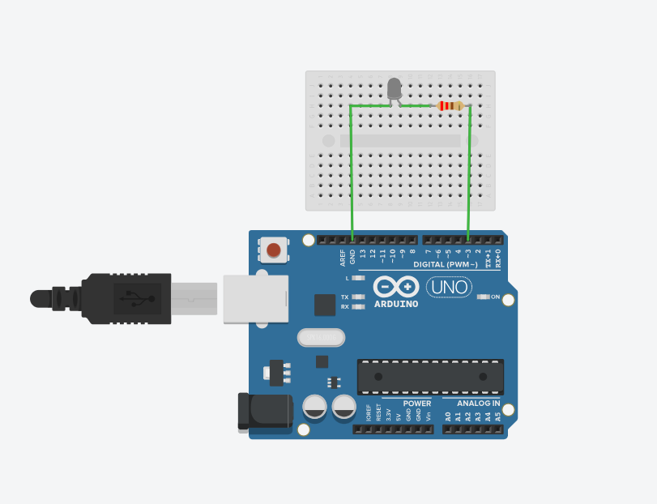
Figure 3. Arduino R4, full circuit

Table 1. Hardware Components used
Component | Model / Type | Purpose in the System
Arduino R4 | Arduino Uno R4 WiFi | Main controller, BLE identification, IR transmission
Arduino Mega | Arduino mega 2560 | Actuator board, receives IR packets, drives PWM outputs
IR Transmitter LED | 940 nm IR LED | Sends encoded NEC packets from R4 to Mega
IR Receiver Module | VS1838B | Decodes NEC IR packets
White LEDs (8 pcs) | 5V white LEDs | Room lighting brightness control
Common Anode RGB LED (3 pcs) | 5V RGB LEDs | Ambient color control
5V DC Fan | Brushless DC fan | Airflow control (OFF/LOW/MED/HIGH)
NPN Transistors | PN2222 | Allows MCU PWM to control LED/fan loads
Resistors | 220Ω and 1kΩ | Protect LEDs and transistor bases
USB Serial Connection | Standard USB | MATLAB-to-R4 communication, and Arduino R4 and mega code uploading

Tools and Frameworks with justification for selected approach

Arduino UNO R4 WiFi
Used as the main controller responsible for BLE authentication and IR transmission. The R4 provides built-in Bluetooth Low Energy support and was mandatory to be used in our course project.

Arduino Mega 2560
Chosen as the receiver/controller because it offers many PWM pins and multiple hardware timers. This solved us a PWM timer issues encountered on the R3 UNO due to some pwm pins using the same IRreceiver timer.

IR Transmitter (IR LED)
Serves as the communication link between the R4 and Mega. The IR is simple and wireless. It is reliable and avoids wiring complexity between distant microcontrollers.

IR Receiver Module (TSOP38238)
Decodes the infrared packets sent from the R4. It internally handles filtering, carrier detection, and demodulation, allowing the Mega to receive clean digital frames. This module is essential for remote, wireless operation.

RGB LED Lamp
Controlled through PWM signals to modify the red, green, and blue intensity based on the user’s selected season or manual configuration. The RGB lamp allows customizable lighting environments to match different classroom moods.

White LED Lamp
Used for general lighting control. The brightness is adjusted using PWM, enabling smooth dimming from 0–100%. This component represents the “environment lighting” aspect of the smart classroom.

DC Fan
Represents the ventilation subsystem. Different speed presets (OFF/LOW/MED/HIGH) are implemented through PWM. The fan allows demonstration of real-world fan control inside a smart room interface.

Interface approach used

Table 2. Interface approach used
Interface Type | Where used | Why
USB Serial Communication | MATLAB → Arduino R4 | Reliable command transfer and debugging
Bluetooth Low Energy (BLE) | Phone → Arduino R4 | User identification and automatic profile selection
IR NEC Protocol | Arduino R4 → Arduino Mega | Wireless control of lighting, RGB, and fan
Pulse Width Modulation (PWM) | Mega → LEDs and Fan | Smooth dimming and analog control

Novel Aspects of the Interface Design

Dual-Microcontroller Architecture
Instead of controlling all hardware from one board, our design uses two:
- Arduino R4 (High-level logic, BLE, presets, manual mode, user identification)
- Arduino Mega (actuator only)
This separation increases: reliability and scalability.

Custom Multi-Packet NEC Control Scheme
Instead of sending one IR code, the system sends five NEC packets:
- LIGHT
- RED
- GREEN
- BLUE
- FAN
This turns IR packets into a structured control bus.

Software
The software architecture consists of three interconnected layers. The MATLAB GUI (Figure 4) serves as the user interface, formatting user selections into high-level control commands. These commands are transmitted through USB Serial to the Arduino R4(Figure 5), which acts as the system's main controller. The R4 interprets the command, retrieves profile-based values for presets or parses numerical values for manual mode, and then transmits device-specific control packets over infrared using the NEC protocol. The Arduino Mega (Figure 6), equipped with an IR receiver, decodes each arriving packet, maps its address to the corresponding device (light, RGB channels, or fan), and applies PWM outputs to actuate the room environment in real time. This layered flow allows clean separation between user interface, logic/control, and hardware actuation.

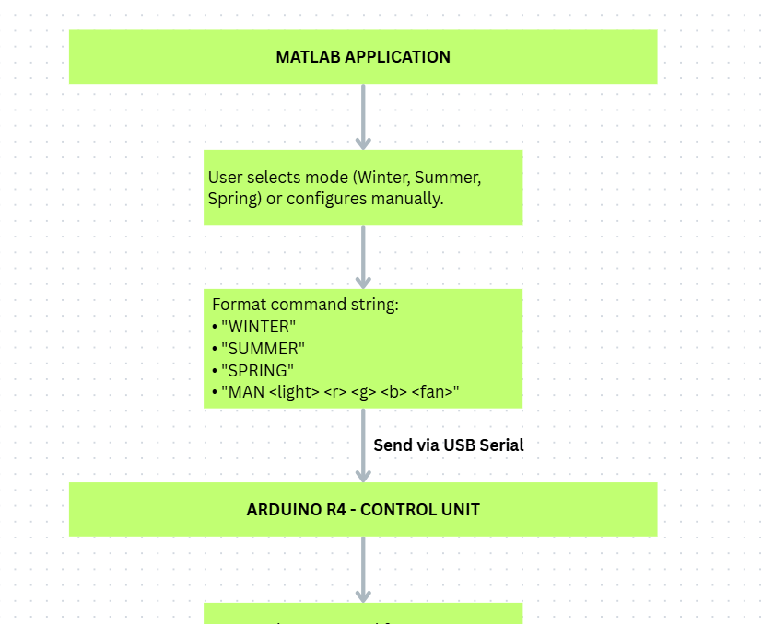
Figure 4. MATLAB APPLICATION

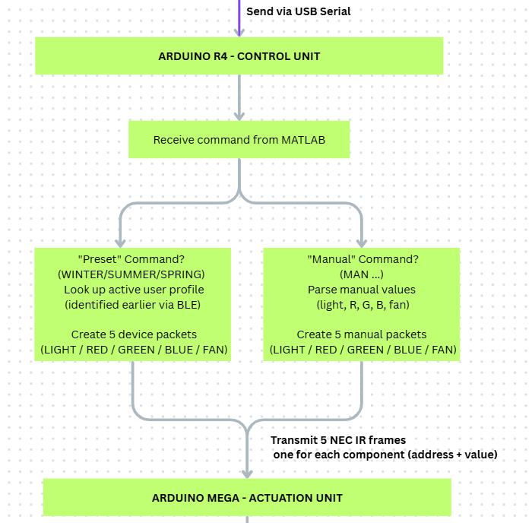
Figure 5. ARDUINO R4 - CONTROL UNIT
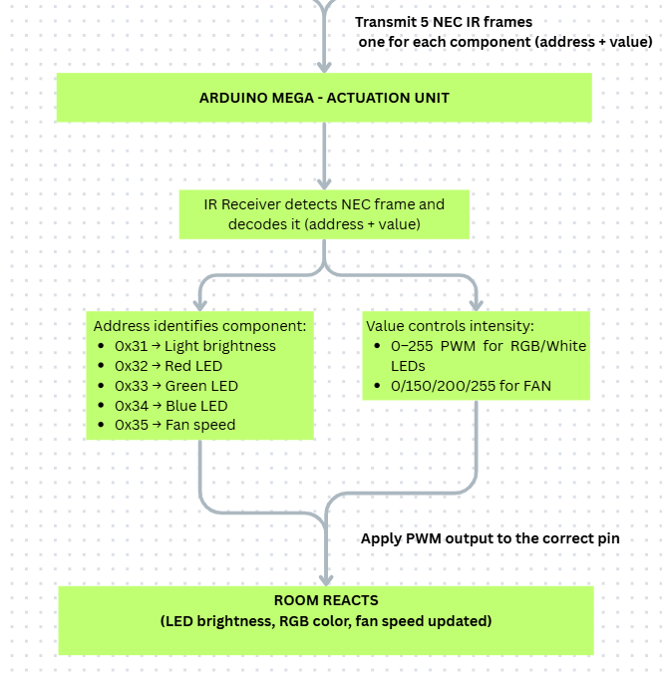
Figure 6. ARDUINO MEGA - ACTUATION UNIT

Software’s used for implementing the design, with justification

MATLAB App Designer
MATLAB App Designer provides a structured, drag and drop feature with automatic creation of frontend code (code view) creating a nice user interface. As well as its simplicity in adding backend functions for action. Also, it was mandatory for us to include it in the course project.

MATLAB Serial I/O
The MATLAB serial port interface offers a reliable and straightforward way to send control commands over USB to the Arduino R4, ensuring clean communication between the UI and the hardware. This removes the need to use additional communication libraries or packages.

Arduino IDE
Arduino IDE serves as the primary environment for writing code and uploading it to both the R4 and Mega boards.

ArduinoBLE Library [1]
The ArduinoBLE library implements Bluetooth Low Energy communication on the R4, enabling a limited but fast communication, which is very suitable to our design to use for user identification. This allows the system to authenticate users with minimal overhead.

IRremote Library [2]
The IRremote library provides robust support for encoding and decoding infrared communication protocols, including NEC protocol which is simple and works well with our design for sending small packets.

Client-Server Architecture (Bonus)

Instead of using MATLAB’s Arduino Support Package, the design implements a lightweight, text-based protocol over a standard serial UART connection, as shown in Figure 7.

Client (MATLAB UI Application)
- Sends high-level commands through serialport using writeline().
- Performs all user interaction logic (presets, manual configuration sliders, fan mode buttons).
- Converts GUI actions into command strings (“WINTER” or "SUMMER" “SPRING” or "MAN 120 255 180 255 200").
Server (Arduino UNO R4)
- Continuously listens on UART for incoming command strings.
- Parses each received string and maps it to the appropriate preset.
- Converts the logical command into five NEC IR packets and transmits them to the Mega.
- Acts as the gateway between MATLAB and the physical room actuators.
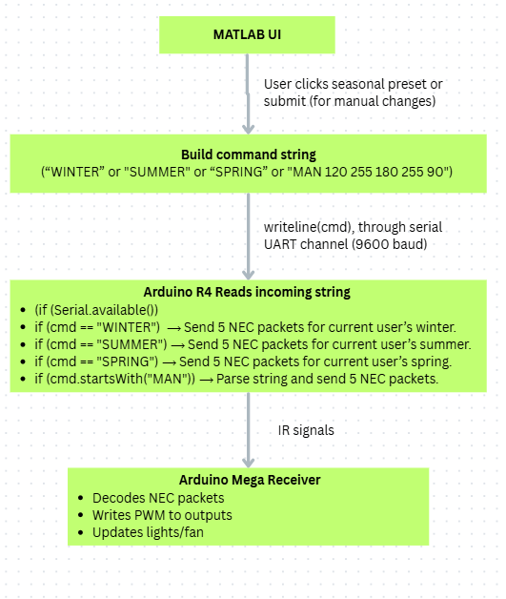

Figure 7. Client-Server Architecture

Hierarchy MATLAB’s side:

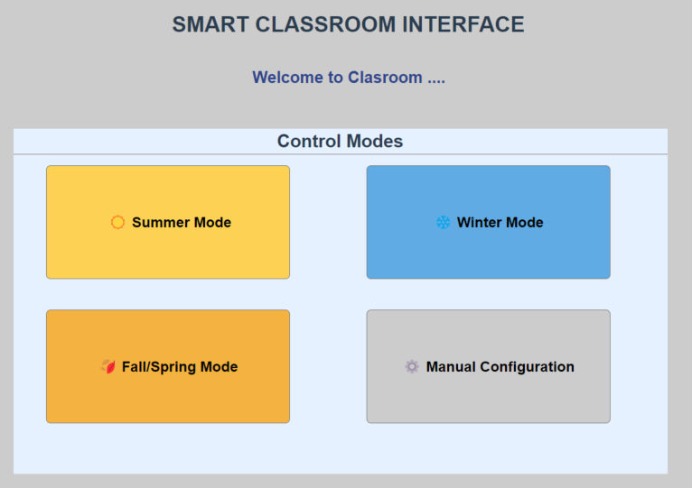
Figure 8. Home MATLAB GUI
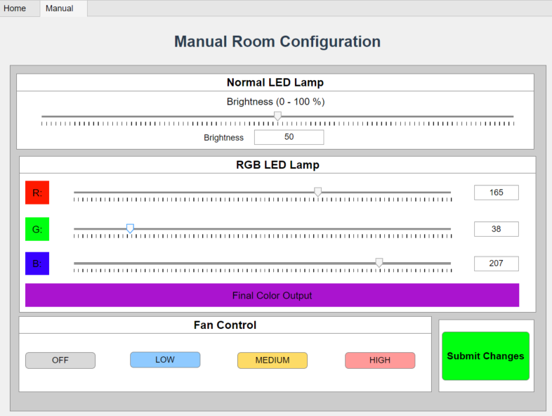
Figure 9. Manual Room Configuration GUI

Setup Connection with Arduino:
app.arduino = serialport("COM3",9600);
writeline(app.arduino, "CONNECTED");

Summer Button:
function SummerModeButtonPushed(app, event)
writeline(app.arduino, "SUMMER");
end

Winter Button:
function WinterModeButtonPushed(app, event)
writeline(app.arduino, "WINTER");
end

Spring Button:
function FallSpringModeButtonPushed(app, event)
writeline(app.arduino, "SPRING");
end

Submit changes Button:
function SubmitChangesButtonPushed(app, event)

light = round(app.BrightnessEditField.Value);
r = round(app.RField.Value);
g = round(app.GField.Value);
b = round(app.BField.Value);
fan = app.fanValue;

light = max(0, min(100, light));
r = max(0, min(255, r));
g = max(0, min(255, g));
b = max(0, min(255, b));

cmd = sprintf("MAN %d %d %d %d %d", light, r, g, b, fan);
writeline(app.arduino, cmd);
end
end

Hierarchy Arduino R4’s side:

Check if serial string is available from MATLAB:
if (Serial.available()) {
String cmd = Serial.readStringUntil('\n');
cmd.trim();

For Presets:
if (cmd == "CONNECTED")
sendPacket(ADDR_CONNECTED,255); // to blink LEDs indicating connection
else if (cmd == "WINTER")
sendFullSetting(profiles[currentUser].winter);
else if (cmd == "SUMMER")
sendFullSetting(profiles[currentUser].summer);
else if (cmd == "SPRING")
sendFullSetting(profiles[currentUser].spring);
For manual:
else if (cmd.startsWith("MAN")) {
int light_i, r_i, g_i, b_i, fan_i;
sscanf(cmd.c_str(), "MAN %d %d %d %d %d",&light_i, &r_i, &g_i, &b_i, &fan_i);

uint8_t light = (uint8_t)light_i;
uint8_t r = (uint8_t)r_i;
uint8_t g = (uint8_t)g_i;
uint8_t b = (uint8_t)b_i;
uint8_t fan = (uint8_t)fan_i;

sendManualValues(light, r, g, b, fan);

Sensor
Infrared Transmitter Sensor (IR LED) [2], [3]
The infrared transmitter used in this project is a gallium-arsenide (GaAs)–based IR LED that emits electromagnetic radiation in the near-infrared spectrum (typically around 940 nm). When the diode is forward-biased, electrons and holes recombine within the semiconductor junction, releasing energy in the form of photons whose wavelength lies outside the visible band. This physical process is the underlying principle enabling IR emission. To ensure reliable communication, the LED output is modulated at 38 kHz, meaning the diode is rapidly pulsed rather than continuously illuminated. This modulation is essential: ambient light sources such as sunlight, incandescent bulbs, and displays emit broadband IR, and without a carrier frequency the receiver would be overwhelmed by noise. By embedding data within a 38 kHz carrier, the system guarantees that only intentionally generated IR bursts are accepted by the receiver, enabling robust short-range wireless transfer of preset lighting and fan configuration values from the Arduino R4. This technique is standard in remote-control systems and provides high immunity to environmental interference while remaining inexpensive and power efficient.

Infrared Receiver Sensor [4]
The infrared receiver in this design is a demodulating IR sensor module that integrates a photodiode, automatic gain control (AGC), a narrow 38 kHz band-pass filter, and a digital demodulator into a single package. The sensing process begins when incident infrared photons generate a photocurrent within the photodiode. This current is amplified and fed through the internal AGC circuit, which dynamically adjusts sensitivity to stabilize detection under varying lighting conditions. A precise 38 kHz band-pass filter then suppresses all IR signals not matching the transmitter’s carrier frequency, effectively rejecting noise from ambient illumination. Finally, the demodulator extracts the underlying digital pulse stream by removing the carrier, outputting clean logic-level transitions corresponding to the NEC protocol timing structure. This allows the Arduino Mega to interpret the transmitted packets as exact numeric configuration values. The combination of optical filtering, electronic gain control, and built-in demodulation is what makes these receivers highly reliable even in complex lighting environments, ensuring consistent and accurate decoding of preset and manual user commands.

Implementation and Testing
Below you can find pictures of the actual circuit implementation (Figure 10, Figure 11, Figure 12).

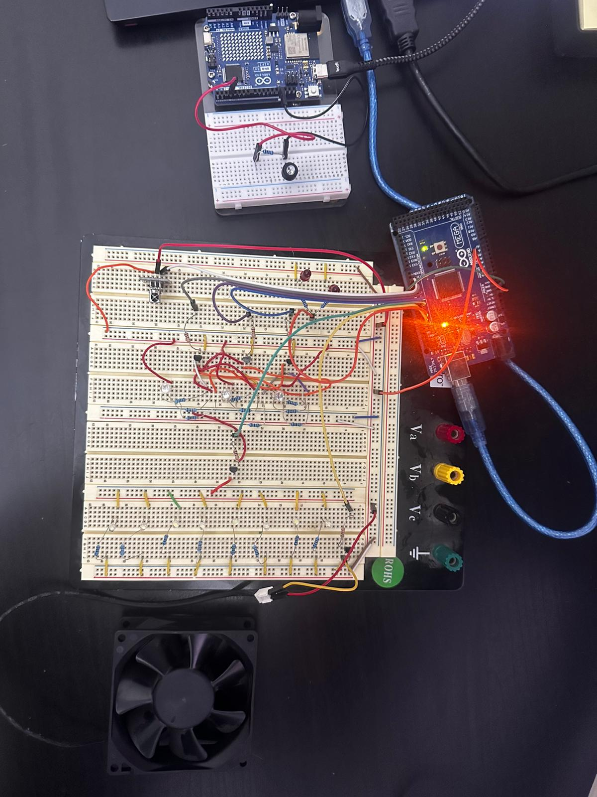
Figure 10. Full implementation circuit design
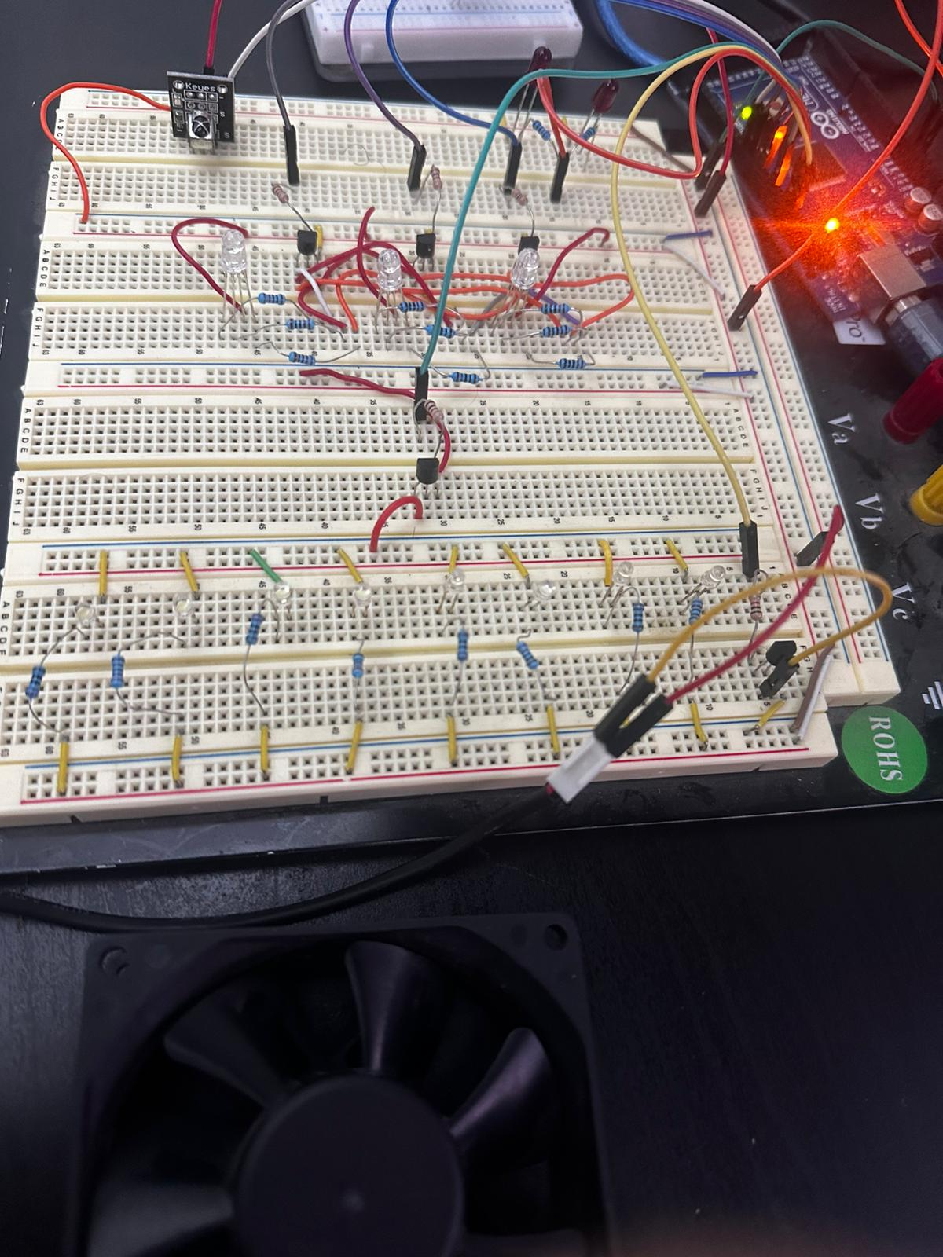
Figure 11. Receiver implementation circuit

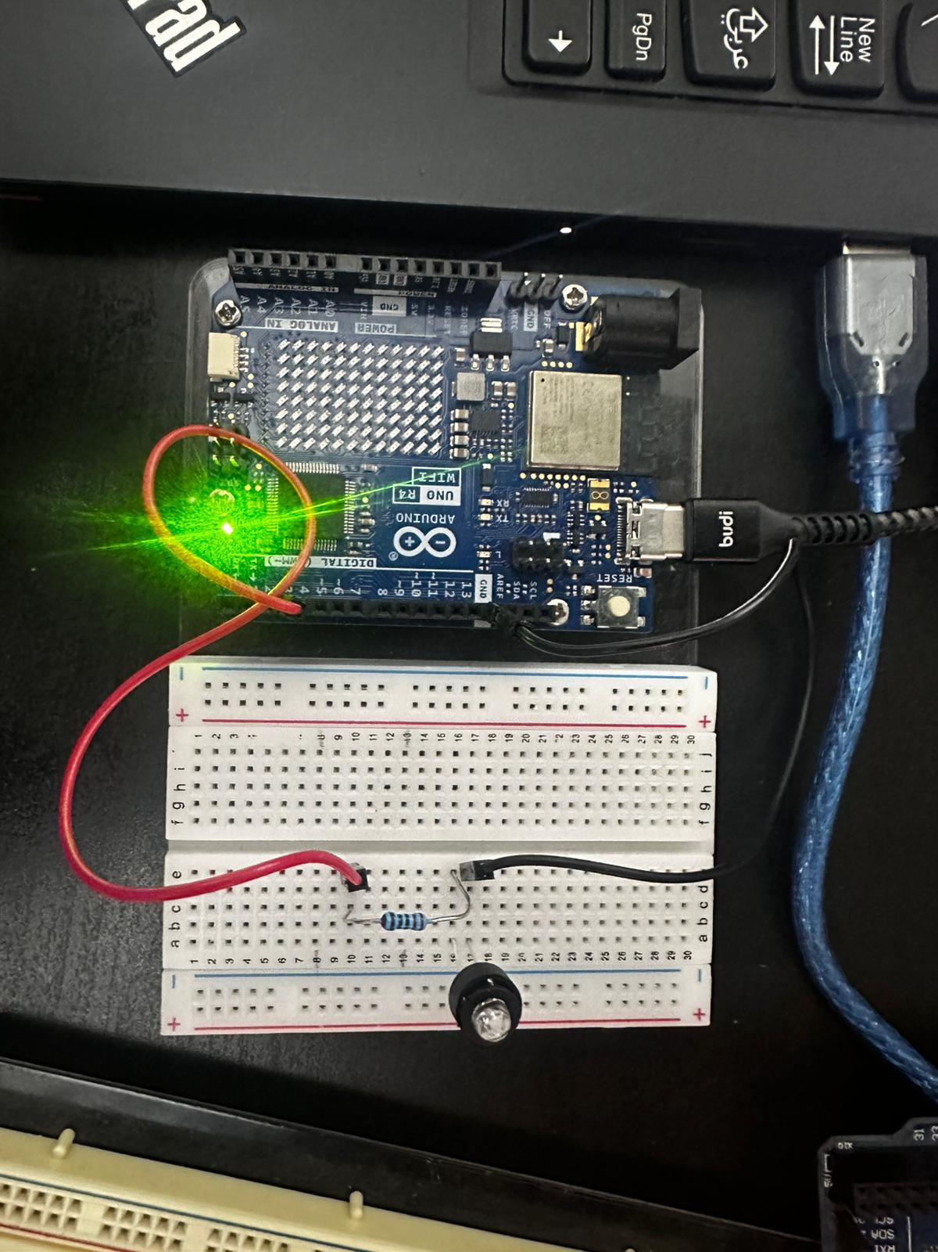
Figure 12. Transmitter implementation circuit

Testing and Evaluation

- Connecting to Arduino R4 via Bluetooth BLE application, user “uvais” is selected.
- Running the MATLAB program, LEDs blink 5 times indicating connection establishment.
Dr. Uvais has the following profile:
(Light brightness, Red, Green, Blue, Fan level max)
{ "uvais", "Dr. Uvais",
{255, 0, 128, 128, FAN_LEVEL_OFF}, //winter
{70, 75, 0, 130, FAN_LEVEL_HIGH}, // summer
{200, 255, 0, 255, FAN_LEVEL_MEDIUM} // spring
}

Figure 13 shows room updating after pressing SUMMER button in MATLAB, dim(70) room with purple ambient lighting and fan at the highest level.

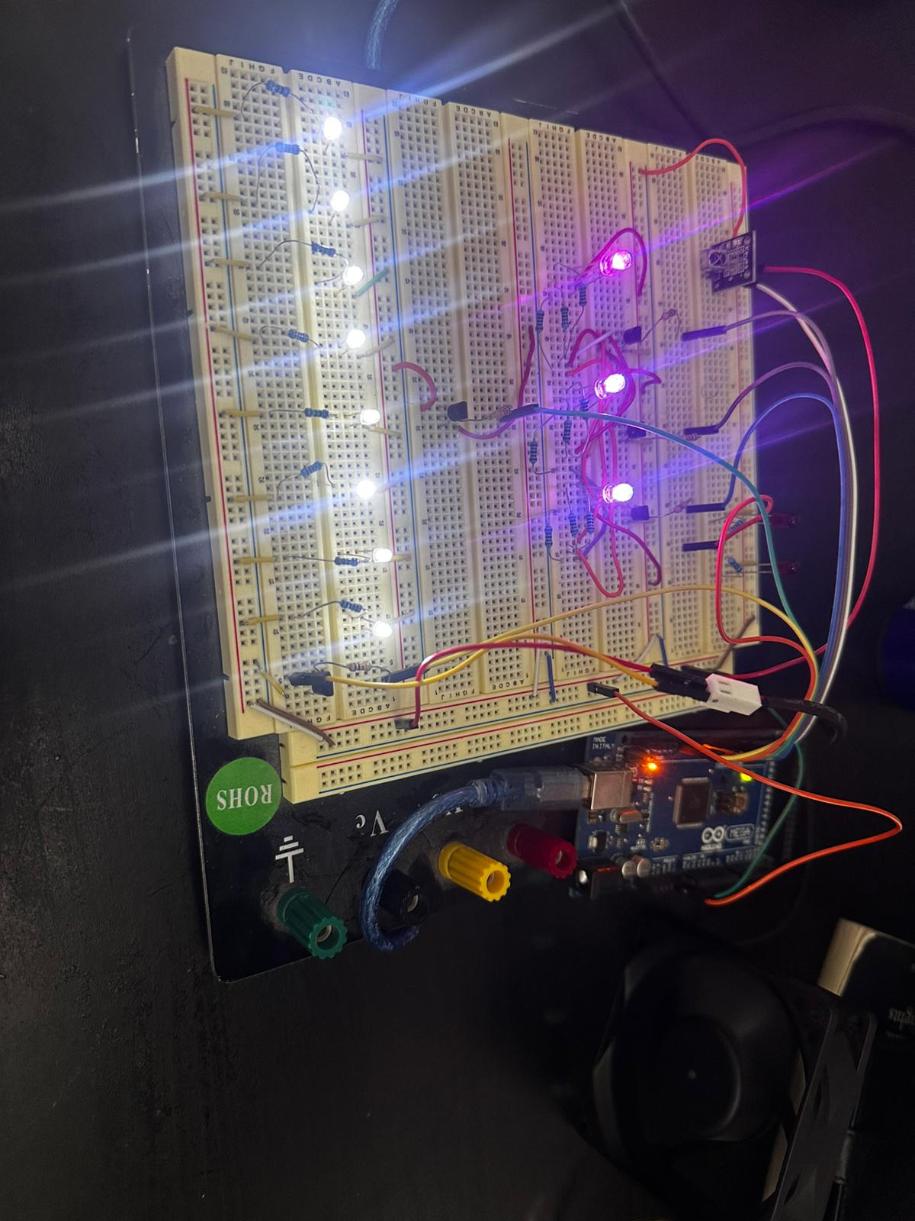
Figure 13. Summer Preset for user "uvais"

Figure 14 shows room updating after pressing WINTER button in MATLAB, bright(255) room with emerald ambient lighting and fan OFF.

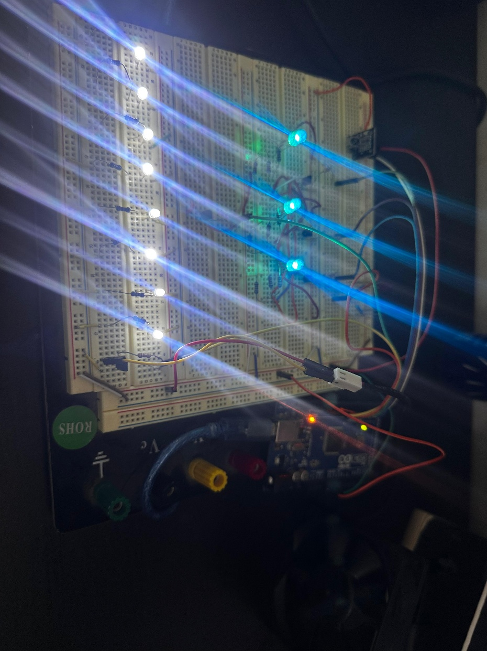
Figure 14. Winter Preset for user "uvais"

Figure 15 shows room updating after pressing SPRING button in MATLAB, bright (200) room with pink ambient lighting and fan level at medium.

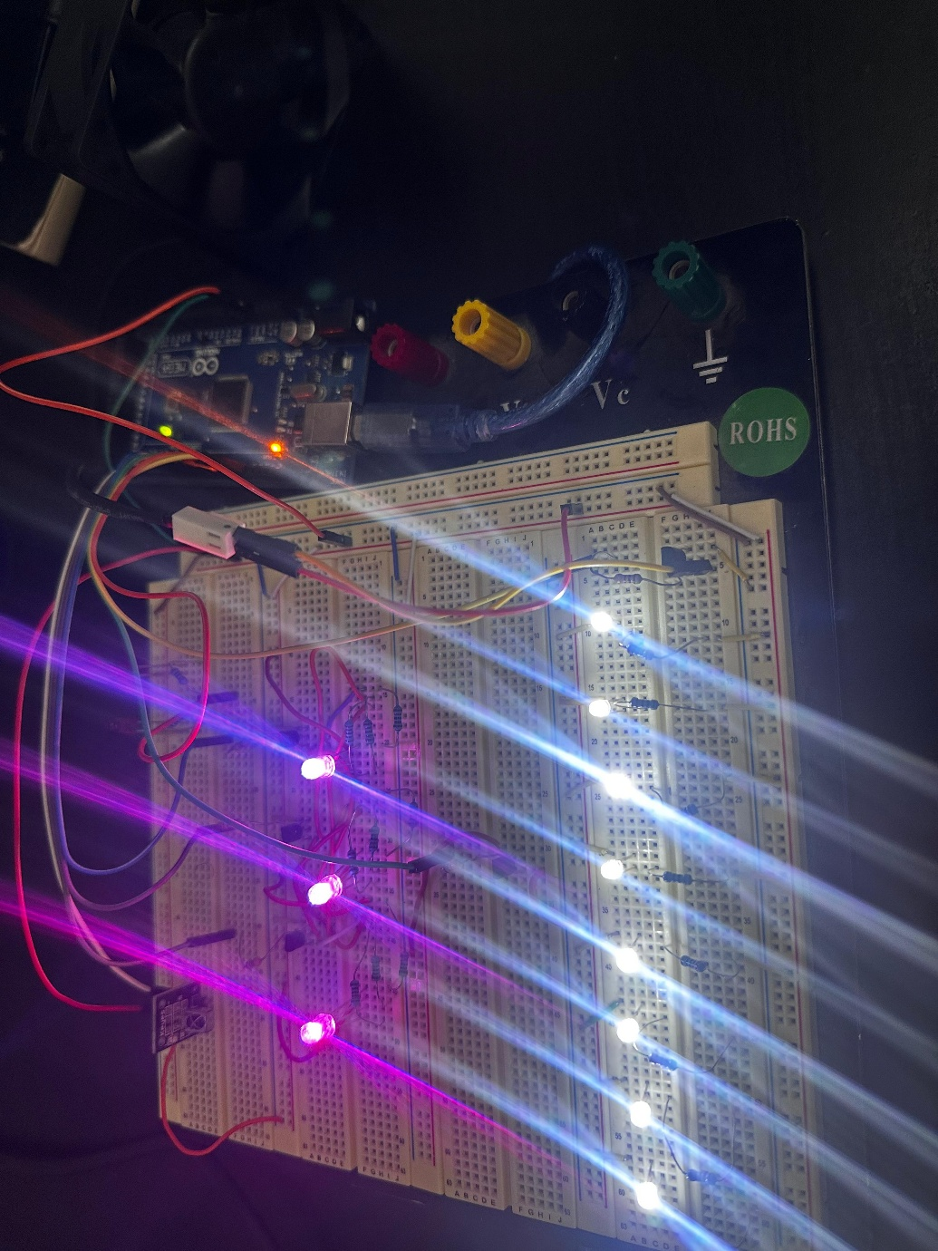
Figure 15. Spring preset for user "uvais"

Figure 17 shows room updating after selecting manual configuration in MATLAB, customizing the room (Figure 16, 16% light brightness, yellow ambient lighting, Fan level HIGH) and then pressing Submit Changes button.

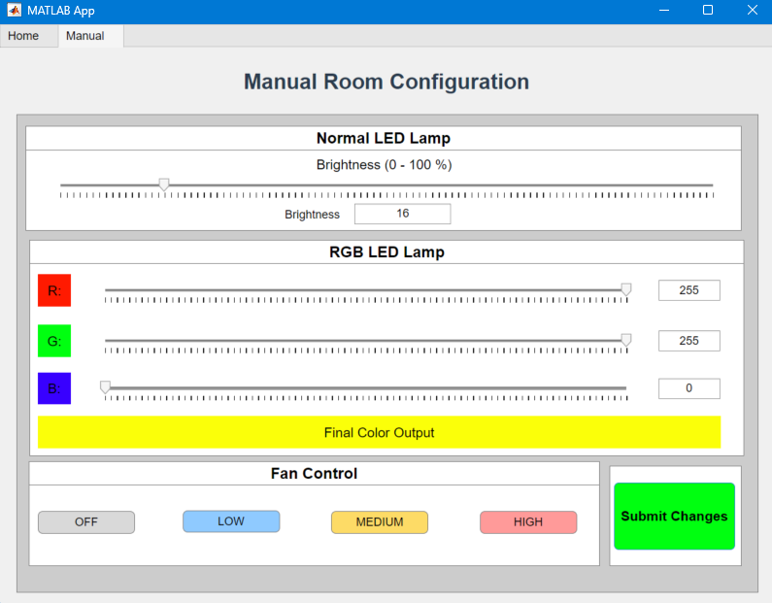
Figure 16. Manual user customization

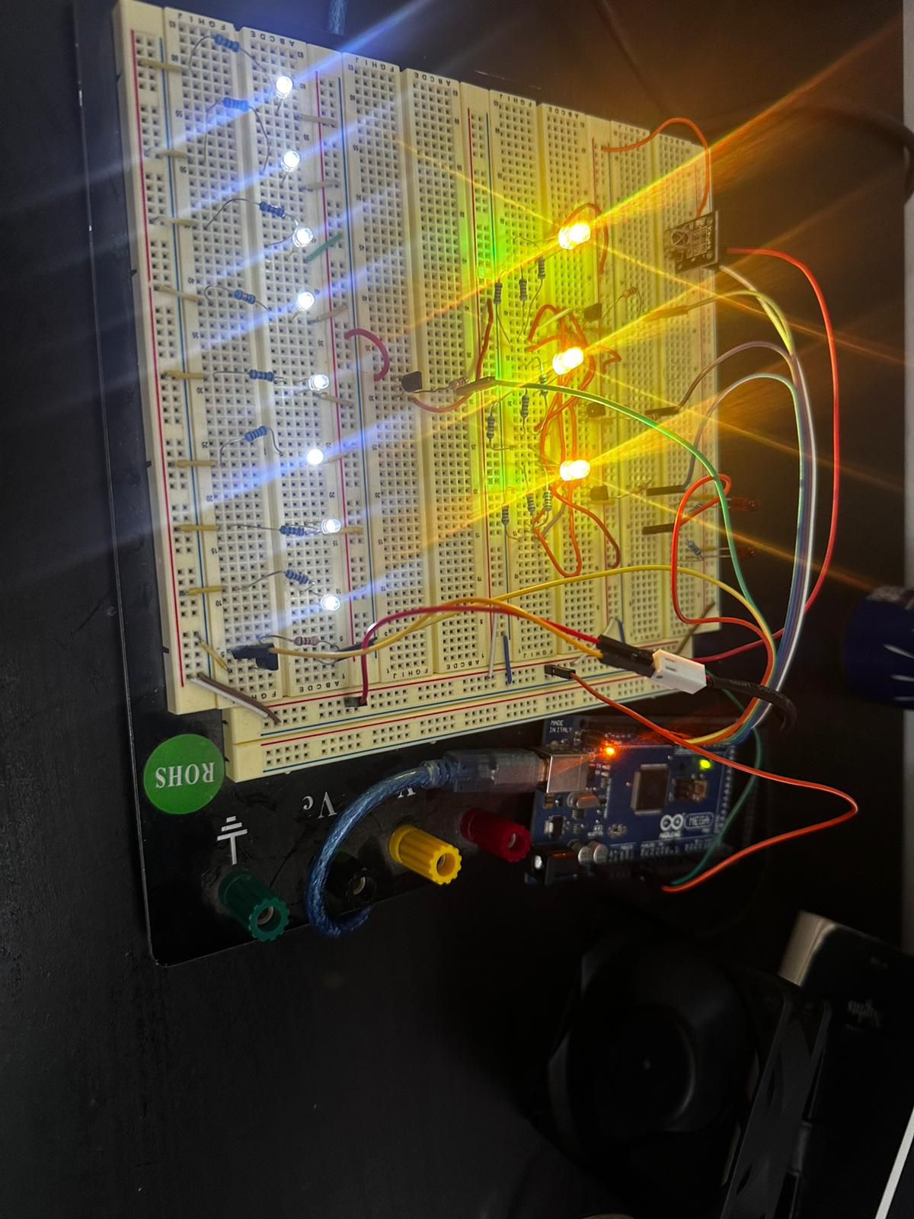
Figure 17. Manual configuration applied

The prototype successfully met the primary objectives of the system: reliable wireless preset selection, robust manual configuration through the MATLAB UI, and accurate reproduction of lighting and fan settings on the receiver side. The BLE authentication worked consistently, and the NEC-based IR communication proved stable. The system demonstrated full end-to-end functionality, validating the architecture. Overall, the prototype achieves the intended goals and provides a strong foundation for future refinement.

References
< Include the list of references relevant to your work using IEEE citation style. Use research papers and good quality references (such as journal and conference papers from ACM, IEEE and Springer). Do not just use web links. Embed citations of the references in the text of your document.>

[1] Arduino-IRremote Developers, *Arduino-IRremote: Infrared remote library for Arduino*, GitHub Repository, 2024. [Online]. Available: https://github.com/Arduino-IRremote/Arduino-IRremote

[2] Arduino, *ArduinoBLE Library: Bluetooth Low Energy support for Arduino boards*, GitHub Repository, 2024. [Online]. Available: https://github.com/arduino-libraries/ArduinoBLE

[3] M. Ishida and T. Nakamura, “Infrared Light-Emitting Diodes and Their Applications,” IEEE Transactions on Electron Devices, vol. 33, no. 5, pp. 626–632.

[4] “IR Remote Control – Basics, Operation & Application,” Elprocus, 2024. [Online]. Available: https://www.elprocus.com/ir-remote-control-basics-operation-application/.
[5] K. K. Wong and K. Y. Chen, “Design Considerations of Infrared Remote Control Receiver Front-End,” IEEE Transactions on Consumer Electronics, vol. 44, no. 4, pp. 1301–1309.

