B.Tech Computer Engineering
Semester – VII

Agile Methodology & Devops Lab

20CP408P

ACY: 2026-27



Name: Mahek Kamol
Roll No: 23BCP178

Submitted to
Dr Komal Singh
Department of Computer Engineering
School of Technology
Pandit Deendayal Energy University
Gandhinagar, Gujarat, India

Index

Sr.  No. | Experiment Title | Pages |  | Date of Completion | Marks (out of 10) | Sign.
Sr.  No. | Experiment Title | From | To | Date of Completion | Marks (out of 10) | Sign.
1 | Overview of Version Control Using Git | 3 | 7
2 | Creating infrastructure on Aws/Azure using Cloud Formation Templates | 8 | 13
3 | Using Intrinsic Functions in CloudFormation  Templates | 8 | 13
4 | JIRA | 14 | 24
5 | GitHub Actions | 25 | 33
6 | GitHub Actions Workflows | 25 | 33
7 | Introduction to Docker & Docker Installation | 34 | 40
8 | Docker Commands and Dockerfile | 34 | 40
9 | Introduction to PyTest | 41 | 47
10 | Testing using PyTest | 41 | 47
11 | Selenium Tool | 48 | 56

Lab 1
Aim:
Overview of Version Control Using Git

Theory
1. Version Control
Version Control is a system used to track and manage changes made to source code. It helps developers maintain different versions, recover previous changes, and collaborate on projects.
Advantages:
- Tracks changes in source code.
- Helps recover previous versions.
- Supports teamwork and collaboration.
- Maintains a history of modifications.
2. Introduction to Git
Git is a distributed version control system developed by Linus Torvalds in 2005. It is used to manage repositories, track changes, create branches, and collaborate on software projects.
3. Types of Version Control Systems
Centralized Version Control System (CVCS):
- Uses a single central repository.
- Requires network access for most operations.
- Server failure may result in data loss.
Distributed Version Control System (DVCS):
- Every developer has a complete repository copy.
- Supports offline operations.
- Provides faster operations and better data recovery.
4. Important Git Commands
- git init: Initializes a new Git repository in the current directory.
- touch hello.txt: Creates a new empty text file.
- nano hello.txt: Opens a file for editing in the terminal.
- cat hello.txt: Displays the contents of a file.
- git status: Shows the current status of files, including tracked, untracked, and staged changes.
- git add .: Adds all changes to the staging area before committing.
- git commit -m "First commit": Saves staged changes in the local repository with a message.
- git remote add origin <url>: Connects the local repository to a remote GitHub repository.
- git push -u origin main: Uploads local commits to the main branch of the remote repository.
- git branch Naitik: Creates a new branch named Naitik.
- git checkout Naitik: Switches from the current branch to the Naitik branch.
- git push -u origin branch2: Uploads the new branch and its commits to GitHub.
- git clone <url>: Creates a local copy of an existing remote repository.

5. Important Git Concepts
Repository: A storage location containing project files and their version history.
Staging Area: A temporary area where changes are prepared before committing.
Commit: A saved record of changes made to the repository.
Branch: An independent line of development used to work on different features.
Pull Request: A request to review and combine changes from one branch into another.
Merge: Combines changes from different branches into a single branch.

6. Git Workflow
- Create a repository on GitHub.
- Initialize the local repository using git init.
- Create files and check their status using git status.
- Stage changes using git add .
- Save changes using git commit.
- Connect the repository using git remote add origin.
- Upload changes using git push.
- Create and switch branches using git branch and git checkout.
- Create a pull request and merge changes into main.
- Clone the repository using git clone.

7. Result
Successfully created and managed a Git repository, performed basic Git commands, created branches, pushed changes to GitHub, and merged changes using a pull request.

Source Code:
file1.txt
Today is a practice session on Git Version Control.
Tomorrow is Friday.

Demo2branch.txt
this is a test case to see how it is working.

Output:
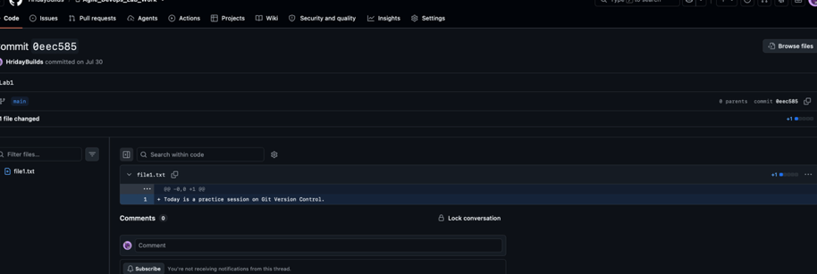

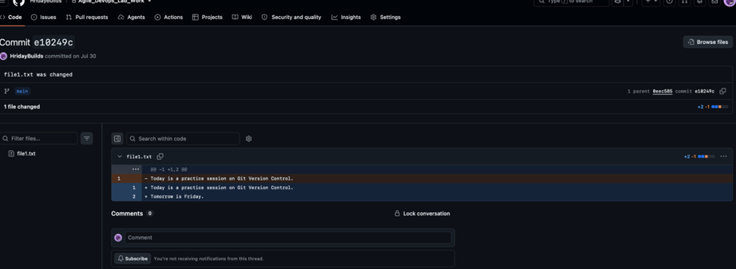

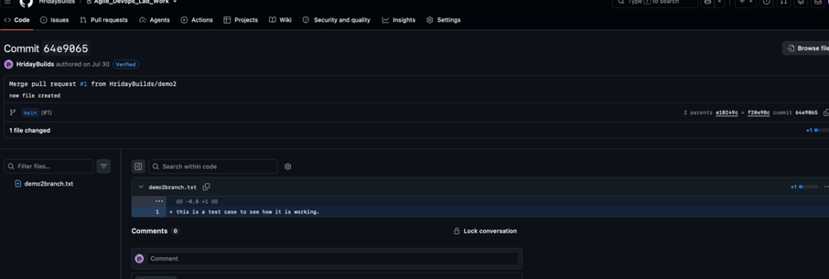

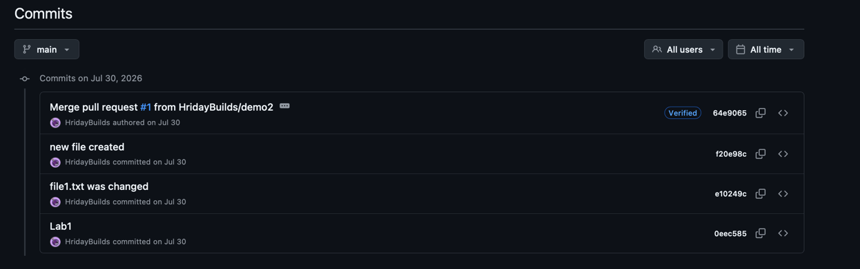

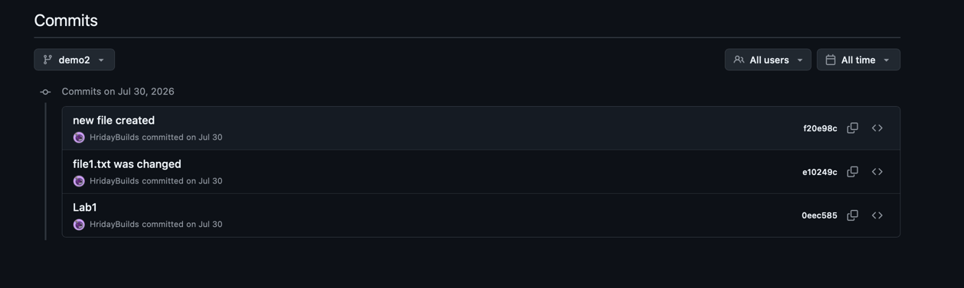

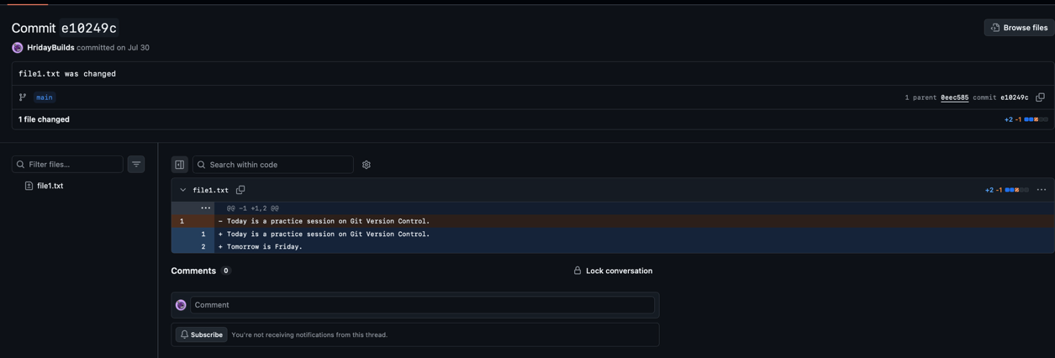

Lab 2 and 3
Aim:
Creating infrastructure on AWS/Azure using Cloud Formation Templates and Using Intrinsic Functions in CloudFormation Templates

Theory:
1. Introduction to AWS
Amazon Web Services (AWS) is a cloud computing platform that provides services such as virtual servers, storage, networking, and databases. It allows users to run applications without maintaining physical hardware.

2. Amazon EC2
Amazon Elastic Compute Cloud (EC2) is an AWS service used to create and manage virtual servers called instances.
Features:
- Provides virtual servers in the cloud.
- Allows users to select CPU, memory, and storage.
- Supports different operating systems.
- Provides scalable computing resources.

3. AWS CloudFormation
AWS CloudFormation is a service used to create and manage AWS resources automatically using templates. It follows the concept of Infrastructure as Code (IaC), where cloud infrastructure is defined using configuration files instead of manually creating resources.
Advantages:
- Automates resource creation.
- Reduces manual configuration.
- Provides consistent infrastructure.
- Allows multiple resources to be managed together.

4. Important AWS Components
- EC2 Instance: A virtual server used to run applications in the AWS cloud.
- Instance Type: Defines the computing capacity of an instance. In this experiment, t3.micro is used.
- Amazon Machine Image (AMI): A predefined image containing the operating system required to launch an EC2 instance. Amazon Linux 2023 is used.
- Virtual Private Cloud (VPC): A logically isolated network within AWS where cloud resources are deployed.
- Subnet: A smaller network within a VPC where EC2 instances are launched.
- Security Group: A virtual firewall that controls incoming and outgoing network traffic.
- Elastic IP: A static public IPv4 address assigned to an EC2 instance for internet accessibility.
- Private IP: An internal IP address used for communication within the VPC.
- EC2 Instance Connect: A service that allows users to securely connect to an EC2 instance through the AWS console.

5. Security Group Configuration
Security groups control network access to EC2 instances using inbound and outbound rules.
In this experiment:
- Port 22 (SSH): Allows remote access to the EC2 instance.
- Port 80 (HTTP): Allows web traffic to reach the instance.
- 0.0.0.0/0: Allows access from any IPv4 address.
For better security, SSH access should be restricted to trusted IP addresses.

6. CloudFormation Template Components
- Template Format Version: Specifies the CloudFormation template format.
- Description: Explains the purpose of the template.
- Parameters: Accepts user inputs such as instance type, AMI, VPC, and subnet.
- Resources: Defines the AWS resources to be created, including the EC2 instance, security group, and Elastic IP.
- Outputs: Displays important information after deployment, such as instance ID, private IP, and public Elastic IP.

Source Code:
AWSTemplateFormatVersion: '2010-09-09'
Description: >
Simple EC2 stack - Security Group + EC2 Instance (private IP automatic)
+ Elastic IP (public). You choose the VPC and Subnet from dropdowns
(pick the ones labeled "default"). No Lambda, no SSM, no Key Pair needed
- connect using EC2 Instance Connect.

Parameters:
InstanceType:
Description: EC2 instance type
Type: String
Default: t3.micro

LatestAmiId:
Description: AMI ID (defaults to latest Amazon Linux 2023 via SSM)
Type: AWS::SSM::Parameter::Value<AWS::EC2::Image::Id>
Default: /aws/service/ami-amazon-linux-latest/al2023-ami-kernel-default-x86_64

VpcId:
Description: Select your DEFAULT VPC from the dropdown
Type: AWS::EC2::VPC::Id

SubnetId:
Description: Select a DEFAULT subnet (inside the VPC above) from the dropdown
Type: AWS::EC2::Subnet::Id

Resources:

# ---------- Security Group ----------
InstanceSecurityGroup:
Type: AWS::EC2::SecurityGroup
Properties:
GroupDescription: Allow SSH (for EC2 Instance Connect) and HTTP inbound
VpcId: !Ref VpcId
SecurityGroupIngress:
- IpProtocol: tcp
FromPort: 22
ToPort: 22
CidrIp: 0.0.0.0/0
- IpProtocol: tcp
FromPort: 80
ToPort: 80
CidrIp: 0.0.0.0/0
Tags:
- Key: Name
Value: AgileLab-SG

# ---------- EC2 Instance ----------
MyEC2Instance:
Type: AWS::EC2::Instance
Properties:
InstanceType: !Ref InstanceType
ImageId: !Ref LatestAmiId
SubnetId: !Ref SubnetId
SecurityGroupIds:
- !Ref InstanceSecurityGroup
Tags:
- Key: Name
Value: AgileLab-Instance

# ---------- Elastic IP ----------
MyElasticIP:
Type: AWS::EC2::EIP
Properties:
Domain: vpc
InstanceId: !Ref MyEC2Instance
Tags:
- Key: Name
Value: AgileLab-EIP

Outputs:
InstanceId:
Description: EC2 Instance ID
Value: !Ref MyEC2Instance

PrivateIP:
Description: Private IP address
Value: !GetAtt MyEC2Instance.PrivateIp

ElasticIP:
Description: Elastic (Public) IP address
Value: !Ref MyElasticIP

Output:

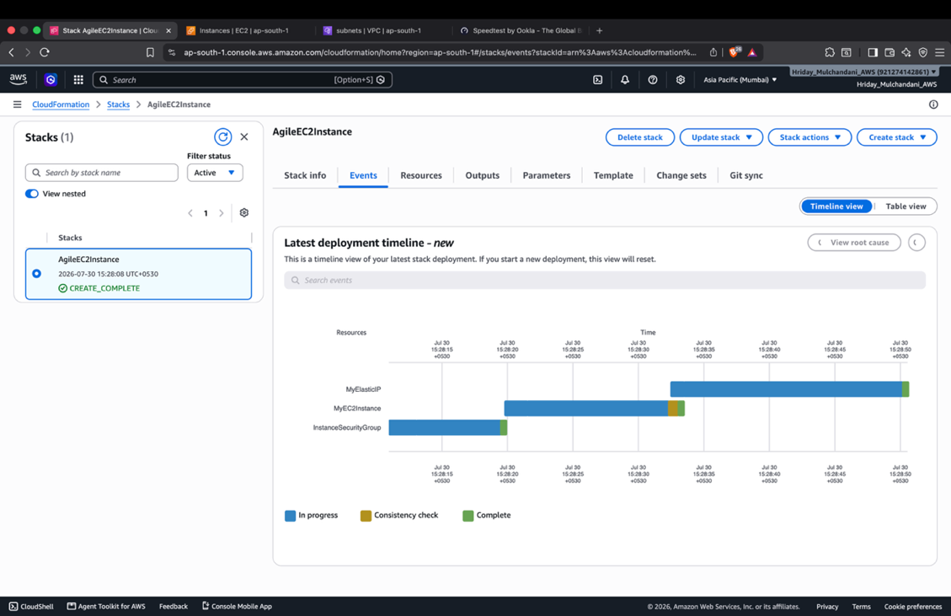

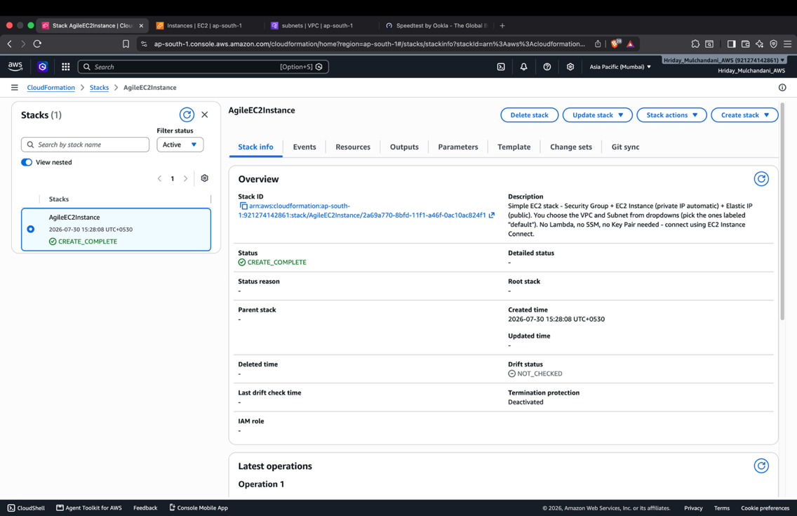

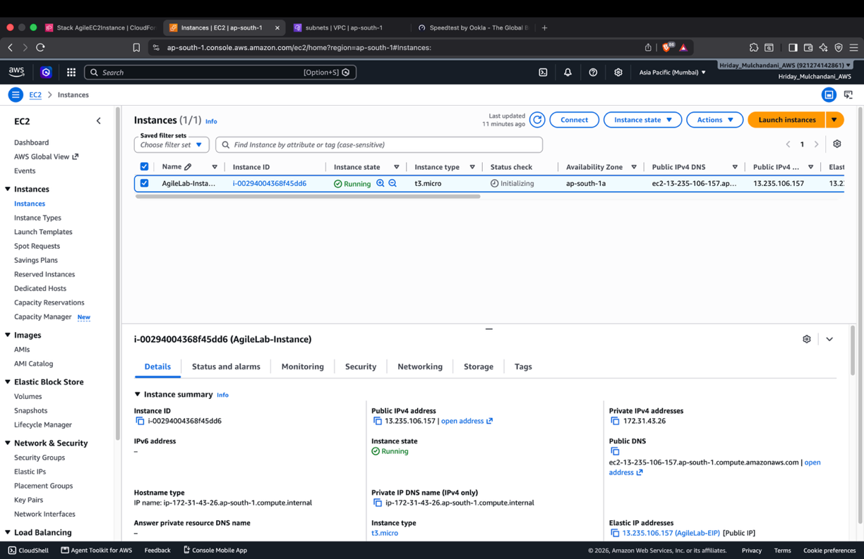

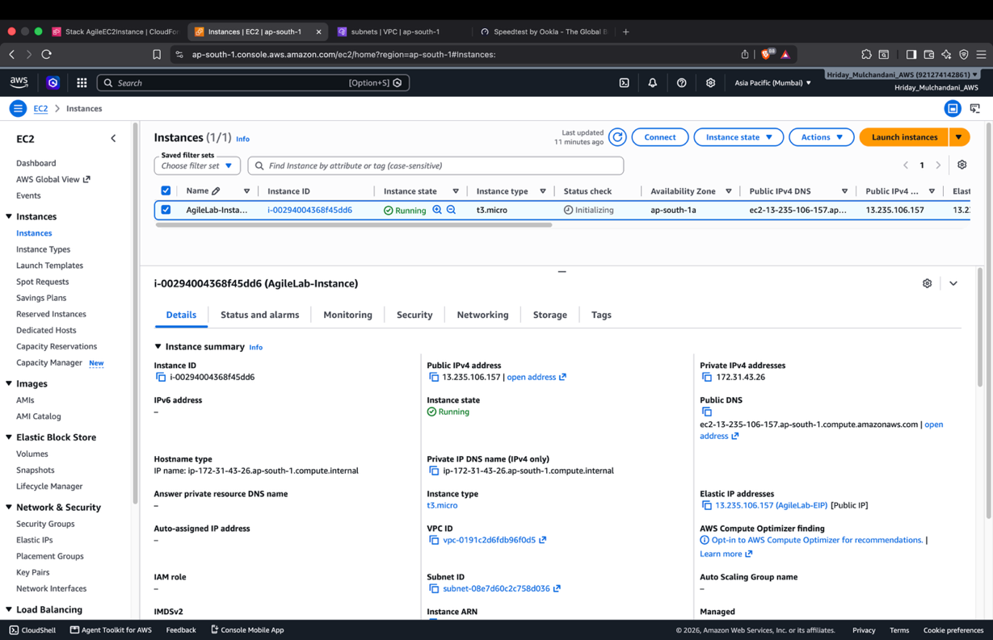

Lab 4
Aim:
JIRA Project Management tool

Theory:
1. Introduction to JIRA
JIRA is a project management and issue tracking tool developed by Atlassian. It is widely used in Agile software development to plan projects, assign tasks, track progress, and manage bugs. JIRA supports Scrum, Kanban, sprint planning, backlog management, and project reporting.
2. Features of JIRA
- Project Management: Organizes and manages software projects.
- Issue Tracking: Tracks tasks, bugs, and user stories.
- Scrum Board: Displays task progress visually.
- Sprint Planning: Helps plan work for a fixed development period.
- Backlog Management: Maintains a list of pending work.
- Reports: Provides burndown charts, velocity reports, and sprint reports.
- Collaboration: Allows team members to assign tasks and monitor progress.
3. Important JIRA Concepts
- Project: A collection of related tasks and activities.
- Epic: A large feature divided into smaller user stories.
- User Story: A requirement describing what a user wants from the system.
- Task: A specific activity assigned to a team member.
- Bug: An error or defect in the software.
- Sprint: A fixed development period, usually 1 to 4 weeks.
- Backlog: A prioritized list of pending work.
- Scrum Board: A visual board used to track task progress.
- Assignee: The person responsible for completing a task.
- Issue: A general work item in JIRA, such as a task, bug, or story.
4. Practical Tasks Performed
Task 1: Create a JIRA Account
Created a JIRA account using an email address and logged into the platform.

Task 2: Create a Scrum Project
Created a team managed Scrum project with the following details:
Project Name: Student Management System
Project Key: SMS

Task 3: Create an Epic
Created an Epic named Student Registration Module to manage student registration functionality.

Task 4: Create User Stories
Created four user stories:
- US1: Student registration into the portal.
- US2: Admin verification of student details.
- US3: Secure student login.
- US4: Student profile updates.

Task 5: Create Tasks
Created and assigned four development tasks:
- Design Registration Page
- Create Database
- Develop Login Page
- Test Registration
All tasks were assigned to ourselves.
Task 6: Create Bugs
Created two bugs to track software defects:
- BUG1: Login button not working.
- BUG2: Registration page crashes on empty input.

Task 7: Create Sprint
Created Sprint 1 with a duration of 2 weeks and moved the user stories from the backlog into the sprint.

Task 8: Start Sprint
Started Sprint 1 to begin working on the selected user stories and tasks.

Task 9: Update Task Status
Updated task progress using the Scrum Board.
The workflow followed was:
To Do → In Progress → Testing → Done

Task 10: Generate Reports
Observed the following reports to monitor project progress:
- Sprint Report: Shows completed and incomplete sprint work.
- Burndown Chart: Shows remaining work during a sprint.
- Velocity Report: Shows the amount of work completed across sprints.
- Backlog View: Displays pending tasks and user stories.

5. Backlog vs Sprint
Backlog:
- Contains all pending project work.
- Includes Epics, User Stories, Tasks, and Bugs.
- Managed and prioritized by the Product Owner.
- Continuously updated throughout the project.
Sprint:
- Contains selected work from the backlog.
- Has a fixed duration, usually 1 to 4 weeks.
- Executed by the Scrum Team.
- Focuses on completing planned work.

6. JIRA Workflow
The general workflow followed in JIRA is:
- Identify project requirements.
- Create Epics and User Stories.
- Create Tasks and Bugs.
- Add work items to the Product Backlog.
- Plan and start a Sprint.
- Track progress using the Scrum Board.
- Review completed sprint work.
- Generate reports to monitor progress.

Output:
Task – 1
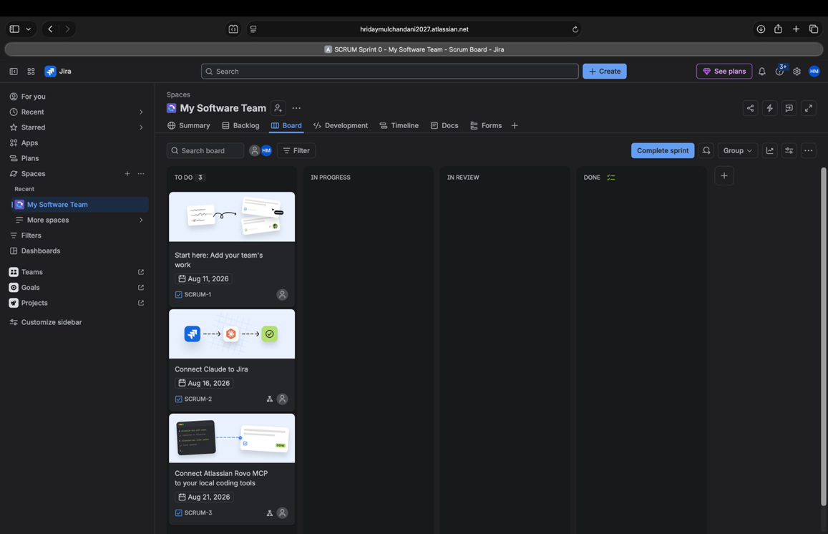

Task – 2
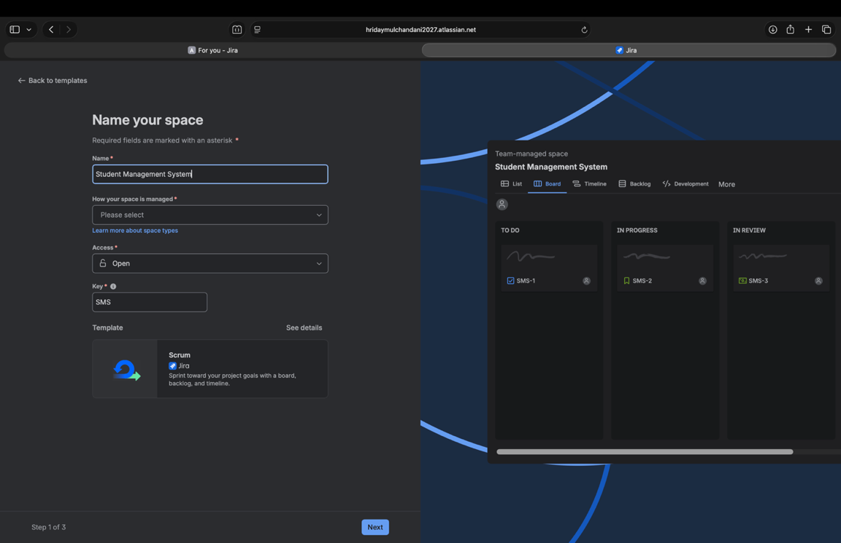
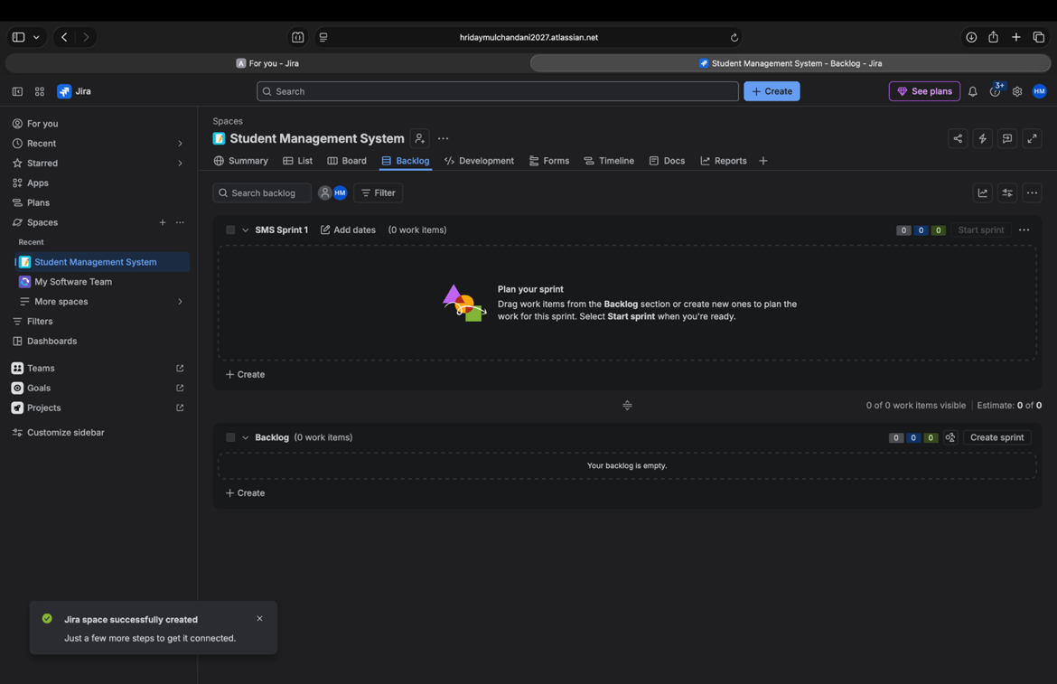

Task – 3
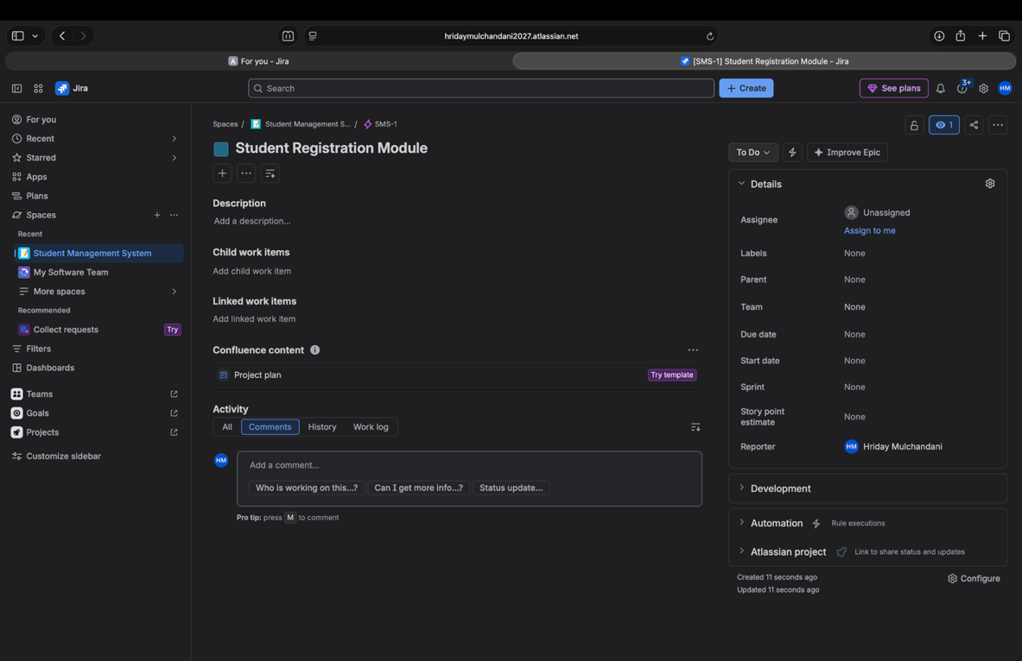

Task – 4
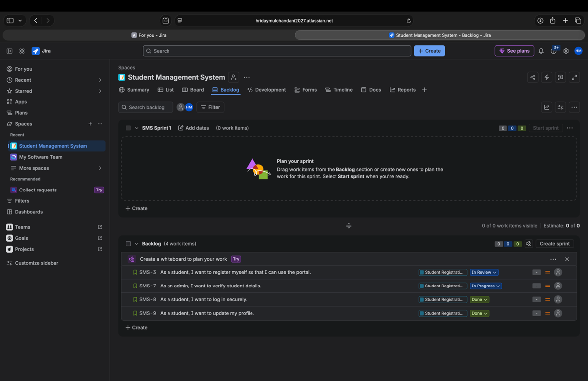

Task – 5
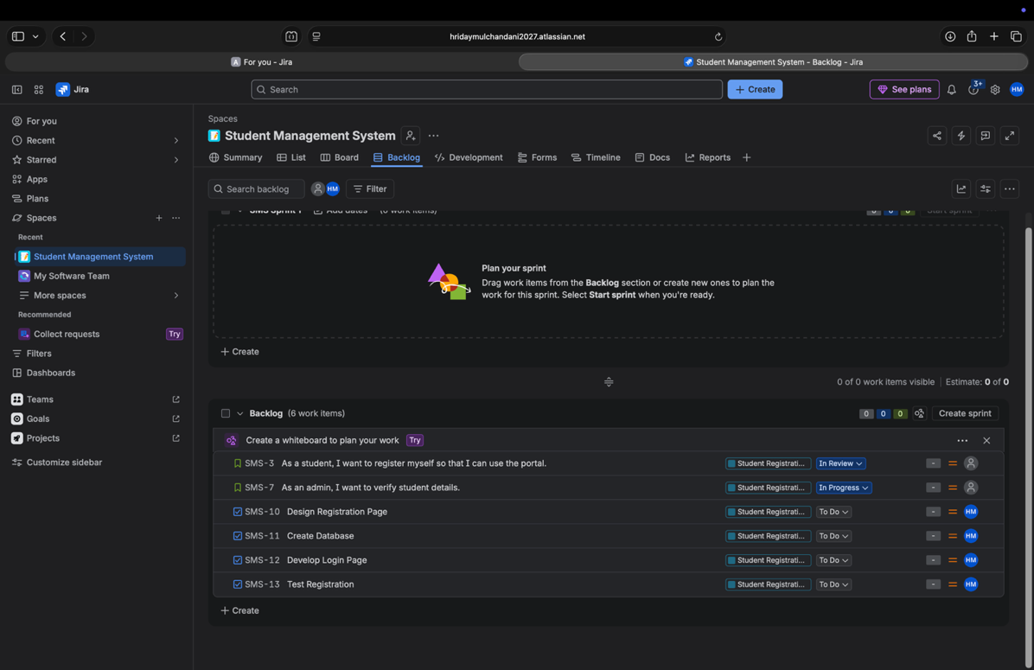

Task – 6
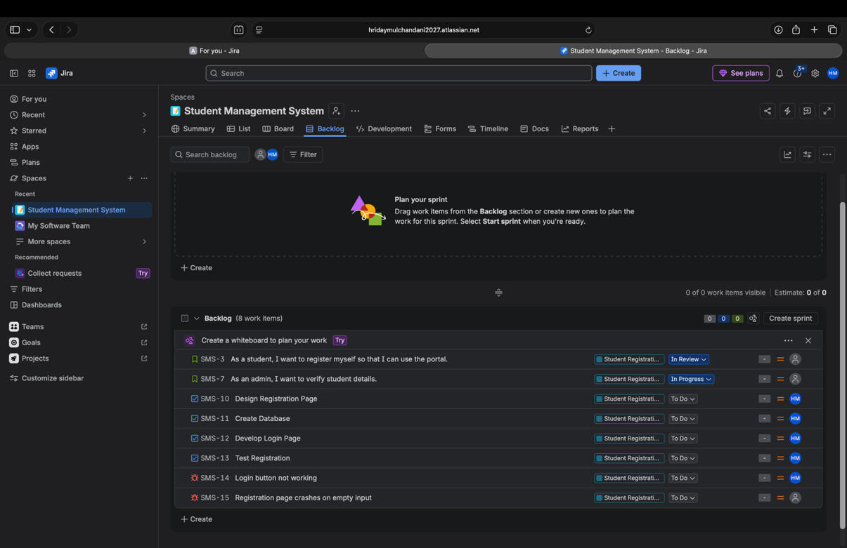

Task – 7
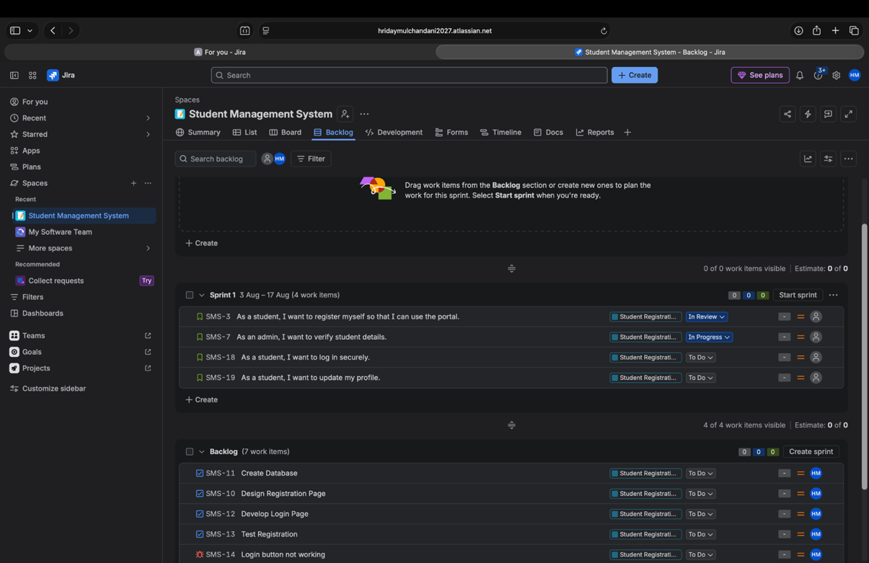

Task – 8
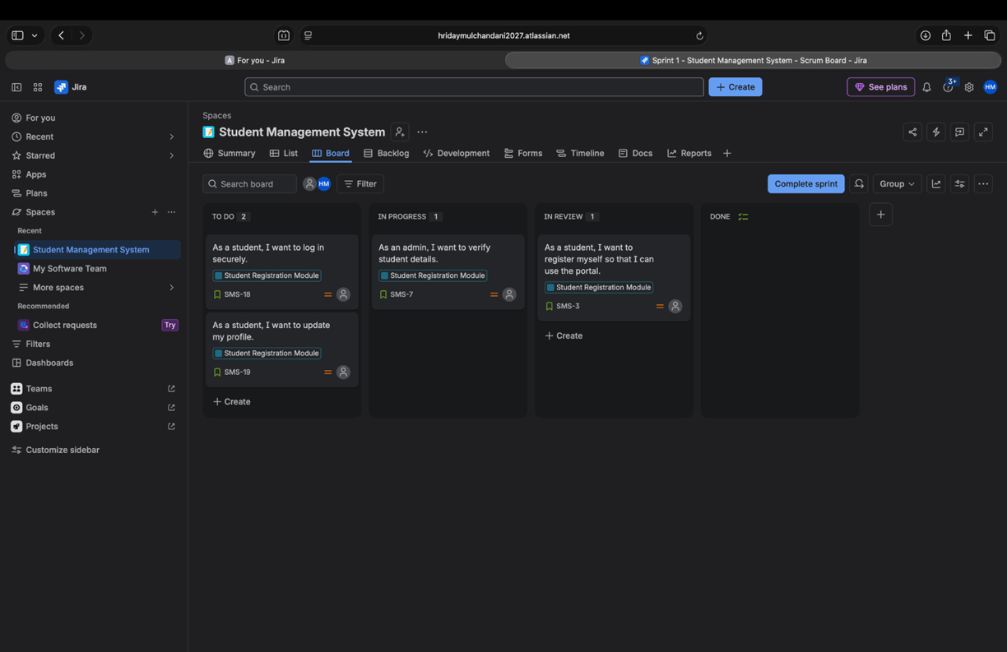

Task – 9
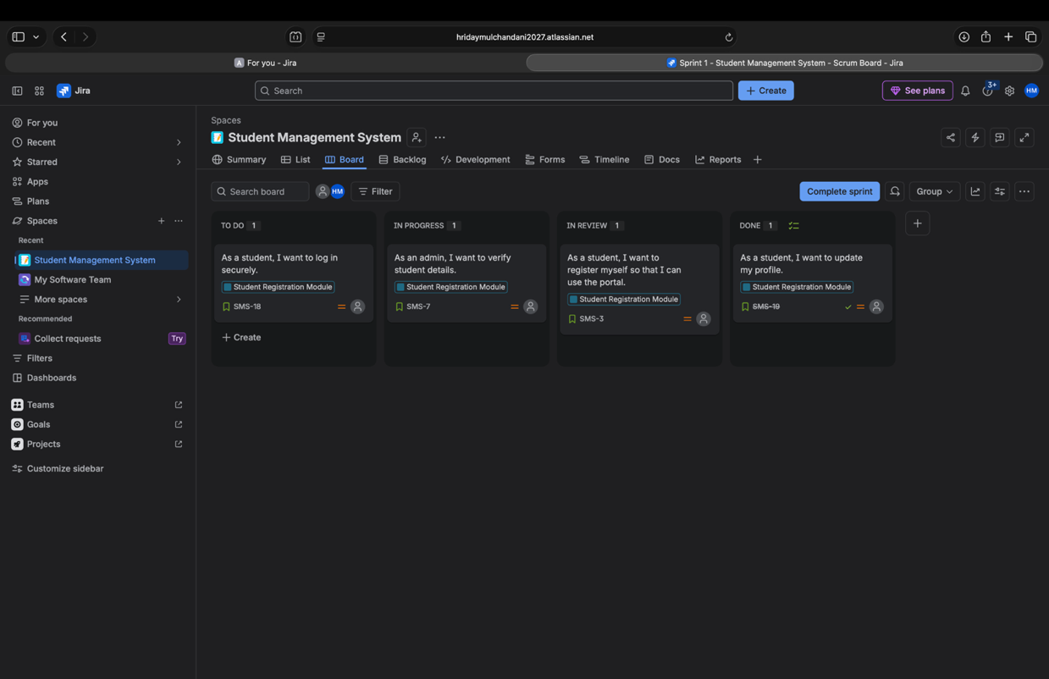

Task – 10
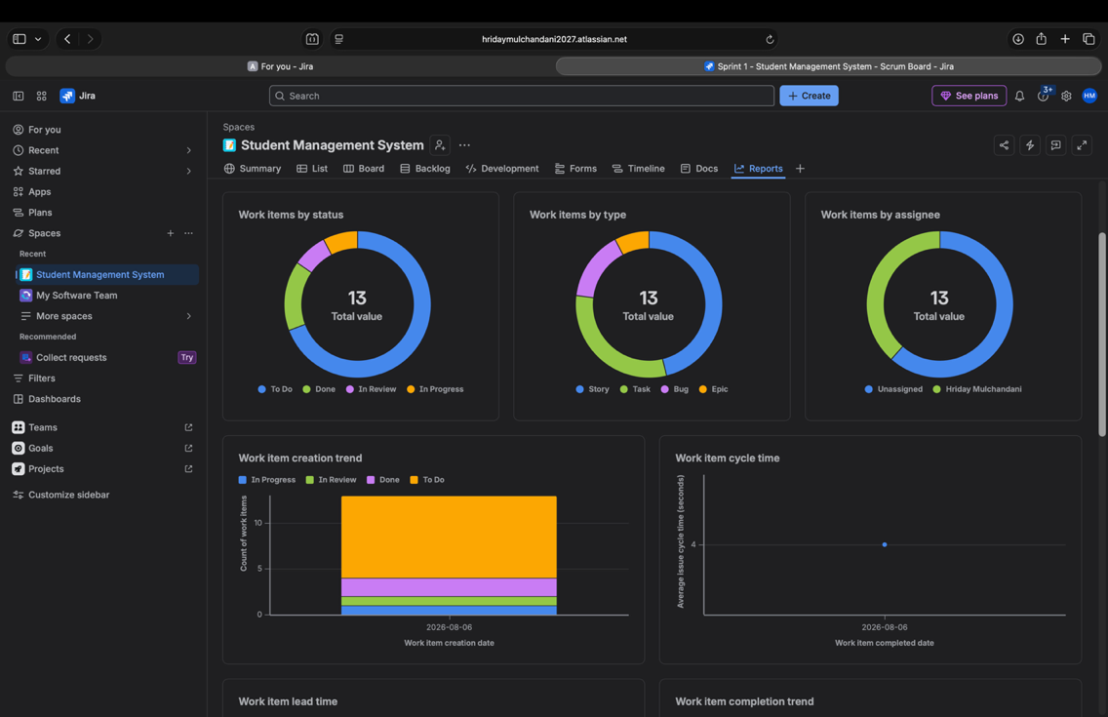

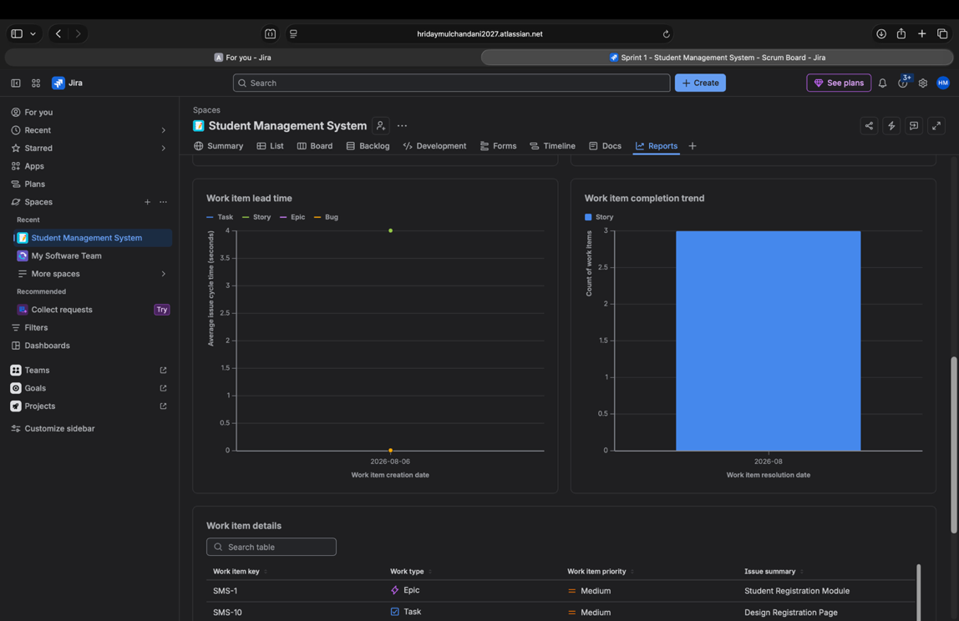
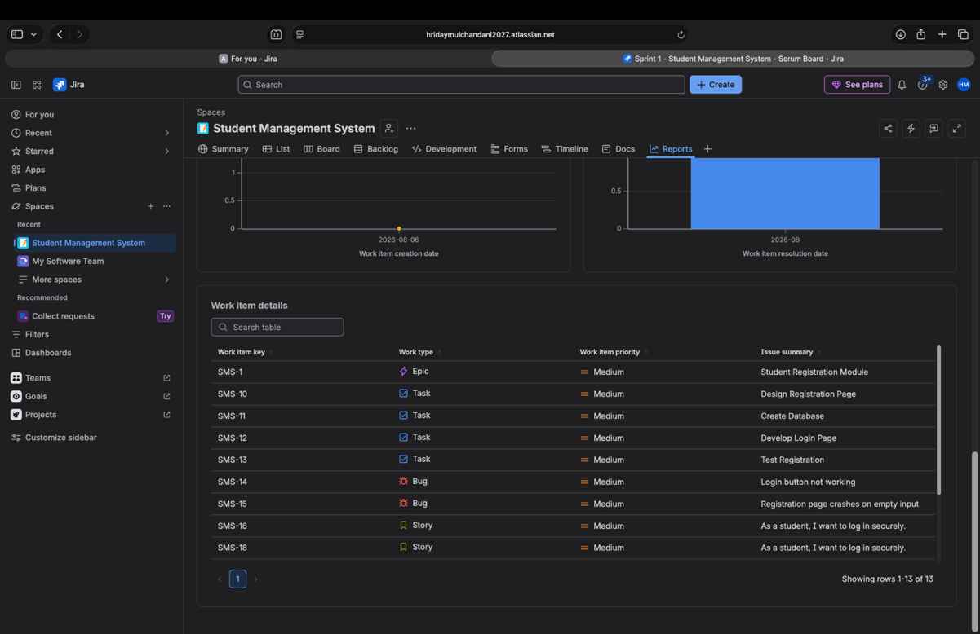
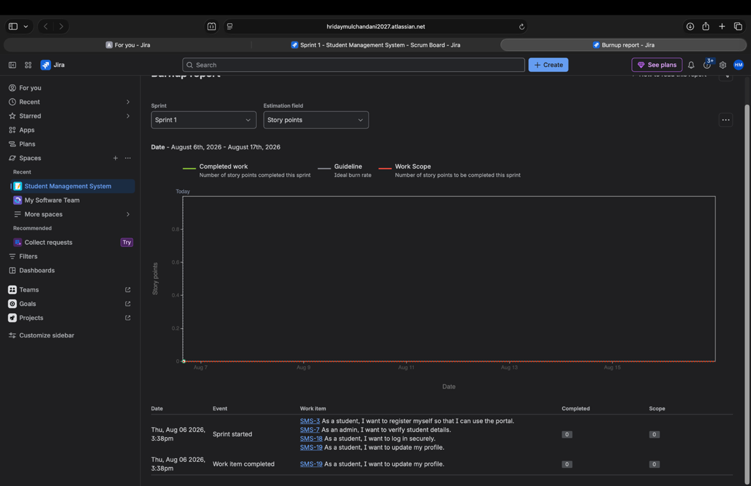

Lab 5 and 6
Aim:
GitHub Actions and GitHub Actions Workflows

Theory:
1. Introduction to GitHub Actions
GitHub Actions is an automation tool provided by GitHub that allows developers to automate software development tasks such as building, testing, and deploying applications. It is mainly used to implement Continuous Integration and Continuous Deployment (CI/CD) directly within GitHub repositories.

2. Features of GitHub Actions
- Automation: Automatically executes tasks when specific events occur.
- CI/CD: Automates building, testing, and deployment of applications.
- Event Based Execution: Triggers workflows when code is pushed or pull requests are created.
- Multiple Platforms: Supports Linux, Windows, and macOS.
- Integration: Works with GitHub repositories and external services.
- Monitoring: Provides logs and execution status of workflows.

3. Introduction to GitHub Actions Workflows
A GitHub Actions Workflow is an automated process consisting of one or more jobs. It is defined using a YAML file stored inside the .github/workflows directory of a repository.
Workflows are triggered by events such as pushing code, creating pull requests, or manual execution.

4. Important Components of GitHub Actions
- Workflow: An automated process containing one or more jobs.
- Event: An activity that triggers a workflow, such as push or pull request.
- Job: A collection of steps executed on the same runner.
- Step: An individual task within a job, such as installing dependencies or running tests.
- Action: A reusable component that performs a specific task within a workflow.
- Runner: A machine that executes workflow jobs. It can run on Linux, Windows, or macOS.
- YAML File: A configuration file used to define workflows, jobs, steps, and triggers.
- Secrets: Securely stored sensitive values, such as API keys and authentication tokens, used by workflows.

5. Continuous Integration and Continuous Deployment
Continuous Integration (CI):
CI is the practice of frequently merging code changes into a shared repository. Automated builds and tests are performed to detect errors early.
Continuous Deployment (CD):
Continuous Deployment automatically releases tested code to production without manual approval.
Advantages of CI/CD:
- Reduces manual work.
- Detects errors early.
- Improves software quality.
- Speeds up application delivery.
- Provides consistent build and deployment processes.

6. GitHub Actions Workflow Triggers
Workflows can execute automatically or manually based on specific events.
- Push: Runs when code is pushed to a repository.
- Pull Request: Runs when pull request activities occur.
- Workflow Dispatch: Allows manual execution of a workflow.
- Schedule: Executes workflows at specified times.
- Release: Runs when specified release events occur.

7. GitHub Actions Workflow Execution
The general workflow execution process is:
- Developer pushes code to a GitHub repository.
- GitHub detects the configured event.
- The workflow is automatically triggered.
- A runner is assigned to execute the job.
- Dependencies are installed and the application is built.
- Automated tests are executed.
- The application may be deployed if configured.
- Execution results and logs are displayed in GitHub Actions.

8. Practical Tasks
Task 1: Create a GitHub Repository
Create a new GitHub repository to store the application code and workflow files.

Task 2: Create a Workflow File
Create a YAML workflow file inside the .github/workflows directory to define automation instructions.

Task 3: Configure Workflow Triggers
Configure events such as push or pull request to automatically execute the workflow.

Task 4: Define Jobs and Steps
Specify jobs containing steps such as checking out code, installing dependencies, building the application, and running tests.

Task 5: Execute the Workflow
Push the workflow file to GitHub to trigger automatic execution.

Task 6: Monitor Workflow Execution
Open the Actions tab in GitHub to view running, successful, or failed workflows.

Task 7: Verify Workflow Results
Check execution logs and confirm whether the build and testing processes completed successfully.

9. Advantages of GitHub Actions
- Provides built in automation within GitHub.
- Reduces repetitive development tasks.
- Supports automated testing and deployment.
- Helps identify errors before deployment.
- Supports reusable workflows and actions.
- Improves development speed and collaboration.

Source Code:
name: Calculator CI

on:
push:
branches: [main]
pull_request:
branches: [main]

jobs:
build:
runs-on: ubuntu-latest
steps:
- name: Checkout code
uses: actions/checkout@v4

- name: Set up JDK
uses: actions/setup-java@v4
with:
distribution: temurin
java-version: '17'

- name: Compile
run: javac Calculator.java

- name: Upload compiled class
uses: actions/upload-artifact@v4
with:
name: calculator-class
path: Calculator.class
retention-days: 1

test:
needs: build
runs-on: ubuntu-latest
strategy:
fail-fast: false
matrix:
case:
- { name: "addition", a: "3", op: "+", b: "4", expected: "7", expect_failure: false }
- { name: "negative-operand", a: "-5", op: "+", b: "3", expected: "-2", expect_failure: false }
- { name: "subtraction", a: "10", op: "-", b: "4", expected: "6", expect_failure: false }
- { name: "multiplication", a: "6", op: "*", b: "7", expected: "42", expect_failure: false }
- { name: "division", a: "10", op: "/", b: "2", expected: "5", expect_failure: false }
- { name: "division-decimal", a: "7", op: "/", b: "2", expected: "3.5", expect_failure: false }
- { name: "divide-by-zero", a: "5", op: "/", b: "0", expected: "", expect_failure: true }
- { name: "invalid-operator", a: "5", op: "%", b: "2", expected: "", expect_failure: true }
- { name: "non-numeric-operand", a: "abc", op: "+", b: "2", expected: "", expect_failure: true }
steps:
- name: Set up JDK
uses: actions/setup-java@v4
with:
distribution: temurin
java-version: '17'
- name: Download compiled class
uses: actions/download-artifact@v4
with:
name: calculator-class

- name: "Run case: ${{ matrix.case.name }}"
env:
A: ${{ matrix.case.a }}
OP: ${{ matrix.case.op }}
B: ${{ matrix.case.b }}
EXPECTED: ${{ matrix.case.expected }}
EXPECT_FAILURE: ${{ matrix.case.expect_failure }}
run: |
set +e
actual=$(java Calculator "$A" "$OP" "$B" 2>&1)
exit_code=$?
set -e

if [ "$EXPECT_FAILURE" = "true" ]; then
if [ "$exit_code" -eq 0 ]; then
echo "FAIL: expected non-zero exit code, got 0 (output: $actual)"
exit 1
fi
echo "PASS: correctly failed with: $actual"
else
if [ "$exit_code" -ne 0 ]; then
echo "FAIL: expected success, got exit code $exit_code (output: $actual)"
exit 1
fi
if [ "$actual" != "$EXPECTED" ]; then
echo "FAIL: expected '$EXPECTED', got '$actual'"
exit 1
fi
echo "PASS: $A $OP $B = $actual"
fi

missing-args:
needs: build
runs-on: ubuntu-latest
steps:
- name: Set up JDK
uses: actions/setup-java@v4
with:
distribution: temurin
java-version: '17'

- name: Download compiled class
uses: actions/download-artifact@v4
with:
name: calculator-class

- name: Missing arguments should fail
run: |
if java Calculator 5 +; then
echo "FAIL: expected non-zero exit code for missing argument"
exit 1
fi
echo "PASS: missing argument correctly rejected"

all-tests-passed:
needs: [test, missing-args]
if: always()
runs-on: ubuntu-latest
steps:
- name: Check status of all test jobs
run: |
if [ "${{ needs.test.result }}" != "success" ] || [ "${{ needs.missing-args.result }}" != "success" ]; then
echo "One or more test jobs failed."
exit 1
fi
echo "All test jobs passed."

Output:
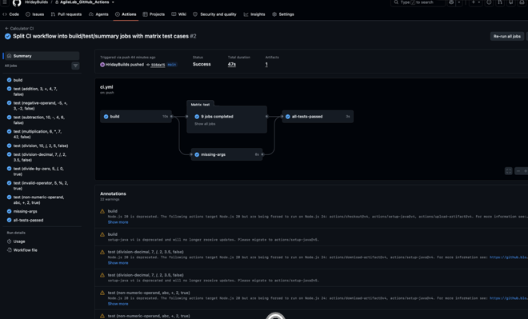

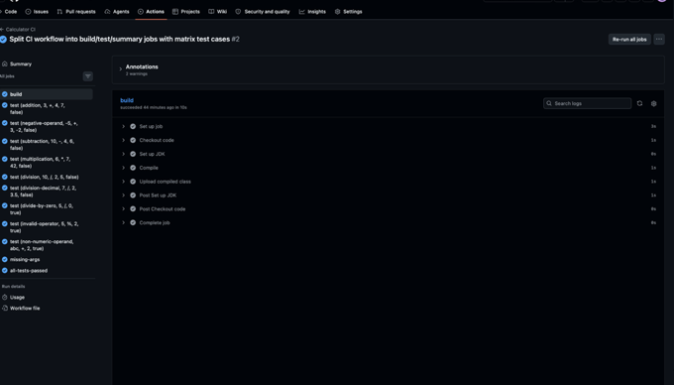

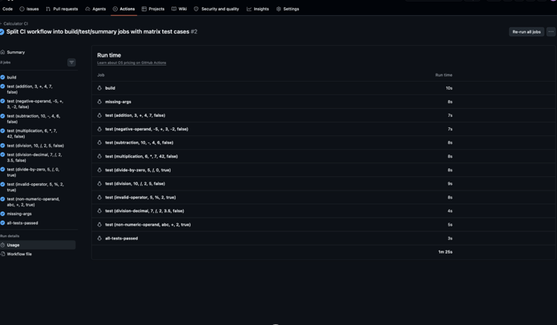

Lab 7 and 8
Aim:
Introduction to Docker & Docker Installation & Docker Commands & Dockerfile

Theory:
1. Introduction to Docker
Docker is a containerization platform used to package applications along with their dependencies into isolated environments called containers. It allows applications to run consistently across different computers, servers, and cloud environments.

2. Features of Docker
- Portability: Applications can run on different systems without major changes.
- Isolation: Containers run independently without interfering with each other.
- Consistency: Provides the same application environment across different machines.
- Fast Deployment: Containers can start quickly compared to virtual machines.
- Easy Management: Simplifies application deployment and maintenance.

3. Important Docker Concepts
- Docker Image: A packaged template containing an application and its required dependencies.
- Docker Container: An instance created from a Docker image that can execute an application.
- Dockerfile: A file containing instructions to build a Docker image.
- Docker Hub: An online platform used to store, share, and download Docker images.
- Containerization: The process of packaging applications and dependencies into isolated containers.
4. Difference Between Docker Image and Container
Docker Image:
- Acts as a blueprint for creating containers.
- Contains application code and dependencies.
- Used to create multiple containers.
Docker Container:
- Created from a Docker image.
- Provides an isolated environment for applications.
- Can be started, stopped, and removed.

5. Important Docker Commands
  - docker pull mysql: Downloads the MySQL image from Docker Hub.
  - docker run mysql: Creates and starts a container using the MySQL image.
  - docker rm <container_id>: Removes a stopped container without deleting its image.
  - docker exec -it MYSQL /bin/bash: Opens an interactive Bash terminal inside a running container named MYSQL.
  - docker inspect <container>: Displays detailed information about a container, including its configuration, network, IP address, and status.
  - docker build -t image_name .: Builds a Docker image using the Dockerfile in the current directory.
  - docker push image_name: Uploads a Docker image to Docker Hub.
  - docker images: Displays all locally available Docker images.
  - docker ps: Lists currently running containers.
  - docker ps -a: Lists all containers, including stopped containers.
  - docker stop <container>: Stops a running container.
  - docker start <container>: Starts an existing stopped container.
  - docker rmi <image>: Removes a Docker image.
  - docker login: Authenticates the user with Docker Hub.
  - exit: Exits the interactive terminal inside a container.

6. Important Dockerfile Instructions
1. FROM: Specifies the base image used to build the Docker image.
2. COPY: Copies application files into the Docker image.
3. CMD: Specifies the default command executed when the container starts.

7. Practical Tasks Performed
Task 1: Create a Project Folder
Created a folder named test to store the Python application and Dockerfile.

Task 2: Create a Python Program
Created a Python file named my_script.py containing a simple program to display "Hello from Docker!".

Task 3: Create a Dockerfile
Created a Dockerfile using Python 3.11 as the base image, copied the Python program, and specified the command to execute it.

Task 4: Build Docker Image
Built a Docker image using the Dockerfile and assigned it the name naitik002/python_file.

Task 5: Run Docker Container
Created and started a container using the built image.
The container executed the Python program and displayed "Hello from Docker!".

Task 6: Push Image to Docker Hub
Uploaded the created Docker image to Docker Hub for storage and sharing.

8. Docker Workflow
The general Docker workflow is:
- Create an application.
- Write a Dockerfile.
- Build a Docker image.
- Run a container using the image.
- Verify the application output.
- Push the image to Docker Hub.
Dockerfile → Build → Image → Run → Container

9. Advantages of Docker
- Simplifies application deployment.
- Reduces environment compatibility issues.
- Provides lightweight application isolation.
- Supports easy application sharing.
- Improves development and testing efficiency.

Source Code:
Dockerfile
FROM python:3.11
COPY my_script.py .
CMD ["python", "my_script.py"]

Output:
Task-1
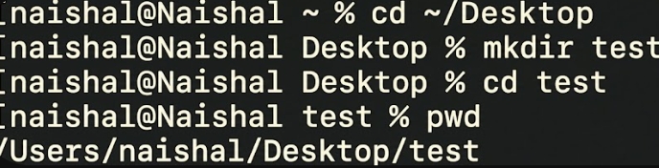

Task-2
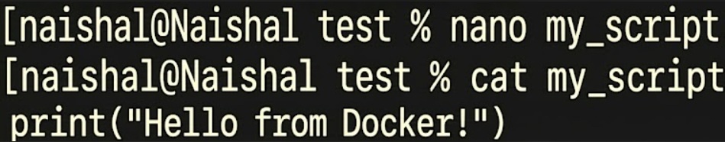

Task-3
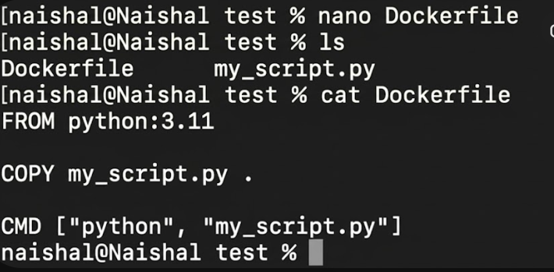

Task-4
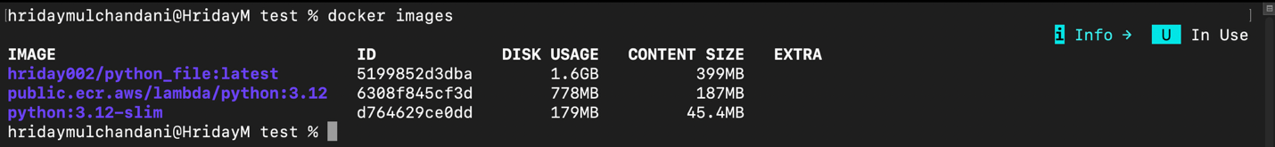
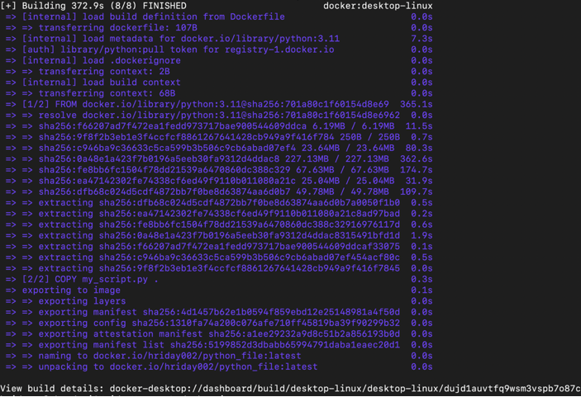

Task-5
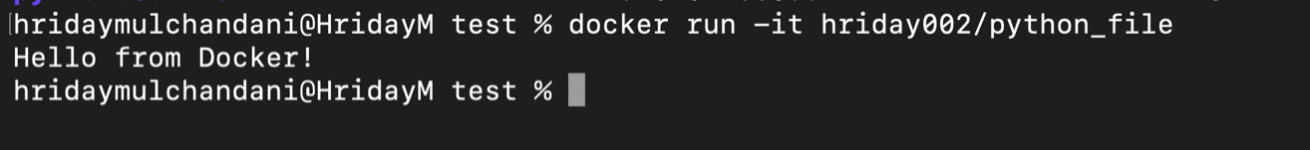

Task-6
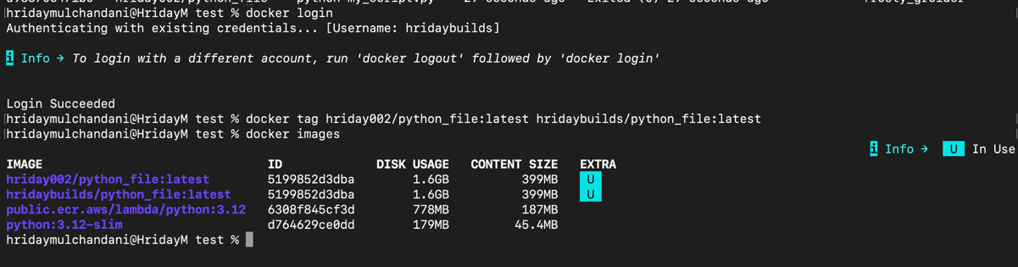
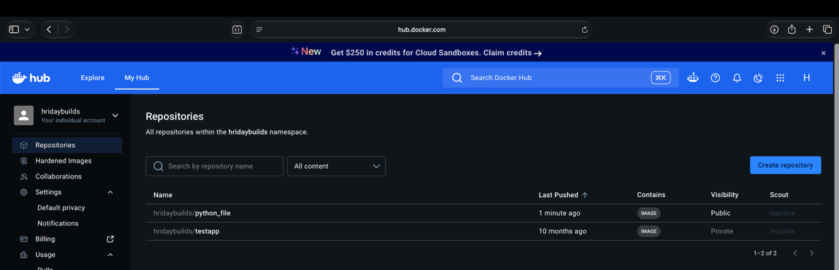

Lab 9 and 10
Aim:
Testing using PyTest

Theory:
1. Introduction to PyTest
PyTest is a Python testing framework used to write and execute automated test cases. It helps developers verify code correctness, identify errors, and improve software reliability.
PyTest automatically detects test files and functions whose names begin with test_.

2. Features of PyTest
- Automatic Test Discovery: Automatically identifies and executes test functions.
- Simple Testing: Uses the assert statement to verify expected results.
- Substring Matching: Executes selected tests based on keywords in their names.
- Markers: Groups tests into categories for selective execution.
- Fixtures: Provides reusable setup data and resources for tests.
- Test Reports: Displays passed, failed, and skipped test cases.
- CI Integration: Supports automated testing in CI pipelines.

3. Important PyTest Concepts
- Test Case: A function that checks whether a particular part of the program works correctly.
- Assertion: A statement used to verify a condition. If the condition is false, the test fails.
- Test Discovery: PyTest automatically identifies files and functions following the test_ naming convention.
- Marker: A label assigned to test functions to organize and execute specific groups of tests.
- Fixture: A reusable function that provides required data or resources before test execution.
- Parameterization: Allows the same test to execute multiple times with different input values.

4. Practical Tasks Performed
Task 1: Basic Tests
Created a directory named pytest_demo and a test file named test_sample.py.
Three basic test functions were created:
- test_greater() checks whether 100 is greater than 50.
- test_greater_equal() checks whether 100 is greater than or equal to 100.
- test_less() checks whether 100 is less than 200.
Command: pytest -v
This command executes all discovered tests and displays detailed results.

Task 2: Substring Matching
Substring matching allows developers to execute only those tests whose names contain a specific keyword.
Command: pytest -k great -v
This command executes the tests test_greater() and test_greater_equal() because their names contain the substring great.
It helps save time by running only relevant test cases.

Task 3: Grouping Tests Using Markers
Markers are used to categorize test functions into different groups.
Custom markers can be created using @pytest.mark.<markername>.
Command: pytest -m great -v
This command executes only the tests assigned the great marker.
Important Markers:
- skip: Skips the execution of a test.
- xfail: Marks a test as expected to fail.
- parametrize: Runs the same test with multiple input values.

Task 4: Fixtures
Fixtures provide reusable data or setup operations required by test functions.
Created a file named test_fixture.py containing a fixture named input_value, which returns the value 10.
The test function test_addition() uses this value to verify that adding 5 produces 15.
Command: pytest test_fixture.py -v
This command executes the fixture based test and displays its result.

5. Important PyTest Commands
- pytest: Executes all discovered test cases.
- pytest -v: Executes tests with detailed output.
- pytest -k great -v: Runs tests containing the keyword great.
- pytest -m great -v: Runs tests assigned the great marker.
- pytest test_fixture.py -v: Executes tests from a specific file.

6. Advantages of PyTest
- Simplifies automated testing in Python.
- Reduces repetitive testing code.
- Supports selective test execution.
- Improves code reliability and debugging.
- Provides clear and detailed test results.
- Supports integration with CI pipelines.

Source Code:
test_task1_basic.py
def test_greater():
num = 100
assert num > 50

def test_greater_equal():
num = 100
assert num >= 100

def test_less():
num = 100
assert num < 200

test_task2_substring.py
def test_greater():
num = 100
assert num > 50
def test_greater_equal():
num = 100
assert num >= 100

def test_less():
num = 100
assert num < 200

test_task3_markers.py
import pytest

@pytest.mark.great
def test_greater():
assert 100 > 50

@pytest.mark.great
def test_greater_equal():
assert 100 >= 100

@pytest.mark.less
def test_less():
assert 100 < 200

test_task4_fixture.py
import pytest

@pytest.fixture
def input_value():
return 10

def test_addition(input_value):
assert input_value + 5 == 15

Output:
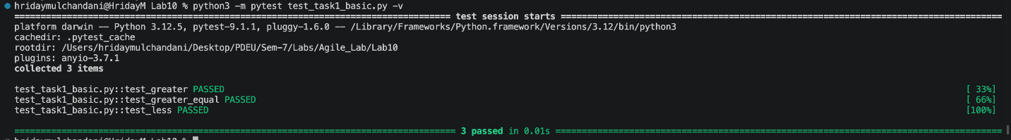
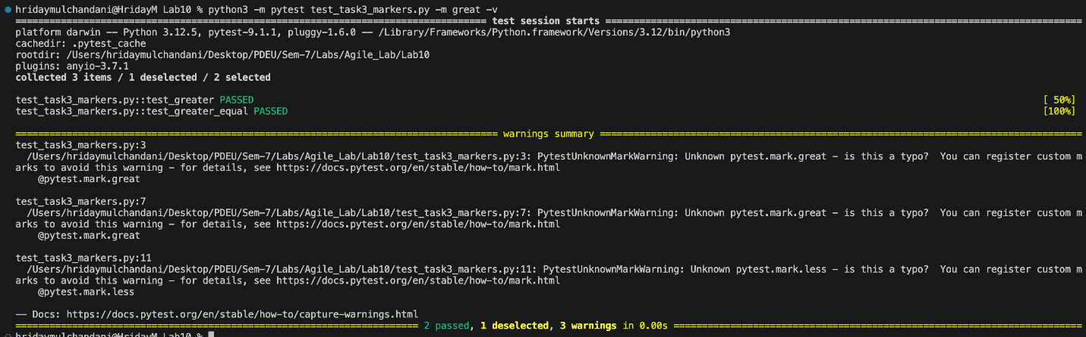
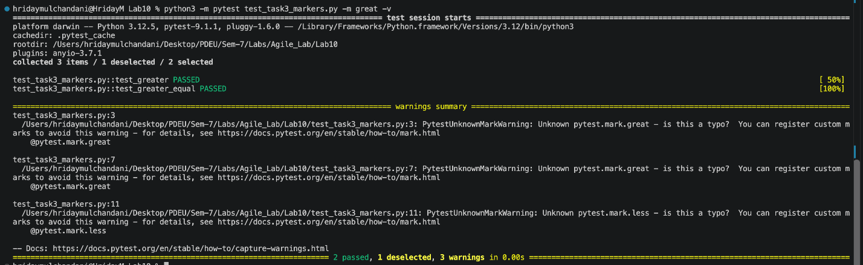
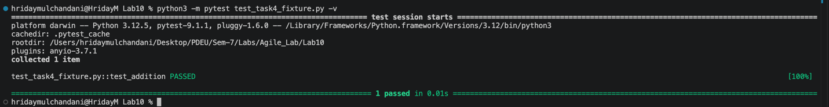

Lab 11
Aim:
Selenium tool

Theory:
1. Introduction to Selenium
Selenium is an open source web automation tool used to automate browser operations. It supports programming languages such as Python, Java, and C# and works with browsers like Chrome, Firefox, and Edge. Selenium is commonly used for automated web testing, browser interaction, and web scraping.

2. Features of Selenium
- Browser Automation: Automates actions such as opening websites, clicking buttons, and entering text.
- Multiple Browsers: Supports Chrome, Firefox, and Edge.
- Multiple Languages: Supports Python, Java, C#, and other languages.
- Web Element Interaction: Allows interaction with buttons, forms, and text fields.
- Screenshot Capture: Saves screenshots of webpages.
- Automated Testing: Reduces manual testing efforts.

3. Important Selenium Concepts
- Selenium WebDriver: A tool that controls web browsers through programming instructions.
- Web Element: An HTML component such as a button, textbox, or link present on a webpage.
- Locator: A method used to identify and access specific web elements.
- Browser Automation: Performing browser operations automatically using scripts.
- Web Testing: Checking whether website features work correctly through automated interactions.

4. Important Selenium Functions
- driver.get(url): Opens the specified webpage in the browser.
- driver.find_element(): Locates a particular element on a webpage.
- send_keys(): Enters text into input fields or sends keyboard inputs.
- click(): Performs a click action on a web element.
- driver.maximize_window(): Maximizes the browser window.
- driver.save_screenshot(): Captures and saves a screenshot of the webpage.
- driver.quit(): Closes the browser and ends the WebDriver session.

5. Methods to Locate Web Elements
- ID: Identifies an element using its unique ID.
- Name: Locates an element using its name attribute.
- Class Name: Identifies elements using their HTML class.
- XPath: Locates elements using their position or structure in the HTML document.
- CSS Selector: Identifies elements using CSS selection rules.

6. Practical Tasks Performed
Task 1: Create a Selenium Project
Created a project folder named selenium_demo and a Python file named test_selenium.py.

Task 2: Launch Web Browser
Imported Selenium WebDriver and launched the Google Chrome browser automatically.

Task 3: Open a Website
Used Selenium WebDriver to open the Google homepage and maximize the browser window.

Task 4: Locate Search Box
Located the Google search input field using the Name locator.

Task 5: Perform Search Operation
Entered the keyword "Selenium Python Tutorial" into the search box and pressed Enter to perform the search.

Task 6: Capture Screenshot
Captured and saved a screenshot of the search results page using the screenshot function.

Task 7: Close Browser
Closed the Chrome browser automatically after completing the operations.

7. Selenium Automation Workflow
- Import Selenium WebDriver.
- Launch the Chrome browser.
- Open the required website.
- Locate the desired web element.
- Enter text or perform an action.
- Capture the webpage screenshot.
- Close the browser.

8. Advantages of Selenium
- Reduces repetitive manual testing.
- Supports multiple browsers and programming languages.
- Automates website interactions.
- Improves testing speed and efficiency.
- Supports automated screenshot capture.
- Helps identify errors in web applications.

Source Code:

test_selenium.py
from selenium import webdriver
from selenium.webdriver.common.by import By
from selenium.webdriver.common.keys import Keys
import time

driver = webdriver.Chrome()
driver.get("https://www.google.com")
driver.maximize_window()

search_box = driver.find_element(By.NAME, "q")
search_box.send_keys("Selenium Python Tutorial")
search_box.send_keys(Keys.RETURN)

time.sleep(3)

driver.save_screenshot("google_search_result.png")

driver.quit()

test_youtube.py
from selenium import webdriver
from selenium.webdriver.common.by import By
from selenium.webdriver.common.keys import Keys
from selenium.webdriver.chrome.options import Options
from selenium.webdriver.support.ui import WebDriverWait
from selenium.webdriver.support import expected_conditions as EC
import time

options = Options()
options.add_experimental_option("detach", True)

driver = webdriver.Chrome(options=options)
driver.get("https://www.youtube.com")
driver.maximize_window()

wait = WebDriverWait(driver, 10)
search_box = wait.until(EC.element_to_be_clickable((By.NAME, "search_query")))

search_box.send_keys("today's news")
search_box.send_keys(Keys.RETURN)

wait.until(EC.presence_of_element_located((By.ID, "video-title")))
time.sleep(2)

driver.save_screenshot("youtube_todays_news.png")

print("Page title:", driver.title)
print("Current URL:", driver.current_url)

test_youtube_video.py
from selenium import webdriver
from selenium.webdriver.common.by import By
from selenium.webdriver.common.keys import Keys
from selenium.webdriver.chrome.options import Options
from selenium.webdriver.support.ui import WebDriverWait
from selenium.webdriver.support import expected_conditions as EC
import time

options = Options()
options.add_experimental_option("detach", True)
options.add_argument("--autoplay-policy=no-user-gesture-required")

driver = webdriver.Chrome(options=options)
driver.get("https://www.youtube.com")
driver.maximize_window()

wait = WebDriverWait(driver, 15)

search_box = wait.until(EC.element_to_be_clickable((By.NAME, "search_query")))
search_box.send_keys("today's news")
search_box.send_keys(Keys.RETURN)

first_video = wait.until(EC.element_to_be_clickable(
(By.CSS_SELECTOR, "ytd-video-renderer a#video-title")))
print("Opening video:", first_video.get_attribute("title"))
first_video.click()

wait.until(EC.presence_of_element_located((By.CSS_SELECTOR, "video")))
time.sleep(5)

try:
skip_button = WebDriverWait(driver, 6).until(EC.element_to_be_clickable(
(By.CSS_SELECTOR, ".ytp-skip-ad-button, .ytp-ad-skip-button")))
skip_button.click()
time.sleep(2)
print("Ad skipped")
except Exception:
print("No skippable ad found")

driver.execute_script("""
var player = document.getElementById('movie_player');
player.unMute();
player.setVolume(100);
player.setPlaybackRate(2);

var video = document.querySelector('video');
video.muted = false;
video.volume = 1.0;
video.playbackRate = 2;
""")

time.sleep(2)

speed = driver.execute_script("return document.querySelector('video').playbackRate;")
volume = driver.execute_script("return document.querySelector('video').volume;")
print("Playback speed:", speed)
print("Volume:", volume)

driver.save_screenshot("youtube_video_2x.png")
print("Page title:", driver.title)
print("Current URL:", driver.current_url)

Output:


