- INTRODUCTION

A web hosting service is a type of Internet hosting service that allows individuals and organizations to make their website accessible via the World Wide Web. Web hosts are companies that provide space on a server owned or leased for use by clients, as well as providing Internet connectivity, typically in a data center.
Web hosts can also provide data center space and connectivity to the Internet for other servers located in their data center, called colocation. The most basic is web page and small-scale file hosting, where files can be uploaded via File Transfer Protocol (FTP) or a Web interface.
The files are usually delivered to the Web "as is" or with minimal processing. Many Internet service providers (ISPs) offer this service free to subscribers. Individuals and organizations may also obtain Web page hosting from alternative service providers.
The Internet is such an intriguing and magical world of codes and scripts and programs. Even now, I’m still amazed at how a string of letters and numbers can do pretty much anything in the cyber world. The Internet is also a platform for different kinds of marketing strategies. If you have ever wished to build your own website in order to spread the word about your business but don’t want to spend time creating it (or money by hiring someone to do it), then itty.bitty is the tool for you.
With programming, online creativity knows no bounds. Every day, programmers across the Internet use their skills to create small projects for the public. Itty Bitty, a website created by former designer for Google and current vice President at Dropbox Nocholas Jitkoff, is one such small project. Using the Itty Bitty site, you can create a tiny HTML website for free even if you don’t have any web hosting.

Nicholas Jitkoff has created a really nifty new web tool he’s calling itty bitty sites, or self-contained microsites that exist solely as URLs. To make any website, we need a hosting provider to host the data of the website.
But this site is actually not hosted anywhere. It can hold as much data as a printable page has. You can create your own by following this URL: itty.bitty.site. From there, you can fill the equivalent of about one printed 8.5 x 11-inch page with any combination of plain text, ASCII characters, or emojis.

2. ABOUT ITTY BITTY SITE
Nicholas Jitkoff, made a great web tool, which he called, itty bitty site. It is a self-contained micro-site which is completely stored in its own URL only. To make any website, we need a hosting provider to host the data of the website. But this site is actually not hosted anywhere. It can hold as much data as a printable page has.

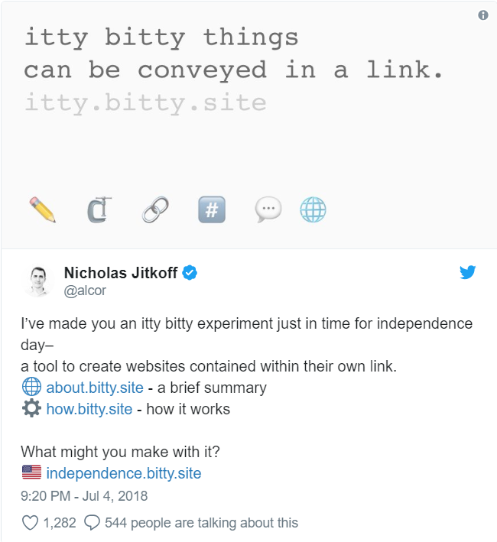

Itty Bitty creates a compressed link of HTML and other data which can be shared with others. When the URL is opened, the data is loaded on the receiver’s side. The most amazing thing about the microsites created from Itty Bitty is that the site is not hosted on any server making it entirely private.
A site made by it is...
💼 Portable - You don't need a server to host.
👁 Private - nothing is sent to–or stored on–this server
🎁 Easy to Share - as a link or QR code



2.1 THE ITTY BITTY SITE
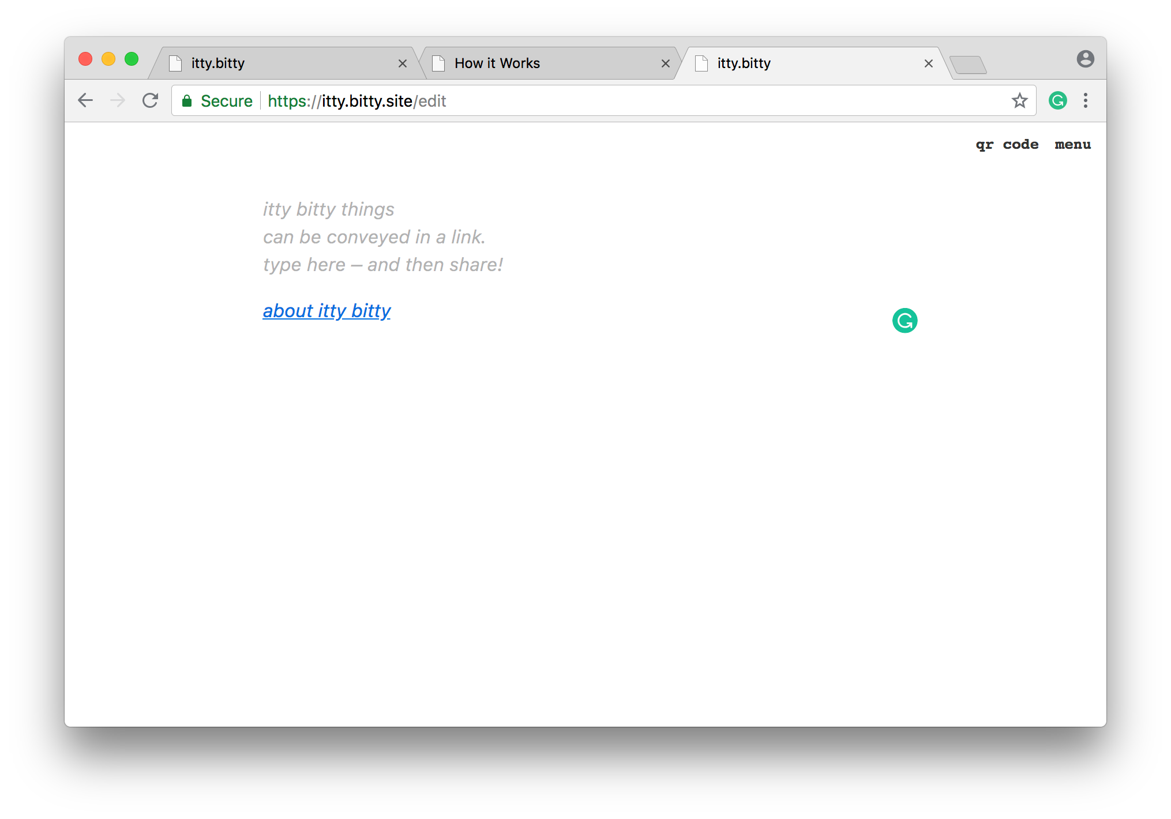
The site presents the size of your website to you at the top-right portion of the window. While sites can fluctuate in size, that also means your link will fluctuate in size as well. Some sites won’t allow you to share links larger than a few bytes, which can limit your ability to share bigger sites.

Here’s how it works: itty.bitty.site creates small sites by loading them through their URLs. In other words, your site is stored, and presented, within its link.
Because of this, websites created using Itty Bitty require absolutely no web hosting. The URL itself holds the entire data of the site: what it looks like, what it says, etc.
You’ll note that once you receive your Itty Bitty link, it’ll be a bit larger than usual. That’s your entire website.

3. WORKING OF ITTY BITTY
The actual site created by Itty Bitty has a very minimal interface. Keep in mind, every additional page on the site is created using the site itself.From this page, you can immediately begin using basic HTML for create a simple page.
If you want to create a more robust Itty Bitty site, you can either drag and drop an HTML document directly into the website or link an existing project directly into the prompt.
While your document or link may use other programming languages like CSS or JS, they’ll still be loaded with your Itty Bitty site. That said, the main benefit of using Itty Bitty (and the central reason it can be loaded from an address) is that your page has to be kept under a certain, small size.
Basically, the itty. the bitty tool takes HTML, or any other data, and compresses it into a URL fragment. It also provides a link that can be shared. When this link is opened, it inflates that data on the receiver’s side.
In terms of composing the microsite, you can edit directly on itty.bitty with simple formatting. For those who want something more complex, they can choose to utilize HTML files or Codepen. All of these data types are then compressed using the Lempel-Ziv-Markov chain algorithm.
“Fragments” are sections of the URL that stores basically everything after the first “#” symbol. It is usually used to identify a portion of that. fragments have a unique property in that they are not sent to the server when requesting a website. The web browser traditionally uses them to scroll the page when it is loaded.

4. CREATION OF LlINK
The site isn’t actually hosted anywhere — the entirety of the webpage exists as a URL compressed using what’s known as the Lempel–Ziv–Markov chain algorithm. In an explanation page for itty bitty sites — stored, of course, as an itty bitty site — Jitkoff says this allows for a “significant reduction in size for HTML, and allows for a printed page worth of content in many cases.” From there, the compressed content is converted from binary into a string of characters that can function as a standard web link. The actual data is stored in the end of the link, comprised of everything after the # symbol. You can also share itty bitty sites as QR codes as well, so long as the site can be compressed into about 2,610 bytes.

Minimum size for links in various app & Browsers
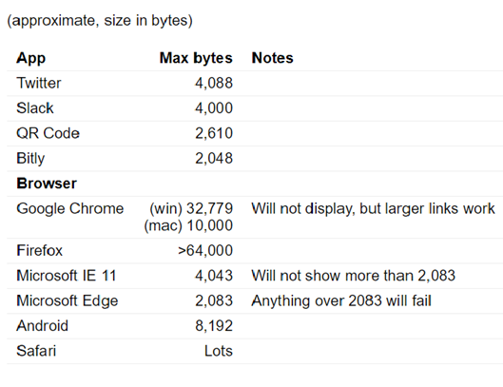

5. LEMPEL-ZIV-MARKOV-CHAIN-ALGORITHM
The Lempel–Ziv–Markov chain algorithm (LZMA) is an algorithm used to perform lossless data compression.
Lossless compression is a class of data compression algorithms that allows the original data to be perfectly reconstructed from the compressed data. By contrast, lossy compression permits reconstruction only of an approximation of the original data, though usually with improved compression rates (and therefore reduced file sizes).
Lossless data compression is used in many applications. For example, it is used in the ZIP file format and in the GNU tool gzip. It is also often used as a component within lossy data compression technologies (e.g. lossless mid/side joint stereo preprocessing by MP3 encoders and other lossy audio encoders).
Lossless compression is used in cases where it is important that the original and the decompressed data be identical, or where deviations from the original data would be unfavourable. Typical examples are executable programs, text documents, and source code. Some image file formats, like PNG or GIF, use only lossless compression, while others like TIFF and MNG may use either lossless or lossy methods. Lossless audio formats are most often used for archiving or production purposes, while smaller lossy audio files are typically used on portable players and in other cases where storage space is limited or exact replication of the audio is unnecessary.
The Lempel–Ziv–Markov chain algorithm (LZMA) has been under development either since 1996 or 1998 by Igor Pavlov and was first used in the 7z format of the 7-Zip archiver. This algorithm uses a dictionary compression scheme somewhat similar to the LZ77 algorithm published by Abraham Lempel and Jacob Ziv in 1977 and features a high compression ratio (generally higher than bzip2) and a variable compression-dictionary size (up to 4 GB), while still maintaining decompression speed similar to other commonly used compression algorithms.

LZMA2 is a simple container format that can include both uncompressed data and LZMA data, possibly with multiple different LZMA encoding parameters. LZMA2 supports arbitrarily scalable multithreaded compression and decompression and efficient compression of data which is partially incompressible. However, it is claimed to be unsafe and less efficient than LZMA.
LZMA uses a dictionary compression algorithm (a variant of LZ77 with huge dictionary sizes and special support for repeatedly used match distances), whose output is then encoded with a range encoder, using a complex model to make a probability prediction of each bit. The dictionary compressor finds matches using sophisticated dictionary data structures, and produces a stream of literal symbols and phrase references, which is encoded one bit at a time by the range encoder: many encodings are possible, and a dynamic programming algorithm is used to select an optimal one under certain approximations.
Prior to LZMA, most encoder models were purely byte-based (i.e. they coded each bit using only a cascade of contexts to represent the dependencies on previous bits from the same byte). The main innovation of LZMA is that instead of a generic byte-based model, LZMA's model uses contexts specific to the bitfields in each representation of a literal or phrase: this is nearly as simple as a generic byte-based model, but gives much better compression because it avoids mixing unrelated bits together in the same context. Furthermore, compared to classic dictionary compression (such as the one used in zip and gzip formats), the dictionary sizes can be and usually are much larger, taking advantage of the large amount of memory available on modern systems.

6. FROM LINK TO ITTY BITTY SITE
While you can also create Itty Bitty sites by dropping HTML files directly into it or by typing the site contents directly, I’ll demonstrate using a Codepen project previously made by Dudley Storey.
Codepen is the easiest way to create your site using Itty Bitty. Codepen provides users with both an easy-to-use developer environment and a convenient linking process.
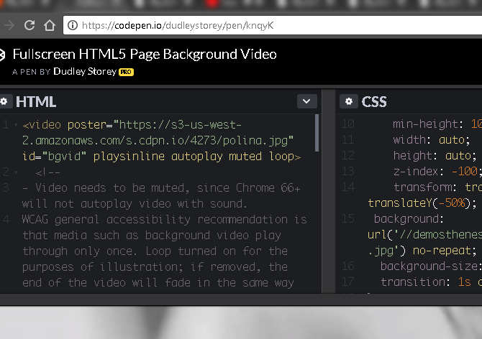

The above is a fantastic example of how a strong HTML backbone—and other subtle programming additions—can create a simple website. Luckily, it’s also small enough to share across many of the platforms listed above.

To convert a Codepen project into an Itty Bitty site, paste the Pen’s link into the Itty Bitty site. Then, mouse over the gray untitled section and edit the text to reflect your site.
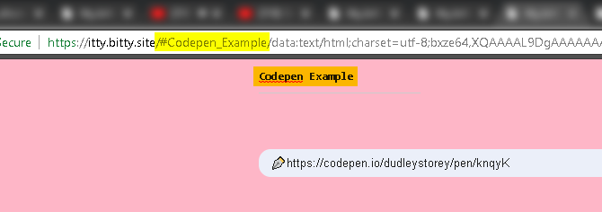
Next, click on the menu at the top right of the window.
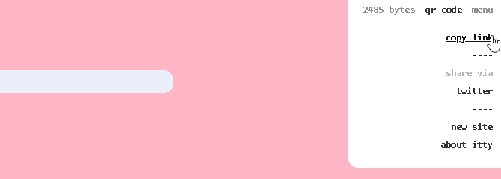
This is where you create the link to your Itty Bitty. While it may not seem as though you’ve just created a website, you have!
Once you click the copy link option, you can paste the link into your browser to view the site. Also important to note: by default, Itty Bitty sites can be sent via QR code.
That allows for a slew of options, like attaching a physical reference for lost devices.

7. LINK CREATION

This compressed data is base64 encoded, which converts it into to a set of letters and numbers that can be included in a URL.
Base64 is a group of similar binary-to-text encoding schemes that represent binary data in an ASCII string format by translating it into a radix-64 representation. The term Base64 originates from a specific MIME content transfer encoding. Each Base64 digit represents exactly 6 bits of data. Three 8-bit bytes (i.e., a total of 24 bits) can therefore be represented by four 6-bit Base64 digits.
The particular set of 64 characters chosen to represent the 64 place-values for the base varies between implementations. The general strategy is to choose 64 characters that are both members of a subset common to most encodings, and also printable. This combination leaves the data unlikely to be modified in transit through information systems, such as email, that were traditionally not 8-bit clean. For example, MIME's Base64 implementation uses A–Z, a–z, and 0–9 for the first 62 values. Other variations share this property but differ in the symbols chosen for the last two values; an example is UTF-7.
The earliest instances of this type of encoding were created for dialup communication between systems running the same OS — e.g., uuencode for UNIX, BinHex for the TRS-80 (later adapted for the Macintosh) — and could therefore make more assumptions about what characters were safe to use. For instance, uuencode uses uppercase letters, digits, and many punctuation characters, but no lowercase.

7.1 The Base64 index table
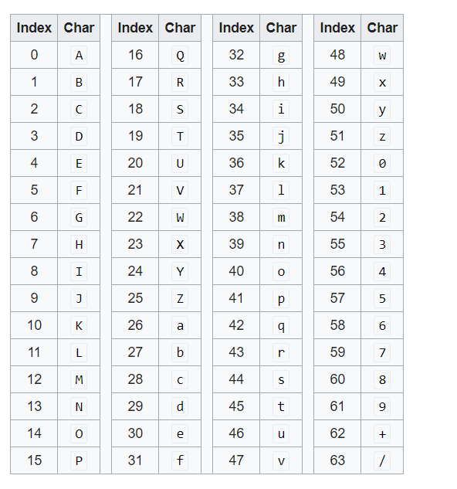

8. SHORTEN YOUR ITTY BITTY EVEN FURTHER
You can also create a clutter-free link using a link shortening tool. I’ll use Bitly, which not only allows you to shorten links but also allows you to customize the link with your own text if you sign up for a free account.
Our original Codepen example is too large to condense using Bitly, so here’s another fantastic project by JT Helms. I simply followed the process above to convert this Pen to an Itty Bitty site.
Once you have your link, head to Bitly. Paste your link into Bitly’s splash page, or sign into your account and select the Create button. Enter your link in the following prompt.

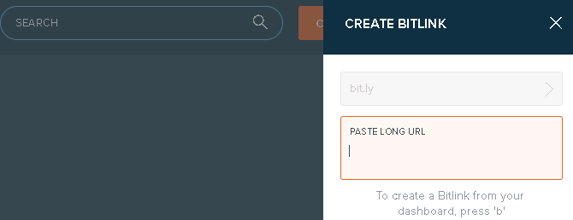
Once you’ve pasted your link, it will automatically be converted. Then, adjust your link as you see fit using Bitly’s editor if you’re logged in.

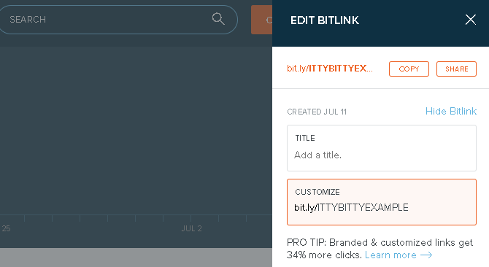
I change the initial link to ITTYBITTYEXAMPLE. You can now head to bit.ly/ITTYBITTYEXAMPLE as you would any other site—except, of course, that it’s free and requires no web hosting or server maintenance.

9. FRAGMENTS IN ITTY BITTY
itty.bitty stores this text in a section of the URL called a fragment–everything after the first # symbol.
http://itty.bitty.site/#Name/SITE_DATA
Fragments have a unique property: they are not sent to the server when requesting a website. Instead, the web browser traditionally uses them to scroll the page when it is loaded.

10. WHERE YOU CAN USE ITTY BITTY SITE
Itty bitty sites can hold about as much as a printed page, and there is a lot you can do with that:
✒️ Compose poetry
🛠 Create an app
🐦 Bypass a 140 280 char limit
🎨 Express yourself in ASCII
We can also use it as an online text editor or HTML editor.
Moreover, it can also be used in Sending Greetings to relatives and loved ones.

11. SHARING OF ITTY BITTY
The links that are generated from this process are complete and substantial. While most sites/apps support about 2000 bytes (2KB), some can handle more.
Twitter, for example, allows 4000 bytes in a link, accommodating a significant amount of text. Edgar Allan Poe's The Raven comes out to just under this. Longer sites can still be used via domain redirect (which is how this and many of the other examples are stored).

12. DISPLAY
Once the link is sent and opened, it loads itty.bitty.site to reverse the process, which is done completely on device. The data is extracted, inflated, and then shown in the web browser.

13. SECURITY IN ITTY BITTY
Scripting is a feature of itty.bitty.site.
It can deliver an entire webpage, including JavaScript, (and yes, even alerts). These pages are loaded in a sandboxed iframe, and thus have more limited access to things like cookies and local storage, but can still be abused.
As there are no databases, user accounts or persistent data, scripting does not allow any meaningful attacks here. This is subject to the same precautions you might have with any website with script content – what is shown on itty.bitty comes from the content people make and it is not inherently more trustworthy than a random site on the internet.
Longer term, this may degrade perception of the domain, but for now, the experimental nature of the site makes it worthwhile.
A persistently open issue about this is maintained on github to discuss this further. We are always open to feedback.

14. ADVANTAGES
- Itty bitty is a new tool to create HTML pages on links.
- A small computer with an Internet connection could easily formulate these URLs to create web pages.

15. DISADVANTAGES
- You can’t host graphics internally.
- You need an external place to point to pictures.
- The length link is too long and hard to remember

16. THE ITTY BITTY POSSIBILITIES
Creativity found online is often impressive. Rarely, however, is it as simple, accessible, and easy to use as Itty Bitty. Want to showcase a small application? Messing around with div elements? It’s all readily doable using the Itty Bitty site.
Moreover, you’re not limited to a certain number or sites. Take a note from the site’s creator Nocholas Jitkoff and link a site within a site for a comprehensive, multi-page explanatory website. Or make an ASCII bulldog. The possibilities are small in size, but endless in scope, so try out this little online experiment today!
Go further and make even better sites by improving your knowledge of HTML and CSS before creating an Itty Bitty site! Or check out our InMotion Hosting review for another way to host your site.

17. A WORD FROM ITS CREATOR
According to Jitkoff, even this portion is kept private, because a web browser will usually not send that fragment of a URL to a server. “Instead, the web browser (usually) uses them to scroll to the right section of the page when it is loaded,” he explains. Jitkoff doesn’t quite know what people will do with his creation yet, which exists as an open source project on Github. But he does suggest using it for standalone poetry, bypassing Twitter’s character limit, and using it as a clever alternative for domain redirecting, so you can host larger-than-normal portions of text as standalone URLs.
The compressed data is base64 encoded, which converts it into a group of letters and numbers that can be integrated into a URL, but it is still advised to avoid sharing any personal information.
According to its creator, Nicholas Jitkoff, “Scripting is enabled on these sites, which allows for greater flexibility, but it can also enable malicious use. It is strongly recommended to approach any content with caution.”
Jitkoff still doesn’t have a concrete idea of what people will do with his creation, which exists as an open-source project on Github, but he does recommend using it for self-contained poetry (which would circumvent Twitter’s limit on character) and as a clever alternative for domain redirecting, which would enable anyone to host larger-than-normal portions of text as self-contained URLs.

18. CONCLUSION
itty bitty site is a really nice web tool, to create simple micro-sites.
You can share information as a page which is stored in its URL. The site made by it is Portable, Secure and Easy to Share.
You can use this tool to share your hobby content, to create a small web app, to bypass 280 char limit, and for geeky people, to express yourself in ASCII.

14. BIBILIOGRAPHY
- https://itty.bitty.site/edit
- https://www.tripontech.com/tag/html/
- https://www.makeuseof.com/tag/create-hosting-free-website-itty-bitty/
- https://www.theverge.com/2018/7/5/17538474/itty-bitty-site-self-contained-websites-urls-open-web
- https://www.mssarticles.com/2018/07/itty-bitty-site-contained-within-own-url.html

